THE MAGICAL WORLD OF CHE-MIST𝔈RY.I
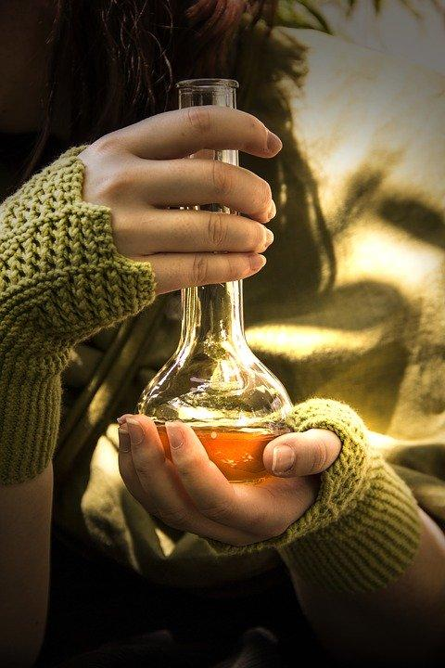

Fig.1

video¹ Chameleon

Initial activity
Discuss in pairs using the following expressions and complete the sentences.
- What happens in that video? Which color had the liquid substance?
I believe..................................................................................................................
- Is this a magical trick?
Yes, I think so.
Non, I do not think so. It has probably been...........................................................
- Or, is this the logical chemistry?
Non, I do not think so.
Yes, I think so, but I do not know how to explain it.
Yes, I think so. Perhaps it is something related to...................................................

TO DISCOVER IF THAT WAS REAL CHEMISTRY OR PURE MAGIC CHANGES, KEEP GOING INTO THIS CHAPTER.

- INTRODUCTION: ALCHEMY ORIGINS

Read the following text and explain to your partners. Work in groups.
Write on the blackboard the words you do not know the meaning. The teacher will translate them.

In Rome, from 37 to 41 dC, it was said that Caligula emperor would have carried out experiments to produce gold starting from orpiment (apparently arsenium sulphide), and that Diocletian emperor (c.III dC) would have given the order to burn all the Egyptian works concerning the chemistry of gold and silver, in order to stop such kind of experiments.
A school of alchemy flourished in Arabia from 750 to 1258. The first known work resulting from this school is the “Summa Perfectionis” (maximum perfection), attributed to the alchemist and philosopher Abu 'Abd Allah Jâbir Ibn Hayyân al-Sufi (latinized as Geber, c.VIII), nicknamed by his contemporaries "king of the Arabs and The Philosophers Prince". This is the oldest book on chemistry properly said¹. Arab alchemists were fascinated by the concept of metal transmutation and attempted to carry out the process². Arab alchemists also worked with gold and mercury, arsenic and sulfur, salts and acids, and became acquainted with a wide range of what we now call chemical reagents³.

“Magic chemistry”, as happened with the rest of Arab science, was communicated to Europe through Spain, thanks to the impressive flourishing that science and arts experienced in Al-Andalus throughout the middle Ages. The first existing works of European magic chemistry are those of the English Roger Bacon and the germanic philosopher Alberto Magno; both believed in the possibility to transmute lower metals into gold. The idea stimulated the imagination of many people throughout the middle Ages. They thought that silver and mainly gold were the most “perfect” metals compared to the rest, which were considered “imperfects” metals. Therefore, they believed in the famous philosopher's stone, a substance much more perfect than gold, which could be used to bring the most common metals to the perfection of gold. Roger Bacon believed that gold dissolved in aqua regia was the “elixir of life”, also known as the elixir of immortality³, which is a legendary potion or drink that guaranteed eternal life. We will focus later on in this legendary potion (point 6 of Che-Mist€ry.II).

In the thirteenth century the Italian scholastic philosopher Saint Thomas Aquino, the Majorcan polymath Ramon Llull also contributed much, by the way of magic chemistry, to the progress of chemistry, with their findings of the uses of antimony , the manufacture of amalgams and the isolation of the spirit of wine, or ethyl alcohol. Significant compilations of formulas and techniques of this period include Pyrotechnics (1540), by the Italian metallurgist Vannoccio Biringuccio; about metals (1556), by the Germanic mineralogist Georgius Agricola, and Alquimia (1597), by Andreas Libavius, a naturalist and Germanic chemist. The most famous of all the alchemists was the Swiss Paracelsus, who lived in the 16th century. He maintained that the elements of the composite bodies were salt, sulfur and mercury, which represented earth, air and water respectively. The 16th-century Swiss alchemist Paracelsus believed in the existence of alkahest, which he thought to be an undiscovered element from which all other elements (earth, fire, water, air) were simply derivative forms. Paracelsus believed that this element was, in fact, the philosopher' Stone, the universal medicine and the irresistible solvent.

After Paracelsus, the alchemists of Europe were divided into two sets. The first was composed of those who permanently work on scientific discoveries with compound and reactions. These scientists were the legitimate predecessors of modern chemistry, as announced by the work of French chemist Antoine Lavoisier. The second set accepted the visionary and metaphysical part of the ancient magic chemistry and developed a practice, inspired by imposture, black magic and fraud, from which the current notion of magic chemistry originates⁴.

LET’S WATCH HERE (video²) THE ALCHEMY HISTORY FROM THE VERY BEGINNING

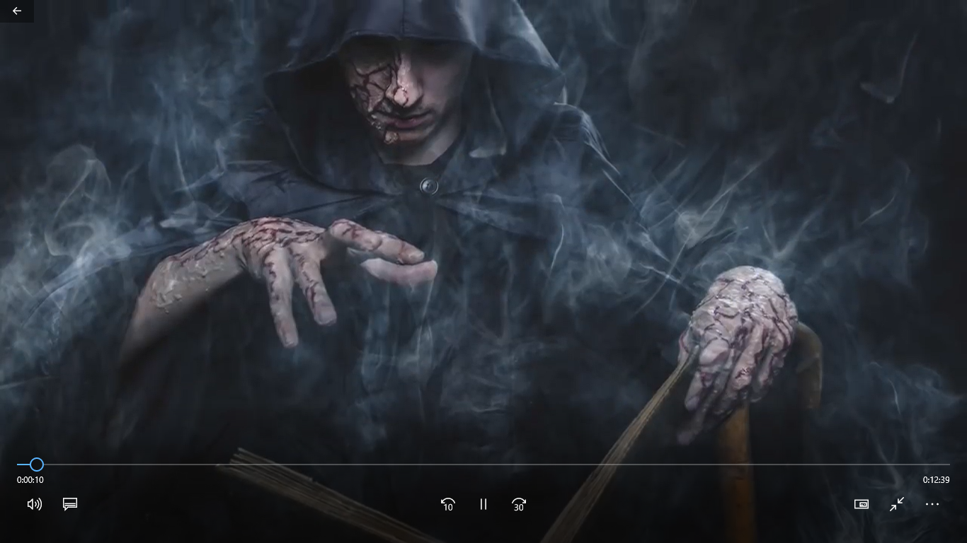
Fig. 2

Activity 1. Answer the following questions:

- Is Alchemy related to Magic? If yes, how or why?
______________________________________________________________________________________________________________________

- Is Alchemy related to Chemistry? If yes, How or why?
______________________________________________________________________________________________________________________

- From the previous text and video, could you complete the following table? (You will probably need a more exhaustive research).

 | Century  or years | Country | Language of written articles/books | Why were they known for?
Roger Bacon
Ramon Llul

Vannoccio Biringuccio

Andreas Libavius

Antoine Lavoisier

- After reading the life of Roger Bacon and Ramon Llul, how many things had them in common? Search in Internet if need it.
_________________________________________________________________________________________________________________________________________________________________________________

- In your opinion, was alchemy related to religion? Justify your answer.
_________________________________________________________________________________________________________________________________________________________________________________

- Do you think that European scientists play an important role in chemistry? Justify your answer.
_________________________________________________________________________________________________________________________________________________________________________________

Now, we will share our conclusions with the rest of the classmates.

- ANTOINE LAVOISIER

You are going to discover who Antoine was by your own resources (Internet), answering these questions:

Activity 2.

Who was Antoine Lavoisier?
_________________________________________________________________________________________________________________________________________________________________________________

Why he became famous?
_________________________________________________________________________________________________________________________________________________________________________________

Which universal law did he settled?
_________________________________________________________________________________________________________________________________________________________________________________

Is he related to Alchemy or to actual Chemistry?
_________________________________________________________________________________________________________________________________________________________________________________

- CHEMICAL REACTION OR CHEMICAL EQUATION?

Previously to well understand Lavoisier’s Law, we need to know a few concepts.
Watch this video³
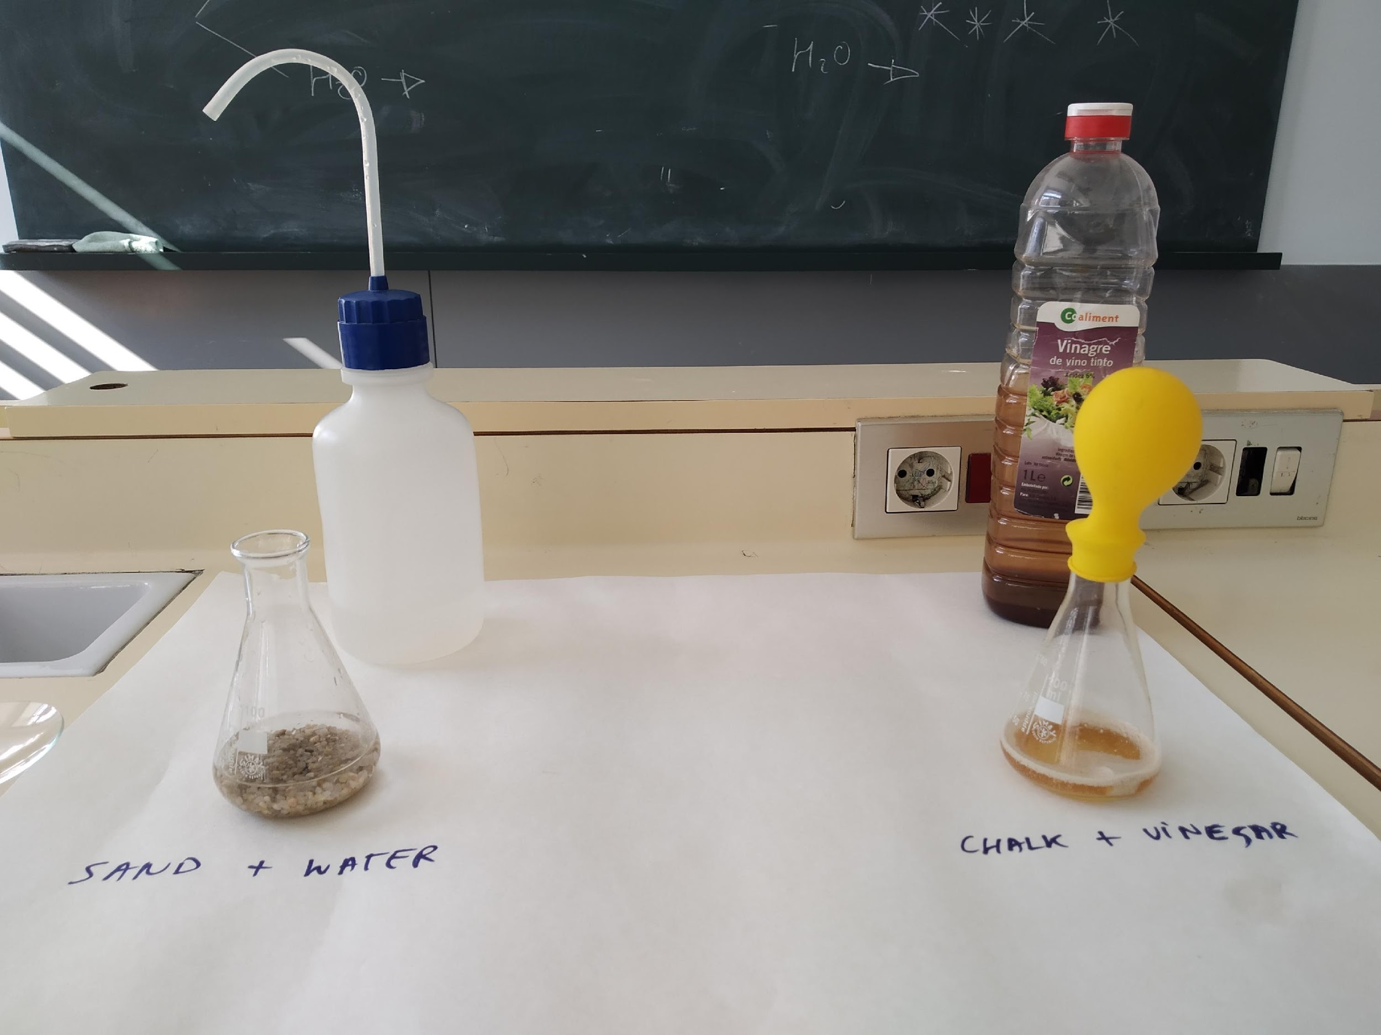
Fig. 3

Sand + Water = NOTHING HAPPENS = NONE CHEMICAL REACTION
Chalk + Vinegar = SOMETHING HAPPENS = CHEMICAL REACTION

After watching the following video⁴, you should be able to answer the following questions:
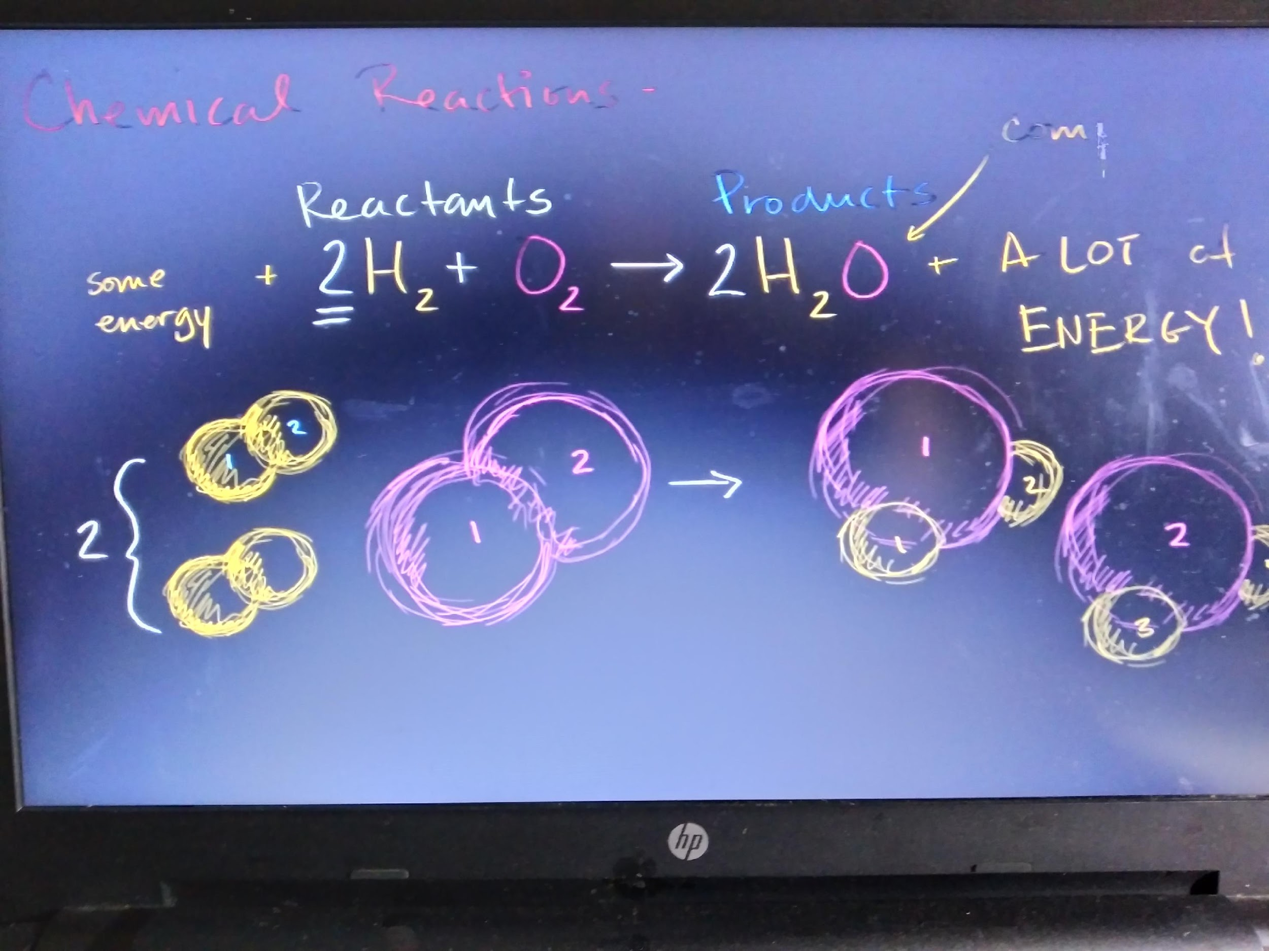
Fig. 4
Activity 3. Work in groups

In general, which are the reactants in a chemical reaction?
_____________________________________________________________________________________________________________________________________________________________________________________________

In general, which are the products in a chemical reaction?
_____________________________________________________________________________________________________________________________________________________________________________________________

Which symbols do we need to represent a chemical reaction?
_____________________________________________________________________________________________________________________________________________________________________________________________

Why a chemical reaction is also named chemical “EQUATION”? Is that something related to Lavoisier’s Law? What does mean “to balance” a reaction?
_____________________________________________________________________________________________________________________________________________________________________________________________

When representing a chemical reaction we use an arrow 🡪. Which mathematical operation is related with this arrow?
_____________________________________________________________________________________________________________________________________________________________________________________________

Now you are going to verify Lavoisier’s Law with your practice.
We are going to run our first reaction!!
P1. LABPRACTICE 1: “Lavoisier’s Law or Law of mass conservation”

Work in pairs

Goal

Classify different reactions, get used to their inorganic names and formula and verify Lavoisier law.

Could you predict if the reaction of vinegar with baking soda (sodium bicarbonate) will occur? (You will learn more at point 4)

Look for the formulas and names (either English than your mother tongue).

Material ________________________________________________________________________________________________________________________________________________________________________________________________

Procedure

- Weight 4g sodium bicarbonate in a watch-glass. Pour 20 ml of vinegar, with a pipette and pro-pipette, in an Erlenmeyer. Introduce the sodium bicarbonate in a balloon. Weight all together. Record the value (W1).
- Mix the sodium bicarbonate with vinegar and close the Erlenmeyer with the balloon (just like at video³). Observe. After 5 min, record the weight again (W2).

Results

Your observations and weights.

Write down the chemical equation: with reagents –look for their formulas- and try to predict the products.

Conclusions

Answer the initial goals.
Is W1 equal or really close to W2? _______________________________________________________________

Is that related to Lavoisier’s law? Explain why yes or why not_____________________________________________________________

Finally try to balance the chemical equation, what means, to accomplish Lavoisier’s law.___________________________________________________

WEBGRAPHY

1 – http://www.science-et-magie.com/ALCHIMIE/alchimie01.htm (15/05/2020)
2 - https://en.wikipedia.org/wiki/Philosopher%27s_stone#cite_note-Strohmaier-6 (15/05/2020)
3 - https://ca.wikipedia.org/wiki/Usuari:Mcapdevila/Elixir_de_la_vida (15/05/2020)
4 - http://www.escuelapedia.com/academia/alquimia-en-europa (15/05/2020)

Fig.1. https://pixabay.com/es/images/search/alchemy/ (https://pixabay.com/es/photos/poci%C3%B3n-magic-alquimia-botella-3539394/)
Fig. 2. https://www.youtube.com/watch?v=gxiLuz9kHi0, from CrashCourse
Fig. 3. Instituto Bisbe Berenguer, Hospitalet del Llobregat, Catalunya.
Fig. 4. https://www.youtube.com/watch?v=TStjgUmL1RQ, from Khan Academy

Video 1: It was suppose to be a homemade video from Instituto Bisbe Berenguer, Hospitalet del Llobregat, Catalunya. Because of Covid-19, I had to use this other video, https://youtu.be/fEZD1k4SL_I?t=50, from https://www.youtube.com/user/spitfire979/
Video 2: https://www.youtube.com/watch?v=gxiLuz9kHi0, from CrashCourse
Video 3: Instituto Bisbe Berenguer, Hospitalet del Llobregat, Catalunya. Març 2020

Video 4: https://www.youtube.com/watch?v=TStjgUmL1RQ, from KhanAcademy

Icons and symbols:
https://www.flaticon.es/icono-gratis/busqueda_1150645
https://www.flaticon.es/icono-gratis/aplausos_305488?term=aplausos&page=1&position=34, by Z. Najdenovski

