THE MAGICAL WORLD OF CHEMIST€RY.II
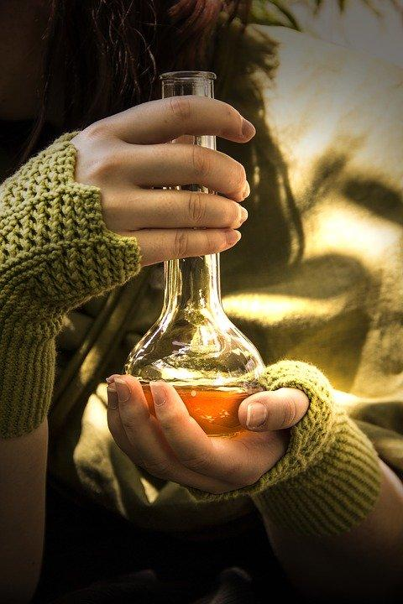

Fig.1

Now, we already know that “CHAMELEON video”, from previous scenario, is not a magical trick. Let’s help our ancestors to classify chemical reactions solving a final che-mistery question regarding “elixir of life” or the “Legendary potion” (at point 2 of Chemist€ry.I).

- REACTION CLASSIFICATION

4.1 Single-replacement reaction.
When one element is substituted for another element in a compound, generating a new element and a new compound as products. For instance,

2HCl(aq) + Mg(s) → MgCl₂(aq) + H₂(g)
2NaBr(aq) + Cl₂(g) → 2NaCl(s) + Br₂(g)
At the single-replacement reaction there is one element as a reactant and another element as a product.
But not all single-replacement reactions will occur, only elements on top of the column are able to replace the elements below them on the periodic table but not the other way around. For example, the elements called halogens (F, Cl, Br, I) follow a pattern, which is:
Fluorine is able to replace Chlorine, Bromine and Iodine.
Chlorine is able to replace Bromine and Iodine but not Fluorine.
Bromine is able to replace Iodine but not Fluorine neither Chlorine.
Thus, the reaction represented by

MgBr₂(s) + Cl₂(g) → MgCl₂(s) + Br₂(ℓ) will occur,
but the reaction MgBr₂(s) + I₂(s) → MgI₂(s) + Br₂(ℓ) will not.
When replacing anions (ions negatively charged), reactivity trends are easy to predict using their relative positions on the periodic table.

However, replacing cations (ions positively charged), chemical reactivity trends are more complicated because there are much more elements that can form cations. A list of activity series for single-replacement reactions is shown below.

Activity Series for Cation Replacement in Single-Replacement Reactions⁵
- Li
- K
- Ba
- Sr
- Ca
- Na
- Mg
- Al
- Mn
- Zn
- Cr
- Fe
- Ni
- Sn
- Pb
- H₂
- Cu
- Hg
- Ag
- Pd
- Pt
- Au
An element on top will replace an element below it in compounds undergoing a single-replacement reaction. Elements will not replace elements above them in compounds.

Example
Use the activity series to predict the products, if any, of each equation. Fill the gaps, if need it.
- SnCl₂ + Fe → _________? + __________?
- SnCl₂ + Au → _________? + __________?
Solution
- Because iron is above tin, it will replace tin in the compound. The products of this single-replacement reaction are FeCl₂ and Sn.
- Gold is below tin in the activity series. No reaction is predicted.

Activity 4.1 Fill the gaps
- Mg + HCl → _________? + __________?
- HI + Br₂ → _________? + __________?
- NaI + Cl₂ → _________? + __________?
- AgCl + Au → _________? + __________?

4.2 Double-replacement reaction
A characteristic of a double-replacement equation is that there are two compounds as reactants and two different compounds as products. For instance,

KI (aq) + Pb(NO₃)₂(aq) → K(NO₃) (aq) + PbI₂ (s)

There is a couple exchange; the anions have exchanged their cations. Or, what is the same, the cations have exchanged their anions.

Example
Predict the products of this double-replacement equation:
CuCl₂(aq) + AgNO₃(aq) → _________? + __________?

Solution
You can either switch the cations or switch the anions, we would expect the products to be Cu(NO₃)₂(aq) and AgCl(s)

Predicting whether a double-replacement reaction occurs is more difficult than predicting a single-replacement reaction. However, there is one type of double-replacement reaction that we can predict: the precipitation reaction. (LABPRACTICE 2, could be done by the teacher in class as a demonstration).
A precipitation reaction occurs when two ionic compounds are dissolved in water and form a new insoluble compound in water. This new compound turns into a solid precipitate. One of the driving force that makes the reaction occurs is the formation of a solid precipitate⁵.

Activity 4.2 Work in pairs or groups

- Predict the products of this double-replacement equation: KBr + AgNO₃ → ?
_______________________________________________________________

Check in Internet if one of the 2 products formed is a solid precipitate. If it is, then the reaction will occur.

- Define what a single-replacement reaction is.
_______________________________________________________________

- Define what a double-replacement reaction is.
_______________________________________________________________

- Define what a precipitation reaction is.
_______________________________________________________________

- In chemistry the formation of a gas is symbolized by an up arrow ( ). Which symbol will represent a solid formation?
_______________________________________________________________

- Which is the relation between a “precipitation” reaction and rain “precipitations”?
_______________________________________________________________

- This chemical equation is balanced:
CuCl₂(aq) + 2AgNO₃(aq) → Cu(NO₃)₂(aq) + 2AgCl(s)
Or as what is similar, Lavoisier Law is accomplish because there are same number of atoms at products than reactants.
Is the following equation balanced? Does this equation accomplish Lavoisier Law? Fill the gaps if need it

____ KI (aq) + ____ Pb(NO₃)₂(aq) → ____ K(NO₃) (aq) + ____ PbI₂ (s)
Now, we are going to run our second reaction!! DOUBLE CLAP

P2. - LABPRACTICE 2: WHICH KIND OF REACTION IS THIS?
Work in pairs

Goal

Classify different reactions, get used to their inorganic names and formula.
Could you predict if the reaction of potassium iodine with a Pb(NO₃)₂ solution will occur?

Material
____________________________________________________________________________________________________________________________________________________________________________

Procedure
- Mix 3 ml of potassium iodine solution, with 3 ml of Pb(NO₃)₂ solution. Observe.

Results Fig.5

Your observations and weights before and after reaction.
Write down the chemical reactions and try to balance them.

Conclusions

Answer the initial goals and titol.

Remember: The final production of a Labpractice will be your Labreport

And now, we are going to run our third reaction!! DEADLY TRIPLE CLAP

P3 – LABPRACTICE 3: MOLE AND YIELD CALCULATIONS

Work in pairs

Goal

Prepare solutions. Introduce mole concept. Obtain the reaction yield.
Get familiar to stoiquiometry and its European origins.

Material
________________________________________________________________________________________________________________________________________________________________________________________________

Procedure

- Prepare one solution of KI (potassium iodine) with 2g of it introduced into a 100 mL volumetric flask. Add up to 100 mL of distilled water.
- Prepare one solution of Pb(NO₃)₂ (Plumb dinitrate) with 2g of it introduced into a 100 mL volumetric flask. Add up to 100 mL of distilled water.
- Pour solution 1 into a beaker and slowly add solution 2 to the same beaker. Record your observations.
- Wait 10 min before filtering with and special filter paper, funnel and Erlenmeyer. Which is the solid (and filtered) compound? (Predict its name and formula)
- Leave the solid to dry for a week (write your name on the filter paper). After that, weight the obtained mass over a watch-glass.

Results

- Write the chemical equation.
- Calculate of the Molecular Mass (or Molar Mass –MM-) of each reagent/product. Use the atomic mass from your periodic table.
- Calculate the number of mole for each reactant/products.
n (mole) = compound weight / Molecular Mass
Example:
n(KI) = 2g / (39+126,9) = 2/165,9 = 0,01206 mol of KI
- Find the stoiquiometrical coefficients in this chemical equation. You’ll need it in order to verify Lavoisier’s Law of mass conservation (Reactants Mass = Products Mass).
- Which is the PbI₂ mass obtained? And which should be the theoretical mass obtained? Then, calculate the yield of real reaction. Help = 100% yield means you have obtained same PbI₂ mass than the theoretical one.

 | Reactant 1 | Reactant 2 | Product 1 | Product 2
Formula
Stequiometrical coeff.
Mass, g | 2 | 2
MM | 165,9
n, mol | 0,01206

Conclusions

Verify Lavoisier’s Law applied to your reaction. Justify your reaction yield.
How does number of “mol” help us?
________________________________________________________________

Who invented the word Stoquiometry?

Was him related to Alchemy or to Actual Chemistry? Which was his nacionality?

________________________________________________________________

In which continent was the word Chemistry original?
________________________________________________________________

Remember: The final production of a Labpractice will be your Labreport

- OTHER CHEMICAL REACTIONS

Retaking video1 (Chemist€ry.I, Chameleon), now all of you should know that the color change of this solution is produce for a chemical reaction. But:

Activity 5.1

Which kind of reaction? _____________________________________________

(I will give you a clue; watch this video⁵)

Have we already studied these reactions?________________________________________________________

Could you explain where the other colors of the same solution come from?____________________________________________________________________________________________________________________________________________________________________________________________
________________________________________________________________

(I will give you a clue; the initial violet color is due to Manganese in its +7 valence or oxidation number)

Activity 5.2
This is the most basic COMBUSTION REACTION
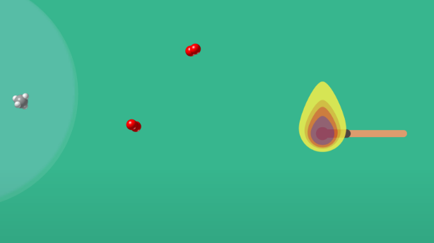
Fig.6
https://interactives.ck12.org/simulations/chemistry/balancing-chemical-equations/app/index.html?lang=en&referrer=ck12Launcher&backUrl=https://interactives.ck12.org/simulations/chemistry.html

Watch the precedent applet and write down which are the 2 reactants, which are the 2 products and which are the stoichiometric coefficients.
________________________________________________________________
Now try to find the stoichiometric coefficients for these following combustion reactions:
C₂H₆ + O₂ 🡪 CO₂ + H₂0
C₃H₈ + O₂ 🡪 CO₂ + H₂0
C₄H₁₀ + O₂ 🡪 CO₂ + H₂0

HELP: In order to find the stoichiometric coefficients the reaction needs to be balanced. That means we need to keep same number of atoms (for each different element) in both sides of the reaction. This is just because Lavoisier’s law.
But I will give you one more clue or help: Watch this video⁶.

Activity 5.3
How are currently named the 2 reactants in a neutralization reaction?
________________________________________________________________________________________________________________________________
________________________________________________________________

Is there any other way to name this neutralization reaction? If yes, which is?
________________________________________________________________________________________________________________________________
________________________________________________________________

- ELIXIR OF LIFE: A CONTROVERSIAL SUBJECT

To end this unit, you will have to solve a huge CHEMIST𝔈RY. Going back to “elixir of life” or the “Legendary potion” in point 2 (Chemist€ry.I). You have two main researches to do:
Activity 6 – GUIDED RESEARCH ACTIVITY
Half class chose 6.1 or 6.2 questions as a topic to research
6.1 Our rich European ancestors used to drink water from a metal pitcher or vase, since there was no tap water. The richer, the nobler the metal (gold or silver) that stored the water was. The poorer, they drank the water stored into ceramic pitchers but with a gold coin dropped into it. Why people in the past used to add this gold coin into water?___________________________________________________________________________________________________________________________________________________________________________________________________________________________________________________________________________________________________________________________
6.1.1 From your research on the previous question, do you think there is any kind of chemical reaction between gold or silver with water? If yes, explain which should be the products of these reactions? ________________________________________________________________________________________________________________________________________________________________________________________________________________________________________________________________
6.2 More recently (even now), gold or silver colloidal suspensions were used before antibiotics appeared.
6.2.1 Look for colloidal suspension definition___________________________________________________________________________________________________________________________________________________________________________________
6.2.2 Search the actual uses of gold or silver colloidal suspensions
__________________________________________________________________________________________________________________________________________________________________________________________

A new clue: (https://firewaterstar.com/colloidal-gold-benefits/)

DRAWING CONCLUSIONS IN COMMON
6.3 Argue among your classmates if you think that points 6.1 and 6.2 are related. Justify either both possible answers __________________________________________________________________________________________________________________________________________________________________________________________

  - Do you know the difference between pseudoscience and science? Could you evoque one possible origin of “pseudoscience”? Do you think that old Europe contributes in a large way to pseudoscience history evolution?
__________________________________________________________________________________________________________________________________________________________________________________________

FINAL ACTIVITIES

Activity 1. Balance the following reaction:
1) H₂S + NaOH→ Na₂S + H₂O

2) NH₃ + O₂ → H₂O + NO

3) FeS₂ + O₂ → SO₂ + Fe₂O₃

Activity 2. Classify the following reactions:
a) H₂S + SO₂ → S + H₂O

b) KClO → KCl + KClO₃

c) H₂CO₃ + Ca(OH)₂ 🡪 CaCO3 + H₂O

d) C₃H₈ + O₂ → CO₂ + H₂O
e) NaOH + HCl 🡪 NaCl + H₂O

Activity 3. HOMEMADE POPCORN. Make a short homemade video explaining these 4 kinds of reactions:

Combustion Reaction
Precipitation Reaction
Neutralization Reaction
Redox (Reduction/oxidation) Reaction

You will be co-evaluated by your classmates and your teacher. Prepare popcorn while watching your “mates” videos and grade them.

WEBGRAPHY

5 - https://scholar.flatworldknowledge.com/

Fig.1.https://pixabay.com/es/images/search/alchemy/ (https://pixabay.com/es/photos/poci%C3%B3n-magic-alquimia-botella-3539394/)
Fig. 5 https://commons.wikimedia.org/wiki/File:Lead_(II)_iodide_precipitating_out_of_solution.JPG
Fig. 6 by CK12 (3/12/2020)

Clue:
https://firewaterstar.com/colloidal-gold-benefits/ (15/05/2020)
https://interactives.ck12.org/simulations/chemistry/balancing-chemical-equations/app/index.html?lang=en&referrer=ck12Launcher&backUrl=https://interactives.ck12.org/simulations/chemistry.html (15/05/2020) By CK12

Video 5: Student Yassin El Kaisi, from Instituto Bisbe Berenguer, Hospitalet del Llobregat, Catalunya. May 2020

Video 6: Student Victor Domene, from Instituto Bisbe Berenguer, Hospitalet del Llobregat, Catalunya. May 2020

Icons and symbols:
https://www.flaticon.es/icono-gratis/busqueda_1150645
https://www.flaticon.es/icono-gratis/aplausos_305488?term=aplausos&page=1&position=34, by Z. Najdenovski

