Worksheet for “LESSON 2: Space telescopes”
Class divides students into two teams. Each team fills up a column of the comparison table below. Teams can also use Wikipedia to get more information.

Basic technical  characteristics  of the space telescopes | Hubble  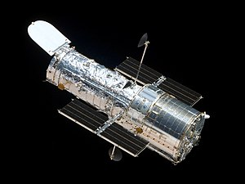 | James Webb  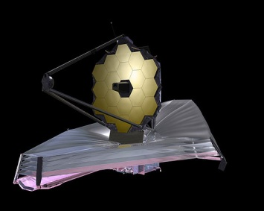
Dimensions (m)
Launch date
Primary mirror’s diameter (m)
Focal length (m)
Power (KW)
Regions of electromagnetic spectrum observed (UV/IR)
Orbits away from Earth (km)
Period (time)
Uses sunshield (y/n)
Uses solar panel arrays (y/n)
Serviceable (y/n)

