WATER
WORKSHEET 3
Instructions
- Form groups of four following your teacher’s instructions.
- Look at your ID card (Who are you? What is your job? Where do you come from?)
- Can you discover where you are? When you do that go to https://padlet.com/mepr4/tdfiopik7imelumm and place a pin on it. ( ).
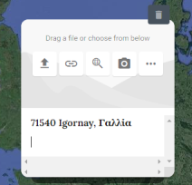
- Then discuss with the members of your group and try to find the answer to the questions that follow.
- In the padlet, in the space that opens near your location write down the answers to the questions (preferably in a full text)

Group 1

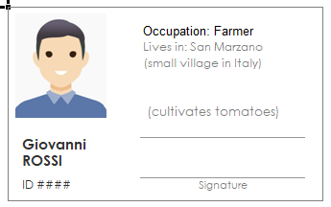

Group 2

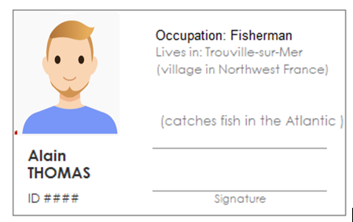

Group 3

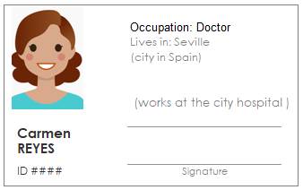

Group 4

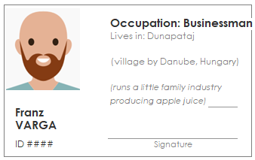

Group 5

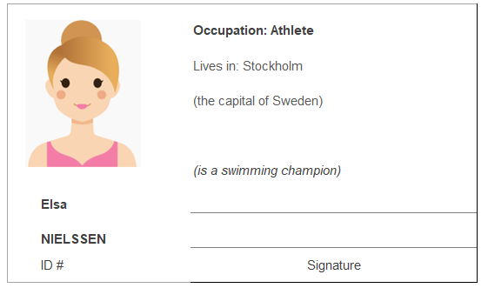

Group 6

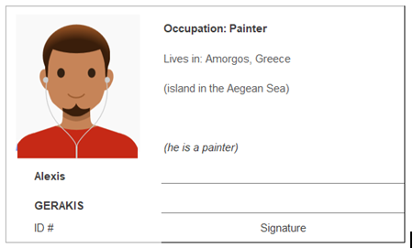

Group 7

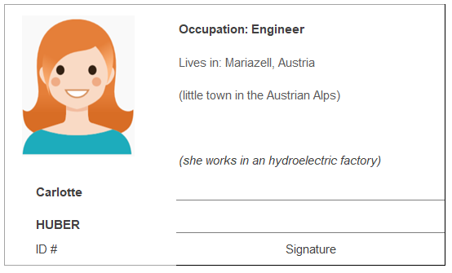

Questions
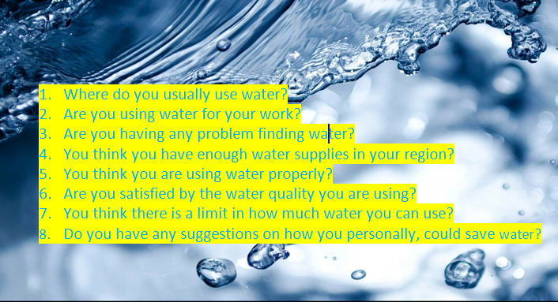

ID images from: www.freepik.com

Homework

Watch the short film the Water Diary and keep notes.
https://safeyoutube.net/w/YaoM

In the next lesson we are going to discuss your opinion on the following questions. You can watch the film as many times you want and you can keep notes. (Some important vocabulary has been added to your quizlet glossary)

- What is the problem that they are facing?
- What happened to the horses? How do we know it?
- How are the people’s dreams related to the water cycle?
- What happened to Sam’s father?
- What do the kids decide to do?
- What would you have done if you were there?

