OLA Scenario 1 - Probability using Arduino
Creators: Falagaras Aristeidis, Ampatzoglou Ioannis
School: 1o Peiramatiko Gymnasio Athinas
This scenario uses tinkercad to simulate an arduino circuit in order to show determinism and probability. The electronic circuit can also be assembled from students or from the teacher.

1st teaching period

1st Activity: Deterministic experiment.
Time: 15’
Type of activity: Mathematical experiment using software simulator (Tinkercad) or arduino platform, data log, outcome of conclusions, pattern recognition, Euclidean division.
Class organization: Class splits to teams of two.
Actions/Tasks: Every team uses tinkercad simulation to simulate the given circuit on https://www.tinkercad.com/things/kgT3Kzv0kLP (or assembles the given circuit using an arduino platform, if possible). They also use the worksheet1 for data log.

Click on TINKER THIS button to open a copy of this circuit or click SIMULATE>START SIMULATION to simulate the circuit.
The circuit consists of an ARDUINO board, a RED led, a GREEN led, a PUSH BUTTON (switch), two 330 Ohm RESISTORS (orange, orange, brown), a 10.000 Ohm RESISTOR (brown, black, orange), some CABLES and a BREADBOARD.
Press the CODE button to see the code.

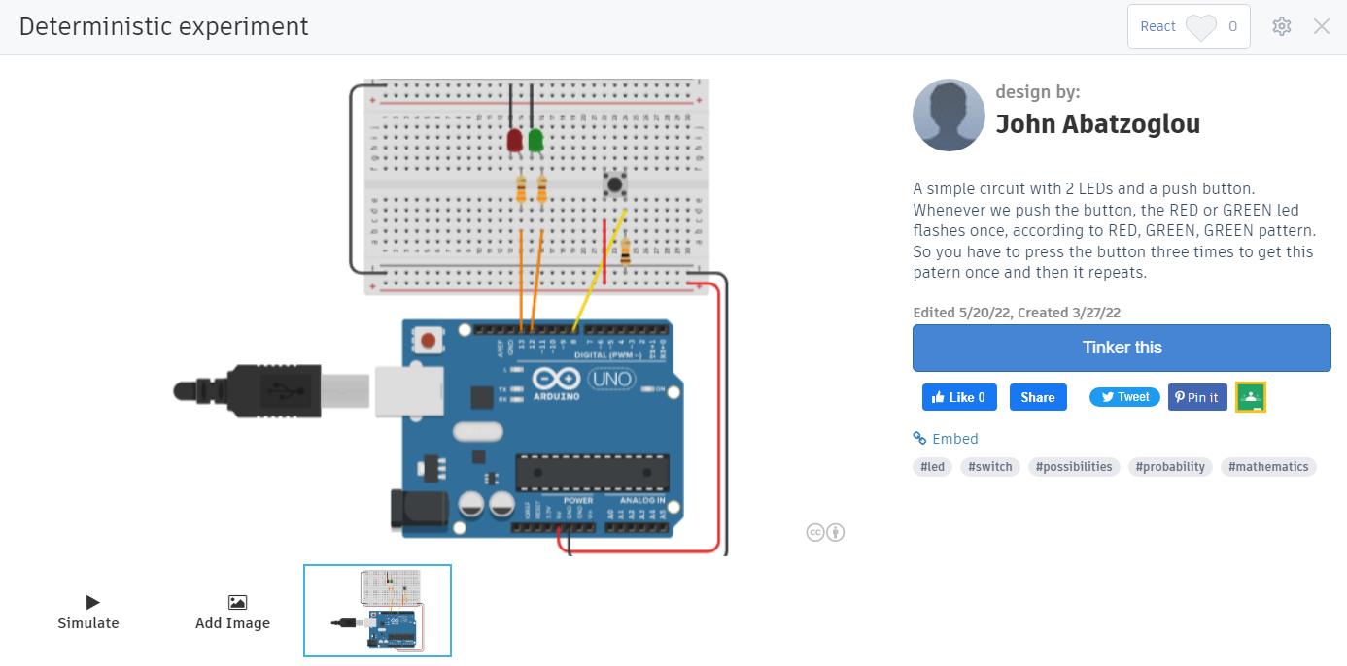

One student handles the experimental circuit and the other keeps notes on the worksheet. The experimental circuit has two leds (a green and a red one) and a switch. The circuit is programmed to follow a pattern: 1st button press flashes RED LED, 2nd button press flashes GREEN LED, 3rd button press flashes GREEN LED and this pattern repeats so on.
Each group has to discover and recognise the pattern, in order later to predict which LED will flash next and to confirm it experimentally. At the end of the activity, the results are announced in the plenary session of the class and the teacher gives the definition of the “Causal Experiment”.

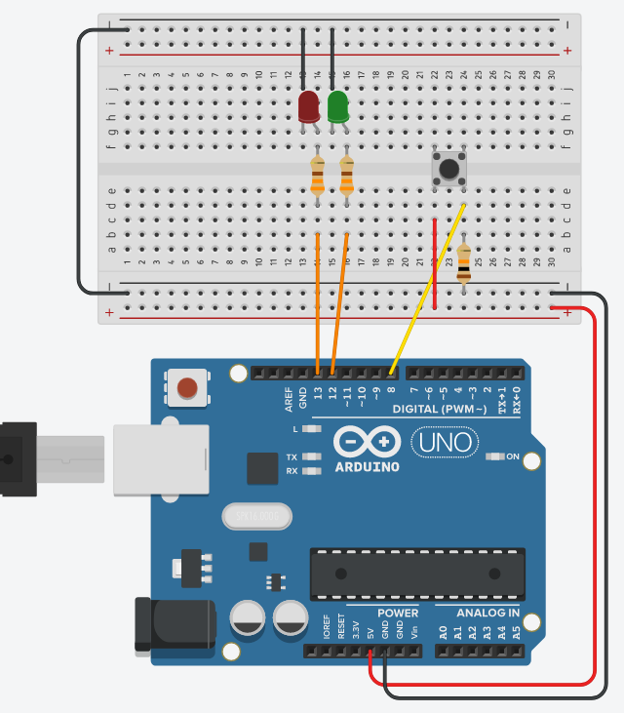
Circuit explanation:
The arduino platform gives power (+5V, GND) to the circuit.
When the button is not pressed, pin8 connects at Ground (LOW) through the 10K resistor.
When the button is pressed, pin8 connects to +5V (HIGH).
Pin 13 controls RED led and Pin 12 controls GREEN led.
Leds flash only when control pins are HIGH.

Press the SIMULATION button to run it.

Code explanation:
The code always checks the status of the button connected at pin8. Whenever the push-button is pressed (pin8=HIGH), then the variable ‘counter’ raises up by one.
IF variable counter<2 (counter=1), THEN the RED led connected at pin13 will flash once for a second, ELSE (when counter>=2) the GREEN led connected at pin10 will flash for a second. If the variable counter=3, then the variable resets to 0 and the pattern is repeated.
So, if we press the button on and on, we’ll get the flash pattern [RED, GREEN, GREEN], [RED, GREEN, GREEN], [RED, GREEN, GREEN], etc.

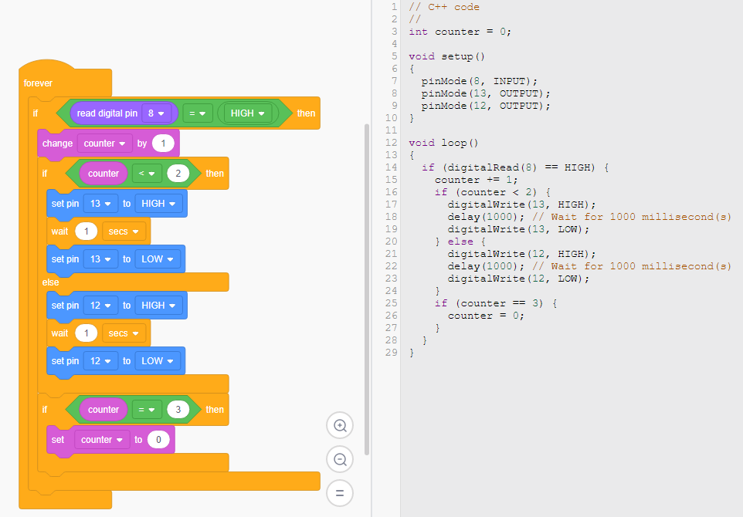

2nd Activity: Color Dice (Random number) experiment.
Time: 30’
Type of activity: Mathematical experiment using software simulator (Tinkercad) or arduino platform, data log, outcome of conclusions
Class organization: Class splits to teams of two.
Actions/Tasks: Every team uses the tinkercad to simulate the given circuit on https://www.tinkercad.com/things/2lmH1s1j7uL (or assembles the given circuit using an arduino platform, if possible). They also use worksheet1 for data log.

Click on TINKER THIS button to open a copy of this circuit or click SIMULATE>START SIMULATION to simulate the circuit.
The circuit consists of an ARDUINO board, 4 color LEDs, a PUSH BUTTON (switch), four 330 Ohm RESISTORS (orange, orange, brown), a 10.000 Ohm RESISTOR (brown, black, orange), some CABLES and a BREADBOARD.
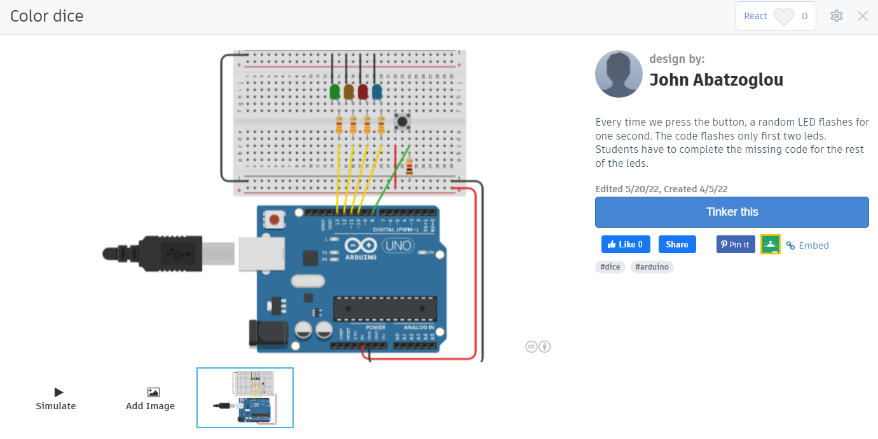

One student handles the experimental circuit and the other keeps notes on the worksheet. The experimental circuit has 4 color leds consisting of a dice and a switch to roll the dice. The circuit is programmed to pick randomly a number between 1 to 4 and only one of the 4 LEDs will flash.
Each group has to discover the fault of the code and fill in the block code appropriately. At the end of the activity, the results are announced in the plenary session of the class and the teacher gives the definition of “Random”.

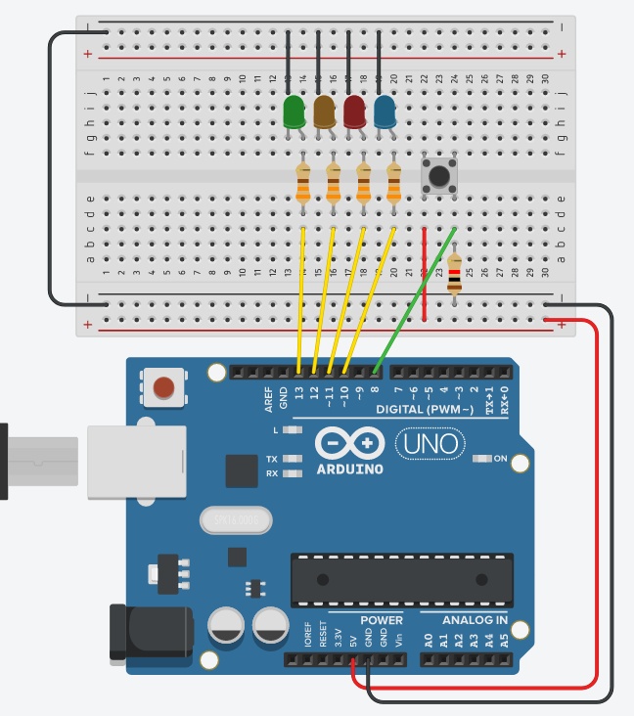
Circuit explanation:
The arduino platform gives power (+5V, GND) to the circuit.
When the button is not pressed, pin8 connects at Ground (LOW) through the 10K resistor.
When the button is pressed, pin8 connects to +5V (HIGH).
Pin 13 controls RED led and Pin 12 controls GREEN led.
Leds flash only when control pins are HIGH.

Press the SIMULATION button to run it.

Code explanation:
The code always checks the status of the button connected at pin8. Whenever the push-button is pressed (pin8=HIGH), then the variable ‘number’ is given a randomly chosen number between 1 to 4.
IF number=1, THEN the GREEN led connected at pin1 will flash once for 0.5 seconds. Same happens for YELLOW, RED and BLUE LEDs, when number=2 or 3 or 4 accordingly.
Missing code should be filled in by students (in case number=4 and BLUE led flashes).
All control pins are set LOW (LEDs are off), when the button is not pressed.

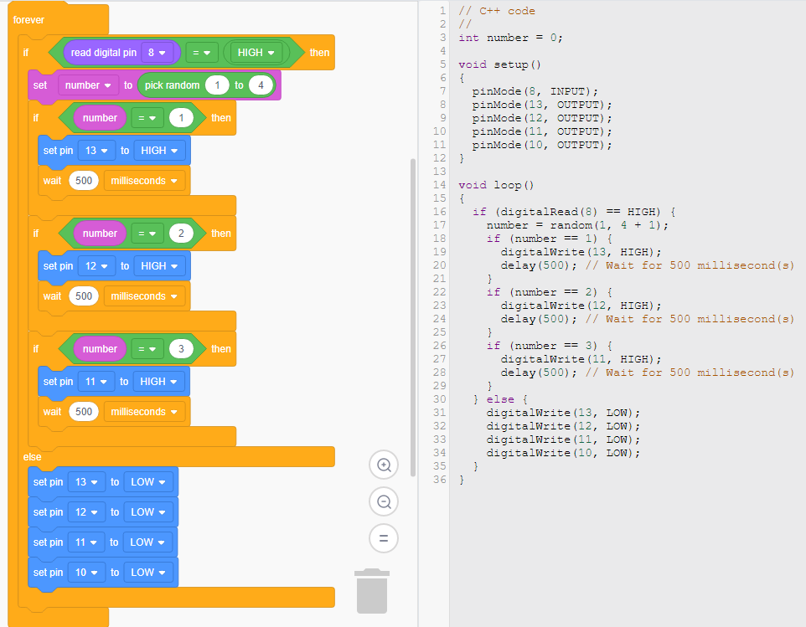

2nd teaching period

1st Activity: Luck experiment
Time: 20’
Type of activity: Mathematical experiment using software simulator (Tinkercad) or arduino platform, data log, outcome of conclusions, Luck Experiment.
Class organization: Class splits to teams of two.
Actions/Tasks: Every team uses the tinkercad to simulate the given circuit on https://www.tinkercad.com/things/20Rl7DEfjux (or assembles the given circuit using an arduino platform, if possible). They also use worksheet2 for data log.

Click on TINKER THIS button to open a copy of this circuit or click SIMULATE>START SIMULATION to simulate the circuit.
The circuit consists of an ARDUINO board, 2 color LEDs, a PUSH BUTTON (switch), two 330 Ohm RESISTORS (orange, orange, brown), a 10.000 Ohm RESISTOR (brown, black, orange), some CABLES and a BREADBOARD.

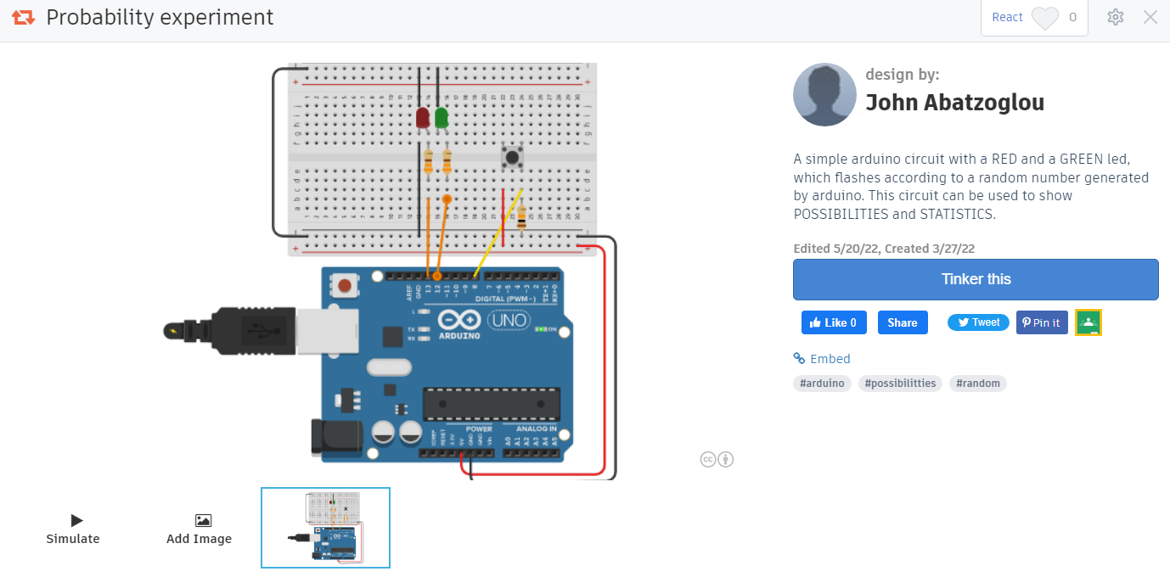
One student handles the experimental circuit and the other keeps notes on the worksheet. The experimental circuit has two leds (a green and a red one) and a switch. The circuit is programmed to flash RED or GREEN led, every time the button is pressed, with a probability ratio of 30/70.
Each group has to discover experimentally the probability of every flashing color LED and predict the next flashing color. At the end of the activity, the results are announced in the plenary session of the class and the teacher gives the definition of the “Chance Experiment”.

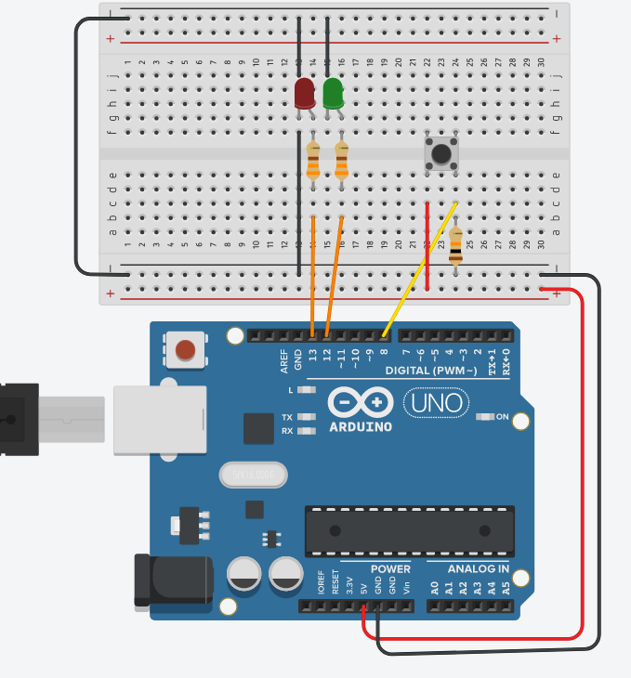

Circuit explanation:
The arduino platform gives power (+5V, GND) to the circuit.
When the button is not pressed, pin8 connects at Ground (LOW) through the 10K resistor.
When the button is pressed, pin8 connects to +5V (HIGH).
Pin 13 controls RED led and Pin 12 controls GREEN led.
Leds flash only when control pins are HIGH.

Press the SIMULATION button to run it.

Code explanation:
The code always checks the status of the button connected at pin8. Whenever the push-button is pressed (pin8=HIGH), then the variable ‘number’ is given a randomly chosen number between 1 to 10. If number<4 (number=1 to 3), THEN the RED led connected at pin13 will flash once for a second, otherwise (number=4 to 10) the GREEN led connected at pin12 will flash once for a second. This means that the probability is 30% for RED and 70% for BLUE.

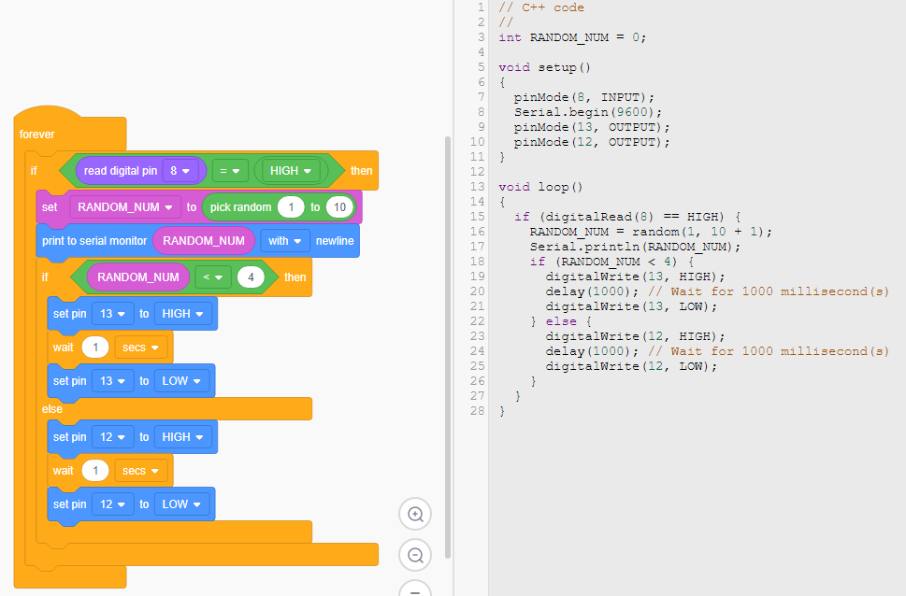

2nd Activity: Probability experiment
Time: 25’
Type of activity: Mathematical experiment using software simulator (Tinkercad) or arduino platform, data log, outcome of conclusions, probability prediction
Class organization: Class splits to teams of two
Actions/Tasks: Every team uses the tinkercad to simulate the given circuit on https://www.tinkercad.com/things/20Rl7DEfjux (or assembles the given circuit using an arduino platform, if possible). They also use worksheet2 for data log.
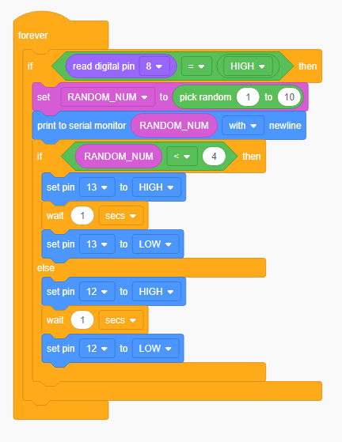

Each group has to understand through the block code that the probability for RED led is programmed at 30% and for BLUE is at 70%.
Groups are called to change the probability ratio to 50%-50%. They simulate again the circuit and record 20 new values to calculate the new probability ratio between RED and BLUE leds.
At the end of the activity, the results are announced in the plenary session of the class and the teacher gives the definition of the “Probability”.

ΑΝΝΕΧ
If you have assembled the real arduino circuit and you want to program it, then you have to do the following:
- Change BLOCKS to BLOCKS+TEXT to see the text code next to the block code.
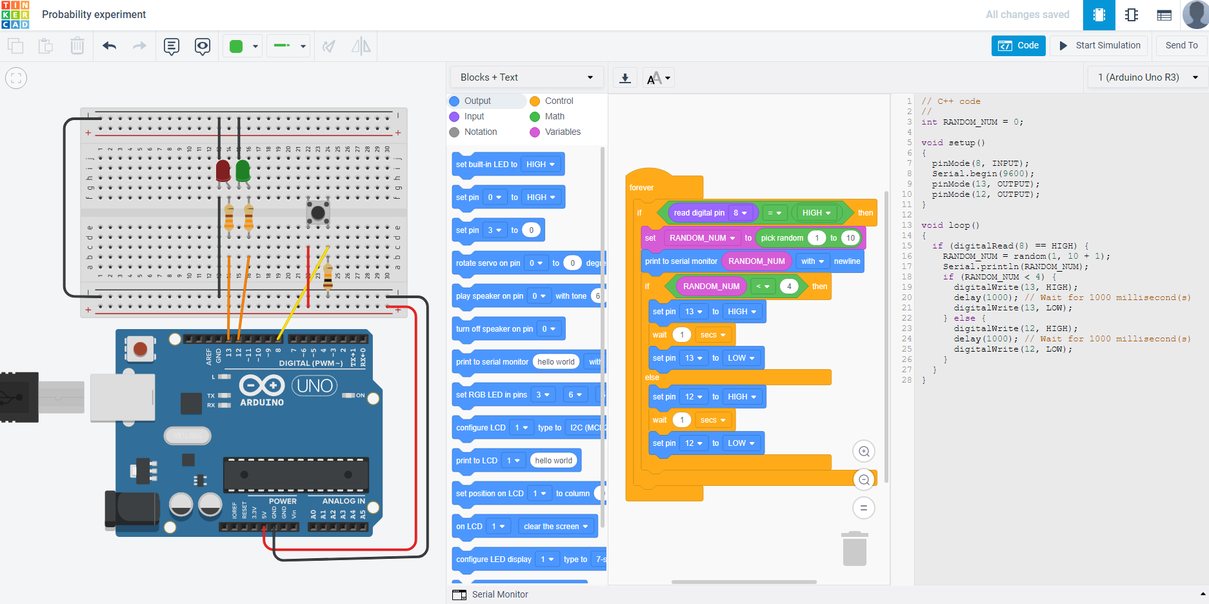
- You can COPY the code and PASTE it to the ARDUINO IDE environment.
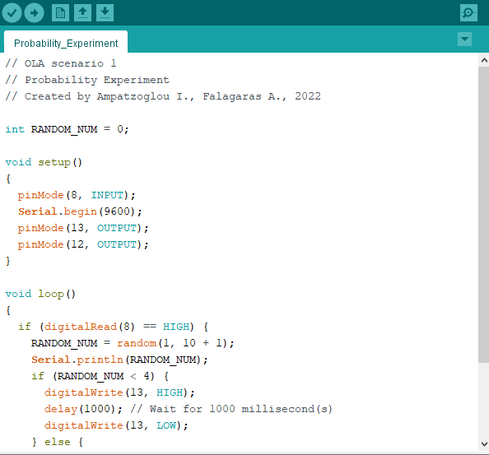
- Choose TOOLS from the menu to select the ARDUINO UNO board and the right serial COM, where the arduino board is connected.
- Click the UPLOAD button (->) to program the ARDUINO board.

