Probability - Worksheet1

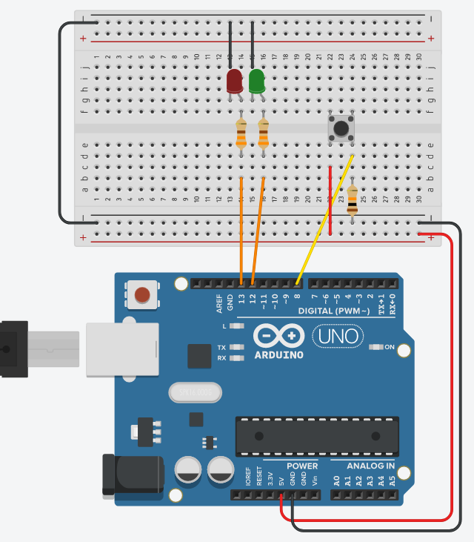
1st Activity
To perform the activity’s experiment follow the link https://www.tinkercad.com/things/kgT3Kzv0kLP , click “Tinker This” and then click “Start Simulation” to simulate the circuit.

Α. As you can see in the right picture, there is an electronic circuit with an arduino platform, two colour LEDs, three resistors and a button. If you start the simulation, then every time you press button, green or red light LED flashes for a second.

Push the button 10 times and fill the next table with R if Red LED flashes or G if Green LED flashes.

Trial | 1st | 2nd | 3rd | 4th | 5th | 6th | 7th | 8th | 9th | 10th
LED Colour

Β. Without pressing the button, make a prediction about the colour of the lamp that will flash at the 11th trial: _____

C. Now push the button for the 11th time. Has your prediction been confirmed?____

D. If you answered yes, then:
- Is there an explanation for this? ________________________________
b. Which LED will light up at the 28th or at the 90th trial? _____________

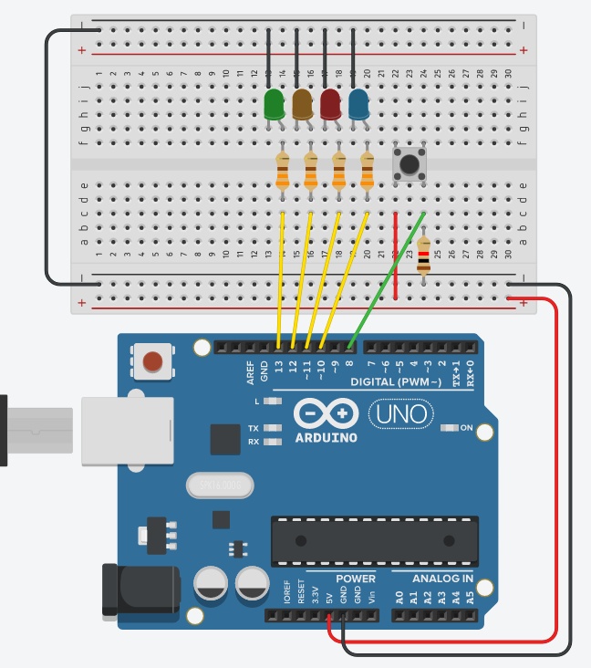
2nd Activity
To perform the activity’s experiment follow the link https://www.tinkercad.com/things/2lmH1s1j7uL click “Tinker This” and then click “Start Simulation” to simulate the circuit.

Α. As you can see in the right picture, there is an electronic circuit with an arduino platform, four colour LEDs, five resistors and a button. If you start the simulation, then every time you press the button, green or red light LED flashes for 0.5 second.

Push the button 18 times and fill the next table with the initial letter of flashing LED’s colour:
G(reen), Y(ellow), R(ed) or B(lue).

Trial | 1 | 2 | 3 | 4 | 5 | 6 | 7 | 8 | 9 | 10 | 11 | 12 | 13 | 14 | 15 | 16 | 17 | 18
LED Colour

Β. Is there a pattern to predict the colour of the next flashing LED? _______

C. Are there any colours that haven’t flashed at all? __________

D. If you answered yes, then do you have a possible explanation for this? ________________________________________________________________

E. Click “Stop simulation” and click “Code” to show the block code. Check the code and find which number is never picked as a random number, whenever you press the button? ______

F. Fill in the block code to flash for 0.5 seconds the rest of the LEDs, using an IF/THEN command.

G. Now test your code and fill again the next table.
Trial | 1 | 2 | 3 | 4 | 5 | 6 | 7 | 8 | 9 | 10 | 11 | 12 | 13 | 14 | 15 | 16 | 17 | 18
LED Colour

