Probability – Worksheet2

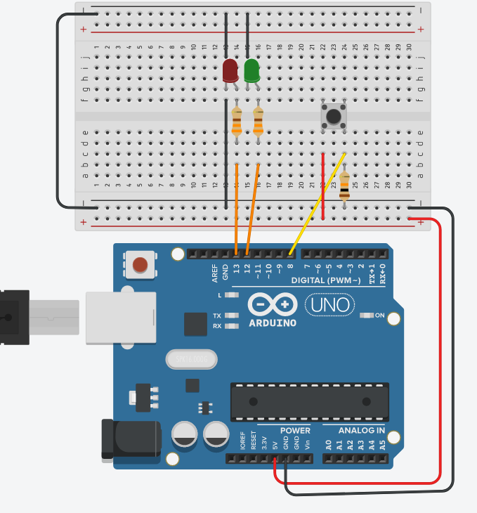
1st Activity
To perform the activity’s experiment follow the link https://www.tinkercad.com/things/20Rl7DEfjux click “Tinker This” and then click “Start Simulation” to simulate the circuit.

A. As you can see in the right picture, there is an electronic circuit with an arduino platform, two colour LEDs, three resistors and a button. If you start the simulation, then every time you press the button, green or red light LED flashes for a second.

Push the button 20 times. Each time you push the button, note in the table below, R if the red LED flashed or G if the green LED flashed.

Trial | 1 | 2 | 3 | 4 | 5 | 6 | 7 | 8 | 9 | 10 | 11 | 12 | 13 | 14 | 15 | 16 | 17 | 18 | 19 | 20
LED Colour

B. Without pushing the button, write down on the table below your prediction about the LED colour that will flash at the 21st, 22nd, 23rd, 24th and 25th trial.
trial | 21st | 22nd | 23rd | 24th | 25th
Prediction
Result of trial

C. Push the A button for the 21st, 22nd, 23rd, 24th and 25th time. Write at the above table the results. Has your prediction been confirmed?
D. In which manner the first activity of the previous lesson (deterministic experiment) differs from this one (luck experiment)?
E. Give an estimation of the probability that the RED led will come on the next time you press the A button.
F. Compare your estimation with the estimations of your classmates. What do you notice?
G. How could you find a better estimation of the probability that the RED led will flash the next time you push the A button? Use the data of your classmates.
H. If the probability that the RED led will light up the next time is 30%, how close was your estimation?

2nd Activity
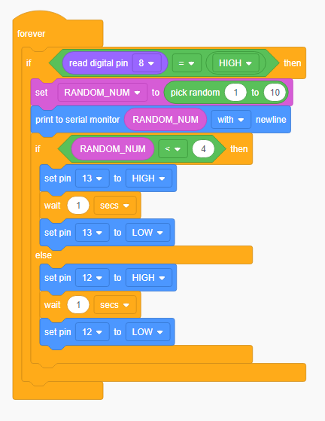
To perform the activity’s experiment follow the link https://www.tinkercad.com/things/20Rl7DEfjux click “Tinker This” and then click “Code” to see the block code.

A.Which numbers are picked randomly?
_______________________

B. Which numbers are used to flash RED led? ___________________

C. Which numbers are used to flash GREEN led? _________________

D. Has the RED led the same probability to flash with the GREEN led?_________
If not, then why? ___________

E. Can you change the block code in order to make the probability of each LED equal?

F. Click on “Start Simulation” to check your code! Push the A button 20 times. Each time you push the button, note in the table below, R if the red LED flashed or G if the green LED flashed.

Trial | 1 | 2 | 3 | 4 | 5 | 6 | 7 | 8 | 9 | 10 | 11 | 12 | 13 | 14 | 15 | 16 | 17 | 18 | 19 | 20
LED Colour

G. What’s the probability of each LED now?

