P1S11Y2 – Measuring speed of sound and distances using Arduino – Proportional amounts
Teachers: Falagaras Aristeidis, Abatzoglou Ioannis
School: 1o Peiramatiko Gymnasio Athinas
This scenario uses tinkercad to simulate an arduino circuit with an ultrasonic sensor in order to measure experimentally the travelling time of sound (to the obstacle and back). Using the theory of proportional amounts, students calculate the speed of sound and then produce the formula to calculate distances.

1st teaching period

1st Activity: Introduction on “Sound”
Time: 10min
Type of activity: presentation, discussion
Class organization: Whole class
Actions/Tasks: Class discovers sound characteristics through comics, discussion and a TRUE/FALSE game.

The teacher presents the following comic and students have to give a possible solution to this problem. They can also use the internet.
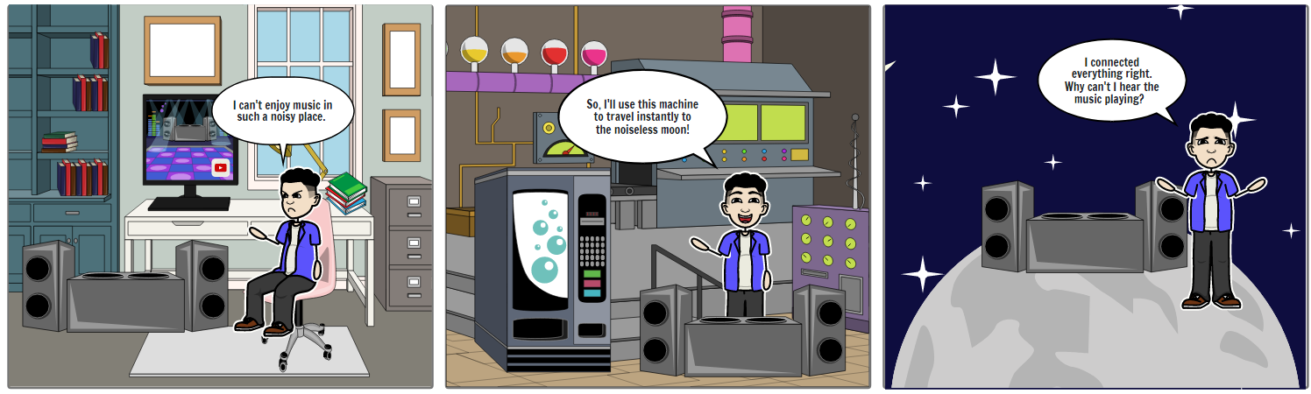
1st scene: I can't enjoy music in such a noisy place.
2nd scene: So, I'll use this machine to travel instantly to the noiseless moon!
3rd scene: I connected everything right. Why can't I hear the music playing?

TRUE/FALSE
- Sound is a wave or vibration that travels through matter. (TRUE)
- Sound travels only through solid or liquid, but not through gas. (FALSE)
- Sound is a mechanical movement that creates molecule vibrations. (TRUE)
- Sound is louder in vacuum. (FALSE)

2nd Activity: How does an ultrasonic sensor work?
Time: 10min
Type of activity: video, TRUE/FALSE
Class organization: Whole class

Actions/Tasks: Teacher presents youtube video “Otto DIY Academy Ultrasonic sensor” https://www.youtube.com/watch?v=RxjmMTAeqBo and after a short discussion, students try the TRUE/FALSE (they can also use the internet).
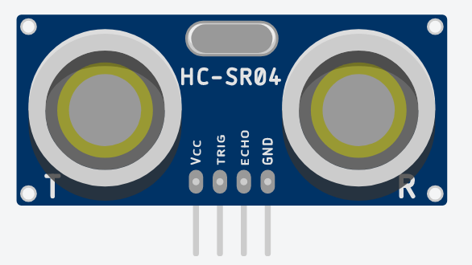

TRUE/FALSE
- We can hear frequencies from 20Hz to 20.000Hz. (TRUE)
- Infrasound is the band of frequencies below 20Hz. (TRUE)
- Animals can hear ultrasounds (frequencies above 20000 Hz). (TRUE)

3rd Activity: Measuring experimentally the speed of sound
Time: 25’
Type of activity: Arduino circuit simulation on Tinkercad
Class organization: Class splits to teams of two.
Actions/Tasks: Every team simulates the given arduino circuit and fill 3rd activity on worksheet1.

You can find the circuit at https://www.tinkercad.com/things/9E0WWgOVEZx
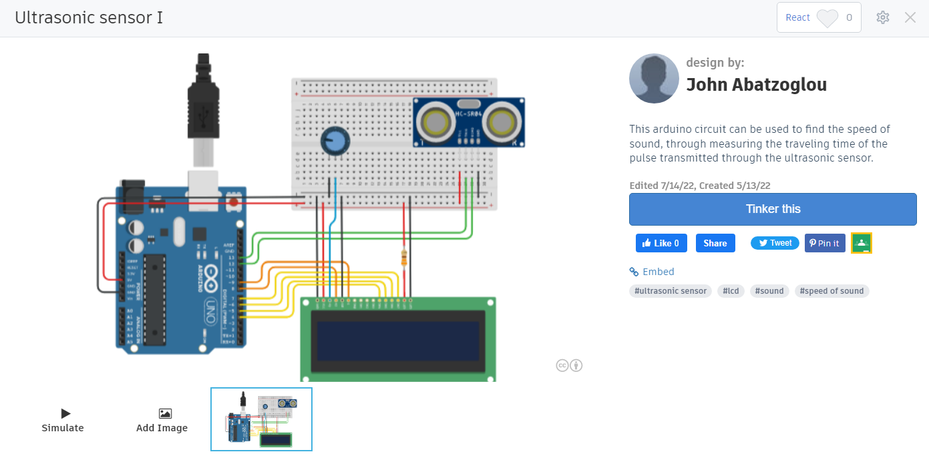
Click on TINKER THIS button to open a copy of this circuit.
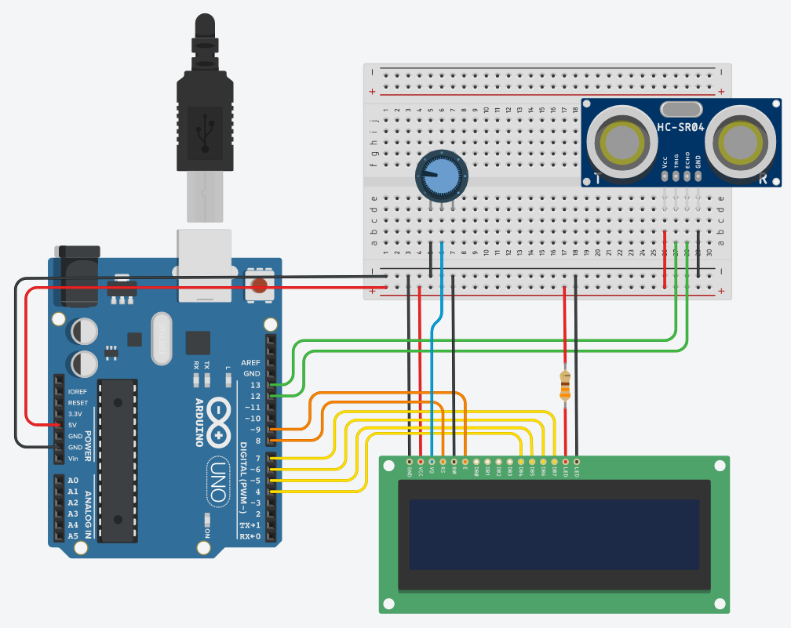
Circuit explanation:
The circuit consists of an ARDUINO board, a breadboard, a Liquid Crystal Display, an ultrasonic sensor, a 330Ohm resistor (orange, orange, brown) and a potentiometer (to adjust the contrast of the LCD).

We can use the potentiometer to adjust the contrast of the LCD.
Through the arduino’s pin13, a 10μsec pulse is transmitted through the sensor’s transmitter ‘T’ and then detected back, through the receiver ‘R’, which is connected at pin12. The total travelling time of sound (from source to obstacle and back) is displayed on the LCD.

Press the CODE button to see the code.
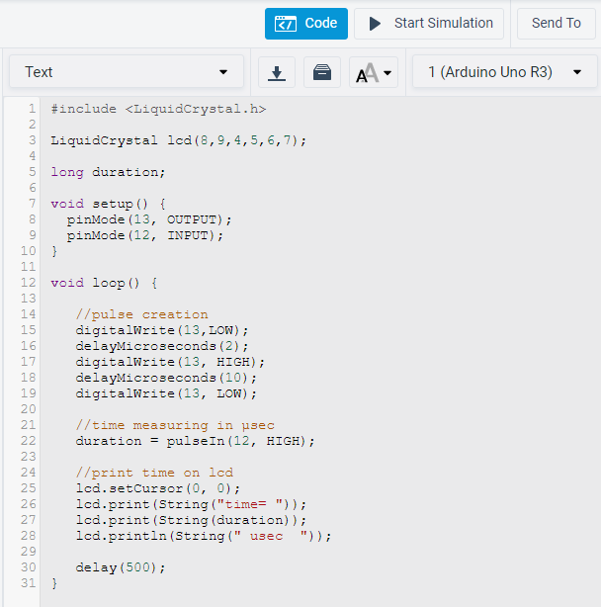

Code explanation:
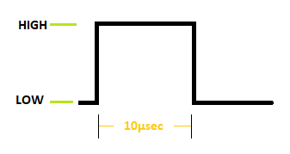
First we produce and transmit a 10μsec (HIGH) ultrasonic pulse.
Then we measure the time (in microseconds) that the pulse travels to the obstacle and back.
The travelling time is printed on LCD’s first line, e.g. time=6426μsec.
This process is repeated every 500 msec.

Press the SIMULATION button to run it.
Click on the ultrasonic sensor to be able to move the blue dot (obstacle) in various positions.
Total travelling time of sound is displayed on the LCD.
Fill the table and make the graph on worksheet1.

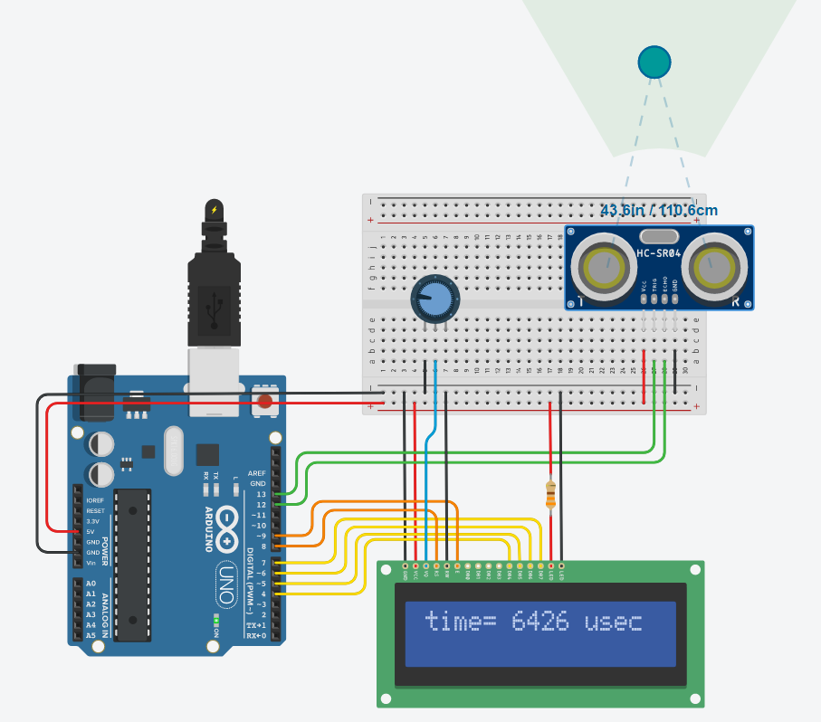

2nd teaching period

1st Activity: Formula construction
Time: 15’
Type of activity: Construction of a formula to calculate the speed of sound
Class organization: Class splits to teams of two.
Actions/Tasks: Every team tries to construct the formula for distance calculation (in cm) using the value of sound speed measured from the previous activity

- Find the average value of sound’s speed using the values from the previous experiment.
- Can you construct a formula to calculate the distance of the obstacle, if you know the total travelling time of sound?
- Use your formula to calculate the distance S (between the sensor and the obstacle), if the sound’s total travelling time is equal to 0,1msec.

2nd Activity: Distance calculation
Time: 30’
Type of activity: Physical experiment using software simulator (Tinkercad) or arduino platform, data log, outcome of conclusions
Class organisation: Class splits to teams of two
Actions/Tasks: Every team uses the tinkercad to simulate the given circuit on (or assembles the given circuit using an arduino platform, if possible). They use worksheet2 for data log.

You can find the simulation circuit at https://www.tinkercad.com/things/fdZ7OsE9K74
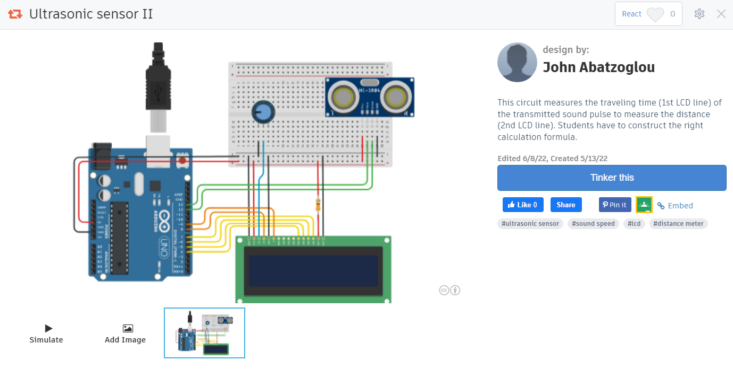
Click on TINKER THIS button to open a copy of this circuit.

Code explanation:
First we produce and transmit a 10usec (HIGH) ultrasonic pulse.
Then we measure the total travelling time of sound (in microseconds) that the pulse travels to the obstacle and back.
The travelling time is printed on LCD’s first line.
We use a formula to calculate distance using the speed of sound and total measured time.
The distance is printed on the LCD’s 2nd line.
This process is repeated every 500 msec.

Press the SIMULATION button to run it.
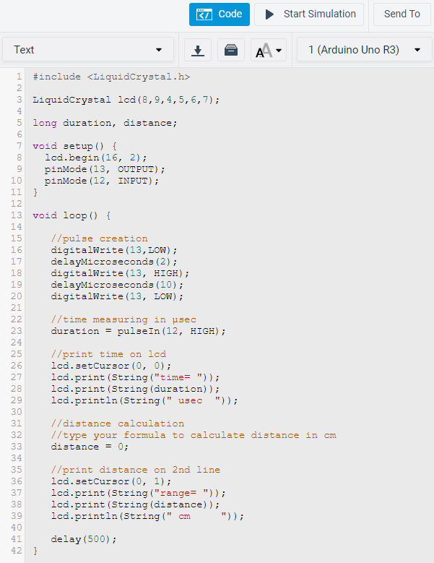

Click on the ultrasonic sensor and move the blue dot (obstacle).
The distance is always zero, because you have to construct and fill the right formula at the 33rd line of the code.

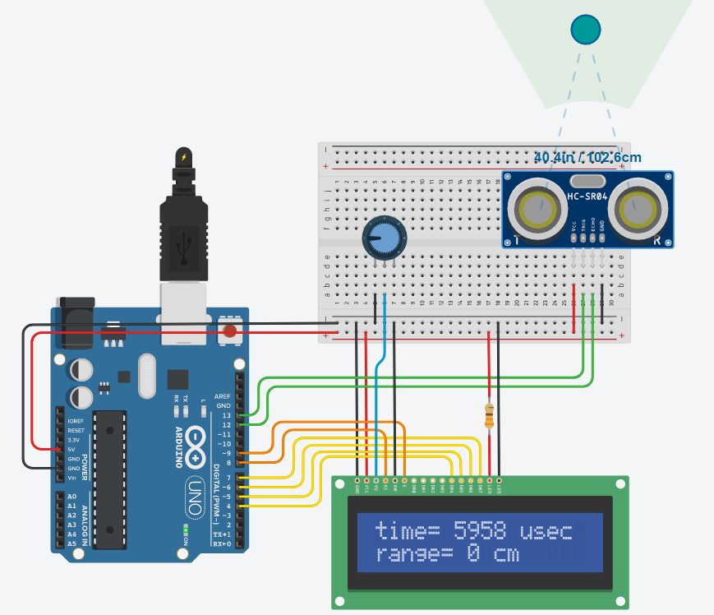

Compare your result (distance in cm) displayed on the LCD with the corresponding one from the simulation. Is it the same?
If you are using a real ultrasonic sensor, use a ruler to measure the actual distance.

ΑΝΝΕΧ
If you have assembled the real arduino circuit and you want to program it, then you have to do the following:
- Press the CODE button to see the code.

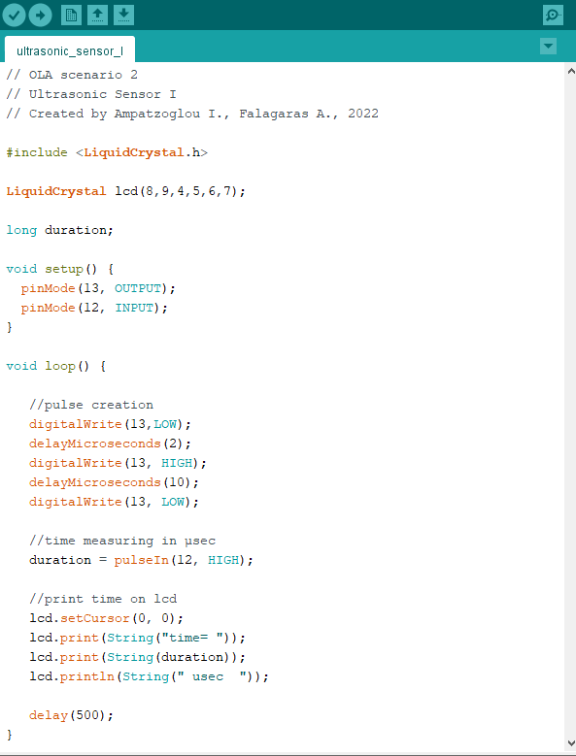

- You can COPY the code and PASTE it to the ARDUINO IDE environment.

- Choose TOOLS from the menu to select the ARDUINO UNO board and the right serial COM, where the arduino board is connected.
- Click the UPLOAD button to program the ARDUINO board.

