Speed of Sound - Worksheet1

3rd Activity
To perform the activity’s experiment follow the link https://www.tinkercad.com/things/9E0WWgOVEZx, click “Tinker This” and then click “Start Simulation” to simulate the circuit.

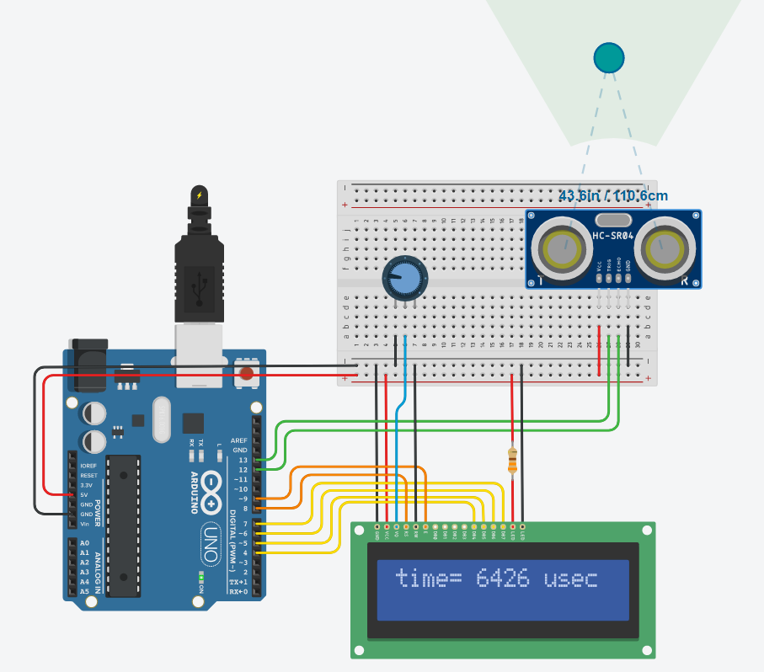

Click on the ultrasound sensor and move the blue dot (obstacle). You can see at the LCD, the total time that sound has travelled from the sensor to the obstacle and back. Repeat this process to fill the following table.

Distance (S) from obstacle (cm) | 50cm | 100cm | 150cm | 200cm | 250cm | 300cm
Total time (μsec)
Total time/2 (μsec) (T)
Ratio S/T (cm/μsec)
Ratio S/T (m/sec)

Try to answer the questions below.
- What happens to the sound’s travel time, if I double, triple or quadruple the distance of the obstacle?
- If we call S the distance of the obstacle (in cm) and T the half of Total time (in μsec) for each of your measurements, calculate all the ratios $\frac{Distance from the obstacle (S)}{half travelling time of the sound (T)}$. What do you notice?
- Note the data from the table with spots on the following graph.
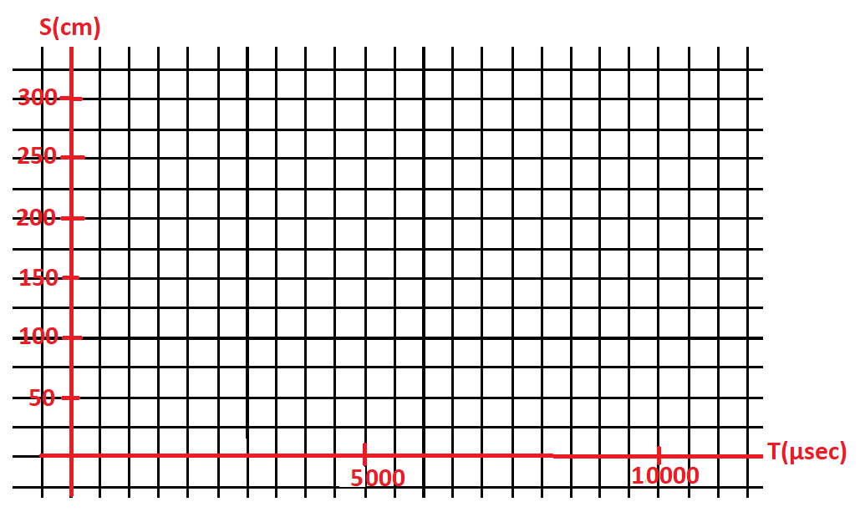
- Can you make an average line between the spots you made? What does this line mean?
- Calculate the speed of sound (ratio S/T) in m/sec.

