Title: How Eratosthenes calculated the circumference of the Earth
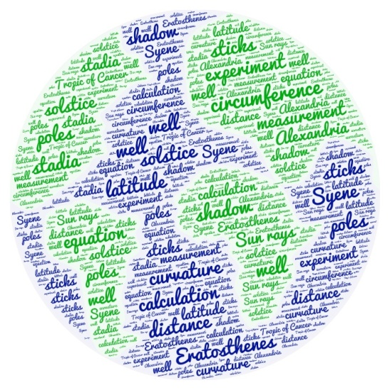

1st Teaching period
1st Activity
Time: 10’
Type of activity: class discussion based on visual input
Class organisation:whole class
Actions/Tasks: as a warm-up activity, the teacher shows a picture of the world (google maps) and invites students to consider how big the earth is in relation to each of us and to think how, in the past, people could measure the size of the earth or how they knew the earth is round without the use of satellites.
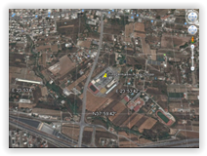
The aim is to arouse their curiosity, encourage them to use their speaking skills and develop their critical thinking.

2nd Activity
Time: 15’
Type of activity: explanation of terms / use of online dictionary
Class organisation: whole class
Actions/Tasks: students are asked to explain, if they know, the terms 'meridian', 'longitude', 'latitude', 'circumference', 'equator', 'equinox' and 'solstice'. If they do not know the words in English, they are given the corresponding terms in L1 and they are then asked to explain in English what they know about these terms. The aim is to get to know terms from the fields of Geography and Geometry in L2. Then, they are guided through an online dictionary where they are asked to find the specific terms and experiment with the dictionary's features.

3rd Activity
Time: 20’
Type of activity: video projection, note taking and discussion
Class organisation: individual, pair, plenary
Actions/Tasks: students are asked to watch a video (up to 5.54 '), in which American astronomer / cosmologist / astrophysicist Carl Edward Sagan explains how Eratosthenes calculated the circumference of the earth and to keep notes on questions on the worksheet given to them (alternatively they work in the computer lab or asynchronously if necessary).
After taking notes individually, students in pairs compare and discuss their notes and form complete answers. The aim is to use audiovisual material in order to take notes and then to compare, decide and use their knowledge to produce full answers with accuracy. A plenary discussion follows on concepts from the video and their application in the experiment which is to follow. The teachers explain that the experiment which students will take part in is based on Eratosthenes' calculations.
Homework: α) students watch the video again and do a T/F exercise (H5P exercise embedded in moodle) and try to understand the experiment.
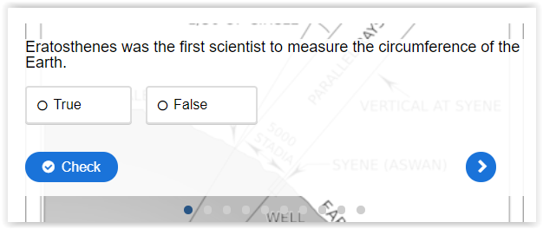
b) Students are asked to create a word cloud with the key words they have encountered and could prove useful for their own experiment (suggested tool: https://wordart.com/)
Example: https://wordart.com/r3f8w5cwegys/word-art%2013
c) Students are asked to see Sagan’s video again and answer the questions which have been inserted by the teachers by using H5P (embedded in moodle)
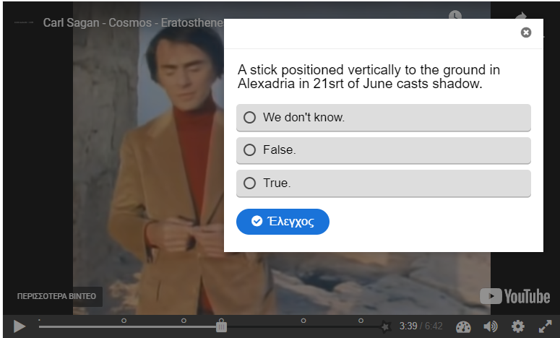

2nd Teaching period
1st Activity
Time: 15’
Type of activity: gap filling with key words
Class organisation: individual
Actions/Tasks: students are given a summary of Eratosthenes’ experiment in which they have to complete keywords missing (circumference, solstice, latitude etc) they have met so far (H5P embedded in moodle). For each word there is a tip for less able students.
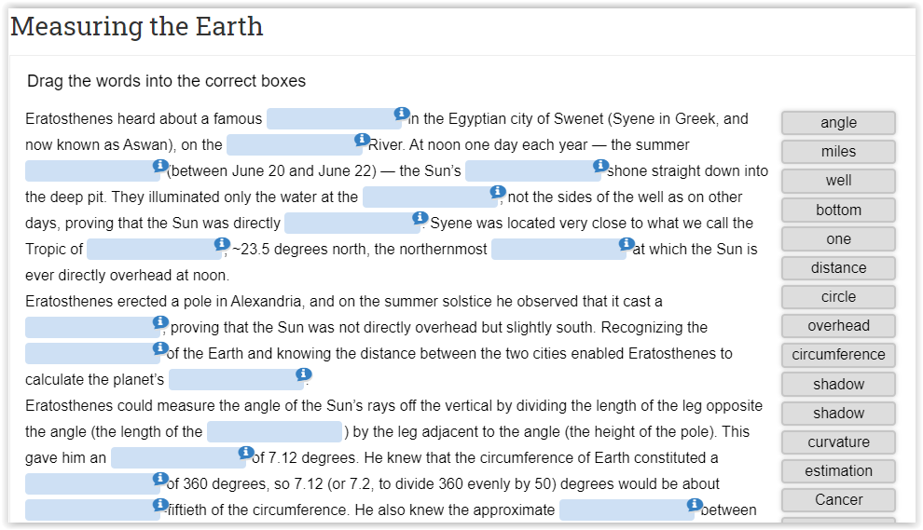

2nd Activity
Time: 20’
Type of activity: linking information from different sources
Class organisation:individual, pair, plenary
Actions/Tasks: the students are given an interactive photo of the Library of Alexandria (H5P embedded in moodle) which includes hotspots with information (texts with links, photos, videos) about the library but also about many of Eratosthenes’ contemporaries. Students click on the various hotspots and try to relate all the information so far. There is a discussion on how Alexandria is related to Eratosthenes, first individually, then in pairs, then there is a whole-class discussion.
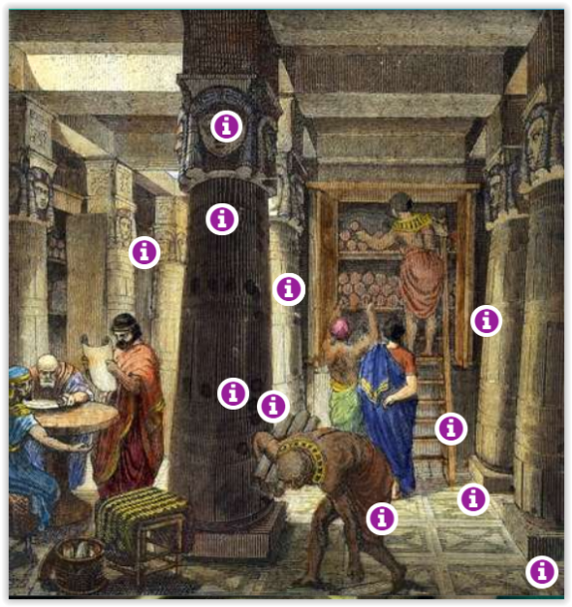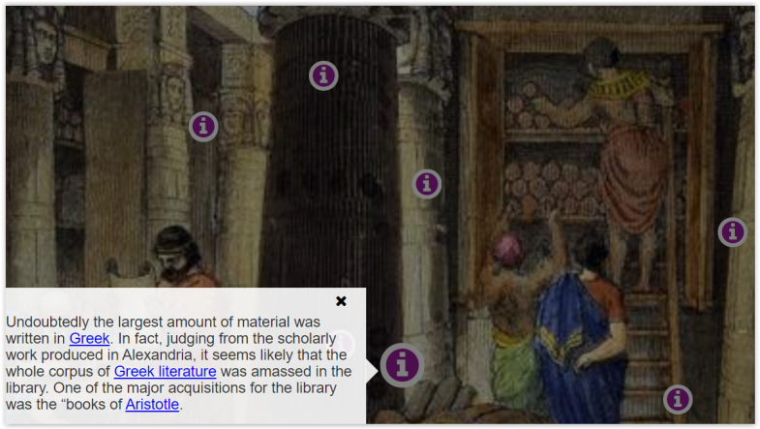

3rd Activity
Time: 10’
Type of activity: explanation of information on an interactive poster
Class organisation: plenary
Actions/Tasks: students are presented with an infographic which shows Eratosthenes’ ingenuity and his versatile nature. The infographic is incomplete and after a brief interpretation of the info, students are asked to do their research and complete as much as they can on Eratoshenes’ contribution to world science. R information that the students will find will be added to the H5P hot spot.
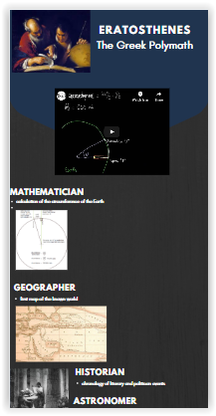
Students are also presented with an interactive map with important cities in the history of Math. Some very important cities are pinned providing some visual help and students are asked to find and post information on the map about how these cities are connected to Eratosthenes and interrelate information. This could also help them complete the infographic.
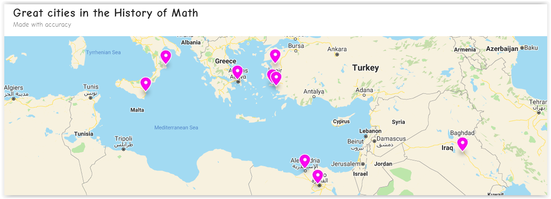

3rd Teaching period
1st Activity
Time: 7’
Type of activity: video projection, note taking, discussion, answer questions.
Class organisation:
Actions/Tasks: students are asked to watch an animated video (up to 2.14 '), in which Charles and Ray Eames explains how Eratosthenes figured out that the sun rays beaming parallel to the Earth calculated the circumference of the Earth and to keep notes on questions on the worksheet given to them (alternatively they work in the computer lab or asynchronously if necessary).
After taking notes individually, students in pairs compare and discuss their notes and form complete answers. The aim is to use audiovisual material in order to take notes and then to compare, decide and use their knowledge to produce full answers with accuracy. A plenary discussion follows on concepts from the video and their application in the experiment which is to follow. The teachers explain that the experiment which students will take part in is based on Eratosthenes' calculations.
Homework: α) students watch the video again and do a T/F exercise (H5P exercise embedded in moodle) and try to understand the experiment.
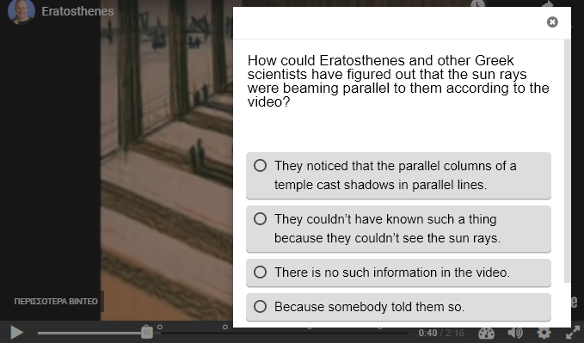

2nd Activity
Time: 25’
Type of activity: video projection, note taking and discussion
Class organisation:individual, pair, plenary

Actions/Tasks:students are asked to watch two videos( video1 (up to 7.29 ') & video2 (up to 1.43’) , where they explain the mathematics that Eratosthenes used in order to calculate the circumference of the earth and to keep notes on questions on the worksheet given to them (alternatively they work in the computer lab or asynchronously if necessary).
After taking notes individually, students in pairs compare and discuss their notes and form complete answers. The aim is to use audiovisual material in order to take notes and then to compare, decide and use their knowledge to produce full answers with accuracy. A plenary discussion follows on concepts from the video and their application in the experiment which is to follow. The teachers explain that the experiment which students will take part in is based on Eratosthenes' calculations.
Homework: α) students watch the video again and do a T/F exercise (H5P exercise embedded in moodle) and try to understand the calculations .

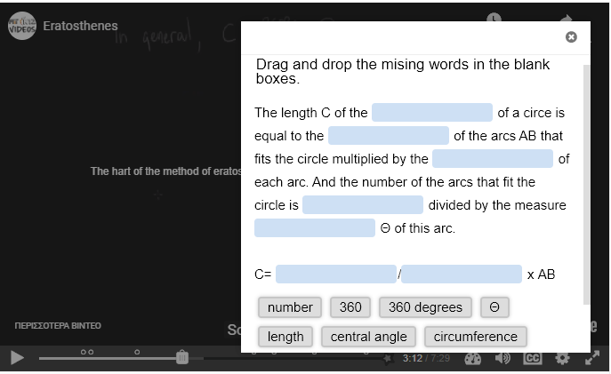

3nd Activity
Time: 13’
Type of activity: Apply the method of Eratosthenes to another problem.
Class organisation:individual, pair, plenary
Actions/Tasks: The students do Activity 3 on their worksheet and are asked to apply the method of Eratosthenes in order to determine the circumference of a fictional planet after they have all the information.

4th Teaching period
1st Activity
Time: 20’
Type of activity:
Class organisation: pair work
Actions/Tasks: The teacher demonstrates the Stellarium software and explains its capabilities. It is explained that through this interactive tool, they can see the position of the sun during the day and at different times, as well as understand the terms ‘solstice’ (equator) and ‘equinox’ (equinox). After a short demonstration, students, in pairs at a computer, are asked to follow the instructions on the worksheet and find the answers to the questions. Teacher supervises students and helps where needed.
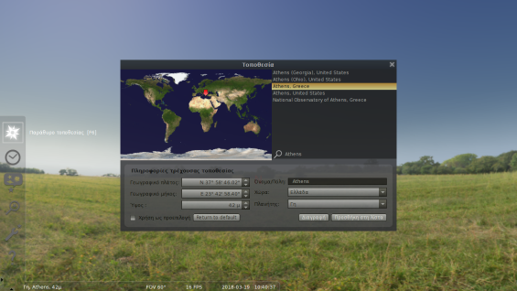
2nd Activity
Time: 25’
Type of activity: drill and practice on content and language
Class organisation: pairs
Actions/Tasks:Students are asked (in pairs) to follow the instructions on the worksheet and answer the questions. The aim is to learn about the properties of the circle and do practice on them:
• arc of a circle, central angle and relationship between central angle and arc: http://www.mathsisfun.com/geometry/degrees.html , https://www.mathopenref.com/arcangle.html
• parallel lines and relationship between the angles formed when the parallel lines intersect with another line: http://www.mathsisfun.com/geometry/parallel-lines.html
A vocabulary list of geometry terms with their translation is available to students in their mother tongue (aiming at reducing the cognitive load) https://quizlet.com/_8bl2xf?x=1qqt&i=6m3w6

Project (Eratosthenes Experiment):
Time: 90’ (experiment & discussion of results)
Type of activity: experiential and discussion of experiment results
Class organisation: group work
Actions/Tasks:
The school will register on the website of the Ellinogermaniki Agogi (endorsed by IAU, the European project spaceEU, OSOS Project and the Hellenic Mathematical Society). and then the school will come in contact with a European school of the same longitude. They will do the experiment on 20-21st March (vernal equinox) outside school and then they will compare the results with those of the other European school that they have been assigned to. Alternatively the experiment could be performed on 22-23 September (Autumnal equinox).
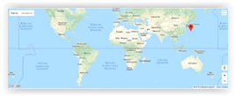
Students in the Technology class will create the necessary equipment for the experiment.
On March 21, the day of the vernal equinox, around 12 noon, students will go outside to take their measurements.
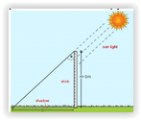
The measurements along with photos will be posted on the website and will be compared with those of the partner country.
The school will take part in the competition for the best photos from the experiment.

Expansion: students read the novel ‘The Parrot Theorem’, which is a mystery story exploring the story of Mathematics. It could be done in collaboration with the Literature teacher.
