The Age of Exploration
Authors: Zoe Spanoudi, Eirini Bompolou

The scenario should be taught in a computer lab or in a classroom equipped with an interactive whiteboard. In the latter case, the students should use mobile devices (tablets, mobile phones) provided by the school, or brought by themselves. It is also suitable for online teaching. However, all of the activities can be adapted to be used without technology, in case a computer lab or mobile devices are not available, or if there is no internet connection in the school. The alternatives are provided in the scenario.

1st Teaching period: What led to the European Age of Explorations?

1st Activity: The old world

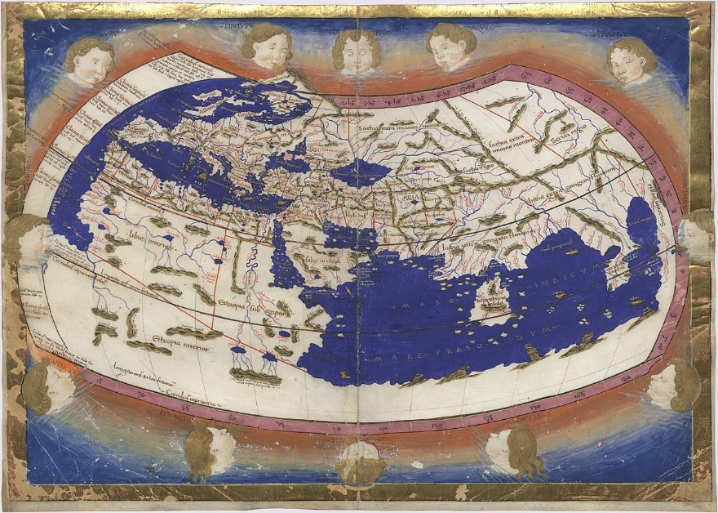

Time: 10’
Type of activity: Warm up activity - Discussion
Class organisation: whole class
Actions/Tasks: The class is told to look at this map (in online or printed form) and the teacher initiates a discussion about the way people used to conceive the word before 15th century, by asking the following questions:
- When do you think this map was drawn? Why do you think so?
- Which parts of the world were known at that time?
- Can you identify any countries?
- Which means of transport did the people of the time used in order to travel?
The teacher asks the students to look at the other maps before the 15th century CE:
https://en.wikipedia.org/wiki/History_of_cartography
https://en.wikipedia.org/wiki/Early_world_maps
The teacher divides the class into 3 groups and asks each group to look at the pictures and describe the maps from other periods of time (Ancient Greek, Romans, Arab and Persian cartography) and asks some additional questions:
- Which parts of the world did they know at that period of time?
- How did the cartographer find information to depict the countries as accurately as they could?
- Do you know what the Latin term “terra incognita” that was written in some old maps means?
- Apart from their natural curiosity, can you think of any other reasons why people wanted to explore the world?

2nd Activity: The Causes of the Explorations
Time: 10’
Type of activity: Interactive presentation and collaborative activities
Class organisation: whole class
Actions/Tasks: Students are presented with the information in the form of a flipbook that has been created by the teacher, using the “Story Jumper” app. In case the internet is not available the teacher might present the same information through the form of a power point stored in their computer, or even print the information. The students are encouraged to understand the factors that led to the discovery of the new world and check if their guesses in the last question of the previous activity were right

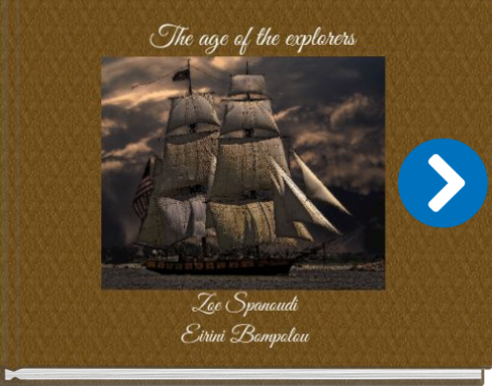

3rd Activity: Explorers and explorations (part 1 - preparation)
Time: 25´
Type of activity: Interactive group activity
Class organisation: Ss work in 5 groups of 4-5
Actions/Tasks: The teacher gives each group a worksheet about a different explorer. The activity consists of three tasks. In task 3a each group is instructed to search the web or through books from the school library or brought by the teacher, to find a portrait of the explorer (they can also draw one if there is a student in the group who can do it and then scan the painting) and some biographical information about him (full name, date of birth, country of origin) and then to select the appropriate template from “Canva” (poster, infographic, a newsletter or even a brochure) about the explorer that they have been assigned.
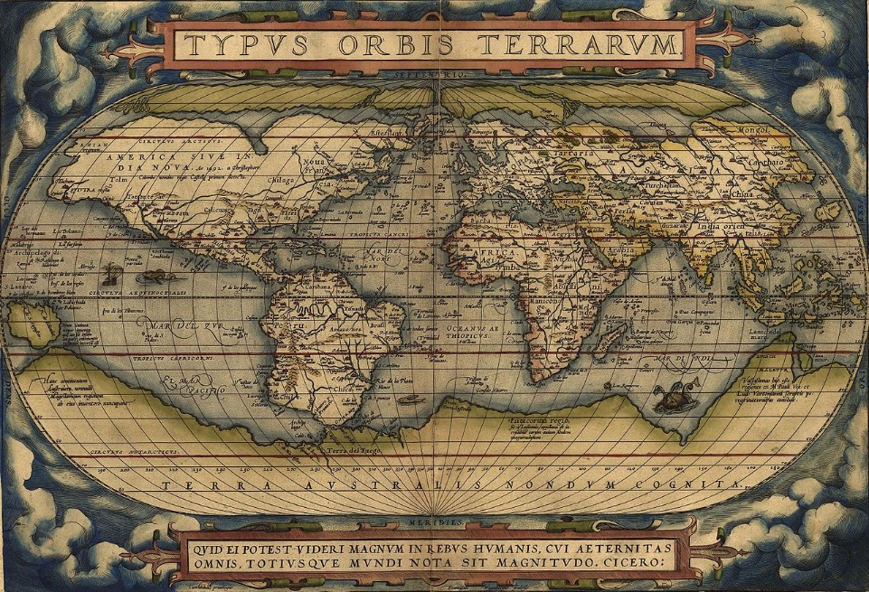
https://upload.wikimedia.org/wikipedia/commons/e/e2/OrteliusWorldMap1570.jpg

2nd Teaching period: The explorations and their consequences

1st Activity Explorers and Explorations (part 2 - presentation)
Time: 25’
Type of activity: Interactive presentation and collaborative activities
Class organisation: whole class
Actions/Tasks: each group has 5’ to present the products of their teamwork to their classmates

2nd Activity The Impact of the European Age of Explorations

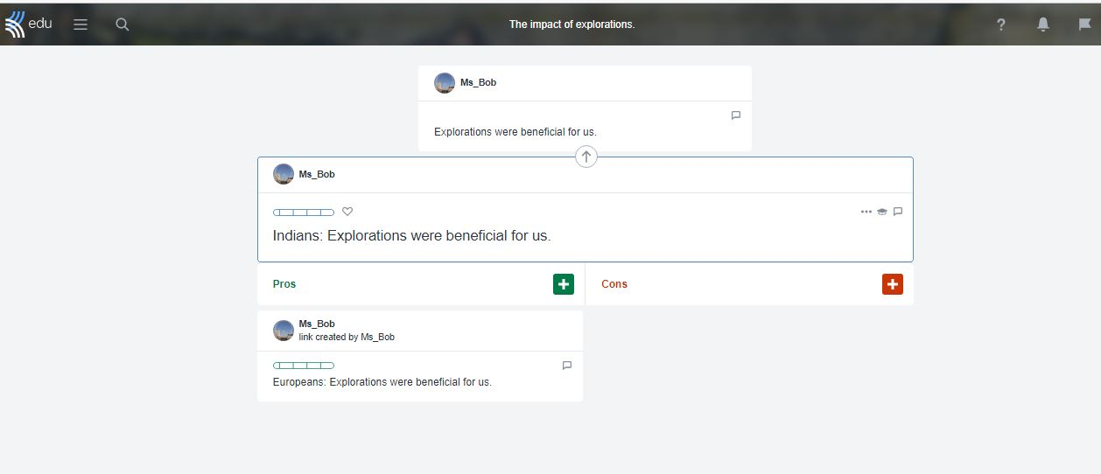

Time: 20’
Type of activity: Debate
Class organisation: Whole class
Actions/Tasks: The pupils discuss the consequences of the discovery of the New World.
The students are divided into two groups:
- The Europeans
- The native people of the West Indies/ Indians
The students of the first group are asked to skim through their schoolbooks and this text about the Impact of the Explorations on Europe:
https://brewminate.com/causes-and-impacts-of-the-european-age-of-exploration/
The students of the second group are asked to skim through their schoolbooks and the following text about the Impact of Exploration on the colonies:
https://brewminate.com/colonies-and-empires-from-the-medieval-world-to-the-age-of-discovery/
Then they go to Kialo.edu in order to take part in the following discussion: https://www.kialo-edu.com/p/b97806d9-4e2f-454f-922d-ebb8d017e261/84284 (The impact of explorations).
According to the group that they belong to, they have to write arguments in favour or against one of the two theses:
Thesis 1= Europeans: Explorations were beneficial for us.
Thesis 2= Indians: Explorations were beneficial for us.

However, in case of lack of technology, the task can take the form of an oral debate.

In the last 5’, the teacher summarizes the answers and leads a discussion, so that conclusions will be drawn. If necessary, s/he can point our omissions or arguments that are not valid. The discussion can remain open, after the end of the lesson.

As an extension all of the students can write an essay titled: “The consequences of the discovery of the New World for the Europeans and the Indians” for homework.

