The Age of Exploration
Worksheet 1
Activity I: The old world
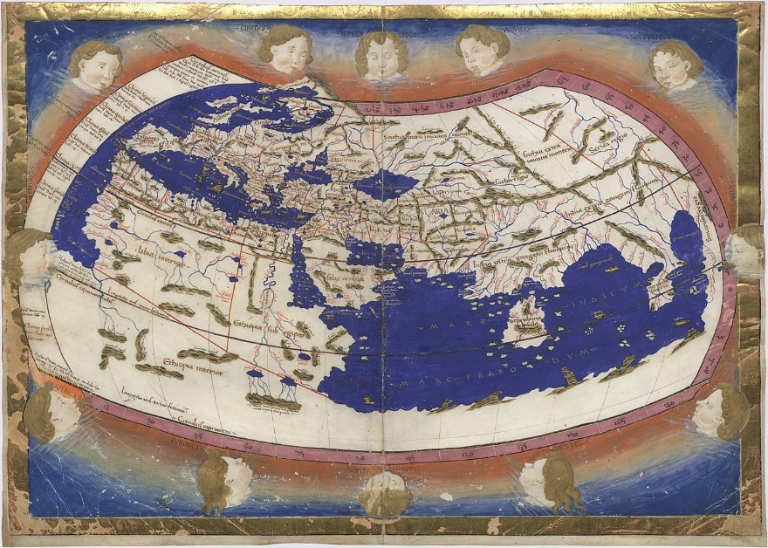
Look at this old map!
- When do you think this map was drawn? Why do you think so?
- Which parts of the world were known at that time?
- Can you identify any countries?
- Which means of transport did the people of the time used in order to travel?
Now visit the following webpages and do the activity with the other members of your group:
https://en.wikipedia.org/wiki/History_of_cartography
GROUP A: Look at the Ancient Greek maps.
GROUP B: Look at the Roman maps.
GROUP C: Look at the Arabic and Persian maps.
Now, answer the questions:
- Which parts of the world did they know at that period of time?
- How did the cartographer find information to depict the countries as accurately as they could?
- Do you know what the Latin term “terra incognita” that was written in some old maps means?
- Apart from their natural curiosity, can you think of any other reasons why people wanted to explore the world?

Activity 2: The causes of the explorations
Your teacher is going to show you a flipbook. Read it and learn about the factors that led the Europeans to explore the world. Are your guesses confirmed?
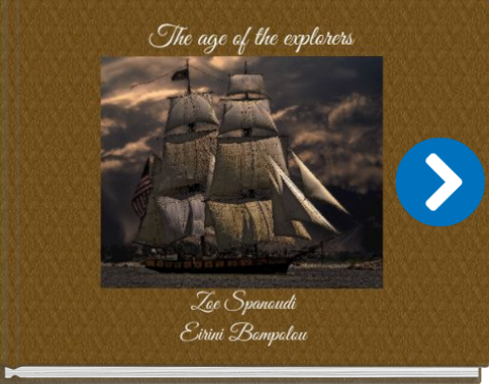
Activity 3: Explorers and explorations (part 1-preparation)
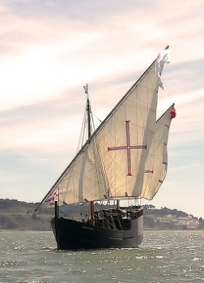
You are going to be divided into 5 groups. Each group is going to research about a different explorer!
GROUR A: Bartolomeo Dias
GROUP B: Vasco da Gama
GROUP C: Christopher Columbus
GROUP D: Amerigo Vespucci
GROUP E: Ferdinand Magellan
Task 3a: Instructions for all the groups
- Find a picture of your explorer or assign to a member of your group who can draw well to make a portrait of the explorer and then scan it with your phone or tablet.
- Find some biographical information about your explorer (Full Name, Date of Birth, Country of Origin etc).
- Go to https://www.canva.com/ . Browse through the templates and use your imagination to select one where you can put the information so that it can be more attractive to be presented to your classmates. There is no limit to your imagination! You can select a poster, an infographic, a newsletter or even a brochure.
- Before you decide on what format you want to present the information take a look at tasks 3b and 3c, because you might want to paste the answer to these tasks there too!
Task 3b: Instructions for all the groups
- Go to: https://support.google.com/mymaps/answer/3433053?hl=en&co=GENIE.Platform%3DDesktop and read the instructions on how to draw lines on a google map.
- Draw the explorer’s main journey on the map!

Task 3c: Different instructions for each group
GROUR A: Bartolomeo Dias
Describe the purpose and main events of your explorer’s main journey. Tell why he went on this main exploration. Also, describe where his trip started, where he travelled to, and what he found or saw. Your description should have the form of a letter written by the explorer to the king of Portugal John II.
GROUP B: Vasco da Gama
Describe the purpose and main events of your explorer’s main journey. Tell why he went on this main exploration. Also, describe where his trip started, where he travelled to, and what he found or saw. Your description should have the form of a letter written by the explorer to his family.

GROUP C: Christopher Columbus
Describe the purpose and main events of your explorer’s main journey. Tell why he went on this main exploration. Also, describe where his trip started, where he travelled to, and what he found or saw. Your description should have the form of a diary of the explorer.

GROUP D: Amerigo Vespucci
Describe the purpose and main events of your explorer’s main journey. Tell why he went on this main exploration. Also, describe where his trip started, where he travelled to, and what he found or saw. Your description should have the form of a narration of the journey in front of Spanish citizens.

GROUP E: Ferdinand Magellan
Describe the purpose and main events of your explorer’s main journey. Tell why he went on this main exploration. Also, describe where his trip started, where he travelled to, and what he found or saw. Your description should have the form of an interview with a geographer who wants to draw the map of the world.

Homework: Finish and edit your work in Canva! In the next lesson you are going to present it to your classmates!

