Title: M.C.Escher’s paintings and the mathematical concept of symmetry.
Learning how to sketch like MC Escher.
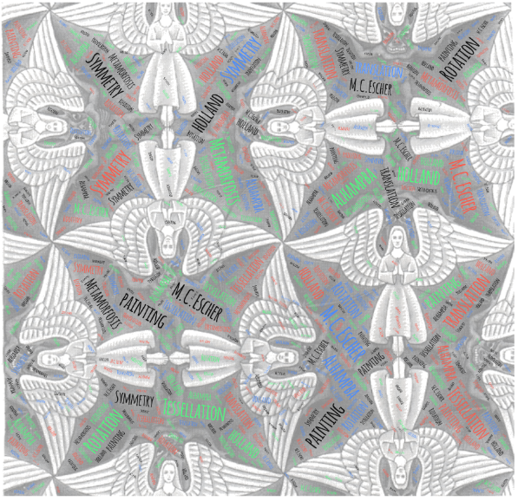

1st Teaching period
1st Activity
Time: 10 min
Type of activity: Discussion on the content of a documentary about the life and the work of MC Escher .
Class organisation: whole class.
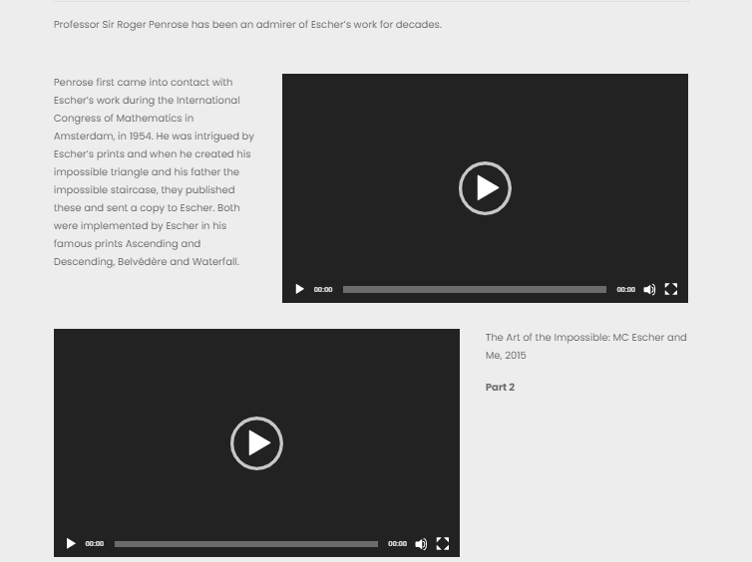
Actions/Tasks: The teacher has asked students to watch at home a BBC’s 30 minutes documentary about the work of the Holland painter MC Escher. The presenter of the documentary is Roger Penrose , a professor of mathematics , who had inspire and been inspired by the work of M.C. Escher. He presents how mathematics, especially the concepts of symmetry and infinity, influenced the work of M.C. Escher. The teacher will pose some questions in order to lead the discussion at the direction of revealing the mathematical concepts that Escher used at his paintings.

https://mcescher.com/about/video-on-m-c-escher/
2nd Activity
Time: 10 min

Type of activity: Discussion, taking notes, terminology, interactive applets.
Class organisation: whole class.

Actions/Tasks: The teacher explains what we mean by the term symmetry. He presents to the students three sketches and asks them to indentify the kind of symmetry that every sketch has. For better understanding of the notions the teacher may use the interactive web pages where students can find the requested definitions, applets and examples.
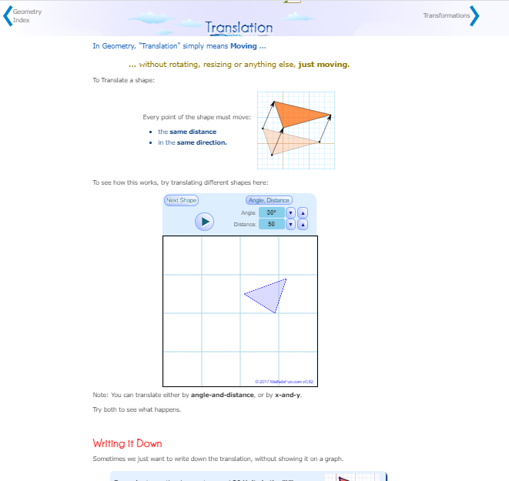
https://www.mathsisfun.com/geometry/symmetry-reflection.html

https://www.mathsisfun.com/geometry/symmetry-rotational.html

https://www.mathsisfun.com/geometry/translation.html

3nd Activity
Time: 25 min
Type of activity: Use of manipulative tools and digital applets for consolidation of the dealt concepts .
Class organisation: In groups and in plenary.

Actions/Tasks: The first 15 minutes of the activity the teacher gives to the students a worksheet with patterns and a piece of transparent paper and asks them to reproduce the patterns. At the same time teacher asks them to keep a record with the kind of symmetry that they use at each step. The last 10 minutes , in plenary, asks them to use certain commands in a Geogebra applet (https://www.geogebra.org/m/ryuxj3n6 ) from the platform Geogebra.org in order to reproduce the same patterns .
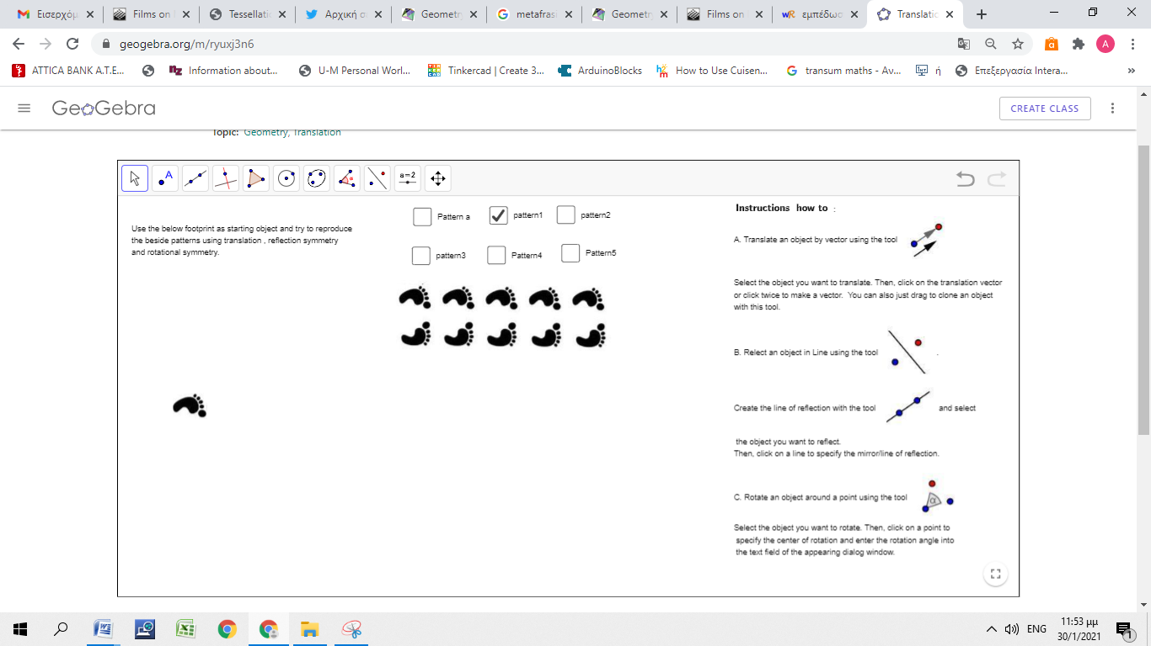

Home work
Α. The student asked to make some sketches with symmetry at the web page
https://www.mathsisfun.com/geometry/symmetry-artist.html or by their hand and post a
picture of it on a Google jamboard.
https://jamboard.google.com/d/1n7xq3JijMTotnUOrixn3E9DSAFTvj-LbLfhcmB4px-Q/viewer
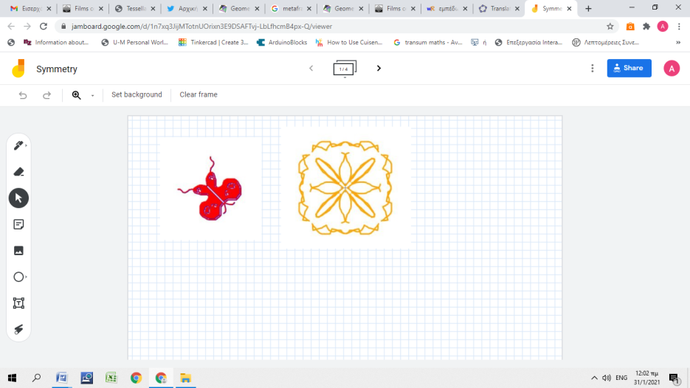

Β. Students are asked to create a word cloud with the key words they have encountered and could prove useful in order to keep in mind the important things of the scenario. (suggested tool: https://wordart.com/)
Example: https://wordart.com/41ucafl370c2/symmetry

2nd Teaching Period
1st Activity
Time: 10
Type of activity: Observation , group discussion , make conjectures .

Class organisation: Group discussion , whole class.

Actions/Tasks The teacher gives the students the painting “Angels and Demons” and asks them to recognize each of the 3 types of symmetry , those they learned at the previous lesson. The students work in groups and at the end of the activity they are asked to announce the results in plenary. The goal of this activity is the students to spot the smallest part of the Painting by which they can reconstruct it, through the processes of rotation about a vertex, reflection by line and translation.
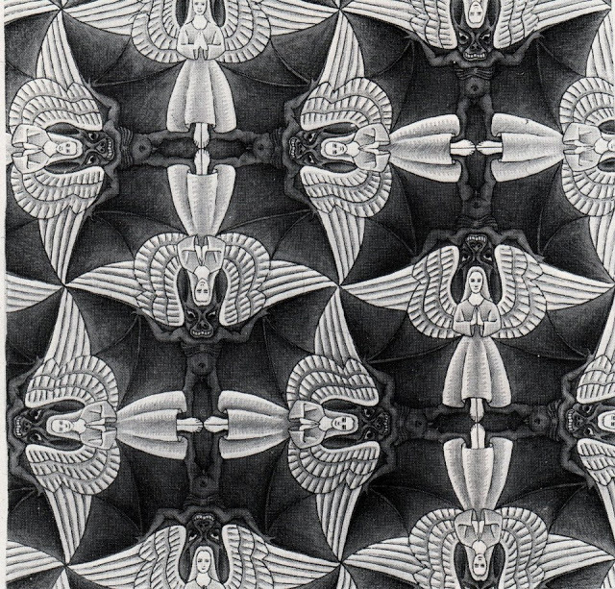

2nd Activity
Time: 15
Type of activity: Manipulative tools, design , implementation

Class organisation:.Work in small groups.

Actions/Tasks
Students are asked to use transparent paper in order to copy on it half of the figure of the Angel and try to follow the steps of MC Escher’s that he did when he was designing the painting. At each step they should record the mathematical concept that is behind of each of their action .
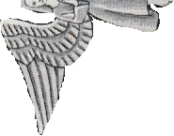
3nd Activity
Time: 10
Type of activity: Interactive applet, clarifying gained knowledge, discussion .

Class organisation:. Whole class.
Actions/Tasks The teacher presents to the students the interactive Geogebra applet by which they can do the process of reconstructing the painting through the available commands of the applet. It is essentially the same process as in the 2nd activity. The difference is at the tools that is used each time. At the 2nd activity students will use manipulative tools that are not accurate neither at the construction of the painting nor at the mathematical concepts that underlying each of their actions. At the 3rd activity the students are forced to give explicit commands so that the applet reconstruct the painting. The added value of this activity is the clarification of the knowledge that they gained at the 2nd activity by a more, mathematically, strict process such as selecting the suitable commands for the construction and of course the accuracy that the applet offers.
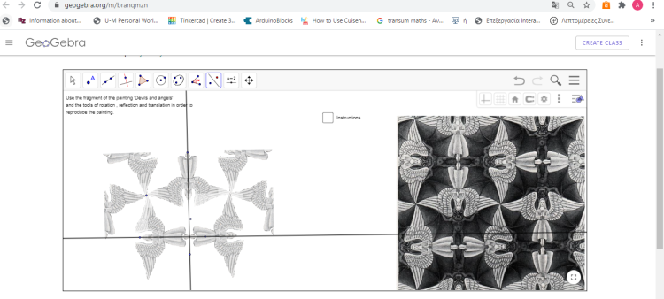
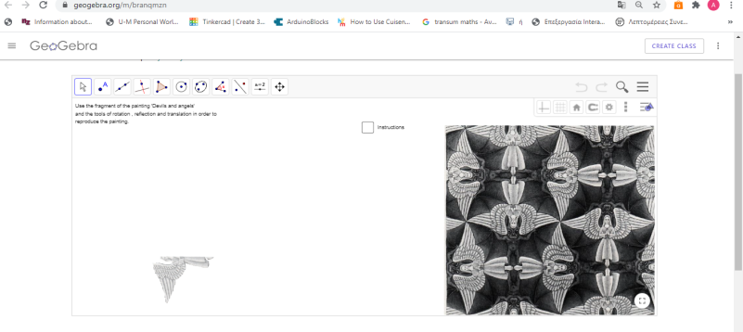

4nd Activity
Time: 10
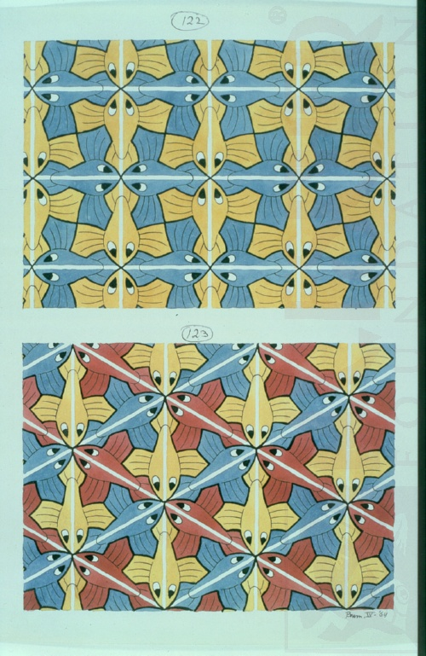
Type of activity: Discussion, implementation gained knowledge,

Class organisation:. Whole class.
Actions/Tasks Students are given two painting from the collection of paintings of Escher : Symmetry and are asked to analyze the Paintings from the mathematical point of view. The activity will serve as a warm up for the next teaching period which is about the concept of tessellation .

Homework
The students are asked to pick one of the painting of the collection Symmetry and to write a text of around 500 words, analyzing the painting from the mathematical point of view.
3nd Teaching period
1st Activity
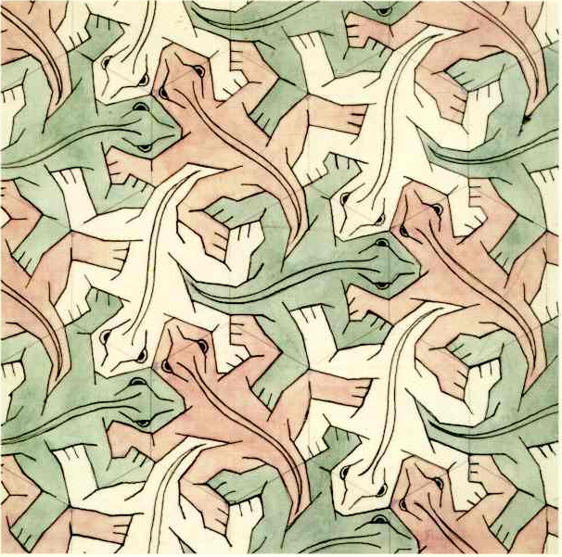
Time: 25’
Type of activity: warm up, Discussion, taking notes, terminology, interactive applets.
Class organisation: individual/ pairs / in plenary.
Actions/Tasks: The teacher shows to the students the sketch no 25 of Escher’s collection : Regular division of the plane and discuss with them the terms Tessellation, Regular Tessellation , Regular polygon . The teacher can use the interactive page for the examples and terminology.

2nd Activity
Time: 10’
Type of activity: Observation, making conjectures.
Class organisation: pairs /in plenary.
Actions/Tasks: The teacher gives to the students some time to study the painting and encourage them to try to find out which kind of regular tessellation Escher uses in order to create the painting. At the begging of the activity the students are working in pairs and at the end of it they will be asked to present in plenary their findings.

3nd Activity
Time: 10’
Type of activity: Apply the conclusions that emerged from activity 1 and 2 , manipulative tools, construction
Class organisation: pairs / in plenary.
Actions/Tasks: The teacher gives to the students a piece of transparent paper , the outline of sketch of one the lizards and asks them to reproduce the painting. For a better understanding of the mathematical concepts that underlie the construction, the teacher could use the interactive applet Geogebra.
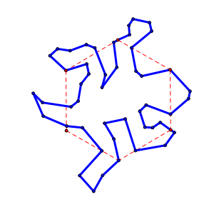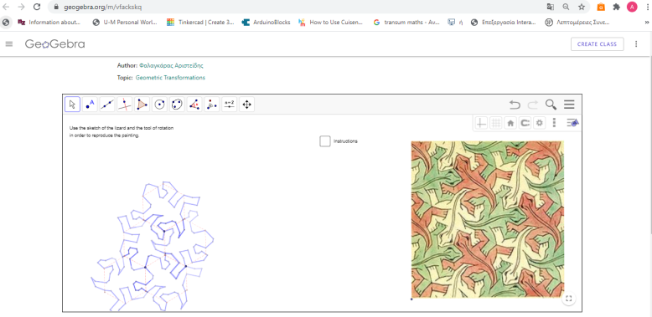
Homework
The students are asked find information about the city of Alhambra and to write a text of around 500 words about its history and its connection with Escher’s paintings .

4th Teaching period
1st Activity
Time: 20 ’
Type of activity: Use manipulative tools, designing , making conjectures.

Class organisation: in plenary / pair work
Actions/Tasks: The students are given a transparent piece of paper , the sketch of the outline of the lizard and encouraged to try find out which parts of it are symmetrical. About the end of the activity's time , is presented to them the interactive web page ( section Rotation about a vertex) where they can find explanation of the way of thinking of Escher and the underlying mathematical concepts.
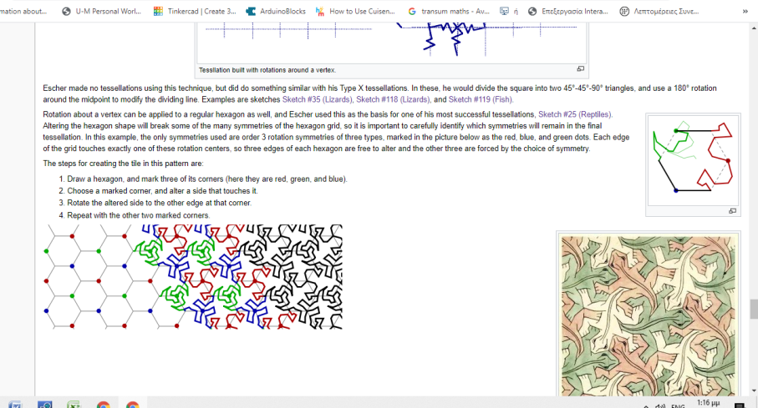

Time: 25 ’
Type of activity: Use manipulative, implement the gained knowledge,
Class organisation: pair work /in plenary
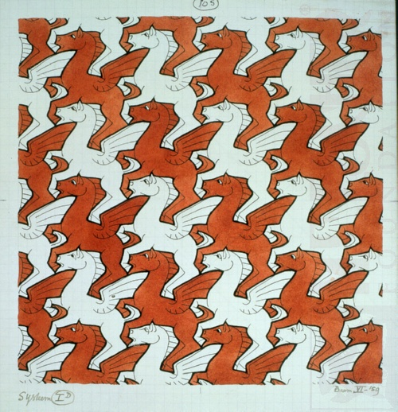
Actions/Tasks: The teacher gives to the students the sketch no 105 (Pegasus ) and asks them to analyze the painting. Encourages them to try to find out the type of tessellation and symmetry that Escher uses in order to create this sketch. The students make conjectures and announce them in plenary. The teacher can give to them some clues during their research from this interactive web page at the section Tessellating with translations .

