1st Teaching Period

1st Activity : Meeting with Mr M.C. Escher ( 10 min)

https://www.youtube.com/watch?v=f7kW8xd8p4s (part 1 )
https://www.youtube.com/watch?v=1CYrGpd8k5w&feature=emb_logo ( part 2)

Try to discuss with your classmates about Mr M.C.ESCHER’s work ,relying on the information that you found at the above mentioned videos, which you have already watched at your home. During the discussion try to answer to the below questions:

Where does M.C.Escher come from, when did he lived, what was his occupation?
Who is R. Penrose and what is his profession ?
What is the relationship of M.C.Escher and R. Penrose?
Where is Alhambra and what is its connection with the source of M.C. Escher’s inspiration?
What is the relationship between mathematics and the work of M.C.Escher?
What mathematical concepts do we come across at the work of M.C.Escher?
Which part of M.C.Escher’s work did you like the most and which one was the most interesting?

2nd Activity : Knowing the 3 types of Symmetry (10 min)
We will analyze some of Mr. M. C. Escher's paintings in which he used the mathematical concept of symmetry. Let’s define the term symmetry . When a geometrical shape, design or object of our natural world consist of a repeated part of it, we say that it has symmetry. An object with symmetry looks like it has created through a “copy- paste” process. Each “copy-paste ” process determines a different type of symmetry . It seems to be a matter of economy but not only that. Usually the objects with symmetry create the sense of beauty and harmony .
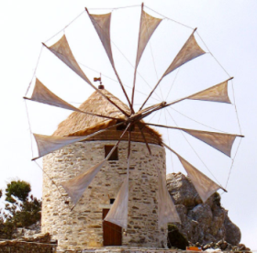
Before we analyze the paintings of M.C.ESCHER let’s try to understand symmetry through some simpler sketches or objects of the real world. For this , observe carefully the figures of the pictures below and try to find what part of each one is repeated and after that try to describe the different type of symmetry that each figure has. Propose a suitable name for each type of symmetry.

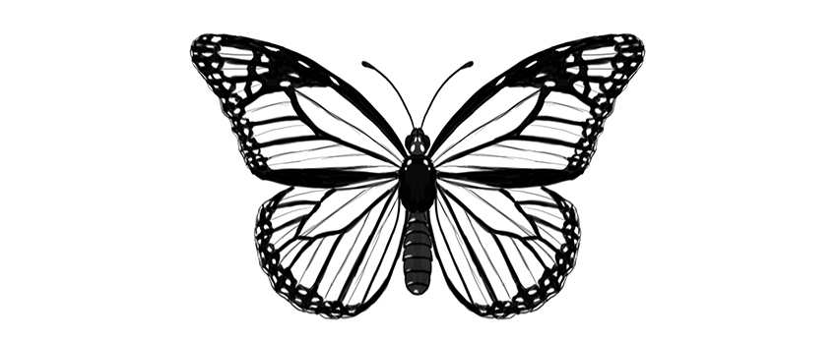

Follow the next links in order to find the definitions and examples of the above types of symmetry.
1st link https://www.mathsisfun.com/geometry/symmetry-reflection.html
2nd link https://www.mathsisfun.com/geometry/symmetry-rotational.html
3rd link https://www.mathsisfun.com/geometry/translation.html

3rd Activity : Using the 3 types of symmetry ( 25 min)
Use a piece of transparent paper , copy one of the footprints on it and try to reproduce the following patterns by folding , rotating and translating the paper in suitable manner. At each step keep a record the type of symmetry that you use ( translation , reflection symmetry and rotational symmetry).

Patterns | Symmetry
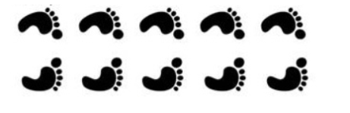
Pattern 1
Pattern 2
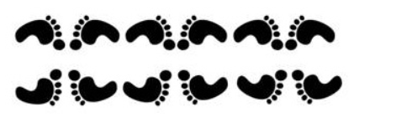
Pattern 3
Pattern 4
Pattern 5
Pattern 6

Click at the following link https://www.geogebra.org/m/ryuxj3n6 where you will find a Geogebra applet. Reproduce the above patterns using the commands of geogebra: translate by a vector, reflect about a line and rotate around a point.

Home work
A. Try to make some artistic symmetrical sketches with the applet at this link https://www.mathsisfun.com/geometry/symmetry-artist.html
and post the picture in this google jamboard https://jamboard.google.com/d/1n7xq3JijMTotnUOrixn3E9DSAFTvj-LbLfhcmB4px-Q/edit?usp=sharing
B. Create a word cloud with the key words you have encountered and you think you should remember. (suggested tool: https://wordart.com/)
2nd Teaching Period
Activity 1 Discovering symmetry in Escher’s paintings. ( 10 min)
Observe carefully the painting “Angels and Demons” . Try to find the smallest part of the painting that is repeated. Can you recognize any of the three types of Symmetry at this painting ?
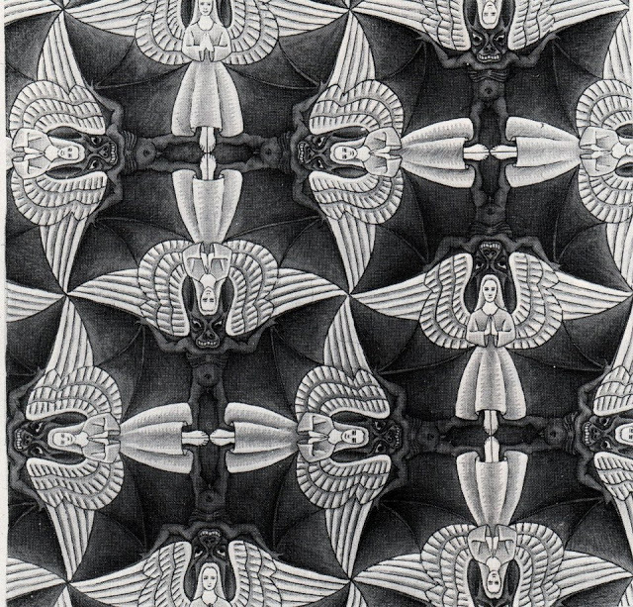

Activity 2 Reproducing the painting “Angels and Demons” (15 min) .
Use a transparent piece of paper, draw on it the outline of the half angel and try to reproduce the above painting. Keep a record for each type of symmetry that you use at the process of copying. Are there any alternative processes in order to achieve the same result?

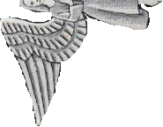

Activity 3 Reproducing the painting “Angels and Demons” using commands in Geogebra (10 min) .

Click at the following link https://www.geogebra.org/m/branqmzn where you will find a Geogebra applet. Reproduce the above painting , using the commands : translate by a vector , reflect about a line and rotate around a point. Can you use all three commands at the process of reproducing the painting?

Activity 4 Implement the gained knowledge. Indentify symmetry at other paintings of Escher (10 min ) .

Observe the following paintings and mention the smallest part of the painting that is repeated and the type of symmetries that Escher have used in order to create this painting.

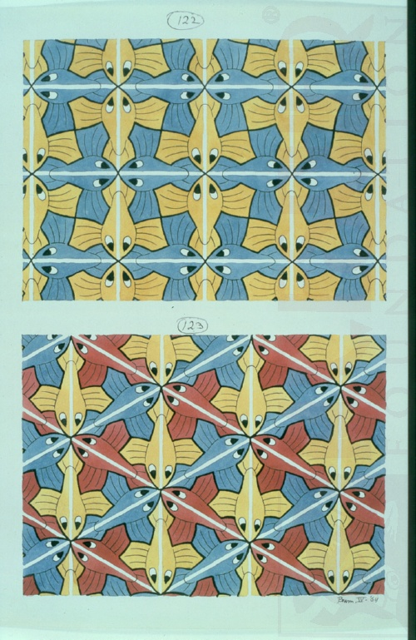

Homework .
Pick one the paintings that you will find here https://mcescher.com/gallery/symmetry/, analyze the way that Escher create that paint and write a text of 500 words .

3nd Teaching Period

1rst Activity Understanding the concept of Tessellation (25 minutes )
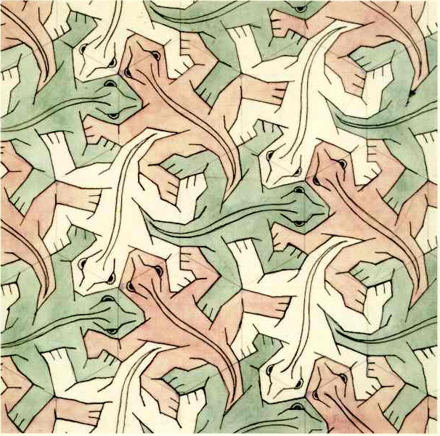
The above drawing belongs to a collection of numbered sketches by M.C. Escher, which he did not intend to publish. The name of the collection is Regular division of the plane and it is consisted of around 100 sketches. The sketch with the lizards is the Sketch no 25. The mathematical term is a regular tessellation . By the term Tessellation or Tilling we mean the covering of a flat surface using one or more flat shapes without over lapping each other and not leaving any gaps. The flat shapes called tiles. A Tessellation is called regular when the shape of all tiles is the same regular polygon. A polygon is called regular when all of its sides and angles are equal.
For some examples follow the link : https://www.mathsisfun.com/geometry/tessellation.html
How many kinds of regular tessellations exist according the above web page? Can you explain why there are only them?

2nd Activity Analyzing the painting (10 min ) .
If you look carefully the sketch, you will notice the auxiliary lines that Escher used in order to draw the painting. Try to find which regular polygon is created. Why do you think that Escher used this polygon? Can you find what is the pattern that is repeated at the painting and which kind of symmetry did he use ?

3rd Activity Reproducing the painting ( 10 min )
Ignore the internal of the lizard, copy it’s outline at a transparent paper and try to reproduce the painting .
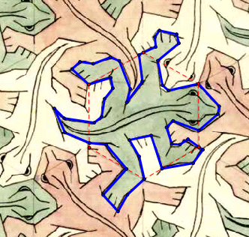

For your convenient you can use the geogebra applet that you will find here https://www.geogebra.org/m/vfackskq . Use the command rotation about a vertex in suitable manner and reproduce the outline of the painting.

Home work
Do a research on internet and find information about the city of Alhambra and it’s history, Write a text of 500 words in which you should mention the reason why this city is famous.

4th Teaching Period
1st Activity :Analyzing the sketch of the lizard (20 min) .
Observe the sketch of the lizard and find which parts of it are repeated . It would be helpfull if you use a piece of transparent paper. Describe the type of symmetry that Escher have used to design the lizard. Try to reproduce the lizard by using a transparent piece of paper.

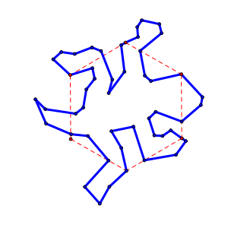
If it’s too hard for you to find out which parts of lizard are symmetrical follow the below link https://mathstat.slu.edu/escher/index.php/Tessellations_by_Recognizable_Figures
and look the section : Rotation about a vertex.

2nd Activity: Implementing (25 min)
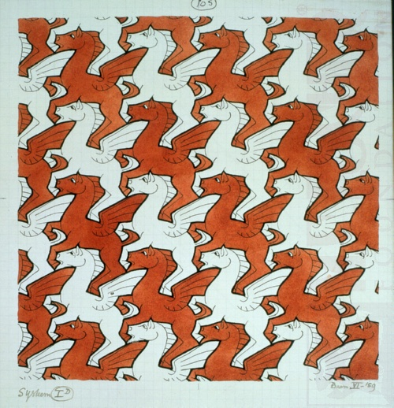
Study carefully the next painting ( Sketch 105, Pegasus) and try to find out which kind of regular tesselletion Escher used. Was it an equilateral triangle , a square or a regular Hexagon ?
Which parts of Pegasus are repeated ? Which kind of symmetry do you think that Escher used to create Pegasus ? It would better if you focus in one horse and your observations, as we did at the painting with the lizards .It would be helpful if you use some transparent paper.

If you still didn’t manage to reveal the secrets of the sketch follow the below link https://mathstat.slu.edu/escher/index.php/Tessellations_by_Recognizable_Figures
and look the section : Tessellating with translations .

