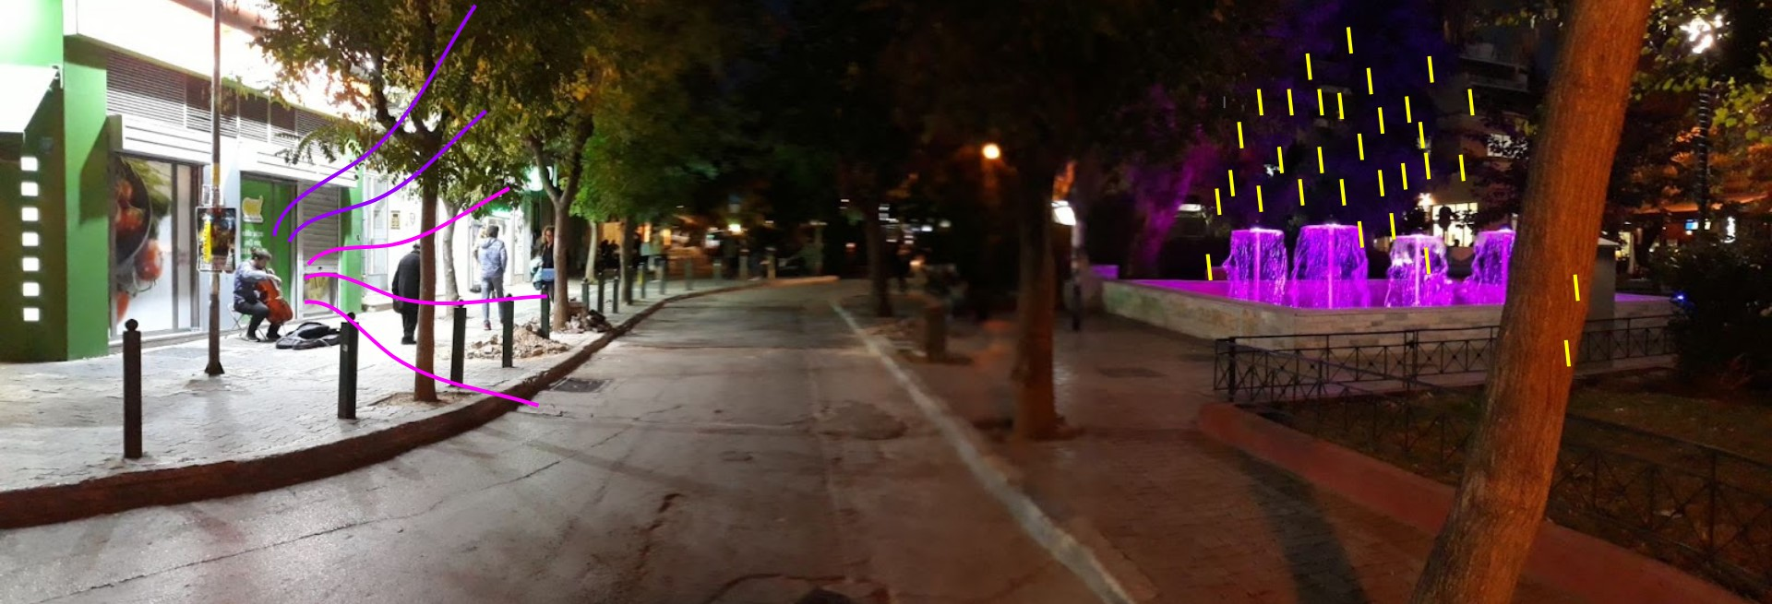

https://padlet.com/palla_eugenia/uo5y720vnwam4x80/wish/2402664556

Cello & Fountain
a Soundscape documentation in the city (Athens).
Recording (with a cell phone) and photograph.
Data: Cello & Fountain @ Fokionos Negri Square, Athens, November 3, 2021, 18:00 , duration 1:15.
Sound File: https://drive.google.com/file/d/1D6aEFH9jLR-ermUZ9E3085W1hAeps2nI/view?usp=sharing

