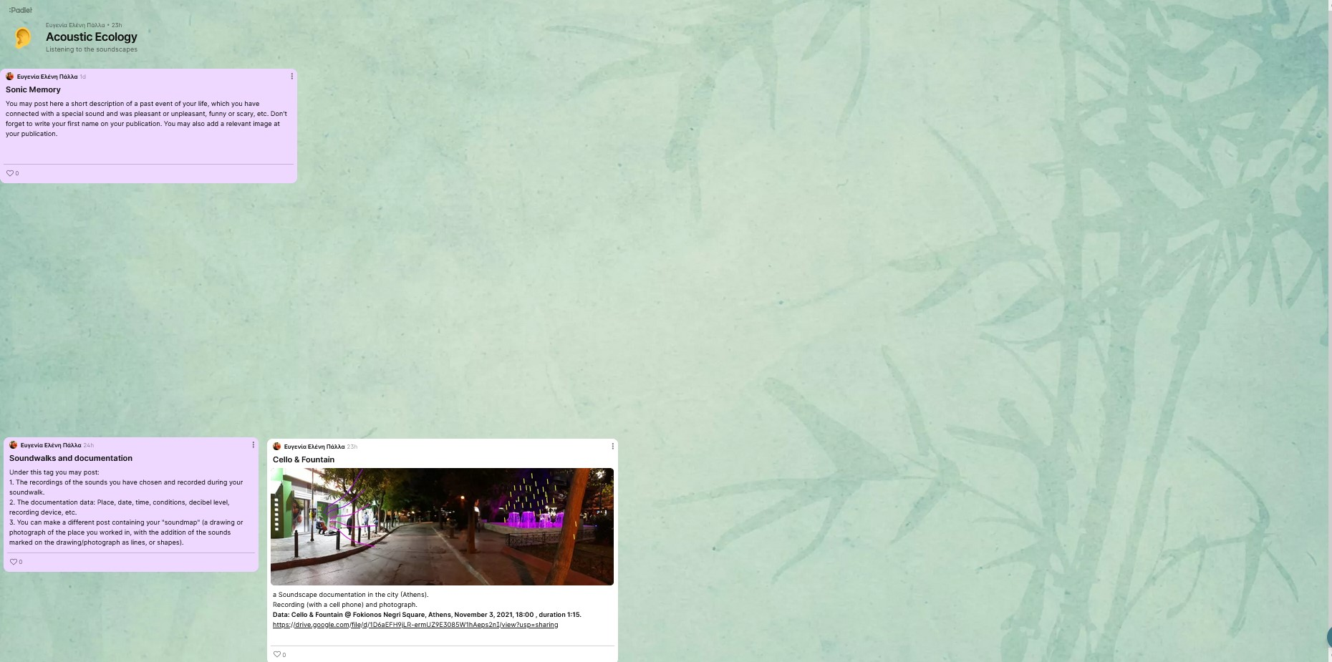

https://padlet.com/palla_eugenia/uo5y720vnwam4x80

