Acoustic Ecology & Soundscapes
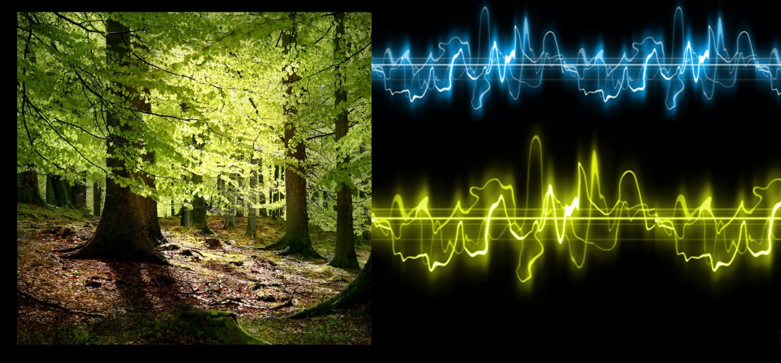

1st Teaching period

1st Activity
Time: 15’
Type of activity: Warm-up activity: listening to the Soundscape of the classroom and discussion
Class organisation: every student on her/his own & the whole class during discussion
Actions/Tasks: Students are asked to listen carefully to all the sounds around them (the classroom’s soundscape) for one minute. They are encouraged to keep their eyes shut during this careful listening and try to distinguish the sounds they hear.
After the listening, students are asked to share the sounds they heard with the class, while answering the following questions:
- Which and how many sounds are internal or external?
- Which sounds are produced by yourself or by others?
- Which ones are natural or manmade?
- Where the sounds pleasant or unpleasant?

2nd Activity
Time: 20’
Type of activity: presentation and discussion
Class organisation: whole class
Actions/Tasks: Presentation of the basic ideas of Acoustic ecology, Soundscapes and Soundwalks and the work of Raymond Murray Schaffer. (PowerPoint Presentation and discussion)

3d Activity
Time: 09’
Type of activity: instructions for the team’s assignment
Class organisation: whole class
Actions/Tasks:
The teacher asks the students to form teams (4, maximum 5 students in each one) and explains their tasks during the Soundwalk (preparation for the next teaching period).
Soundwalk tasks for the members of the teams:
- One student will hold and control the sound recording device (smartphone/tablet/sound recorder)
- One student will hold and control the device which will meter the sound intensity in decibels. This could be a smart phone/tablet with a pre-installed, free, decibel meter application, such as Sound Meter.
- Another student will keep notes and gather all the necessary data during the Soundwalk (The origin of each sound recorded, the time, the day and the place, the decibel level of the sound, etc).
- Another student will be responsible for documenting all the sounds found with an image. This image could be a drawing/sketch or an edited photograph. Editing is needed because the sounds must be represented on the photograph (or on the sketch) with lines, shapes and colors, depending on their volume, intensity, texture, etc.(example of photograph with drawn sounds).
- If there is a fifth member in the team, he/she could be the coordinator and will be responsible for putting all the material together on the padlet and preparing the team’s presentation. If there is no fifth member, the other four will have to prepare the presentation for the third teaching period.

5th Activity
Time: 1’
Type of activity: exercise/game
Class organisation: whole class
Actions/Tasks: Try to get up from your chair and leave the classroom for the brake, without making any sound/noise! Every time you make a sound, you must sit down, and start again!

Homework: Sound & Memory
Under the tag “Sonic Memory”, at the padlet, you have to create a post with a small description of one sonic memory-a past event of your life, which you have connected with a special sound and was pleasant or unpleasant, funny or scary, etc. Don't forget to write your first name on your publication. You may also add a relevant image at your post.

2nd Teaching period

1st Activity
Time: 45’
Type of activity: Soundwalk
Class organisation: the class is divided into teams of 4-5 students each.
Actions/Tasks: The teacher, accompanied by another teacher depending on the number of students, will take the class for a Soundwalk, a walk during which the teams will listen to sounds produced by natural sources, or made by humans and the human activity/technology/civilization. During this walk the teams will listen to the sounds, they will choose the sounds that they find more interesting, they will record them and keep detailed data, as stated before. This walk could take place inside the school, if the teacher wants the class to study the soundscape of the school, or around the city-to listen to sounds made by cars, machines etc., or in a park, where students will have the chance to hear some natural sounds (leaves, birds, running water, etc). If there is more time available, the class could study all of these three sound environments (school, city and park/forest). This is an activity that could also take place during a school excursion and students will have the chance to observe the environment from the aspect of sound.
Important note: the teacher must underline that the recordings of each sound chosen must be very short (10’’-30’’), as clear as possible and must be recorded as closer to the sound source as possible. The recording should not have any unwanted sounds, if possible. To achieve that, the members of each team must be very silent and careful during the soundwalk and especially during the recording, because every abrupt move, talk or laugh will be captured by the recording device and destroy the recording.
When the Soundwalk is over, the teams will have some homework: to organize their material and publish it on the padlet. This is the material for their presentation to the class, during the 3rd teaching period.

3d Teaching period

1st Activity
Time: 40’
Type of activity: Presentations
Class organisation: the class is divided into teams of 4-5 students each.
Actions/Tasks: Each team presents the recorded material, the data they have collected, their Soundmaps (drawings or photographs with drawn sounds) and reflect on their experience. They share their thoughts, referring to the points set for the presentation (in the PPT presentation). A conversation within the class on the results of the Soundwalk could follow the presentation, if there is enough time.

2nd Activity
Time: 5’
Type of activity: Evaluation
Class organisation: Each student on her/his own
Actions/Tasks: Students use tablets to complete a small evaluation questionnaire on google forms.

Visual Art (drawing-painting-collage-photography)
Physics (sound and its meaning for human beings and nature)
Environmental study-Ecology
IT-computers/tablets/smartphones
Google forms
Google slides
Padlet
Outdoor education
Camera
Free photo editing app/software
Free decibel meter app

