Dotplots, Stem and leaf plots, Histograms.
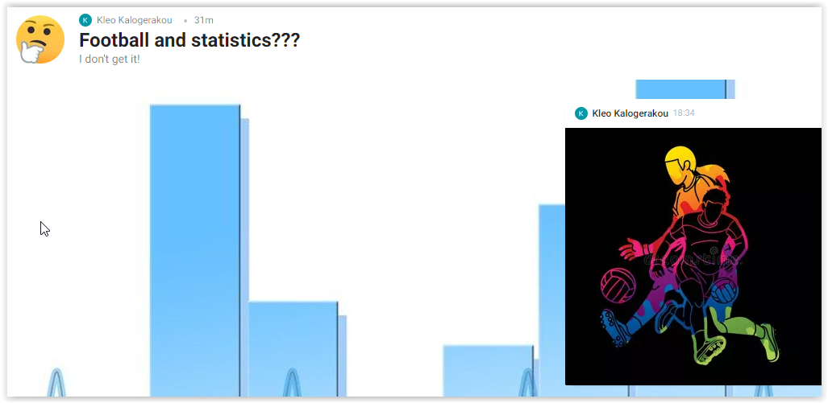

Brainstorming activity (asynchronous, before the beginning of the 1st teaching period): students are provided with a collaborative digital wall and some questions to draw on prior knowledge about what the field of statistics involves and how it is connected to a popular sport of theirs. Students collaborate and post their ideas on padlet with as many ideas and examples as possible having the following questions in mind:

Do you know if there were ancient peoples who played football?

Do you know if women played football in the past?

Do you know what statistics deals with?

How can we use statistics in everyday life?

Which fields of science use statistics?

1st Teaching period
1st Activity

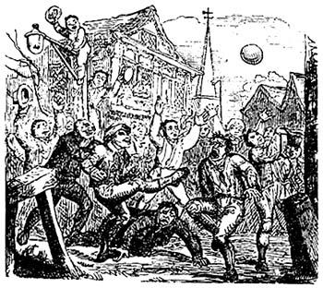 | 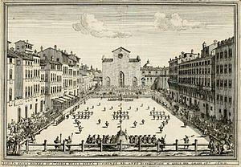
A mob football match played at London's Crowe Street. 1721  Public Domain /wikipedia | Illustration of a game of Calcio Fiorentino from 1688  Public domain /wikipedia
Time: 30’
Type of activity: Split reading, selecting important information and discussion on the content of two web pages about the history of football.

Class organisation: in groups (girls’ and boys’ groups).

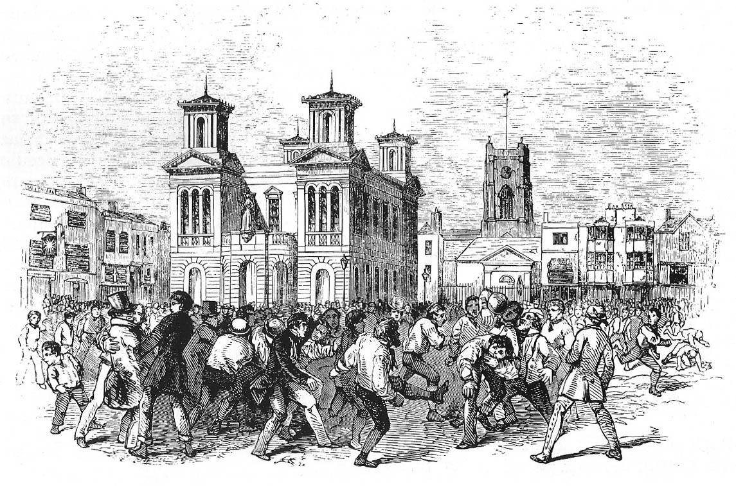 | 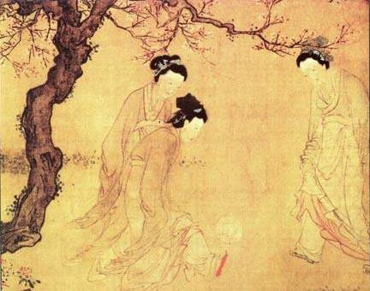
A football game between Thames and Townsend clubs, played at Kingston upon Thames, London, 1846.  Public domain / wikipedia | Chinese ladies playing cuju, by the Ming Dynasty painter Du Jin  Public domain / wikipedia

Actions/Tasks: The teacher gives the girls’ groups a worksheet with a website (or in PDF form) about male football and the boys’ groups another worksheet with a website about female football. The students work in groups, read the text and select the most important information about men’s football and women’s football respectively. On their worksheet they make a ten-point (at least) list of unusual information (Did you know that...?). The aim of the activity is to introduce the students to the idea that football, and sports in general, is a social activity and therefore its function is governed by the rules and the limitations of each society. They can discuss the reasons why football has always been so popular. They may attribute its popularity to the simplicity of rules and the fact that there is no necessity for special equipment. It is enough to have only a ball in order to play football. They can discuss the phenomenon of violence in football throughout the centuries and the source of violence. They may attribute the violence that accompanies the game of football to the easiness of organizing a match , also to the fact that it is a very competitive game and therefore a convenient way of resolving differences between various groups of people. Also the aim of the activity is to trigger a discussion about the prejudice that some social activities are only for men, and how those prejudices were created.

A glossary is available throughout the lessons.

2nd activity

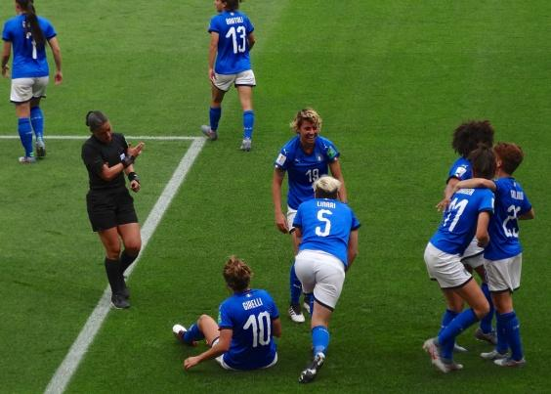
https://commons.wikimedia.org/wiki/File:Italia_Team_(Women_World_Cup_France_2019).jpg

Time: 20’

Type of activity: Presentation and discussion on the content of the web pages about the history of football.

Class organisation: whole class.

Actions/Tasks: students present their unusual facts and find out if the other groups knοw the facts they have found. Depending on the number of unknown facts, there could be a competition, boys or girls who find the most facts that the other teams were not aware of are the winners.

2nd Teaching period
1st Activity

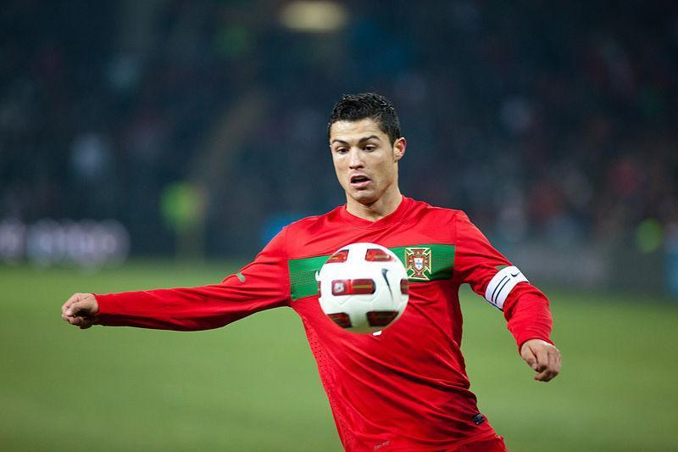 | 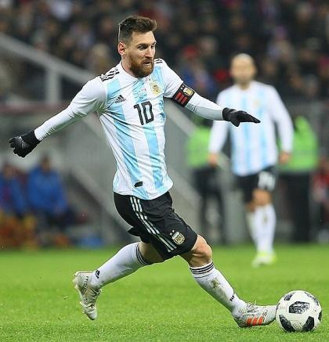
https://commons.wikimedia.org/wiki/File:Argentine_-_Portugal_-_Cristiano_Ronaldo.jpg | https://commons.wikimedia.org/wiki/File:Lionel_Andr%C3%A9s_Messi_Cuccittini.jpg

Time: 20’
Type of activity: Warm up, Reading raw data, reasoning about them , discussion .
Class organisation: In pairs / in small groups and whole class discussion.
Actions/Tasks: As a warm up activity the teacher gives students a worksheet and discusses with the students the two top scorers of the UEFA Champions League competition asks them to make conjectures regarding the possibility of someone scoring a certain number of goals in that competition (Task 1). The aim is for the students to understand the necessity of having data in order to make safe conclusions . Then, students are given a table with the top 52 scorers of the same competition and are asked to answer some questions regarding the data of the table (Task 2). The aim is to demonstrate the necessity for processing data. After that, they are asked to organize their data in a manner that it would be easier to answer such questions. The teacher encourages students to use diagrams of any kind in order to present their data (Task 3). The aim is for the students to understand the advantages of using diagrams when they want to process data in order to draw conclusions.

2nd and 3rd Activity
The class will be divided in two groups of equal size. One group will do the 2nd Activity (the less able students) and the other group will do the 3rd activity. For each activity the teacher will dedicate about 15 minutes. Then, each group will present the results after comparing the two kinds of diagrams.

2nd Activity
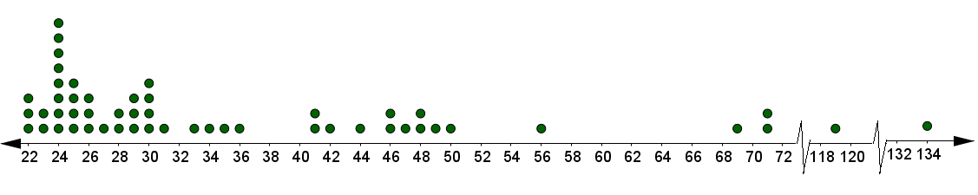
Time: 15 ’
Type of activity: Reading a diagram ,reasoning about it , discussion .
Class organisation: In groups and in plenary.
Actions/Tasks: Students are given a worksheet, the teacher presents the data of the table in a dot plot and asks them to compare them (Task 1). The students discuss guided by the questions on the worksheet.

3nd Activity

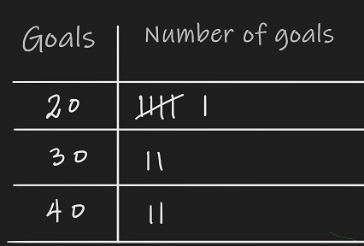 | 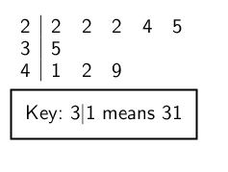

Time: 15 ’
Type of activity: Constructing a diagram ,reasoning about it , comparing it with other diagrams , discussion .
Class organisation: In groups and in plenary.
Actions/Tasks: The teacher presents the data of the table in a stem and leaf plot and asks them to compare it with the dot plot and the table. The students discuss in class guided by the questions on the worksheet (Tasks 2 & 3). And they draw their own stem and leaf plots .
Homework :
The students are asked to read a dotplot and make a stem and leaf plot.

3rd Teaching period
1st Activity
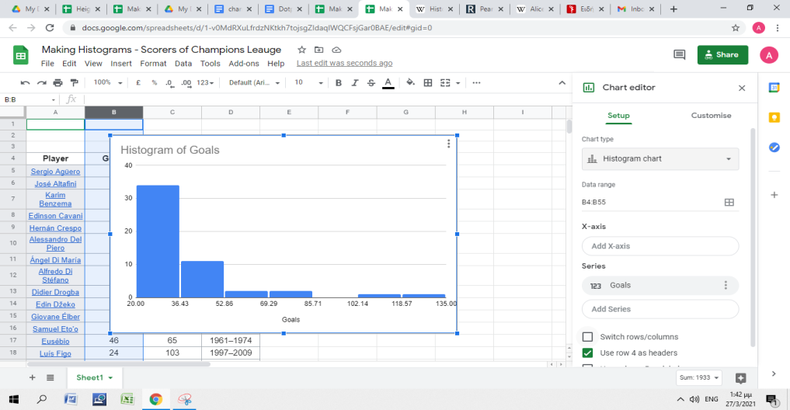 | 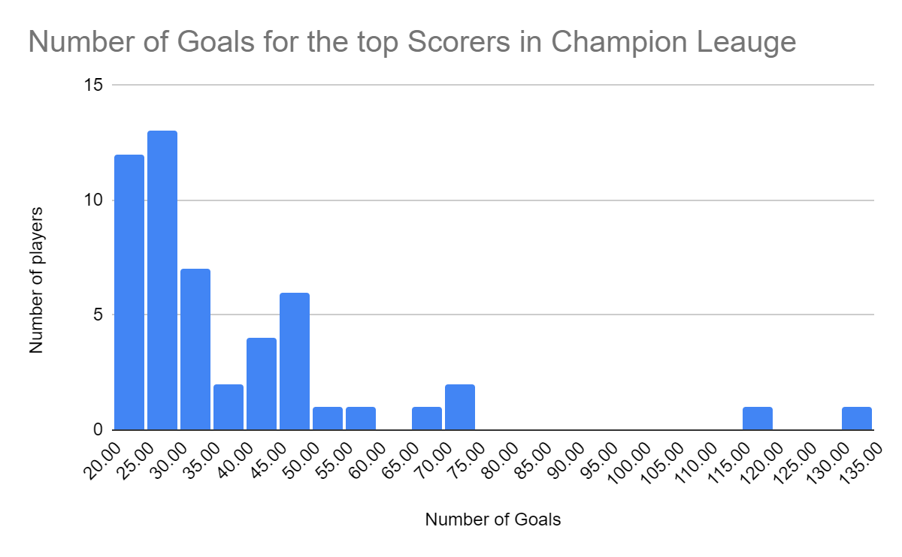

Time: 25 ’
Type of activity: Constructing a diagram in excel of Google sheets ,reasoning about it, comparing it with other diagrams , discussion .
Class organisation: In pairs or in small groups around computers with internet connection and whole class discussion.
Actions/Tasks: The teacher guides students in order to present their data using a Histogram that will be made on Google excel . He/she can use the wiki web page for the definition of the Histogram and clarify terminology . The students work in pairs or in small groups around the PC connected to the internet. The teacher gives students instructions on how to create the histogram using a PPT on h5p and also provides them with a video with the same instructions to watch again if need be. Students are also asked to compare it with the stem and leaf plot.

2nd Activity
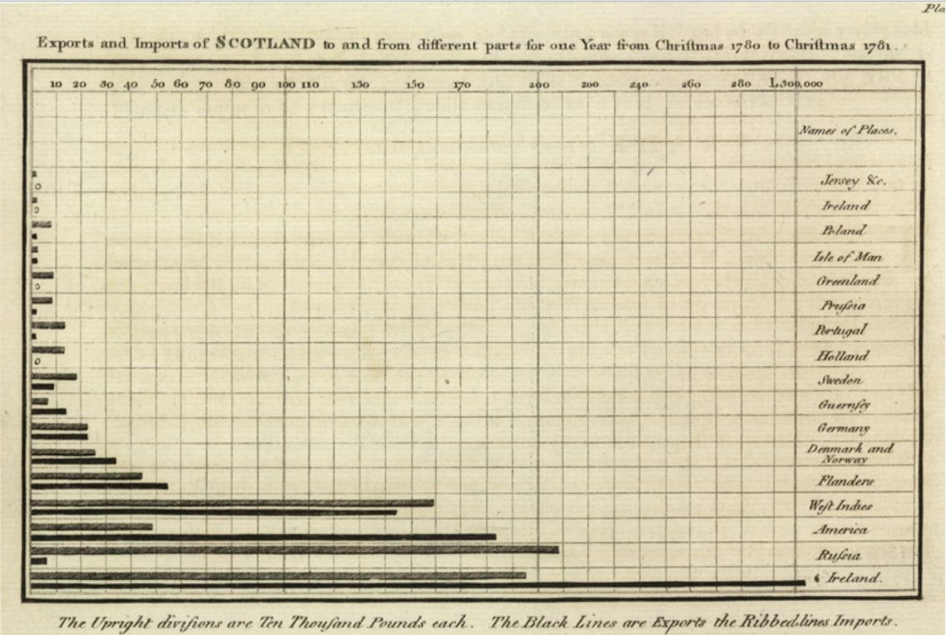
Bar chart.
Exports and Imports of Scotland to and from different parts for one Year from Christmas 1780 to Christmas 1781.
Wikipedia/ Public Domain.

Time: 25 ’
Type of activity: Reading comprehension, keeping notes and discussion on the content of a web page about the history of statistics .
Class organisation: In pairs or in small groups and whole class discussion.

Actions/Tasks: The teacher gives the students a worksheet with questions on the content of the web page https://en.wikipedia.org/wiki/William_Playfair
The students work in pairs or in small groups reading and keeping notes. In plenary they discuss the content of the web page. William Playfair was the first who used diagrams in order to organize data and make conclusions, especially for commercial purposes. The aim is to understand the value of statistics in making decisions in real life situations .
Homework :
The students are asked to interpret Histograms.

4th Teaching period

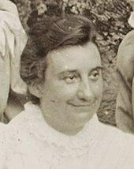 | 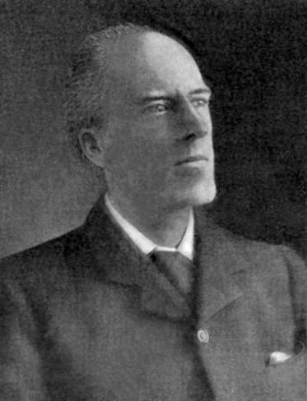
Alice Lee 1858–1939 (statistician)  Wikipedia/ Public domain. | KARL PEARSON 1857-1936- Equally distinguished as mathematician, lecturer, writer, and organizer of statistical research"  Wikipedia/ Public domain.

1st Activity

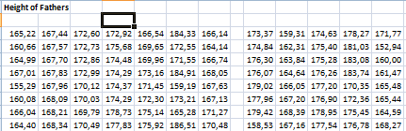
Time: 10 ’

Type of activity: Reading raw data, drawing conclusion, reasoning, making decisions discussion ,
Class organisation: In pairs / in small groups and whole class discussion.

Actions/Tasks: The teacher gives the students a worksheet with information about a survey conducted by Pearson and Lee in 1901 regarding the assumption that in general the Sons grow taller than their Fathers. The teacher presents the raw data that had been collected by Pearson and Lee and asks students what they would have done if they had to answer this question. The aim is to understand the necessity of processing data and presenting them in an appropriate form for drawing conclusions.

2nd Activity
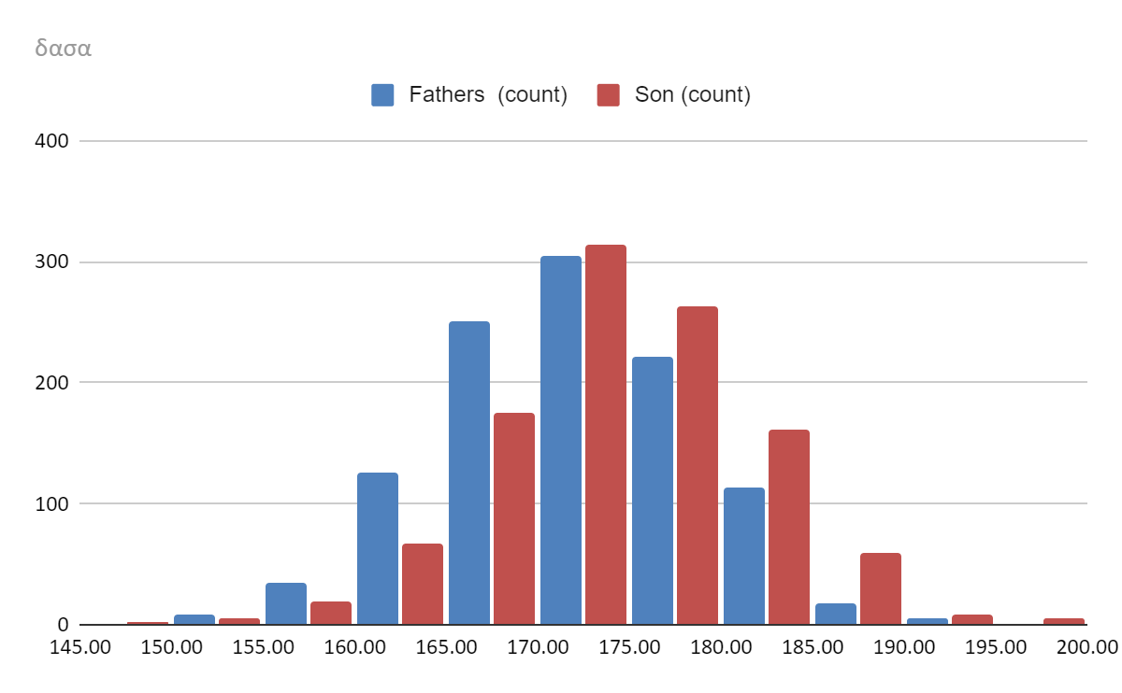
Time: 20 ’

Type of activity: Reading and comparing diagrams ( Histograms), drawing conclusion, reasoning, discussion.
Class organisation: In pairs / in small groups and whole class discussion.

Initially the teacher gives the students the Histograms of Fathers’ and Sons’ Heights separately and asks them to compare them in order to confirm or reject Pearson's and Lee’s assumption. At the next step the teacher gives the Histogram with fathers’ and sons’ data together and asks them if now it is easier to draw conclusions.

3rd Activity
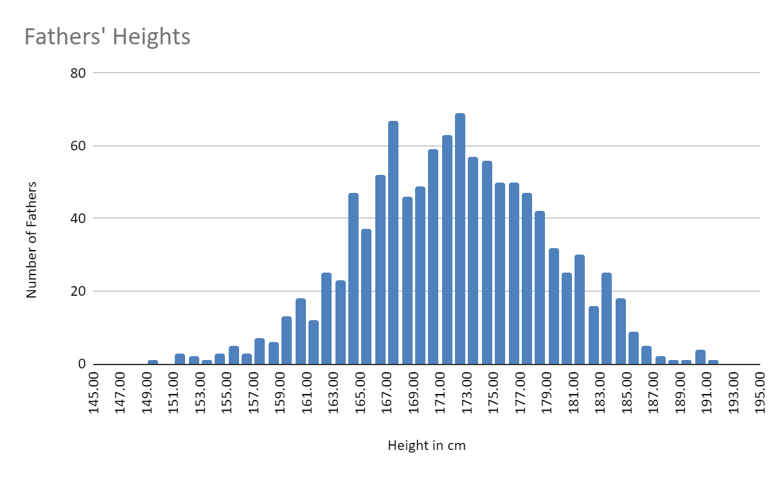 | 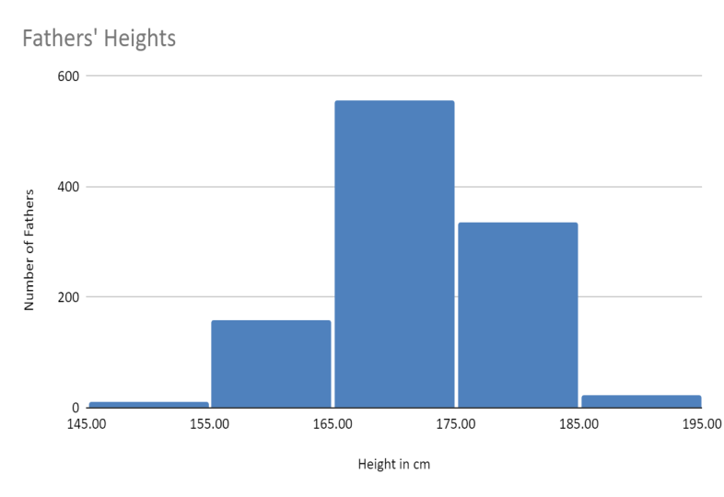

Time: 15 ’

Type of activity:, Constructing and comparing diagrams (Histograms), drawing conclusions, reasoning, discussion.

Class organisation: In pairs / in small groups and whole class discussion.

Actions/Tasks: The teacher asks the students to construct 3 histograms presenting the fathers’ heights , using different buckets and asks them to argue about which one is presenting the data better.

Assessment/Language practice
https://h5p.org/node/1155904?feed_me=nps
https://h5p.org/node/1156544?feed_me=nps
https://quizlet.com/_9svhd9?x=1jqt&i=6m3w6
https://wordwall.net/play/15790/575/715

Expansion

Find information about Pearson and Lee and discuss biostatistics , the position of women in the field of science at the beginning of the 20th century and Pearson’s stand on and the moral issues of the matter.

