Table of Contents
1st Teaching Period 2
Activity 1st : The history of the Football (soccer ) 2
Activity 2nd : The history of the women Football (soccer ) 3
2nd Teaching Period 4
Activity 1 : Introduction- Organizing Raw Data . 4
Constructing graphs 6
Activity 2 : Dotplots 6
Activity 3 : Stem and leaf plots 7
3rd Teaching Period 7
Activity 1 : Using excel for the construction of Histograms 7
Activity 2 : And little bit of the history of statistics 9
Homework 10
4rd Teaching Period 12
Activity 1: Necessity for data processing. 12
Activity 2:Using histograms for data processing. 12
Activity 3: Comparing Histograms 14

Dotplots, Stem and leaf plots, Histograms .

1st Teaching Period

Activity 1st : The history of the Football (soccer )
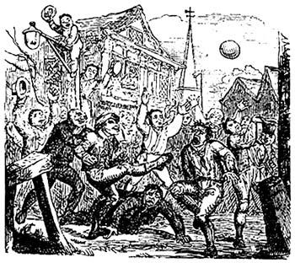 | 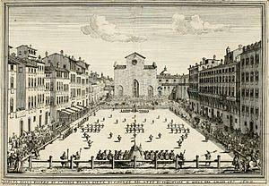
A mob football match played at London's Crowe Street. 1721  Public Domain /wikipedia | Illustration of a game of Calcio Fiorentino from 1688  Public domain /wipedia

Follow the link and learn about the football https://www.footballhistory.org/
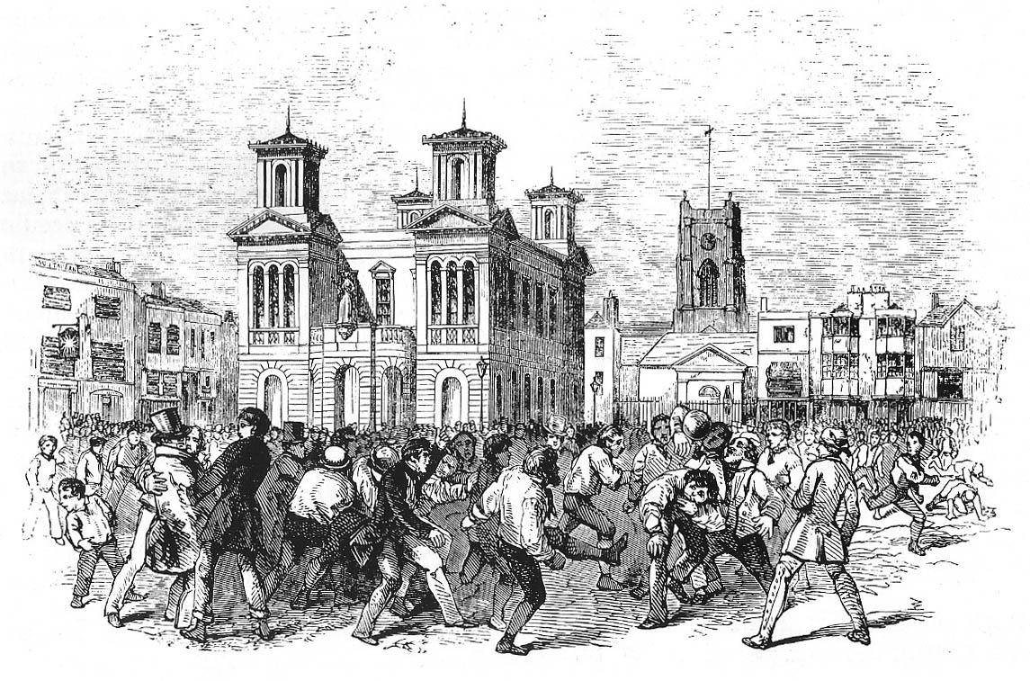
A football game between Thames and Townsend clubs, played at Kingston upon Thames, London, 1846.
Public domain / wikipedia
Which country is considered to be the homeland of modern football? How did they call it in this country?
Which ancient civilizations played a game involving a ball? Which was the country that played the game with a ball for the first time?
What were the consequences for the captain of the losing team when Aztecs played Tchatali?
Why had football been banned for several centuries in England?
When and where were established, for the first time, the rules of modern football?
What were the main differences between the way that played rugby and football?
Which was the difference between English and Scottish teams in the way that they played the game in the 19th century?
Which were the first clubs in England?
Which were the first competitions?
Did black people play football?
Which was the stadium with the biggest capacity that was ever built?
Which is the today's biggest tournament for football clubs?
Why do you think that football was so popular throughout the centuries?
In your opinion, what is the source of violence in football?

Activity 2nd : The history of the women Football (soccer )
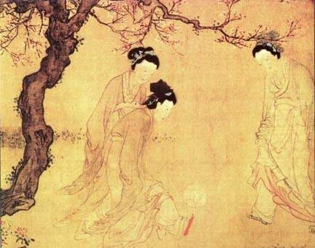 | 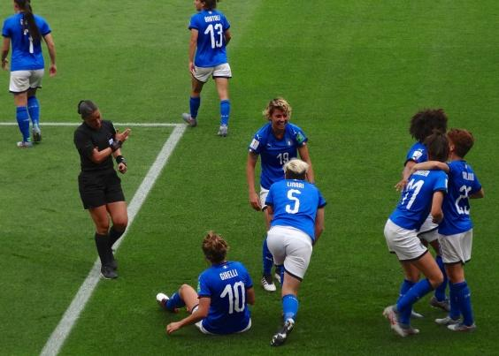
Chinese ladies playing cuju, by the Ming Dynasty painter Du Jin  Public domain / wikipedia | https://commons.wikimedia.org/wiki/File:Italia_Team_(Women_World_Cup_France_2019).jpg

Football is a game only for men. Open the following link and try to find if this is true.
https://en.wikipedia.org/wiki/Women%27s_association_football#History
When is the first time that women believed that they played football?
Did women play football in Europe after the 12th century? If ,yes , where did they play?
What happened on Boxing Day in 1917 in England? Was women football matches popular?
Why were women's football games banned in England 1921? When this ban was recalled? What is your opinion on banning women from playing football?
How do you comment on the suggestion of FIFA’s former president Sepp Blatter that women footballers should "wear tighter shorts and low cut shirts... to create a more female aesthetic" and attract more male fans?

2nd Teaching Period

Activity 1 : Introduction- Organizing Raw Data .
Christiano Ronaldo is the player who scored the most goals ever , in the UEFA Champions League. He scored 134 goals in 174 appearances, until 9th of December 2020. The second best scorer of all times in the UEFA Champions League is Lionel Messi who scored 118 goals in 147 appearances.
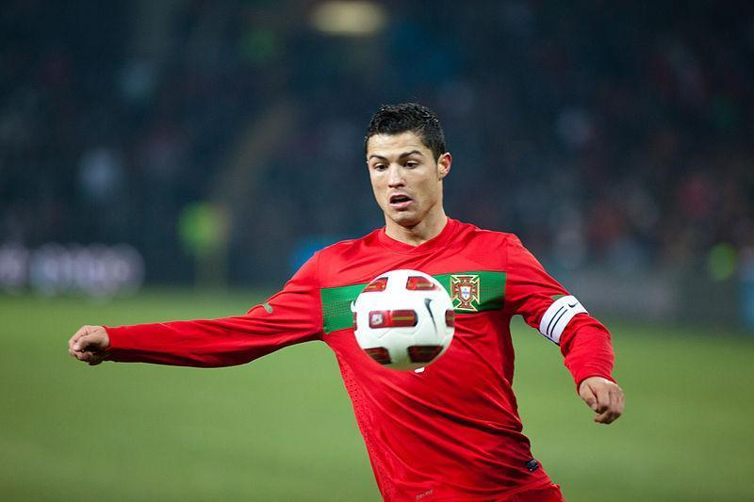 | 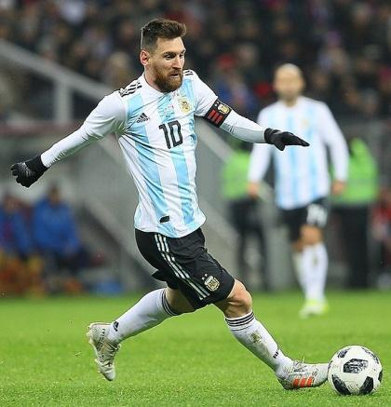
https://commons.wikimedia.org/wiki/File:Argentine_-_Portugal_-_Cristiano_Ronaldo.jpg | https://commons.wikimedia.org/wiki/File:Lionel_Andr%C3%A9s_Messi_Cuccittini.jpg

Is it possible for a football player to score 180 goals in the UEFA Champions League?
Which do you think are the conditions for achieving that?

The next two pages show the top 52 scorers of all times in the UEFA Champions League, the number goals that each player scored, the number of appearances and the seasons that those goals were scored. Study the data on table 1 and draw as many conclusions as you can. Explain your reason.
For example complete the following sentences and write your own.
The players that scored over 60 goals in their career in this competition were ……..
Most of the top 52 players scored between ……...and ……….goals.

Table1: The top 52 scorers in the history of the Champions League.

Player | Goals | Apps | Years
Sergio Agüero | 41 | 73 | 2008–
José Altafini | 24 | 28 | 1959–1976
Karim Benzema | 69 | 125 | 2006–
Edinson Cavani | 35 | 65 | 2011–
Hernán Crespo | 25 | 65 | 1997–2007
Alessandro Del Piero | 42 | 89 | 1995–2009
Ángel Di María | 22 | 89 | 2007–
Alfredo Di Stéfano | 49 | 58 | 1955–1964
Didier Drogba | 44 | 92 | 2003–2015
Edin Džeko | 22 | 55 | 2009–
Giovane Élber | 24 | 69 | 1997–2004
Samuel Eto'o | 30 | 78 | 1999–2014
Eusébio | 46 | 65 | 1961–1974
Luís Figo | 24 | 103 | 1997–2009
Francisco Gento | 30 | 89 | 1955–1969
Ryan Giggs | 28 | 145 | 1993–2014
Mario Gómez | 26 | 44 | 2007–2013
Antoine Griezmann | 25 | 68 | 2014–
Thierry Henry | 50 | 112 | 1997–2012
Gonzalo Higuaín | 24 | 83 | 2007–2020
Zlatan Ibrahimović | 48 | 120 | 2001–2017
Filippo Inzaghi | 46 | 81 | 1997–2012
Mário Jardel | 25 | 46 | 1996–2001
Kaká | 30 | 86 | 2003–2014
Patrick Kluivert | 25 | 71 | 1994–2006
Frank Lampard | 23 | 105 | 2001–2015
Robert Lewandowski | 71 | 94 | 2011–
Jari Litmanen | 23 | 59 | 1993–2003
Roy Makaay | 29 | 61 | 2000–2007
Lionel Messi | 118 | 147 | 2005–
Fernando Morientes | 33 | 93 | 1997–2009
Gerd Müller | 34 | 35 | 1969–1977
Thomas Müller | 47 | 120 | 2008–
Neymar | 41 | 65 | 2013–
Jean-Pierre Papin | 28 | 37 | 1989–1994
Ferenc Puskás | 36 | 41 | 1956–1966
Raúl | 71 | 142 | 1995–2011
Rivaldo | 27 | 73 | 1997–2007
Arjen Robben | 31 | 110 | 2002–2018
Cristiano Ronaldo | 134 | 174 | 2003–
Wayne Rooney | 30 | 85 | 2004–2015
Mohamed Salah | 25 | 54 | 2013–
Santillana | 22 | 46 | 1971–1988
Paul Scholes | 24 | 124 | 1994–2013
Andriy Shevchenko | 48 | 100 | 1994–2012
Marco Simone | 24 | 46 | 1989–2001
Luis Suárez | 26 | 64 | 2010–
José Augusto | 24 | 56 | 1960–1969
David Trezeguet | 29 | 58 | 1997–2009
Ruud van Nistelrooy | 56 | 73 | 1998–2009
Robin van Persie | 25 | 59 | 2002–2014
Wikipedia

Was it easy to draw your conclusion? What were the difficulties that you met?
Can you organize your data in such a manner that it will be easier to draw conclusions?
For example how would you organize the data in order to find out how many goals scored by most of the top 52 players?

Propose one or more diagrams or a list that you think that are suitable for showing the distribution of players according to the goals that they have scored. Try to draw as many conclusions as you can form the diagram or the list that you made.

Constructing graphs
Three of the students, John, Vassiliki , James and Cris, organized their data using graphs. John used the Dotplot , Vassiliki and James the Stem and Leaf plot and Cris the Histogram.

Activity 2 : Dotplots
In the picture below we can see the dot plot that John made. 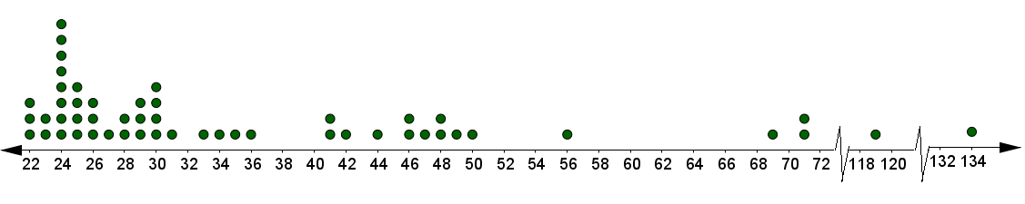number of goals

What are the advantages of the dot plot in comparison to the table 1 of the two previous pages?
What kind of information can you see at once at the dot plot?
Which information can’t you see at the dot plot but you can find it at the tables?
Complete the next sentence and write your own, drawing as many conclusions as you can from the dot plot above.
Only ……… players in the history of the Champions league scored more than 100 goals.
The value that occurs most often in a data set is named the mode. What is the mode of the number of goals that the top 52 scorers achieved in the history of the Champions League?

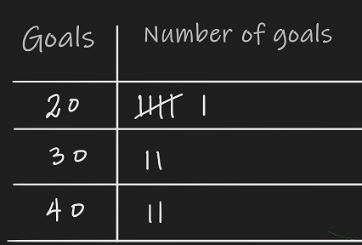
Activity 3 : Stem and leaf plots
James thought that it might be a good idea if he divided the scorers into groups, according to the tens of goals they scored. He made a table like this where we can see the distribution of the scorers in each group.
Complete James’ table and compare it with John’s dotplot .
Which information is easier to see at James’ table and which is missing in his table?
Vasiliki said that at James’ table she could not see the number of the goals that each scorer achieved in his career , so she thought to draw a table like this in order to present the data .
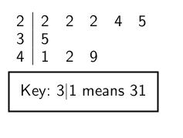
Vassiliki named her table of data as STEM and LEAF PLOT . She explained that the row 2 | 4 5 2 2 2 stands for the 5 players that scored 24 , 15, 22 , 22 and 22 goals respectively.

Copy the stem and leaf plot proposed by Vassiliki and complete it with the data in Table 1 . Compare it with the table of James .
Why do you think that Vassiliki named her plot as Stem and Leaf;
As you see 1rst row of the stem and leaf plot that you made is too big in comparison with the other two rows. Also it is not easy to see how many players scored the same number of goals . So in order to improve the stem and leaf that proposed by Vassiliki draw two new stem and leaf tables as follows:
a. One plot in which you must split each stem in two . One , in which the digit of units to be below five and one five and above .
b . Another one plot that the number of goals are in order. Draw the leaf plots in the same manner that vasilliki did.

3rd Teaching Period

Activity 1 : Using excel for the construction of Histograms

Chris decided to present the data in another way. He had heard of the Karl Pearson who, with Alice Lee , first used a diagram named Histogram for representing a big amount of data. He decided to use the knowledge that he gained from the lesson of informatics in order to create the histogram. He first copied the table 1 in google sheet as below and then selected the column named Goals , opened the tab Insert and chose Chart.
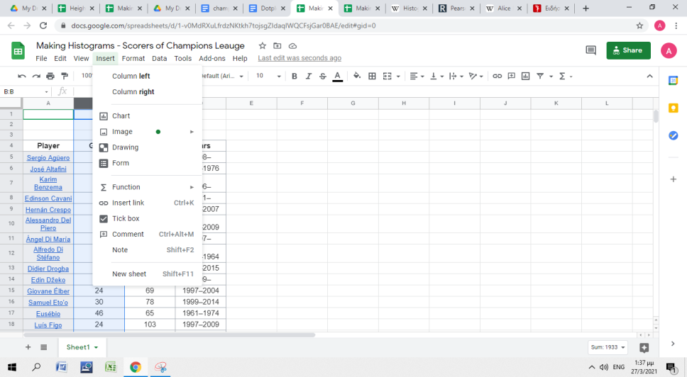
On the right of the table appeared the Chart editor for the selection and customization of the suitable chart. In the Setup menu he chose the chart type to be the HistogramChart
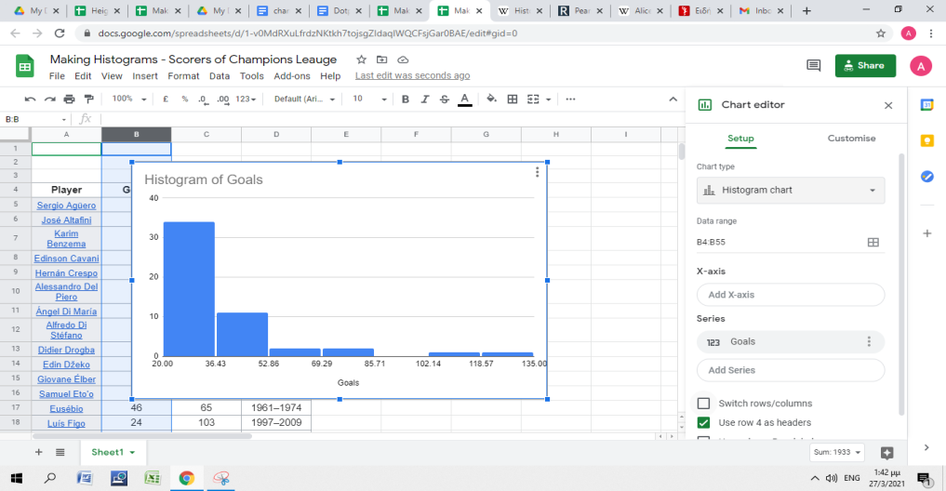
In the menu Customize he selected in the submenu Histogram the bucket size to be 5 .
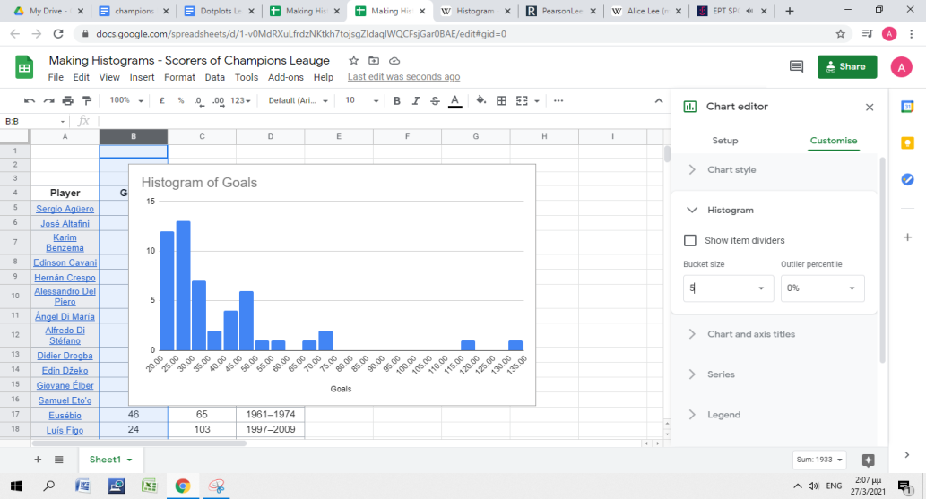
In the submenu Charts and axis titles he named the Axis as follows
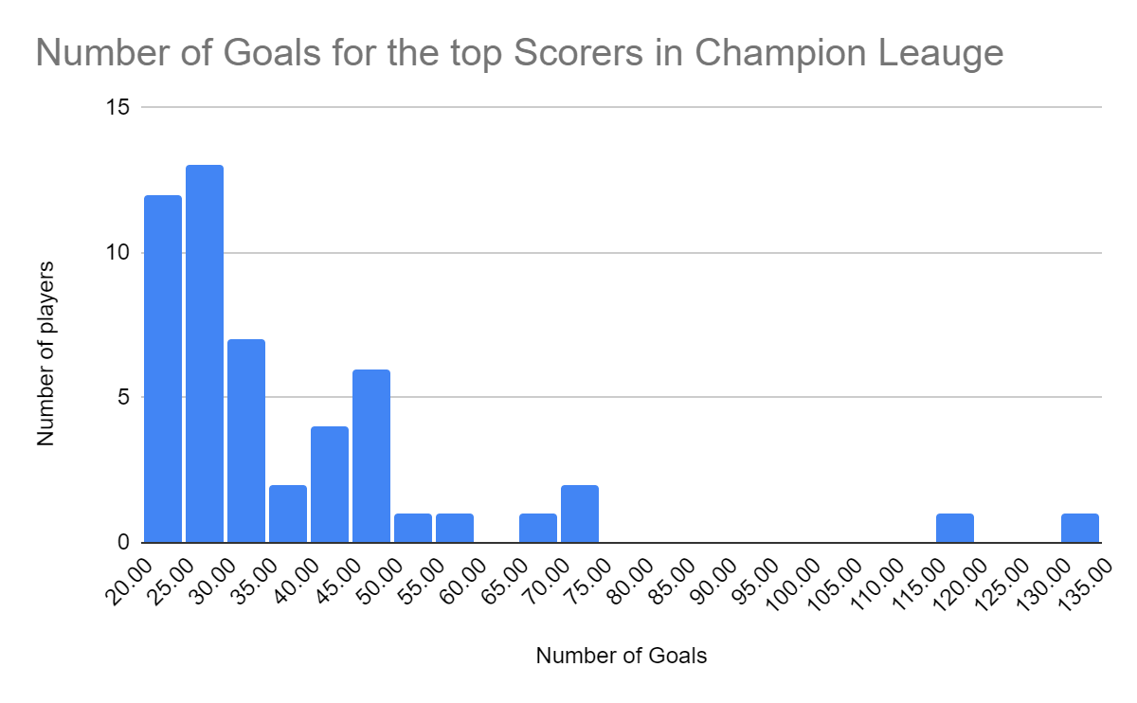
Compare the Vassiliki’s stem leaf plot and Chris' ’Histogram. What are the similarities and what are the differences of the two diagrams? Which information can you find in the leaf plot but is missing from the Histogram?

Activity 2 : And little bit of the history of statistics
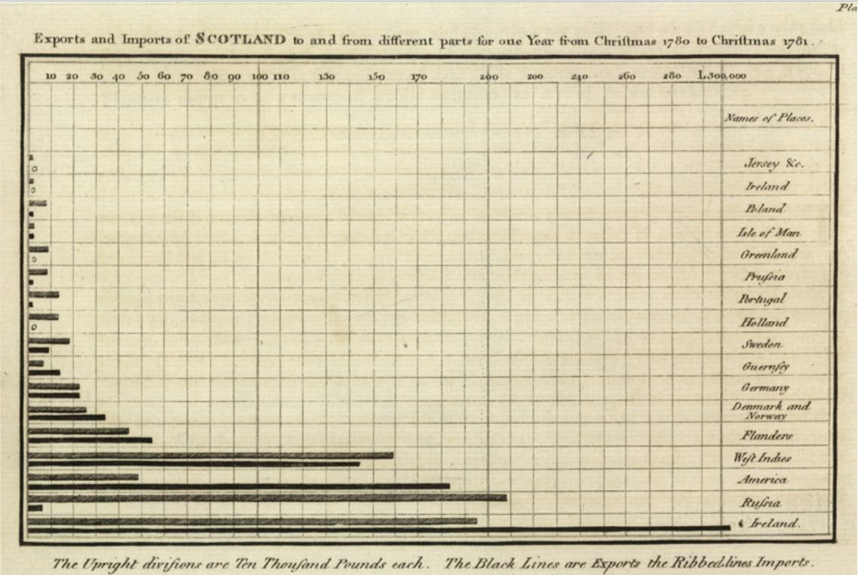
Bar chart.
Exports and Imports of Scotland to and from different parts for one Year from Christmas 1780 to Christmas 1781.
Wikipedia/ Public Domain.

Work in pairs and find information about William Playfair about the first one who used charts in order to represent data.
https://en.wikipedia.org/wiki/William_Playfair
Try to answer to the following questions
Who was William Playfair ?
What was his occupation?
What was his relation with statistics ?
Which Graphs did he invent and for what purpose?

Homework
- At the next dot plot you can see the hours in a week that the students of a classroom are spending in doing their homework . Try to answer to the following questions
΄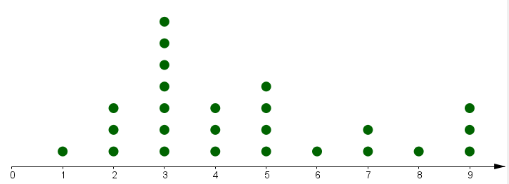
- How many are the students of the classroom?
- How many hours maximum the students spend on their homework?
- How many students spend more than 6 hours for their homework ?
- What is the mode of the hours of reading in a week ?
- What is the average number of hours in a week that students spend on reading ?
2. At the next table you can see the score in a maths test .
18 | 42 | 39 | 41 | 17 | 9
22 | 29 | 31 | 27 | 30 | 11
16 | 28 | 40 | 27 | 35 | 36
45 | 38 | 37 | 30 | 28 | 21
- Make a dot plot and a leaf plot.
- Which one is better for presenting the data?
3. The Histogram that follows presents the number of people by age who answered in phone research that the chocolate cake is their favourite cake .
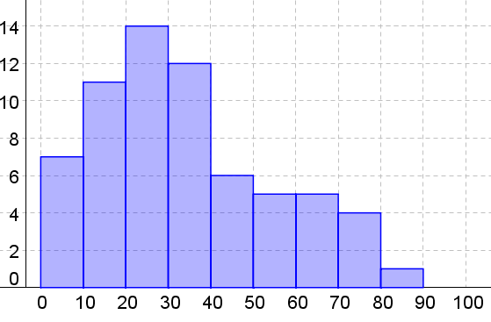
- How many were the people who participated in the research?
- How many people of 30 and 40 years old answered that chocolate cake is their favourite cake?
- How many people above 50 years old prefer chocolate cake among other cakes?
- Which is the age group with the highest frequency? Frequency of a group is the number of people of that age that prefer chocolate cake.
- What is the range of every age group? Note that when we were constructing the histogram we referred to the rage of the group as “Bucket”
- What are the ages of the people who prefer chocolate cake the most?

4rd Teaching Period

Activity 1: Necessity for data processing.
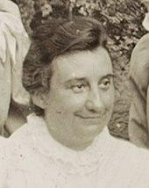 | 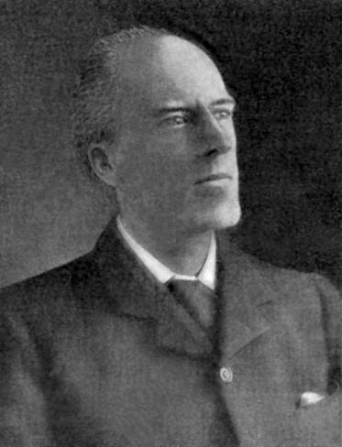
Alice Lee 1858–1939 (statistician)  Wikipedia/ Public domain. | KARL PEARSON 1857-1936- Equally distinguished as mathematician, lecturer, writer, and organizer of statistical research"  Wiki pedia/ Public domain.

Vasilliki found some interesting information about Alison Lee. She was born in England at the end of the nineteenth century and she was one of the first women that took a degree in mathematics. She demonstrated using statistics that there is no correlation between skull size and intelligence, and therefore there is no mental superiority of men to women because of the tendency of men to have a larger head than that of women. She worked together with Karl Pearson , who was an English Mathematician and Biostatician.
They conducted a survey about the assumption that Sons grow taller than their Fathers . For that reason they gathered data in the following manner: They asked more than 1000 families to measure the heights of the Father and the son of the family who was older than 18 years old . At the Appendix 1 you will find the heights of 1068 Fathers and their Sons.

Activity 2:Using histograms for data processing.

When John saw the tables with the data he said that it is impossible to compare them because they are too many. Vassiliki proposed they use the diagrams which they have already learned in the previous lessons. Which of the diagrams ( Stem and Leaf plot , dot plot or histogram) would you choose in order to represent the data? Explain your opinion.
Niki thought it's not convenient to use dot plot because the data are too many to draw 1068 dots. Also the stem and leaf plot is not suitable because the values are not natural numbers and it's not so easy to read the heights of every father . So she thought that it’s more appropriate to use Histogram .She decided to use Excel in order to construct the Histogram.
She chose to distribute the fathers’ heights in groups with the bucket to be 5cm . She made a graph like this.
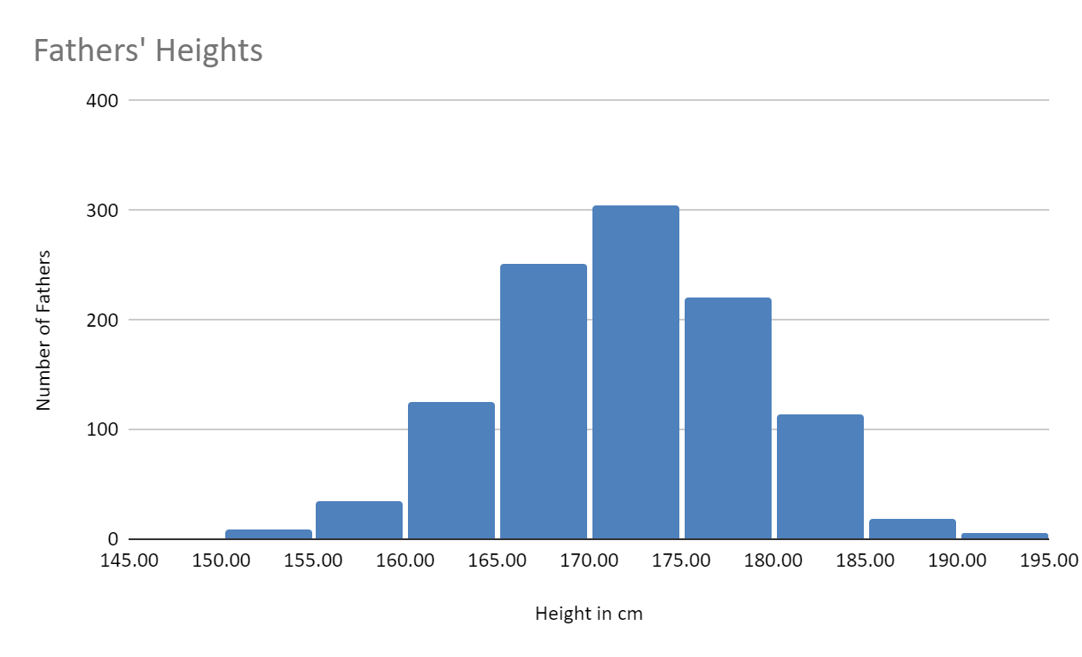
Observe the Histogram above and try to draw as many conclusions as you can about the distribution of Fathers’ height. Try to answer the next questions
Which column has the bigger height ? What does that mean ?
What is the range of the heights of most of the Fathers ? Explain your opinion
Does the Histogram appear to have some kind of symmetry? What does that mean?
Try to construct in google docs the Histogram of the heights of the sons with bucket 5 cm. Is your histogram the same as the diagram below?
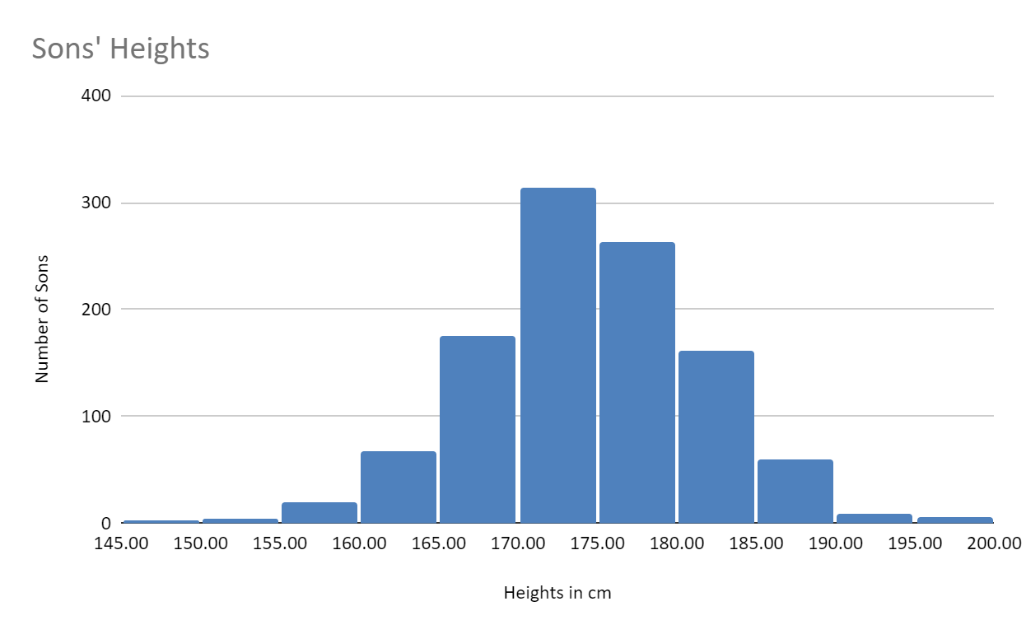
Compare the two Histograms and try to answer to the following questions :
What is the height of most of the fathers and what of the sons ?
What is the height of the tallest Fathers and what of the tallest Son ?
Can you decide if the sons are growing taller than their fathers?
John couldn’t make his mind about whether or not the Sons are in general taller than their fathers by comparing the two Histograms. Therefore he decided to put together the two Histograms in one diagram, like the one below.
Is it easier now to make the comparison? Can you draw the conclusion? Explain your reason. 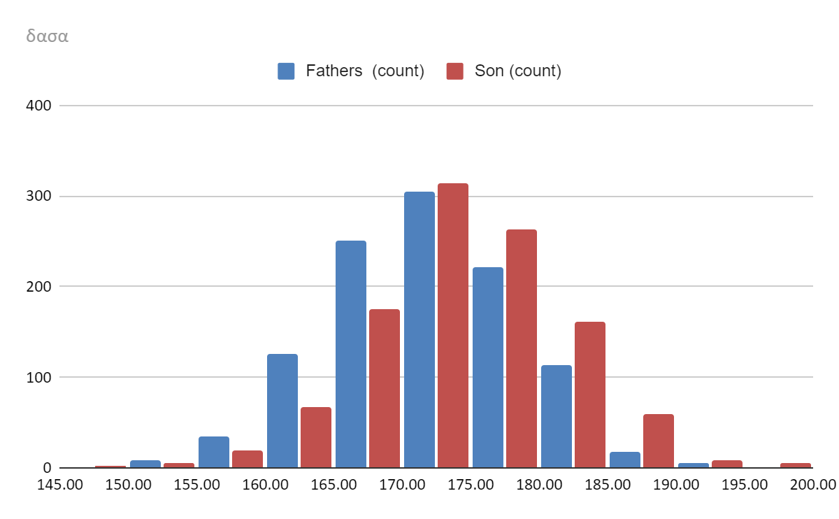

Activity 3: Comparing Histograms
- Construct the histograms of the heights of Fathers with bucket 1, 2 and 10 .

- John constructed the histograms of Fathers with bucket 1, 2 and 10 . Compare them. Which one do you think that is describing the distribution of Fathers heights better ? Explain your reason.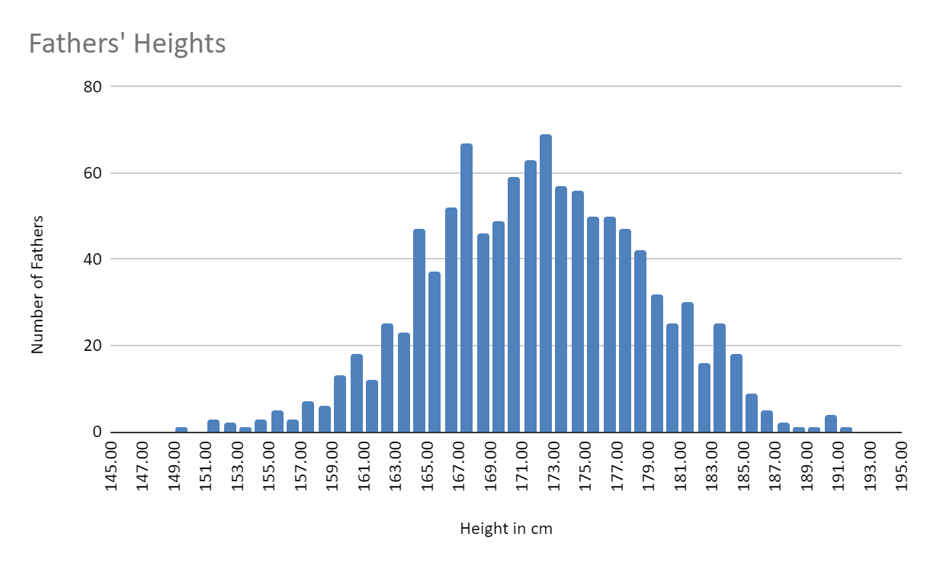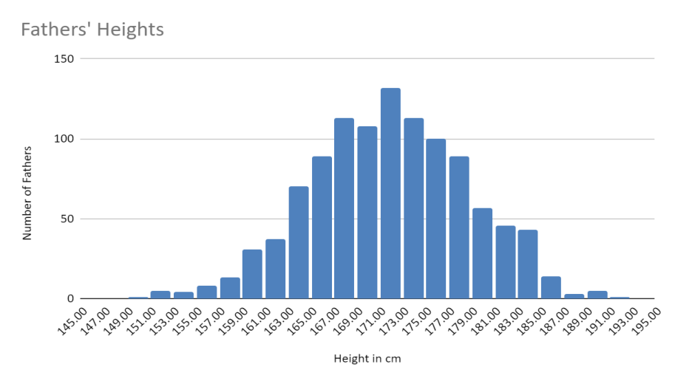

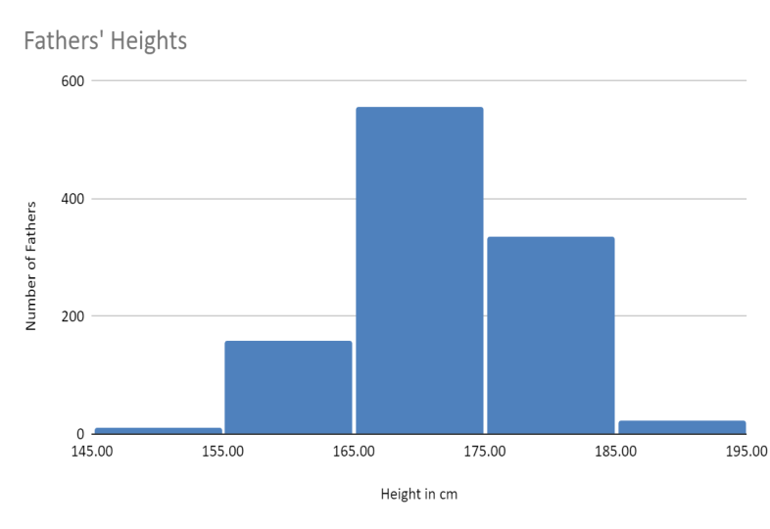
Home work

Use the Appendix 2 in order to construct the histograms of the heights of Sons with bucket 1, 2 and 10 .

