**Scenario Script Template**

**Title: ‘*Lord Byron and the Parthenon Marbles*’**

**Author:** Antiopi Argyriou (1st Model High School of Athens, Greece)

Introduction

The present educational scenario brings together Literature with Political and Cultural History. Starting from an excerpt of the poem *Childe Harold’s Pilgrimage*, written by Lord Byron, the famous 19th c. British Romantic poet and Philhellene, it links the literary context of the poem – with many references to the Romantic view of ancient Greece and to the contemporary early 19th c. Greek War of Independence - with the acquisition of the Parthenon Marbles by Lord Elgin, British Ambassador to the Ottoman Empire and the scorn of Lord Byron to Lord Elgin for his treacherous act. During the three teaching periods, the students are encouraged to become active participants of research activities (mainly in groups) in class, in order to investigate: a) the literary and political figure of Lord Byron, b) the historical context of the poem, and c) the implications of this poem – and other parallel poems – for the issue of the Parthenon Marbles that are until now exhibited in the British Museum, but are requested to return to the Acropolis Museum in Athens. Thus, through various activities, the students realise that a piece of poetry may offer insights into the literary, historical, and political-cultural aspects and help them understand, think, and create their own views and response towards not only literature, but more broadly towards issues of cultural diplomacy and heritage protection as their role as future active citizens requires.

1st teaching period: Lord Byron and Greece

***1st Activity***: Starting point – Summary of video watched at home (homework).

Time: 5 min.

Type of Activity: Discussion in class, summary of notes after watching a video.

Class Organisation: Homework, Class Work, Discussion.

Actions/Tasks: All students have already watched a 45 min. video at home and have kept their notes about the main points of Lord Byron’s life and his relation to Greece (Prof. R. Beaton, King’s College London, ‘*What Byron really did for Greece and why it still matters*’, a lecture at the British School of Athens, 7-5-2015). Short **discussion** summarizing **students’ notes from the video**. URL: <https://www.youtube.com/watch?v=KwjlN_eaTYE>

***2nd Activity:*** Let’s focus and work in groups!

Time: 30 min.

Type of Activity: Research in groups, creative activities using online tools aiming at consolidation of knowledge and historical thinking.

Class Organisation: Group work, Working with tablets (electronic class assignments) or in the PC School Lab (electronic resources). The class is divided into three groups, each of which studies a different aspect of the topic and fills in a separate **WORKSHEET (1A, 1B, 1C).** The teacher asks from students to make their own research, to study relevant material from specific suggested resources, and to concentrate on specific tasks, which are done simultaneously in class by the three groups of students. By these three group tasks the students may understand the aspects of time (*the biographers*), of place (*the* *cartographers*), and of action stimulated by a cause (*the historians*), which are all important for putting the historical person and the literary figure of Lord Byron in his era and within a specific context.

Actions/Tasks: The three groups of students work on equal topics:

a) ‘**The biographers’** (*Byron’s life*): Create a historical timeline with the most important facts about Byron’s life, using <https://www.canva.com/create/infographics/timeline/> (See WORKSHEET 1A)

b) ‘**The cartographers’** (*Byron’s travels*): Put Byron’s travels to the East on a map using <https://www.canva.com/create/maps/> (See WORKSHEET 1B)

c) ‘**The historians’** (*Byron’s Philhellenism*): What impact did the Greek War of Independence have on Byron’s views and actions? How did he prove that he was a Philhellene? (See WORKSHEET 1C).

***3rd Activity:*** Let’s present our work!

Time: 10 min.

Type of Activity: Group presentations in class.

Class Organisation: Group work presentations, electronic class assignments, discussion (formative evaluation).

Actions/Tasks: All three groups present to class the outcomes of their research. Discussion between students and teacher follows with comments from either side about the strong and the weak points of each group presentation and with suggestions for improvement. This final stage of group presentations allows students to cultivate their team working, decision making, co-operation, critical thinking, and self-evaluation combined with formative evaluation.Before leaving class*,* students may be asked: *Which do you consider as Byron’s most important contribution to the Greeks?* (Food for thought - Preparation for the next teaching period).

2nd teaching period: Lord Byron’s Childe Harold’s Pilgrimage

The topic of this teaching period is the study of Byron’s *Childe Harold’s Pilgrimage* (a selected excerpt from the original English edition). First, they read or listen to the literature excerpt (*1st Activity*). After the literature recitation, the students are divided into three groups and are distributed three separate **WORKSHEETS (2A, 2B, 2C).** They work in groups in class and study the relevant material about the topic of their group (*2nd Activity*). They try to identify a) the Romantic features of this poem (1st group), b) the references to Greekness and Greek culture legacy in the poem (2nd group), and c) the scorn of Lord Byron to Lord Elgin about the Parthenon Marbles in the poem (3rd group). After working in groups, the students compare *Childe Harold’s Pilgrimage* to two other poems, which are provided as parallel texts: Byron’s *The Curse of Minerva* (excerpt) and Kiki Dimoula’s (modern Greek poetess), *The* *British Museum (The Elgin Marbles).* Finally, they present their results to class, so that everyone in class can follow their findings and discuss (*3rd Activity*).

***1st Activity:***

Time: 10 min.

Type of activity: **Literature Recitation**. Reading response. Brainstorming (**mind mapping**).

Class Organisation: Class organised with chairs in a circle (it may have a better impact on the students’ response to literature recitation).

Actions/Tasks: The teacher distributes the text of the poem and recites the poem, or guides the students to read it online: <https://www.gutenberg.org/files/5131/5131-h/5131-h.htm>. It is important for the students’ aesthetic pleasure of the art of literature to listen to literature recitation quite often instead of only reading literature silently.

Brainstorming follows which checks to what extent the students have understood: A) the historical context of the poem’s composition, b) the main topic of the poem, and c) the poet’s views. Create a mind map (<https://opensource.com/article/21/12/open-source-mind-mapping-drawio>) summarizing the students’ answers.

***2nd Activity:***

Time: 20 min.

Class organisation: The class is divided in three groups (**team-working in class**) working on three separate WORKSHEETS (2A, 2B, 2C). Make **research** using **online resources**.

Actions/Tasks: The three groups of students work simultaneously in class on the specific topic of their group, using their tablets or PCs in the IT Lab.

* *1st group*: Lord Byron: a Romantic poet (WORKSHEET 2A).

Study the relevant material and fill in the TABLE with information about a) the main features of the Romantic movement in European poetry, and b) Byron’s particular characteristics as a Romantic poet.

* *2nd group*: *Childe Harold’s Pilgrimage* and Greekness (WORKSHEET 2B).

Study the relevant material and try to identify: a) which Greek mythological figures are mentioned in the poem and in what context? B) which historical figures (or groups of people) are mentioned in the poem and in what context? C) which period of Greek history is the poet inspired by? and d) what are his emotions towards Greek monuments and antiquities in particular?

* *3rd group*: Athens and Britain in the time of Lord Byron (WORKSHEET 2C).

Can you identify in the poem how Lord Byron viewed a) Britain and his contemporary British people? b) Greece, c) what particular references are there to Lord Elgin and to the Parthenon? And d) how does the poet refer to ancient Greece compared to his contemporary 19th c. Greece?

***3rd Activity*:** Lord Byron’s *‘The Curse of Minerva’* and Kiki Dimoula’s *‘The British Museum (The Elgin Marbles)’.*

Time: 15 min.

Type of activity: Common Worksheet, after watching a short video in class and listening to the poetess’ literature recitation **(WORKSHEET 3).** **Video watching and literature recitation. Comparison of literary texts**.

Listen to the two poems (video of Kostas Gavras about the Parthenon and recitation of Byron’s *The Curse of Minerva*, and literature recitation by the poetess Kiki Dimoula) and compare with *Childe Harold’s Pilgrimage*. Can you identify any similarities and/or differences between the three poems with reference to: a) the topic, b) the point of reference, c) the poet/poetess’ view on the topic, d) the poetic *persona* and the literary icons. Can you create a painting or colour the poem’s verses? What colours would you use and why? If you were directing a film scene or a theatrical performance of a representation of one of these poems, what music and what scenery would you choose and why? Discuss in groups and decide!

Class organisation: After working in groups, the class returns to their seats. They are distributed a common Worksheet and watch the two parts of audio-visual material.

Actions/Tasks: The students watch a video and listen to the two parallel poems. Then, they are given time to complete the WORKSHEET 3, and discuss in class.

3rd teaching period: The Parthenon Marbles

***1st Activity:*** Lord Elgin and the Parthenon Marbles.

Study the relevant material and present a short summary of the main facts (dates and facts) in a **timeline** focusing on the main question of your group. Fill in your WORKSHEET 3A, 3B, or 3C: A) Who is Lord Elgin, b) What did he do to the Acropolis temples and how? c) How did the Greek sculpture end up in the British Museum?

Time: 10 min.

Type of activity: Group activity. Each of the three groups studies relevant material and puts the main points (facts and dates) on an **online timeline** using for each of the above three questions the online tool: <https://www.canva.com/create/infographics/timeline/>

Class organisation: Divided into three groups (these may not be identical to the three groups created during the previous teaching periods, thus allowing a new mixture of students participating and engaging themselves into different activities and in co-operation with different members of groups each time).

Actions/Tasks: The students study relevant material (via online resources), identify what is relevant to their question, select the main facts and dates and put them on an electronic timeline.

***2nd Activity:*** The claim for the return and reunification of the Parthenon Marbles to Athens.

Time: 15 min.

Type of activity: Read about the history of the issue. Make notes. Discuss with your group. Prepare yourself for an **oral debate***: Arguments for and against the return and reunification of the Parthenon marbles* (**Common Activity I**).

Class organisation: Group working in two groups. Prepare for playing one of the two roles: are you for or against the return of the Parthenon Marbles to Athens and on which grounds?

Actions/Tasks: Study the issue, prepare notes for an oral debate, play the roles in class (**role-play**).

***3rd Activity:*** Historical empathy and creative writing.

Time: 20 min.

Type of activity: **Essay writing (hypothetical scenario).**

Class organisation: Individual participation. Presentation (reading-out) in class. Alternatively, the students may be asked to upload their essays on the Padlet space of the class subject, so that their classmates may also see and comment on the others’ work.

Actions/Tasks: Choose *one of the two hypothetical scenarios* and write your ideas (**Common** **Activity II**).

1. Imagine that you are Lord Byron. As a member of the House of Lords you take the initiative to make a speech before your British compatriots about the issue that your poem ‘*Childe Harold’s Pilgrimage*’ talks about. Write your oral speech before the House of Lords with your views and arguments. (100-150 words)
2. Imagine that you are a Greek fighter of the Greek *War of Independence* (1821). In your *Memoires* you write down your views and describe your sentiments about the issue that the poem ‘*Childe Harold’s Pilgrimage*’ talks about. (100-150 words)

These are different **hypothetical scenarios** that promote historical empathy, critical thinking as well as creative writing. This activity is placed in the final stage of the educational scenario, because it allows the students to think, imagine, choose, and create their own attitude and view towards a contemporary issue, an on-going negotiation and a problem that awaits to be solved, so that young people’s consolidated knowledge and expression of their opinion publicly may help them build their social and political principles and cultivate their interest for the protection of the European and world cultural heritage.

**Suggestions for future development and expansion of the scenario**

A possible expansion of the presented educational scenario may be the preparation of class to contact the *British Committee for the Reunification of the Parthenon Marbles* (BCRPM), in order to ask questions and **interview** them on the topic of their research in class. Such an activity would enable students to think critically and take an active part in forming their own view and attitude towards historical facts, literature pieces, and issues of cultural diplomacy and world cultural heritage protection.

Another possible activity for future development could be the organisation of a **school visit**, e.g., to the British Museum, to the Acropolis Museum and/or to the Parthenon (alternatively, they could watch a virtual tour around these sites)! Visits to museums and archaeological sites form an integral part of teaching, because they contribute to the students’ cultivation of their historical conscience and to their realising the importance and actual impact of historical monuments to their real lives. Thus, starting from a famous English poem of a 19th c. British Philhellene, Lord Byron, the class could be guided to a ‘journey’ with literary, historical, and also political-cultural routes and threads, which our students should learn, explore, and care for.

**Differentiation**

The present educational scenario is different from other similar scenarios from two aspects: a) it encompasses various aspects of the teaching material, i.e., literary, historical, cultural, and political, and engages the students into various activities and tasks, mainly working in groups, and b) it allows the students to broaden their views, think critically, play roles, and write creatively. Using different online resources and tools, they search, study, organise the relevant material according to specific criteria, and they create new materials, e.g., timelines, mind-maps, travel maps, debate argumentation, and essay writing. Thus, the goal of this scenario is to make students active participants of the research project, and creators of new knowledge and ideas.

**WORKSHEET 1A:** ‘**The biographers’** **(*Byron’s life*)**

Study from the online resources given below the relevant material about Lord Byron’s life.

* Identify the main facts about his life
* Write them down keeping notes about dates and years
* Decide which are the most important facts of those you wrote down.
* Discuss with your group
* Choose the main facts and dates/years of Lord Byron’s biography
* Put them in a historical timeline in a chronological order
* Use the electronic tool: <https://www.canva.com/create/infographics/timeline/>

Online resources

* <https://wiki.kidzsearch.com/wiki/Lord_Byron>
* <https://www.lordbyron.org/>
* <https://www.messolonghibyronsociety.gr/timeline-gr/>
* <https://en.wikipedia.org/wiki/Timeline_of_Lord_Byron>
* <https://www.britannica.com/biography/Lord-Byron-poet>

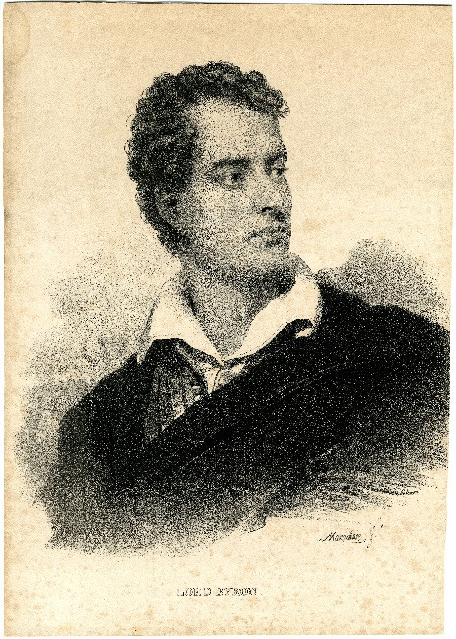

[Byron, George Gordon (1788-1824)](https://commons.wikimedia.org/wiki/File:Byron,_George_Gordon_(1788-1824);_alias_Lord_Byron,_schrijver_en_dichter,_Mauzaisse,_Jean-Baptiste,_Felixarchief,_12_12873.jpg) by Jean-Baptiste Mauzaisse, is licensed under [CC0](https://creativecommons.org/share-your-work/public-domain/cc0/), via [Wikimedia Commons](https://commons.wikimedia.org/)

**WORKSHEET 1B:** ‘**The cartographers’** **(*Byron’s travels*)**

Study from the online resources given below the relevant material about Lord Byron’s travels.

* Identify the main routes of his travels
* Write them down keeping notes about years, destinations, and sojourn
* Find the places that Lord Byron visited on a world map
* Discuss with your group
* Put Byron’s travels to the East on a map
* Use the electronic tool: <https://www.canva.com/create/maps/>

Online resources

* <https://phmus.org/en/lord-byron/>
* <https://wiki.kidzsearch.com/wiki/Lord_Byron>
* <https://www.lordbyron.org/>
* <https://www.messolonghibyronsociety.gr/timeline-gr/>
* <https://en.wikipedia.org/wiki/Timeline_of_Lord_Byron>
* <https://www.britannica.com/biography/Lord-Byron-poet>
* <https://www.open.edu/openlearn/history-the-arts/travelling-culture-the-grand-tour/content-section-3>

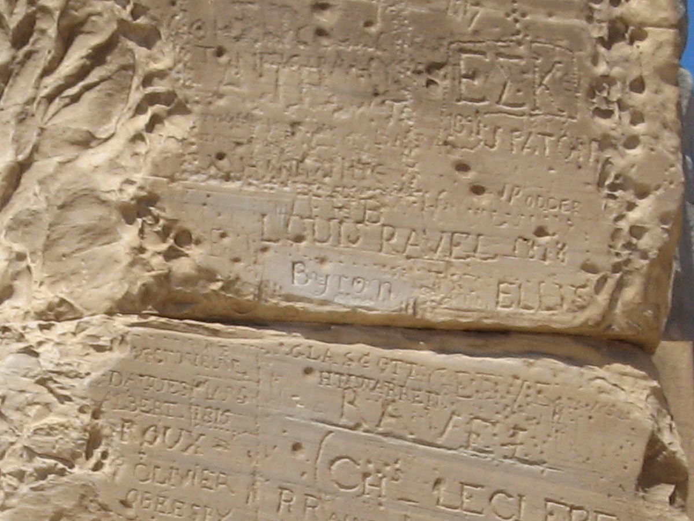

Lord Byron’s graffito, Temple of Poseidon, Sounion

Lord Byron was here, by Adam Sofen, is licensed under CC-BY-2.0 via Wikimedia Commons <https://commons.wikimedia.org/wiki/File:Lord_Byron_was_here.jpg>

**WORKSHEET 1C**: ‘**The historians’** **(*Byron’s Philhellenism*)**

Study from the online resources given below the relevant material about Lord Byron’s Philhellenism.

* What impact did the Greek War of Independence have on Byron’s a) views, and b) actions?
* Choose the most important facts about Byron’s life and death that prove his Philhellenism
* Discuss with your group
* Explain why Lord Byron had such a great impact on the issue of Philhellenism in Europe
* Explore the ways in which Lord Byron’s contribution to the Greek War of Independence was represented in art (paintings).

Online resources

* <https://www.europeana.eu/el/item/2051939/data_euscreenXL_EUS_17BC905C0656F851AAA0048CF32BC97C> (Byron and Greece)
* <https://lordbyron.org/archives.php?choose=MissolonghiMem>
* <https://phmus.org/en/lord-byron/>
* <https://wiki.kidzsearch.com/wiki/Lord_Byron>
* <https://www.lordbyron.org/>
* <https://www.messolonghibyronsociety.gr/timeline-gr/>
* <https://en.wikipedia.org/wiki/Timeline_of_Lord_Byron>
* <https://www.britannica.com/biography/Lord-Byron-poet>

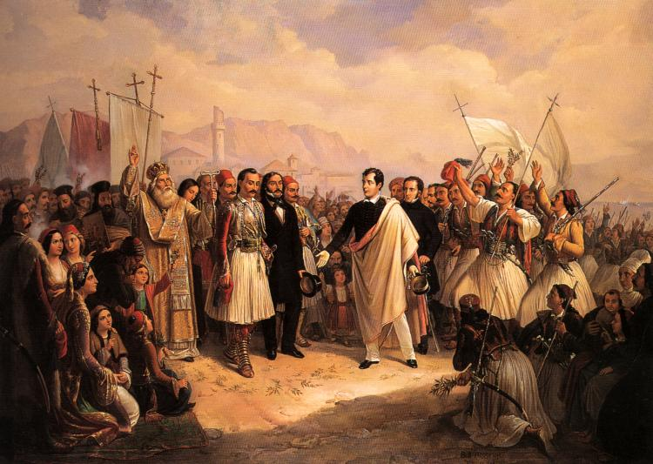

[The Reception of Lord Byron at Missolonghi](https://commons.wikimedia.org/wiki/File:Lord_Byron_at_Missolonghi.jpg) by Theodoros Vryzakis, is licensed under [Public domain](https://en.wikipedia.org/wiki/Public_domain), via [Wikimedia Commons](https://commons.wikimedia.org/)

**WORKSHEET 2A*: Lord Byron, a Romantic poet.***

* Study the relevant material from the online resources given below and fill in the TABLE that follows.

|  |  |
| --- | --- |
| **Main features of Romanticism**  **in poetry** | **Byron’s particular characteristics as a Romantic poet** |
|  |  |

Online Resources

* <https://en.wikipedia.org/wiki/Childe_Harold%27s_Pilgrimage>
* <https://www.britannica.com/art/Romanticism>
* <https://www.oercommons.org/courses/an-exploration-of-romanticism-through-art-and-poetry>
* <https://en.wikipedia.org/wiki/Byronic_hero>
* <https://en.wikipedia.org/wiki/Lord_Byron>

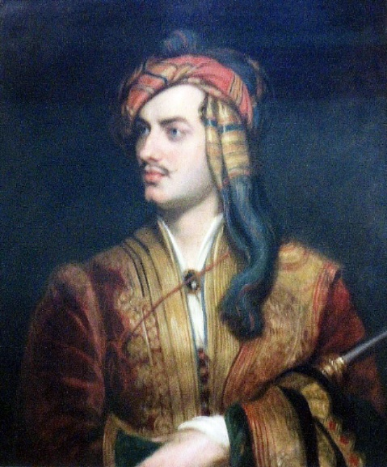

[Lord Byron, poet, by Thomas Phillips, National Portrait Gallery, London](https://www.flickr.com/photos/calotype46/14088090668) by [Snapshooter46](https://www.flickr.com/photos/calotype46/), is licensed under [CC-BY-NC-SA](https://creativecommons.org/licenses/by-nc-sa/2.0/) via [Flickr](https://www.flickr.com/)

**WORKSHEET 2B: *Childe Harold’s Pilgrimage* and Greekness.**

Study the relevant material from the online resources given below and try to identify:

1. Which Greek *mythological* figures are mentioned in the poem and in what context?
2. Which *historical* figures (or groups of people) are mentioned in the poem and in what context?
3. Which period of Greek history is the poet inspired by?
4. What are his emotions towards Greek monuments and antiquities in particular?

Online resources

<https://www.gutenberg.org/files/5131/5131-h/5131-h.htm> (Canto II, X-XV)

<https://en.wiktionary.org/wiki/Category:en:Greek_mythology>

<https://www.worldhistory.org/article/1002/a-visual-whos-who-of-greek-mythology/>

<https://en.wikipedia.org/wiki/Childe_Harold%27s_Pilgrimage#/media/File:Childe_harold.jpg>

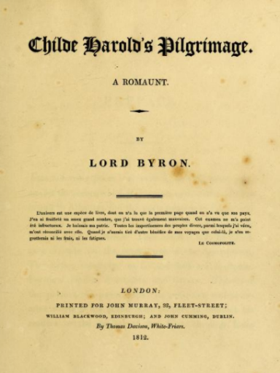

Title page of Childer Harold’s Pilgrimage, circa 1812, is licensed under Public Domain, via Wikimedia Commons <https://commons.wikimedia.org/w/index.php?curid=125402725>

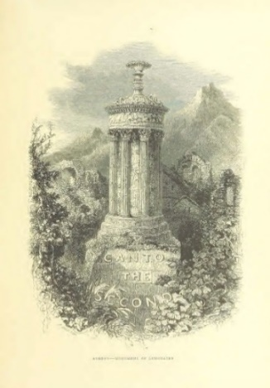

Athens from ‘Childe Harold’s Pilgrimage. A romaunt’, is licensed under Public Domain, via Europeana. <http://www.europeana.eu/el/item/2059209/data_sounds_http___farm4_staticflickr_com_3769_11088145245_b24eb4009e_o_jpg>

**WORKSHEET 2C: *Athens and Britain in the time of Lord Byron.***

Study the relevant material from the online resources given below and try to answer the following questions:

1. Can you identify in the poem how Lord Byron viewed, first, Britain and his contemporary British people, and second, Greece?
2. What particular references to Lord Elgin are there in the poem?
3. What particular references to the Parthenon are there in the poem?
4. How does the poet refer to ancient Greece compared to his contemporary 19th c. Greece?

Online Resources

* <https://www.gutenberg.org/files/5131/5131-h/5131-h.htm> (Canto II, X-XV)
* <https://www.ascsa.edu.gr/uploads/media/hesperia/147687.pdf> (Athens in the time of Lord Byron)

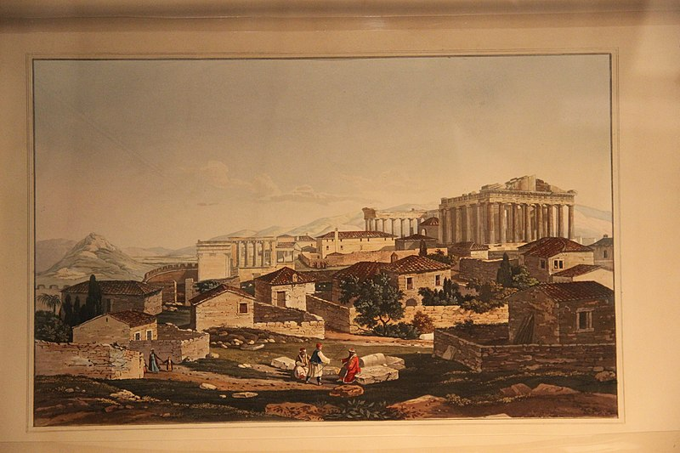

19th Century View of Acropolis, by Gary Todd, is licensed under CC.0 1.0 via Wikimedia Commons:<https://commons.wikimedia.org/wiki/File:19th_Century_View_of_Acropolis_%2828428351471%29.jpg>

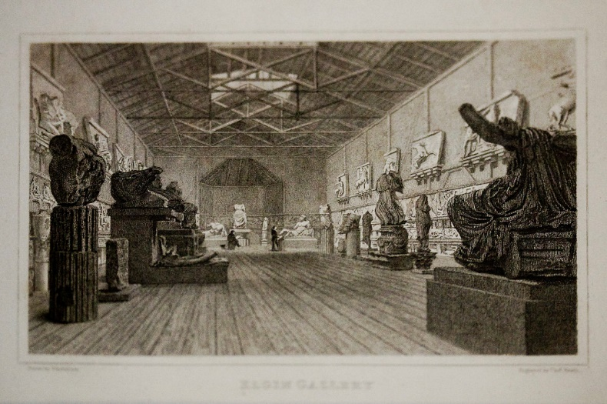

Engravings of the British Museum’s first display of the Elgin Marbles in the early 19th century, by Ann Wuyts, is licensed under CC-BY-2.0, via Flickr: <https://www.flickr.com/photos/vintagedept/4626787532>

**WORKSHEET 3:** Lord Byron’s *‘The Curse of Minerva’* and Kiki Dimoula’s *‘The British Museum (The Elgin Marbles)’.*

* Watch the video about the Parthenon through time (by Kostas Gavras)
* Listen to the recitation of/or/Read Byron’s *The Curse of Minerva*
* Listen to the modern Greek poetess Kiki Dimoula reciting her poem: The British Museum (the Elgin Marbles)
* Compare the two aforementioned poems with *Childe Harold’s Pilgrimage*. Can you identify any similarities and/or differences between the three poems with reference to: a) the topic, b) the point of reference, c) the poet/poetess’ view on the topic, d) the poetic *persona* and e) the literary icons. Fill in the TABLE below.

**TABLE**

|  |  |  |  |
| --- | --- | --- | --- |
| *Childe Harold’ s Pilgrimage* | *The Curse of Minerva* | *The British Museum (the Elgin Marbles)* |  |
|  |  |  | The topic |
|  |  |  | The point of reference |
|  |  |  | The poet/poetess’ view on the topic |
|  |  |  | The poetic *persona* |
|  |  |  | The literary icons |

* Can you create a painting or colour the poem’s verses? What colours would you use and why?
* If you were directing a film scene or a theatrical performance of a representation of one of these poems, what music and what scenery would you choose and why?
* Discuss with your group and decide! (You can prepare your artistic creations as homework).

Online resources

* <https://www.gutenberg.org/files/5131/5131-h/5131-h.htm> (Canto II, X-XV)
* <https://www.gutenberg.org/files/8861/8861-h/8861-h.htm#section116c> (*The Curse of Minerva*)
* <https://www.youtube.com/watch?v=JAMTKxnxzvg> (Kiki Dimoula reciting her poem)
* <https://www.youtube.com/watch?v=1Cj7n3EVTYw> (Parthenon, by Costas Gavras)

**WORKSHEET 3A: ‘*Who is Lord Elgin?’***

Study the relevant material about your research question ‘Who is Lord Elgin?’ from the online resources given below and present a short summary of the main facts (dates and facts) in a timeline using the online tool: <https://www.canva.com/create/infographics/timeline/>

Online resources

* <https://www.britannica.com/biography/Thomas-Bruce-7th-earl-of-Elgin>
* <https://www.khanacademy.org/humanities/ancient-art-civilizations/greek-art/classical/v/who-owns-the-parthenon-sculptures>
* <https://www.culture.gov.gr/el/parthenonas/SitePages/Home.aspx>
* <https://www.parthenonuk.com/> (The British Committee for the Reunification of the Parthenon Marbles)
* <https://melinamercourifoundation.com/en/the-parthenon-marbles/the-time-of-removal-2/>

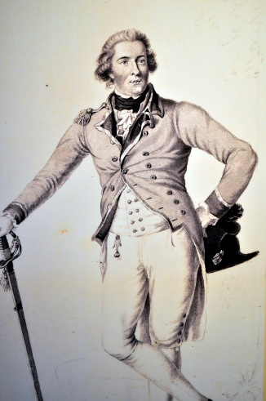

Lord Elgin, by Jim Killock, is licensed under CC BY-SA 2.0, via Flickr <https://www.flickr.com/photos/jimkillock/7087026223>

**Common Activity I**

Read about the history of the issue of the Parthenon Marbles. Make notes. Discuss with your group. Prepare yourself for an *oral debate* in class*: Arguments for and against the return and reunification of the Parthenon marbles* (role-play).

**Common Activity II**

Choose one of the following two separate activities and write in class.

1. Imagine that you are Lord Byron. As a member of the House of Lords you take the initiative to make a speech before your British compatriots about the issue that your poem ‘*Childe Harold’s Pilgrimage*’ talks about. Write your oral speech before the House of Lords with your views and arguments. (100-150 words)
2. Imagine that you are a Greek fighter of the Greek *War of Independence* (1821). In your *Memoires* you write down your views and describe your sentiments about the issue that the poem ‘*Childe Harold’s Pilgrimage*’ talks about. (100-150 words)

**WORKSHEET 3B:** *‘****What did Lord Elgin do to the Acropolis temples, when and how?’***

Study the relevant material about your research question from the online resources given below and present a short summary of the main facts (dates and facts) in a timeline using the online tool: <https://www.canva.com/create/infographics/timeline/>

Online resources

* <https://youtu.be/tlaxSKodmE0?t=26> (The adventures of the Parthenon sculptures in modern times)
* <https://www.theacropolismuseum.gr/en/exhibit-halls/parthenon-gallery> (The Parthenon Gallery, the Acropolis Museum, Athens)
* <https://www.britishmuseum.org/about-us/british-museum-story/contested-objects-collection/parthenon-sculptures> (The Parthenon sculptures in the British Museum, London)
* <https://www.khanacademy.org/humanities/ancient-art-civilizations/greek-art/classical/v/who-owns-the-parthenon-sculptures>
* <https://www.culture.gov.gr/el/parthenonas/SitePages/Home.aspx>
* <https://www.parthenonuk.com/> (The British Committee for the Reunification of the Parthenon Marbles)
* <https://melinamercourifoundation.com/en/the-parthenon-marbles/the-time-of-removal-2/>
* <https://www.worldhistory.org/parthenon/>

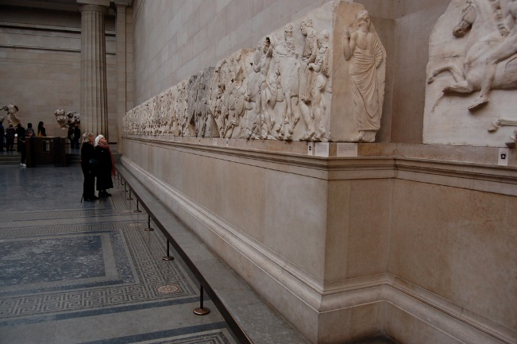 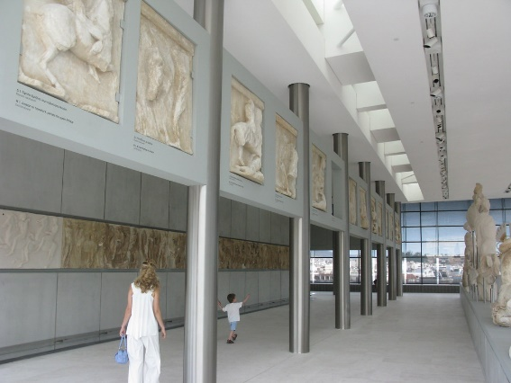

Carved tiles from the Elgin Marbles at the British Museum,

By Chris Devers, is licensed under CC BY-NC-ND 2.0) via

Flickr <https://www.flickr.com/photos/cdevers/2629785485>

New Acropolis Museum, by T. Efthimiadis, is licensed under CC BY-SA 2.0, via Flickr

<https://www.flickr.com/photos/telemax/3668063460>

**Common Activity I**

Read about the history of the issue of the Parthenon Marbles. Make notes. Discuss with your group. Prepare yourself for an oral debate in class*: Arguments for and against the return and reunification of the Parthenon marbles* (role-play).

**Common Activity II**

Choose one of the following two separate activities and write in class.

1. Imagine that you are Lord Byron. As a member of the House of Lords you take the initiative to make a speech before your British compatriots about the issue that your poem ‘*Childe Harold’s Pilgrimage*’ talks about. Write your oral speech before the House of Lords with your views and arguments. (100-150 words)
2. Imagine that you are a Greek fighter of the Greek *War of Independence* (1821). In your *Memoires* you write down your views and describe your sentiments about the issue that the poem ‘*Childe Harold’s Pilgrimage*’ talks about. (100-150 words)

**WORKSHEET 3C: ‘*How did the Greek sculpture end up in the British Museum?’***

Study the relevant material about your research question from the online resources given below and present a short summary of the main facts (dates and facts) in a timeline using the online tool: <https://www.canva.com/create/infographics/timeline/>

Online resources

* <https://www.khanacademy.org/humanities/ancient-art-civilizations/greek-art/classical/v/who-owns-the-parthenon-sculptures>
* <https://www.culture.gov.gr/el/parthenonas/SitePages/Home.aspx>
* <https://www.parthenonuk.com/> (The British Committee for the Reunification of the Parthenon Marbles)
* <https://melinamercourifoundation.com/en/the-parthenon-marbles/the-time-of-removal-2/>

**Common Activity I**

Read about the history of the issue of the Parthenon Marbles. Make notes. Discuss with your group. Prepare yourself for an oral debate in class*: Arguments for and against the return and reunification of the Parthenon marbles* (role-play).

**Common Activity II**

Choose one of the following two separate activities and write in class.

1. Imagine that you are Lord Byron. As a member of the House of Lords you take the initiative to make a speech before your British compatriots about the issue that your poem ‘*Childe Harold’s Pilgrimage*’ talks about. Write your oral speech before the House of Lords with your views and arguments. (100-150 words)
2. Imagine that you are a Greek fighter of the Greek *War of Independence* (1821). In your *Memoires* you write down your views and describe your sentiments about the issue that the poem ‘*Childe Harold’s Pilgrimage*’ talks about. (100-150 words)

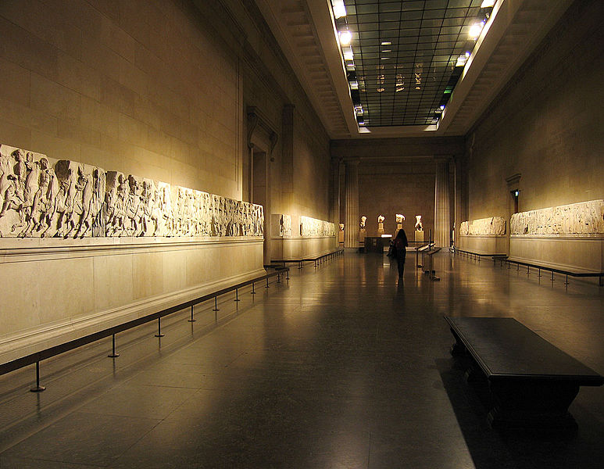

The Elgin Marbles in the British Museum, by Andrew Dunn, is licensed under CC BY-SA 2.0, via Wikimedia Commons

<https://commons.wikimedia.org/wiki/File:Elgin_Marbles_British_Museum.jpg>

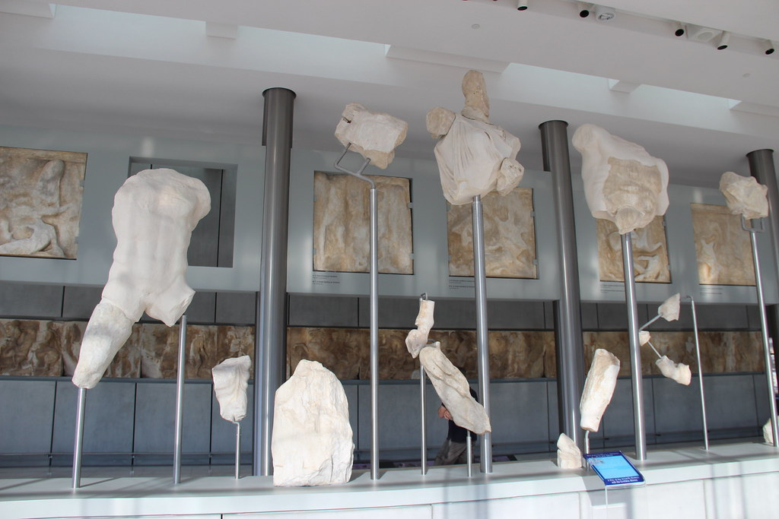

Athens Acropolis Museum Marble Parthenon West Pediment Statues, by Gary Todd, is licensed under Public Domain, via Flickr <https://www.flickr.com/photos/101561334@N08/27824261144>