WORKSHEET 3B: ‘What did Lord Elgin do to the Acropolis temples, when and how?’
Study the relevant material about your research question from the online resources given below and present a short summary of the main facts (dates and facts) in a timeline using the online tool: https://www.canva.com/create/infographics/timeline/

Online resources
- https://youtu.be/tlaxSKodmE0?t=26 (The adventures of the Parthenon sculptures in modern times)
- https://www.theacropolismuseum.gr/en/exhibit-halls/parthenon-gallery (The Parthenon Gallery, the Acropolis Museum, Athens)
- https://www.britishmuseum.org/about-us/british-museum-story/contested-objects-collection/parthenon-sculptures (The Parthenon sculptures in the British Museum, London)
- https://www.khanacademy.org/humanities/ancient-art-civilizations/greek-art/classical/v/who-owns-the-parthenon-sculptures
- https://www.culture.gov.gr/el/parthenonas/SitePages/Home.aspx
- https://www.parthenonuk.com/ (The British Committee for the Reunification of the Parthenon Marbles)
- https://melinamercourifoundation.com/en/the-parthenon-marbles/the-time-of-removal-2/
- https://www.worldhistory.org/parthenon/

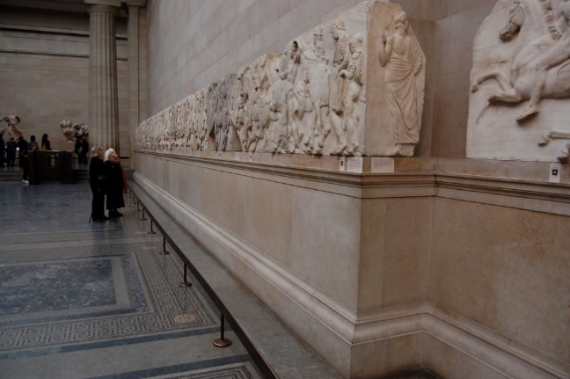
Carved tiles from the Elgin Marbles at the British Museum, by Chris Devers, is licensed under CC BY-NC-ND 2.0) via Flickr https://www.flickr.com/photos/cdevers/2629785485
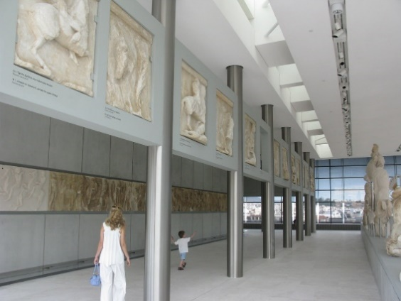
New Acropolis Museum, by T. Efthimiadis, is licensed under CC BY-SA 2.0, via Flickr
https://www.flickr.com/photos/telemax/3668063460

Common Activity I
Read about the history of the issue of the Parthenon Marbles. Make notes. Discuss with your group. Prepare yourself for an oral debate in class: Arguments for and against the return and reunification of the Parthenon marbles (role-play).

Common Activity II
Choose one of the following two separate activities and write in class.
- Imagine that you are Lord Byron. As a member of the House of Lords you take the initiative to make a speech before your British compatriots about the issue that your poem ‘Childe Harold’s Pilgrimage’ talks about. Write your oral speech before the House of Lords with your views and arguments. (100-150 words)
- Imagine that you are a Greek fighter of the Greek War of Independence (1821). In your Memoires you write down your views and describe your sentiments about the issue that the poem ‘Childe Harold’s Pilgrimage’ talks about. (100-150 words)

