**WORKSHEET 1A:** ‘**The biographers’** **(*Byron’s life*)**

Study from the online resources given below the relevant material about Lord Byron’s life.

* Identify the main facts about his life
* Write them down keeping notes about dates and years
* Decide which are the most important facts of those you wrote down.
* Discuss with your group
* Choose the main facts and dates/years of Lord Byron’s biography
* Put them in a historical timeline in a chronological order
* Use the electronic tool: <https://www.canva.com/create/infographics/timeline/>

Online resources

* <https://wiki.kidzsearch.com/wiki/Lord_Byron>
* <https://www.lordbyron.org/>
* <https://www.messolonghibyronsociety.gr/timeline-gr/>
* <https://en.wikipedia.org/wiki/Timeline_of_Lord_Byron>
* <https://www.britannica.com/biography/Lord-Byron-poet>

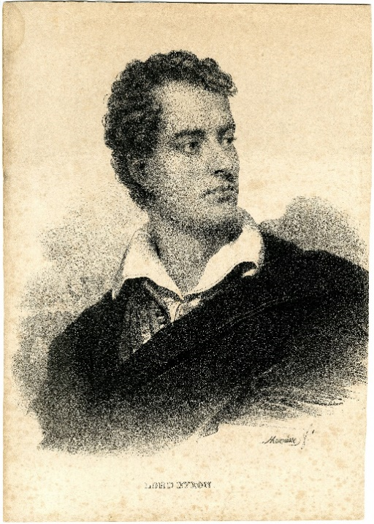

[Byron, George Gordon (1788-1824)](https://commons.wikimedia.org/wiki/File:Byron,_George_Gordon_(1788-1824);_alias_Lord_Byron,_schrijver_en_dichter,_Mauzaisse,_Jean-Baptiste,_Felixarchief,_12_12873.jpg) by Jean-Baptiste Mauzaisse, is licensed under [CC0](https://creativecommons.org/share-your-work/public-domain/cc0/), via [Wikimedia Commons](https://commons.wikimedia.org/)