**WORKSHEET 1B:** ‘**The cartographers’** **(*Byron’s travels*)**

Study from the online resources given below the relevant material about Lord Byron’s travels.

* Identify the main routes of his travels
* Write them down keeping notes about years, destinations, and sojourn
* Find the places that Lord Byron visited on a world map
* Discuss with your group
* Put Byron’s travels to the East on a map
* Use the electronic tool: <https://www.canva.com/create/maps/>

Online resources

* <https://phmus.org/en/lord-byron/>
* <https://wiki.kidzsearch.com/wiki/Lord_Byron>
* <https://www.lordbyron.org/>
* <https://www.messolonghibyronsociety.gr/timeline-gr/>
* <https://en.wikipedia.org/wiki/Timeline_of_Lord_Byron>
* <https://www.britannica.com/biography/Lord-Byron-poet>
* <https://www.open.edu/openlearn/history-the-arts/travelling-culture-the-grand-tour/content-section-3>

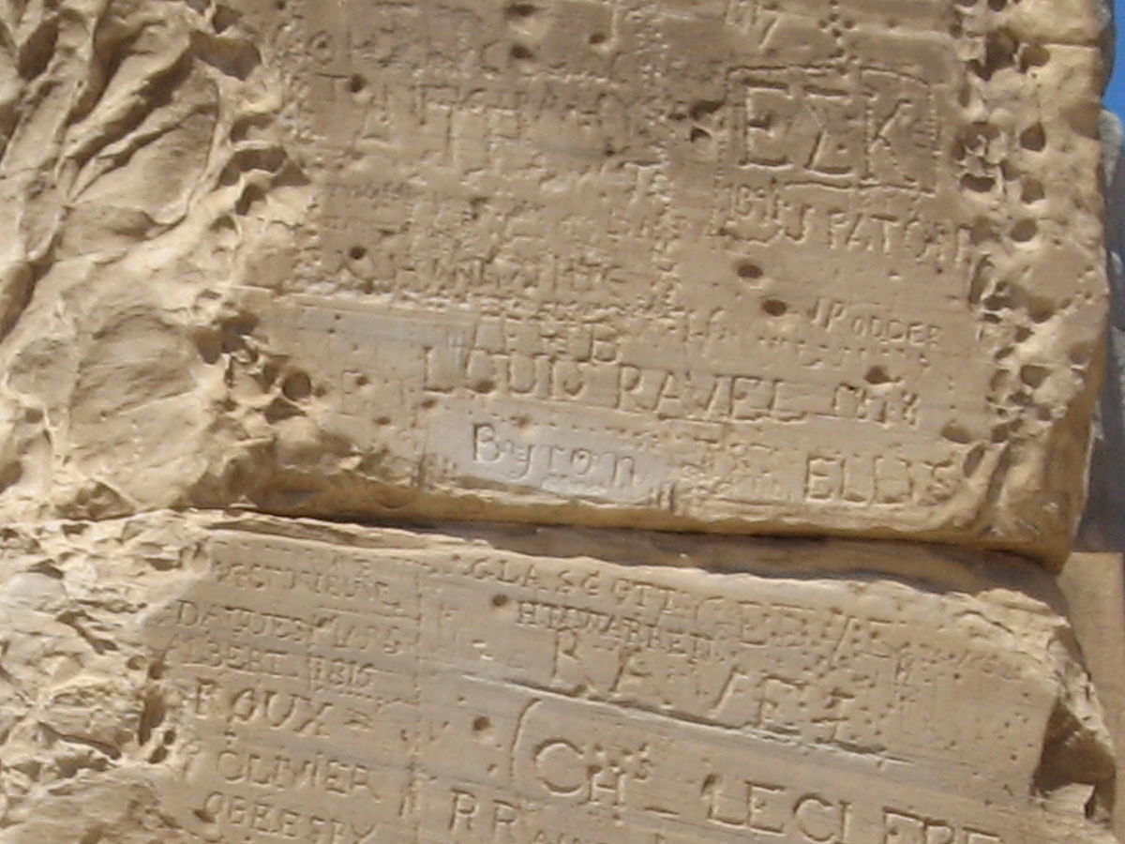

Lord Byron’s graffito, Temple of Poseidon, Sounion

Lord Byron was here, by Adam Sofen, is licensed under CC-BY-2.0 via Wikimedia Commons <https://commons.wikimedia.org/wiki/File:Lord_Byron_was_here.jpg>