WORKSHEET 2B: Childe Harold’s Pilgrimage and Greekness.

Study the relevant material from the online resources given below and try to identify:
- Which Greek mythological figures are mentioned in the poem and in what context?
- Which historical figures (or groups of people) are mentioned in the poem and in what context?
- Which period of Greek history is the poet inspired by?
- What are his emotions towards Greek monuments and antiquities in particular?
Online resources
https://www.gutenberg.org/files/5131/5131-h/5131-h.htm (Canto II, X-XV)
https://en.wiktionary.org/wiki/Category:en:Greek_mythology
https://www.worldhistory.org/article/1002/a-visual-whos-who-of-greek-mythology/
https://en.wikipedia.org/wiki/Childe_Harold%27s_Pilgrimage#/media/File:Childe_harold.jpg
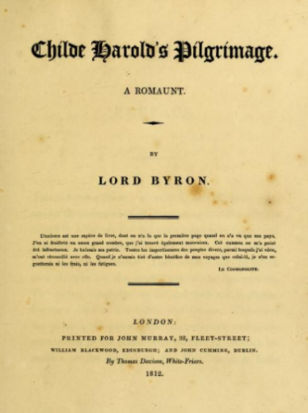
Title page of Childer Harold’s Pilgrimage, circa 1812, is licensed under Public Domain, via Wikimedia Commons
https://commons.wikimedia.org/w/index.php?curid=125402725
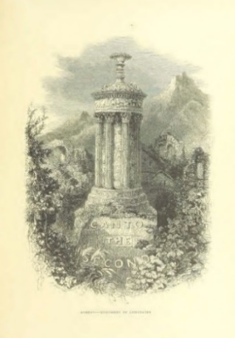
Athens from ‘Childe Harold’s Pilgrimage. A romaunt’, is licensed under Public Domain, via Europeana. http://www.europeana.eu/el/item/2059209/data_sounds_http___farm4_staticflickr_com_3769_11088145245_b24eb4009e_o_jpg

