**WORKSHEET 2C: *Athens and Britain in the time of Lord Byron.***

Study the relevant material from the online resources given below and try to answer the following questions:

1. Can you identify in the poem how Lord Byron viewed, first, Britain and his contemporary British people, and second, Greece?
2. What particular references to Lord Elgin are there in the poem?
3. What particular references to the Parthenon are there in the poem?
4. How does the poet refer to ancient Greece compared to his contemporary 19th c. Greece?

Online Resources

* <https://www.gutenberg.org/files/5131/5131-h/5131-h.htm> (Canto II, X-XV)
* <https://www.ascsa.edu.gr/uploads/media/hesperia/147687.pdf> (Athens in the time of Lord Byron)

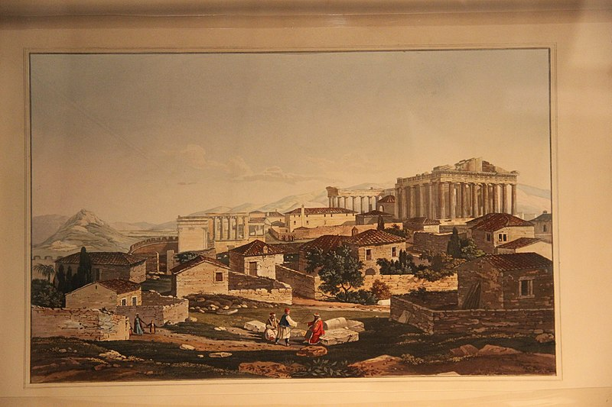

19th Century View of Acropolis, by Gary Todd, is licensed under CC.0 1.0 via Wikimedia Commons:<https://commons.wikimedia.org/wiki/File:19th_Century_View_of_Acropolis_%2828428351471%29.jpg>

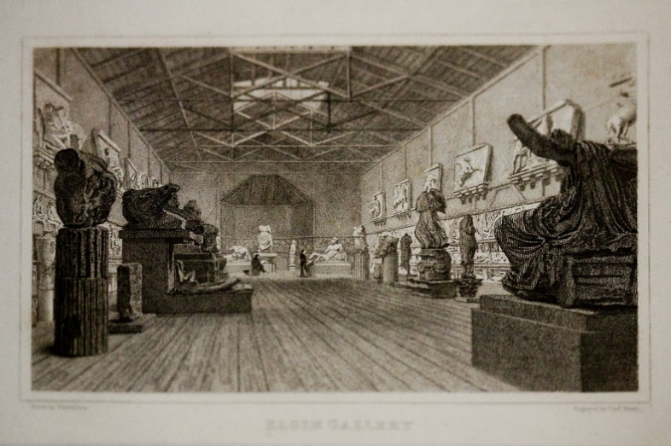

Engravings of the British Museum’s first display of the Elgin Marbles in the early 19th century, by Ann Wuyts, is licensed under CC-BY-2.0, via Flickr: <https://www.flickr.com/photos/vintagedept/4626787532>