WORKSHEET 3A: ‘Who is Lord Elgin?’
Study the relevant material about your research question ‘Who is Lord Elgin?’ from the online resources given below and present a short summary of the main facts (dates and facts) in a timeline using the online tool: https://www.canva.com/create/infographics/timeline/

Online resources
- https://www.britannica.com/biography/Thomas-Bruce-7th-earl-of-Elgin
- https://www.khanacademy.org/humanities/ancient-art-civilizations/greek-art/classical/v/who-owns-the-parthenon-sculptures
- https://www.culture.gov.gr/el/parthenonas/SitePages/Home.aspx
- https://www.parthenonuk.com/ (The British Committee for the Reunification of the Parthenon Marbles)
- https://melinamercourifoundation.com/en/the-parthenon-marbles/the-time-of-removal-2/

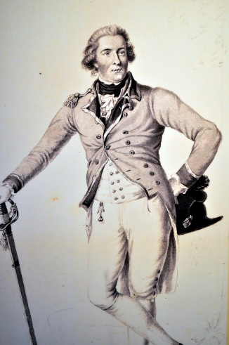
Lord Elgin, by Jim Killock, is licensed under CC BY-SA 2.0, via Flickr https://www.flickr.com/photos/jimkillock/7087026223

Common Activity I
Read about the history of the issue of the Parthenon Marbles. Make notes. Discuss with your group. Prepare yourself for an oral debate in class: Arguments for and against the return and reunification of the Parthenon marbles (role-play).

Common Activity II
Choose one of the following two separate activities and write in class.
- Imagine that you are Lord Byron. As a member of the House of Lords you take the initiative to make a speech before your British compatriots about the issue that your poem ‘Childe Harold’s Pilgrimage’ talks about. Write your oral speech before the House of Lords with your views and arguments. (100-150 words)
- Imagine that you are a Greek fighter of the Greek War of Independence (1821). In your Memoires you write down your views and describe your sentiments about the issue that the poem ‘Childe Harold’s Pilgrimage’ talks about. (100-150 words)

