Solve the Enigma of Source Evaluation
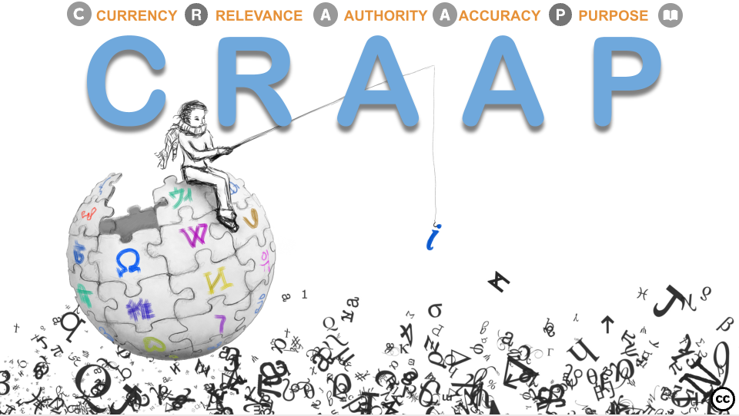
Creator: Sofia Mougiakou
1st Teaching period

1st Activity
Time: 10’
Type of activity: Warm-up activity - Discussion
Class organisation: whole class
Actions/Tasks: Due to a vast number of online sources, it can be difficult to tell whether these sources are trustworthy to use as tools for research. Students are encouraged to:
- Discuss the importance of source evaluation
- Think of the criteria one should use to evaluate a web source.
The CRAAP Test is one of the evaluation methods. CRAAP is an acronym and stands for Currency, Relevance, Authority, Accuracy and Purpose. The CRAAP test aims to make it easier for educators and students to determine if their sources can be trusted.
2nd Activity
Time: 30’
Type of activity: Interactive presentation and collaborative activities
Class organisation: whole class
Actions/Tasks: Students are presented with the interactive presentation CRAAP Test (H5P via thinglink.com or PPT presentation) that has been prepared by the teacher. The students are encouraged to explore the CRAAP test criteria through collaborative activities.

3rd Activity
Time: 5’
Type of activity: One-minute paper
Class organisation: whole class
Actions/Tasks: Students are asked to reflect on their understanding on a One-Minute Paper
“What was the most important point or central concept communicated during today’s class?”
2nd Teaching period
1st Activity
Time: 20’
Type of activity: Interactive group activity – Is it a CRAAP?
Class organisation: Work in pairs
Actions/Tasks: Students are presented with the following scenario:
A student has found a website with some exciting information about Alan Turing:
"The corporate logo of Apple computers is a poignant tribute to Alan Turing who was found dead at his home with a half-eaten poisoned apple beside his bed."

Students are encouraged to work in pairs in order to evaluate the specific web source
using the Interactive Source Evaluation Scorecard.
2nd Activity
Time: 20’
Type of activity: Assessment activity
Class organisation: Whole class
Actions/Tasks: Students are prompted to evaluate their understanding by completing the Source Evaluation Report (download the H5P file) They are asked to:
- Select one of the web resources they have already discussed in Activity 1.2.
- Add criteria for the source evaluation project. They should describe each criterion in their own words.
- Evaluate their source. Answer the questions related to the criteria they defined.
- Assess how well the source complies with the criteria they defined
- Create and submit their report

3rd Activity
Time: 5’
Type of activity: One-minute paper
Class organisation: whole class
Actions/Tasks: Students are asked to reflect on their understanding on a One-Minute Paper

“For you, what interesting questions remain unanswered about the topic?”

