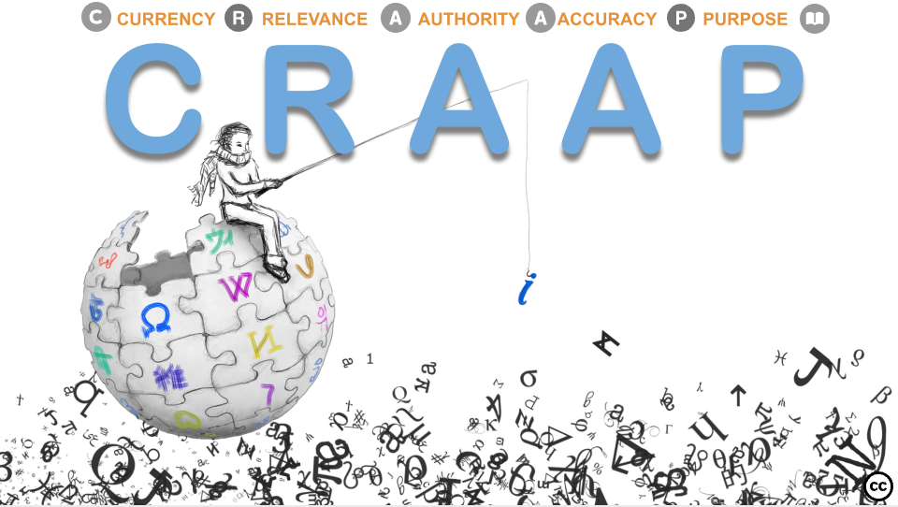

Name:
Class:
Date:

One-minute paper

For you, what interesting questions remain unanswered about the topic?

