DEVELOPMENT OF SITUATION

Subject: | TECHNOLOGY
Unit: | PROGRAMMING: Scratch + Makey Makey
Level: | 2nd year of Secondary School
Sessions: | 2

STORYTELLING:

INTERACTIVE ARTISTIC PRODUCTION

We will create a sound drawing telling a story through several cartoons or drawings (Example: https://vimeo.com/203363741 ). The aim is to practise skills related to programming, circuit set-up, the manipulation of conductor materials and the ability to tell stories (storytelling).

What do we want to communicate with our work?

MATERIALS: CONTENTS:
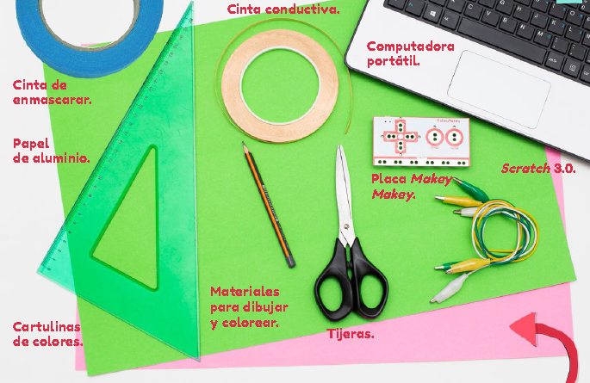
- Simple circuit
- Conductor materials
- Programming
- Visual arts

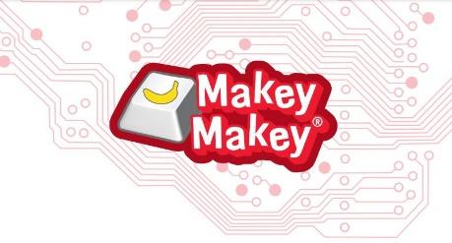

TASKS TO DO:
Since this is a group project, planning the task will be an important part of it. It will also be necessary to define the following roles among students:

ILLUSTRATORS | PROGRAMMERS AND SOUND RECORDERS | CIRCUIT ASSEMBLERS
Make a drawing with the chosen theme | Make the programme and record sounds on Scratch | Are in charge of circuits with conductive tape; aluminium foil and earthing system
Draw a sketch so that it serves as guidance to those setting up the circuit | Choose characters and assign them sounds | Connect the Makey Make board

- Illustrators:
They will be in charge of making the drawing with the theme chosen by the team. The circuit set-up will be conditioned by the illustrators’ work. To speed up this task, the illustrators should make a sketch to serve as guidance to those setting up the circuit.

- Programmers and sound recorders:
This task will be done on Scratch. They will have to choose a character and assign it all the sounds that they would expect the drawing to make. By using Scratch’s sound editing tools, the necessary adjustments will be made so that a good sound signal is achieved.

The sounds will be then assigned to each of the Makey Makey keys. To do this, adding an event for each sound will be necessary, using the following block in the control block group: "When pressing key...". A different key will be assigned to each of these events, taking into account the possibilities offered by the board (Space, Up Arrow, Down Arrow, Right Arrow, etc.). Then, the corresponding sound will be assigned to each event by adding the blocks "Play sound...".
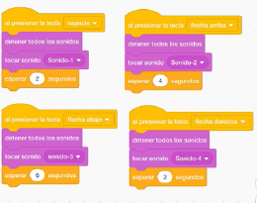
We will also integrate the block "stop all sounds", which will ensure that there is no overlap between the different recordings.

Finally, the block "wait ... seconds" will be added to the Control group, whose time should be equal to the duration of each recording. This prevents the drawing from playing uncontrollably.

- Circuit assemblers:
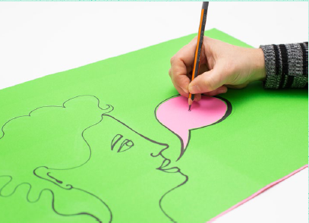
Once the sketch of the drawing is done, a white cardboard piece will be placed underneath, which will be taped with masking (or cello) tape on the longer upper side. Then, these two things will have to be marked: the parts of the drawing where the conductive materials will be placed and the marks indicating where the conductive material has to pass through.
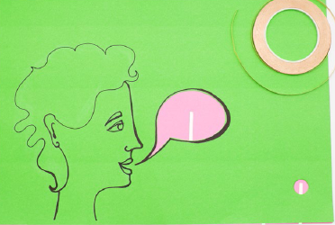

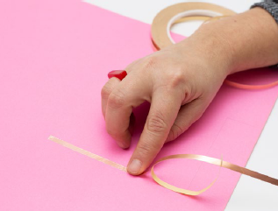
Once those spaces have been defined, the team will outline the circuits on the white sheet with conductive tape, defining the terminals where the Makey Makey board will be connected.

After that, the conductive tape should be covered with some aluminium foil of sufficient size. To finish, a space will be provided for earthing.
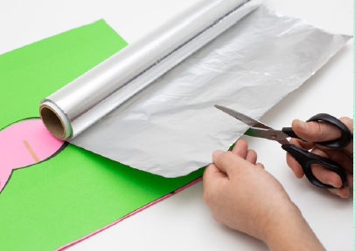
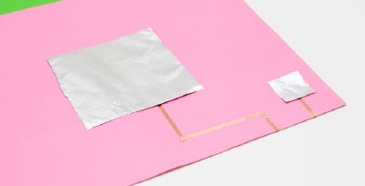
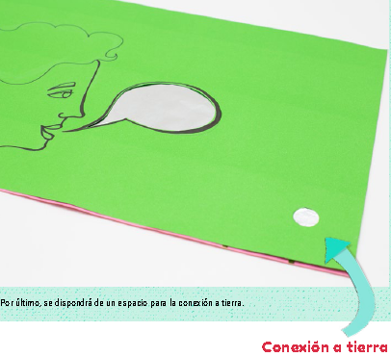

When the drawings and circuits are finished, they will have to be connected to the Makey Makey board linked to the programme planning on Scratch. To play the sound of the drawing, we will have to simultaneously press on the earthing and one of the spaces where the conductor material has been placed.

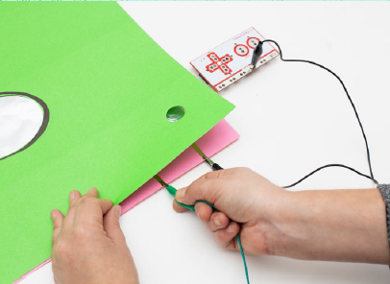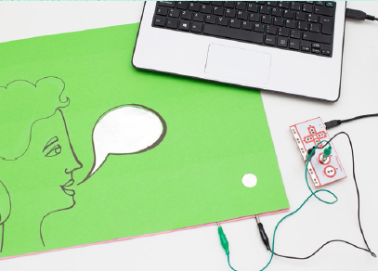

Masking tape, aluminium foil, coloured cardboard, conductive tape, scissors, tools for drawing and colouring, scissors, a laptop, a Makey Makey board and Scratch 3.0.

