“BEYOND-Gender equality in sport”

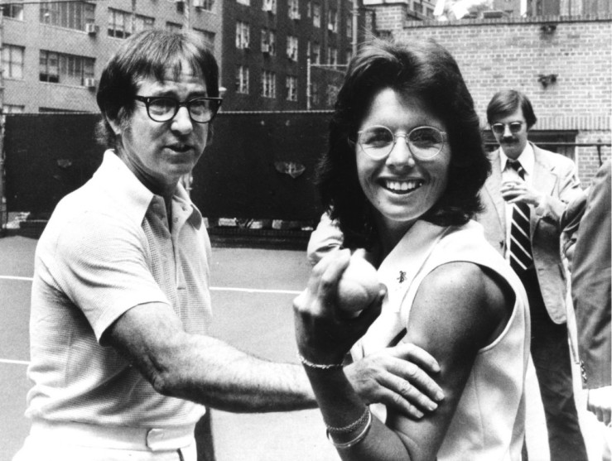
Gender education in third year of secondary school
(Arts and physical education)
Creator: Teachers Roberto Lanzano and Angela Raffaella Pulcrano
Student profile: 20 students, aged 12/13-ISCED Level 2
1st teaching period

1st Activity: INTRODUCTION: Sport is considered a field Masculine (?!?)
Time: 30 MINUTES
Type of activity: ORAL EXPOSURE OF THE PROJECT, WITH REFERENCE TO THE STAGES TO BE TAKEN AND THE PURPOSES TO BE ACHIEVED.
IN THIS FIRST PERIOD OF ACTIVITY, STUDENTS REFLECT ON CLICHÉS ABOUT SPORTING ABILITY, SCAFFOLDED BY TEACHER WHO SHOWS THEM THE FILM “THE BATTLE OF SEXES”
Link to vision of the trailer film “ THE BATTLE OF SEX”

https://www.youtube.com/watch?v=5AWP1K7FaFI

Class organisation: THE PUPILS ARE PRESENT IN THE CLASSROOM.
Actions/Tasks: AT THE END OF THE DISCUSSION ABOUT GENDER IN SPORTS, THE PUPILS ARE ASKED TO MAKE A LIST WITH SPORTS AND SEXISM, USING THE MATERIAL PROVIDED BY THE TEACHER AND ANSWERING THE QUESTION: “WHAT ARE THE SPORTS CHAMPIONS YOU REMEMBER IN FOOTBALL, TENNIS, SWIMMING OR OTHER SPORTS YOU KNOW”?

(See Annex “Gender in sports”)

LINK suggestion for Web researches:

https://eige.europa.eu/search?t=sport+equality&op=Search

Recommended Digital Application:

https://wordart.com

2nd Activity: Stereotypes in the media keep women in the background
Time: 30 MINUTES
Type of activity: LET'S ENTER THE TOPIC. THE PUPILS ARE PROVIDED, THROUGH A LINK, TO “ENTER YOUR GENDER AND COUNTRY OF BIRTH TO SEE HOW YOUR LIFE COULD TURN OUT”
Class organisation: IN CLASS
Actions/Tasks: DEEPENING OF THE LESSON, VIRTUAL PAGES AND TEXT BOOKS. IN ADDITION THE PUPILS ARE ASKED TO DO A TASK AT HOME: EXPLORE THE STATE OF THE ART OF GENDER EQUALITY IN EUROPE, COMPARING THE ITALIAN SITUATION AGAINST OTHER EUROPEAN COUNTRIES

Link for the Activity

https://eige.europa.eu/gender-equality-index/game/IT/W

2nd teaching period

1st Activity: Applying a gender perspective
Time: 30 MINUTES

https://videohub.inspiring-girls.com/en/videos/tag/Sport

Type of activity: EVALUATION OF THE WORKS ASSIGNED IN THE FIRST LESSON CONCERNING THE REALIZATION OF THE LISTS AND DESIGNING OF THE ARTISTIC POSTERS; BRAINSTORMING ABOUT FEMALE PERPECTIVE
Class organisation: IN CLASS.
Actions/Tasks: PUPILS ARE ASKED TO DO A GROUP WORK AS A TASK AT HOME: CREATING, ACCORDING TO THEIR CREATIVITY, DRAWING ON POSTERS, EXPLAINING LIFE AND MAIN CHARACTERISTICS OF THE CHOSEN SAMPLE; STARTING FROM AN EXAMPLE PROVIDED BY TEACHER ABOUT A FOOTBALL CHAMPION OF THE PAST “MARADONA”, THEY REPRESENT A FEMALE CHAMPION THEY KNOW

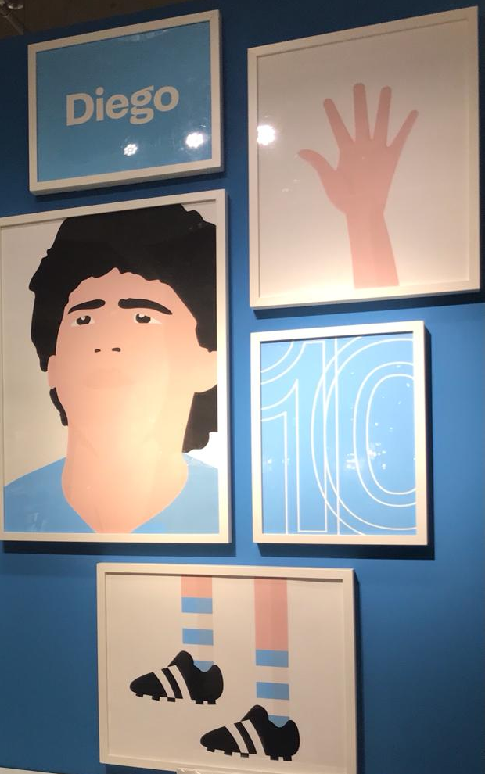

(See Annex “menabo for the composition of the billboard”)

2nd Activity: LET'S REVIEW…. THROUGH THE "GAME".
Time: 30 MINUTES
Type of activity: THROUGH INTERACTIVE GAMES WE STRENGTHEN THE CONCEPTS ALREADY EXPLORED. THE PUPILS PRESENT THEIR WORK AND THEY DISCUSS IT WITH THE CLASS.
Class organisation: IN CLASS
Actions/Tasks: STUDENTS ARE INVITED TO DEEPEN SOME LINGUISTIC AND DISCIPLINE ASPECTS AND TO FIX CONCEPTS ALREADY FACED BY USING SOME INTERACTIVE ACTIVITIES, THROUGH THE COMPILATION OF CROSSWORD PUZZLES, PUZZLE GAMES AND SO ON.

(See Annex “sports grammar and resources”)

FINALLY THEY WILL ANSWER QUESTIONS IN A SHORT QUESTIONNAIRE ON STEREOTYPES

(See Annex “Questionnaire file”)

