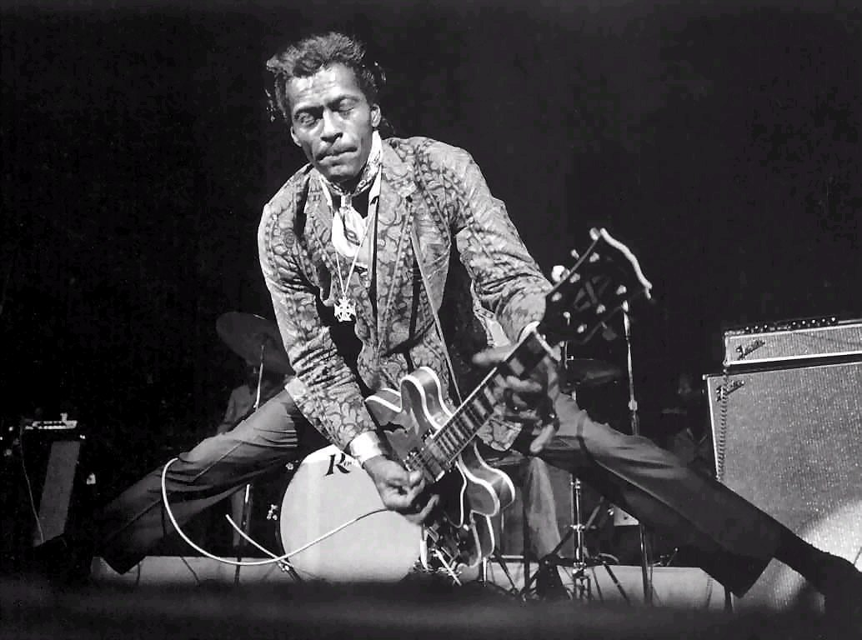

“Rock and recklessness are not an automatic combination!”

Drums and percussion teaching at lower secondary school
Creator: Fazzari Marco
Students profile: aged between 12 and 13 years old, pupils love to share their passion for music and drums working in groups, activating cooperative learning strategies and making brainstorming on the topic mastered.
They attend classes in a music room using percussion instruments and systems provided by the school. Thanks to LIM, TABLET, PC they can have free access to the OER (open educational resources) shared by the teacher, and work on it using digital platform such as Google Classroom.
Students have basically an A2 English level.
Lessons: the course will last 4 hours divided into 4 meetings.
Competences:
- Rock music history knowledge
- critical ability and application
- power point presentation
- use of software and digital skills
This project will be attended by students from the 3rd year of lower secondary school.
At the end of the study program, each pupil will be sensitized on the common and widespread use of stereotypes, that often bring people to associate Rock music with drugs addiction.

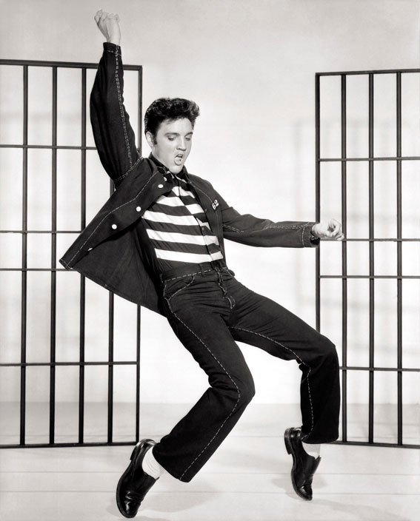

LESSON 1

INTRODUCTION
Time: 5 min
Activity: project presentation.

ROCK STARS
Activity: Rock music history.
Time: 55 min

The students will work in groups to analyse and focus on the main cultural and historical aspects that brought to the birth of Rock stars figure.
Then, under the teacher guide, they will explore deeply the history of some famous Rock stars, such as: Elvis Presley, Jimi Hendrix, David Bowie, The Rolling Stones.
Objective: to learn about Rock music history and most famous Rock stars life.

https://youtu.be/IL6-0mDZoGc

LESSON 2

SEX DRUGS AND ROCK&ROLL
Time: 60’ min
Type of work: documentary screening and brainstorming.
Objective: to make a reflection on the social aspects that brought to the diffusion of drugs use among Rock music artists and the birth of the way of saying “sex drugs and rock&roll”.

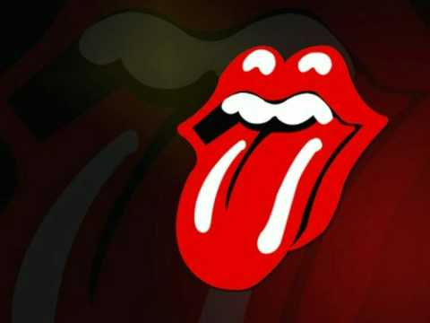

https://youtu.be/sfp8xrNAS6I

https://youtu.be/Oi5A5GS17AQ
LESSON 3
GENIUS AND REGULARITY
Activity: documentary screening and circle time.
Time: 60’ min
Type of work: students will learn about rock stars with no drugs addiction such as Frank Zappa, Bruce Springsteen, Ian Anderson, Kiss, Rage Against The Machine. They will make comparisons with the pervious ones, trying to understand how drugs and excess badly influenced their life and careers.
Objectives: to understand that a great musical performance or artistic research doesn’t happens thanks to drugs use, and to keep a mind open and free from stereotypes it’s really important to avoid mistakes already made.

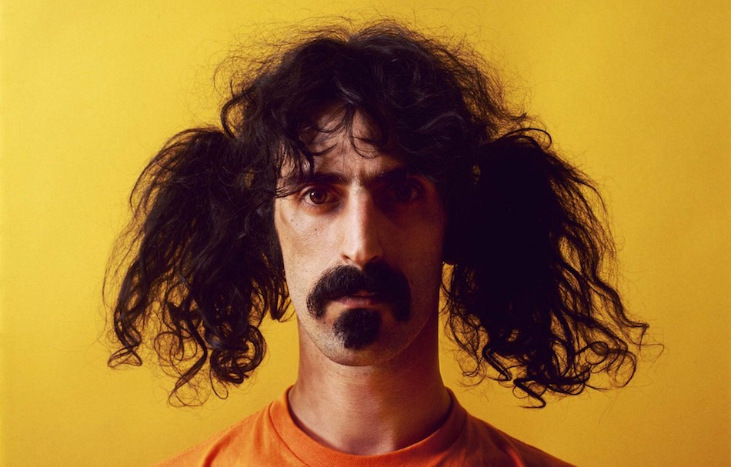

https://youtu.be/BGTRqGeIxOA

https://youtu.be/aX1uBcMfBl8

https://youtu.be/QmfENbEysP0

LESSON 4

Activity: Power point presentation.
Time: 60’ min
Type of work: The students will present their own work against the stereotypical idea that relate Rock stars and music to drug addiction.
Objective: this experience will bring the students to a higher level of consciousness about how musical performances works, and how many Rock stars rejected drugs use to safeguard the right success of their performances and activities, becoming equally famous and iconic such as other artists unfortunately fallen into the vortex of drugs addiction.

