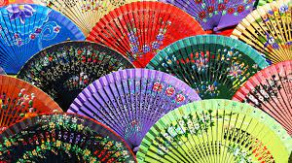
SIAMO SPAGNOLI
PREGIUDIZI SUI POPOLI ED I LORO USI E COSTUMI

QUIZ

GAMES AND QUIZS ABOUT SPAIN HAVE BEEN MADE WITH THE WORDWALL APPLICATION

https://wordwall.net/resource/3003448

https://wordwall.net/resource/17663615

https://wordwall.net/resource/32943704

