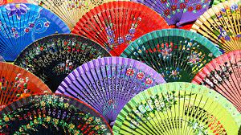
WE ARE SPANISH
PREJUDICES ABOUT PEOPLES AND THEIR CUSTOMS AND TRADITIONS

EUROPEAN PEOPLES AND THEIR STEREOTYPES

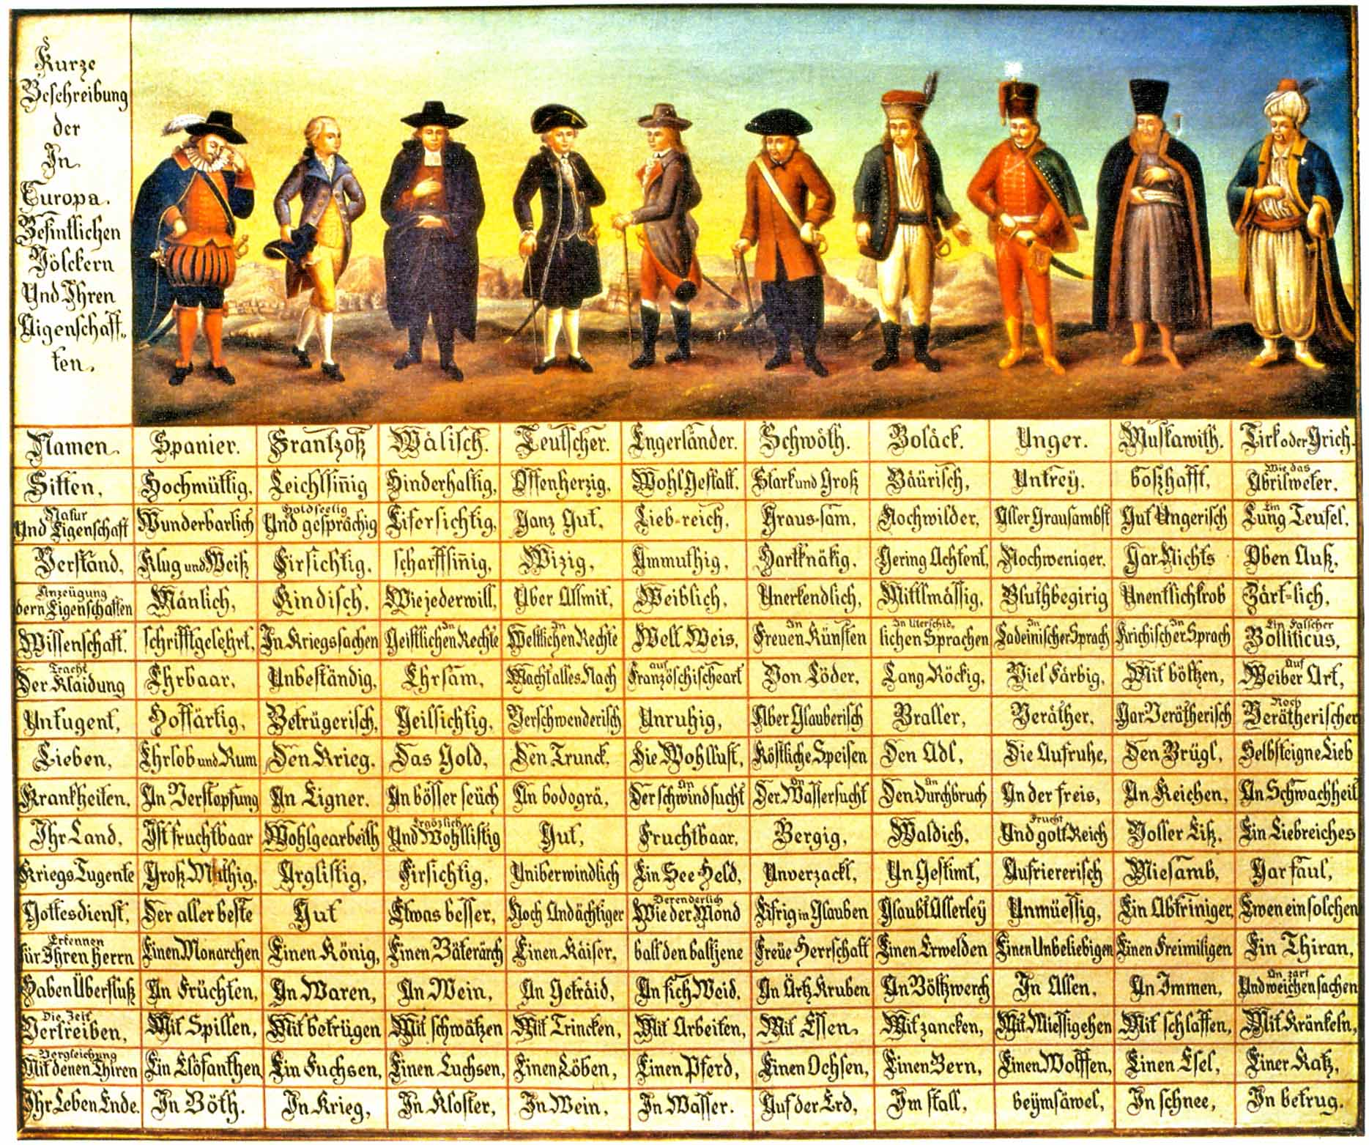

Stereotypes, of course. Once, people enjoyed reading them and looking at the pictures. The Spaniard, pompous albeit a little sad (the glory days of the Empire being long gone), the elegant Frenchman and the Italian dressed like Doctor Balanzone, and going eastwards, the German, the English, Swedish, Polish and Hungarian, the Russian and the Turkish, assimilated to the Greek. After all, this is Europe itself, as we still see it today. Schmid points this out, adding that, as we go eastwards, negative stereotypes prevail over positive ones. With the sole exception of Poland, the only state ruled by an elected government, in a continent dominated by kings, emperors and tyrants, as Henry Müller stresses in his commentary on the Table.
All of Europe was at war. This is known. But cruelty and ferocity lie in the East. In the West, there is the science of war, of which the French are masters (again according to our table). The Germans are unsurpassed in battle, sure, but they are frank and peaceful and they love good wine to the point that they would be glad to be buried into a full barrel. In the following table you can have fun reading the English translation.
AND TODAY?
You are spoiled for choice. National stereotypes gave life to an entire genre, which is mainly visual. Among the many, you can browse the atlas designed for Alpha Designer by the Bulgarian artist Yanko Tsvetkov in which we see how European stereotypes vary according to the states. Italy, for example, for the Americans is synonymous with “mafia and godparents”, for the French it is the land of “noisy and friendly cousins”, for the Germans, instead, it is “the land of pizza and museums”, for the Bulgarians “the homeland of spaghetti”, while England associates our country with the rest of the continent calling it “the federal and diabolical Empire of Europe” (see the review by Francesco Tortora in the Corriere). A courtesy that the Italians (at least those of the North) reciprocate as shown by the map.

https://eige.europa.eu/gender-stereotypes

https://journals.openedition.org/shakespeare/738

