Theater history - a cultural identity

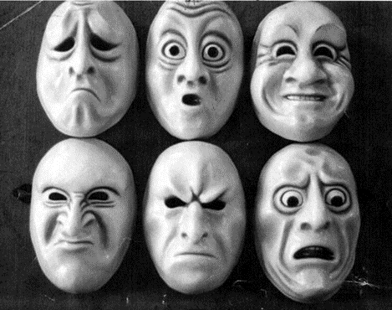

One, none, one hundred thousand stereotypes!

Teachers: VEDOVA DANIELA
STUDENT PROFILE: class III A (lower secondary school), ages 12-13.
Pupils are collaborative and love to work in groups through cooperative learning activities.
They use the digital devices that our school makes available: IWB, TABLET, PC.
They work on the Gsuite digital platform.
Language level: B1 (based on the Common European Framework of Reference for Languages)
Duration: 2 teaching periods (1 hour each)
Skills:
Surf the Internet
Use of Web 2.0
Briefly know the history of Western theater from the point of view of prejudices against women. The “One, none, one hundred thousand stereotypes! Transformation-Action of gender conflicts through the Pirandello Theater. The actions of the project were aimed at questioning and deconstructing gender stereotypes, increasing critical reflection and identifying creative non-violent conflict resolution strategies.

Interdisciplinary activities: English literature: study the texts for the theater written by William Shakespeare. Art and Image: Architectural Evolution of Western Theater. History: The Elizabethan age.

The pupils of class III A (lower secondary school) will participate in the project; they will be divided into groups.
Each teaching period will last one hour and the final product will be a PowerPoint / book creator.

FIRST TEACHING PERIOD
First activity
Time: 60 '
Type of activity: Introduction to the main idea of ​​the project, discussion on the topic.
Class organization: creation of groups, discussion
CIRCLE TIME – COOPERATIVE LEARNING

Second activity:
Time: 60 '
Type of activity: Video projection
Class organization: group work, discussion
Actions / tasks: Under the guidance of the teacher, pupils discuss and reflect on the topic, through research on the subject.
Pupils work in groups in order to promote their collaborative skills and motivate them to achieve common goals.
SECOND TEACHING PERIOD
First activity
Time: 60 '
Type of activity: Video projection
Class organization: group work
Type of activity: Realization of the PowerPoint / book creator.
The groups tackle the actual work, following these WORK PHASES:

Reflect on the topics covered.
• Develop your work creatively
• Making PowerPoint / book creator.
The theme and purpose of the project is the realization of work that highlights the creative and critical skills, starting from what has been learned on the subject and reinterpreting what has been illustrated to them according to their own point of view.
Actions / Tasks: pupils work on their presentation by putting all their skills into play, at the service of the whole group.

https://luzifood.it/unemozione-grande-sostenere-il-genio-del-novecento/?lang=en
https://www.youtube.com/watch?v=YB2yae1t5IY
https://www.pirandelloweb.com/pirandello-in-english/
https://www.youtube.com/watch?v=SzguvCryZEE
https://www.youtube.com/watch?v=dmBDfl9YJY4
https://bookcreator.com/
https://wordwall.net/it-it/community/greci-teatro
https://wordwall.net/it-it/community/regina-elisabetta

