SCENARIO SCRIPT

Materia: | TECHNOLOGY
Tema: | ELECTRICITY: Connection Game
Nivel: | 3rd year of Secondary School
Evaluación: | 2nd Term
Sesiones: | 6 sessions
PROPOSAL JUSTIFICATION:
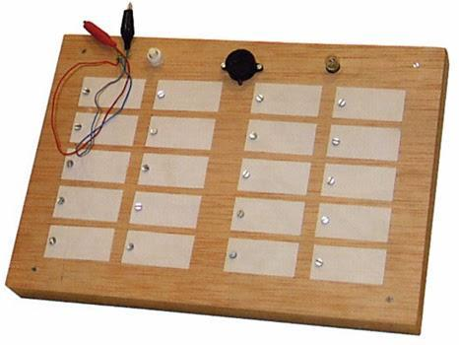
The topic to be covered is Energy and Electricity.

Students will design a technological game (Connection Game) so that they put into practice the knowledge acquired. By doing so, they will also develop teamwork and communication skills.

SCENARIO
A - CONTEXT:
A game development company wants to expand its market. Apart from outdoor games, the company also wants to develop new technologies that are more digital. As a result, it has specialised in electric and electronic games.
B - SCENARIO:
Your game development company has received a new order: the creation and design of a digital game, and more precisely of Connection Game!

C - OBJECTIVE:
To create and design an electric game, whose aim is to successfully match questions and answers. To show this project to the Marketing Department so that a new product is launched.

- TASK
Each team will create and design a technological toy like the so-called Connection Game. On top of that, by using the software Crocodile, each team should research the different types of circuits (series, parallel and mixed) and analyse the differences in their functioning.

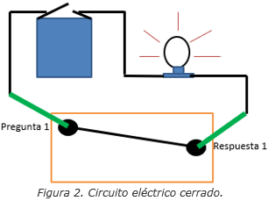Figure 2. Closed electric circuit (Question 1 - Answer 1)
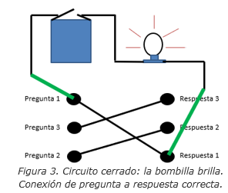
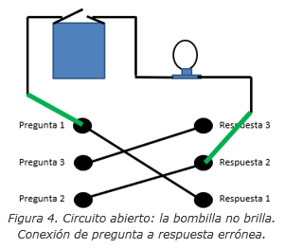

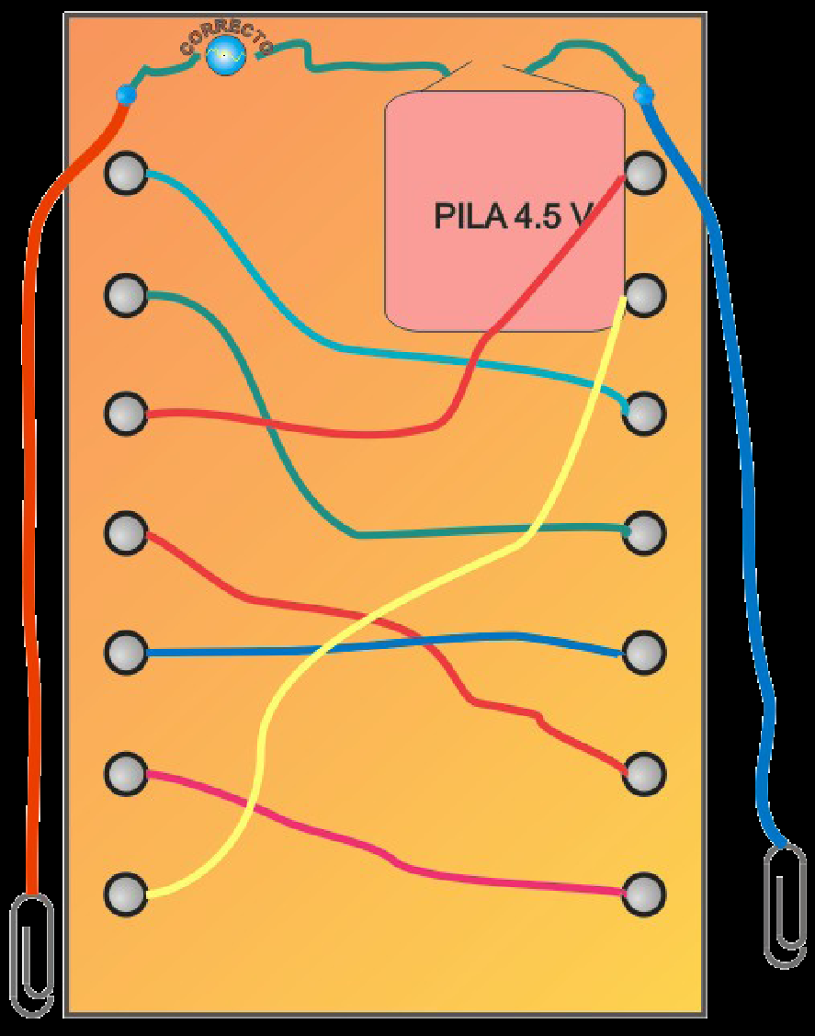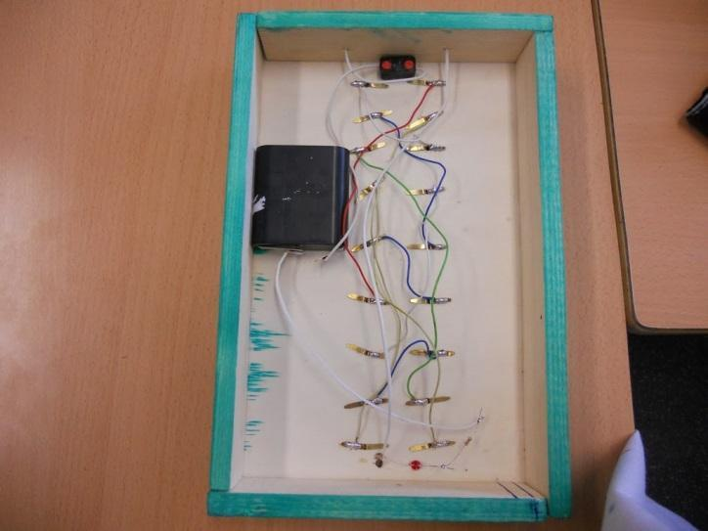
Figure 3. Closed electric circuit: the light bulb comes on. Questions and answers matched correctly.
Figure 4. Open electric circuit: the bulb does not come on. Questions and answers matched incorrectly.

- BASIC COMPETENCES
A - TRANSVERSAL COMPETENCES:
- Verbal, non-verbal and digital communication
- Learning to learn and learning to think
- Cohabiting
- Initiative and entrepreneurship
- Learning to be

B - DISCIPLINARY COMPETENCES:
- Scientific competence
- Technological competence

- EDUCATIONAL OBJECTIVES
- To detect a technological problem, and to design and plan a solution by searching and selecting information from different sources.

- To analyse techological objects and systems methodically. To understand how they work and to be aware of the best way to and control them.

- To represent and simulate the foreseen or realised technical solutions by means of appropriate channels and tools, and to use the correct symbols and vocabulary for that purpose.

- To handle the surrounding technological elements fluently and responsibly, and to propose improvement options or alternatives for their use.

- To carry out the solution to a technological problem, either physically or virtually, and to develop, where appropriate, the necessary control programme, taking into account security and ergonomics rules.

- To assess the followed work process as well as the product obtained, to be aware of the acquired knowledge and to check the quality and functioning of the result according to the proposed conditions.
- CONTENTS
- Study on Energy and Electricity.
- SEQUENCE OF ACTIVITIES
A - INITIAL STAGE:
- ACTIVITY 1: (Session 1) The scenario is presented and both the teams and the work plan will be agreed (the team contract and roles). The assessment criteria for this activity will be announced (PROJECT RUBRIC).
B - DEVELOPMENT STAGE
- ACTIVITY 2: (Session 1) Students search for information about other connection games. List of necessary materials.
- ACTIVITY 3: (Session 2) The design is made in groups. Questions to take into account:
  - How is it going to work?
  - Materials to be used. Mainly recyclable ones.
  - How is the game going to be decorated so that it appeals to children?
- ACTIVITY 4: (Sessions 3 and 4) Project set-up. Make the design and verify that it is valid. (2 sessions)
- ACTIVITY 5: (Session 5) Writing a report with relevant information about the project.
  - It must include diagrams, images, drawings, list of materials, etc.
  - Cover: Project title, names of participants, company name, etc.
  - Introduction: Brief summary of the project.
  - Explain the design and functionaning of the game, the realised connections, etc. Does it work properly?
  - Photos of the final product must be included.
  - List of used materials.
  - Budget (money needed to create the game) and final price of the game.
  - Analysis of potential improvement for the game.
  - Conclusions: Is it a fun and entertaining project?
C - APPLICATION AND COMMUNICATION STAGE:
- ACTIVITY 6: (Session 6) Hand in the report for correction.
Each team will present the most relevant aspects of their project to the Marketing Department so that a new product is launched.
D - GENERALISATION AND TRANSFER
- ACTIVITY 7: (Session 6) Assessment of the completed learning process. Once all presentations have been made, students will try to extrapolate what they have learnt. They will have to raise awareness on the need for the use and proper management of the different technologies used. Self-assessment and co-assessment.
ASSESSMENT
A - INDICATORS:
B - TOOLS:
1. Development of tasks.
1.1 Development of reports and tasks.
Tasks to be carried out and developed | Materials to be handed in | Responsible person | Date
Formation of teams and roles | Team contract
Analysis of materials | List of recycled materials
Set-up | Technological game
In-class presentation | Presentation
Self-assessment and co-assessment | Assessment

Other learning resources that the teacher may consider necessary.
2. Learning contract (fulfillment) and assessment (Self-assessment and co-assessment)
3. Daily observation in the classroom: Being on time, daily observation, active participation, etc.
4. Project rubric
 | BASIC  (1 POINT) | MEDIUM  (2 POINTS) | GOOD  (3 POINTS) | VERY GOOD  (4 POINTS) | EXCELLENT  (5 POINTS)
FINAL PRODUCT  (20%) | It is very fragile, it breaks very easily. Some circuit connections have not been made. It is not decorated. | It is fragile, it breaks with a simple blow. Most cables dismantle easily. It has too few decorations. | It has a hard structure but it also has some flaws. Some cables dismantle easily. It has few decorations. | It has a firm structure but some parts are useless. Most cables are well-connected. It is well-decorated. | It has a firm structure and each part has a fixed purpose. All cables are well-connected. The final product is excellent.
USE OF MULTIMETER  (20%) | Students do not know how to use the multimeter. | Students show no knowledge on the use of the multimeter. | Students show some knowledge on the use and measurements of the multimeter. | Students show great knowledge on the use and measurements of the multimeter. | Students show great knowledge on the use and measurements of the multimeter, and justify them accordingly.
REPORT AND PRESENTATION  (20%) | They are unintelligible.  Little to no information has been searched. | Only one or two ideas are intelligible. Either little information is provided or it is not organised. | It is intelligible but ideas are not organised well.  There is enough information but it is not organised. | Overall, the presentation is intelligible.  There is enough information and it is organised. | Good explanation, illustrated with diagrams and drawings.  Excellent verbal and non-verbal communication.
INDIVIDUAL WORK (Involvement)  (20%) | No team involvement. Lack of organisation and planning. | Little involvement, organisation and planning. | Some involvement and planning. | Overall, enough involvement and team organisation. | Great interest and involvement. Excellent team organisation.
MATERIALS  (10%) | Most days the necessary materials are not brought.  Materials are not appropriate, a lot of material is wasted. | Sometimes students do not bring all the materials or they bring them late.  Materials are not used appropriately. | Most of the time, students bring the necessary materials.  Materials are appropriate and none is wasted. | Most of the time, students brings all the necessary materials.  Recycled materials are used and none is wasted. | Students always bring the materials. All materials are appropriate and they are used properly.  Recycled materials are used and they may be reused.
DEADLINE  (10%) | Deadline is not met and a lot of work remains undone. | The deadline is not met but the final product is not far from finished. | The deadline is met but the final product is not completely finished. | The deadline is met but the final product needs decorating. | The deadline is met and the final product is completely finished.

