PROGRAMMING OF A DIDACTIC UNIT BASED ON A SCENARIO
Subject: English
Topic: Endangered species
Level: 1st year of Secondary School
Sessions: 4-5
Justification of proposal: Teachers have found students struggle to communicate in English. We present this scenario in response to this situation and to increase students' self-confidence when using the language.
- Context
It is widely known that languages are for communicating orally. To reach this goal, it is necessary to take the language out of the classroom, forget about grammar exercises, and lose the fear and embarrassment of speaking in front of an audience, especially when doing so in another language. On the other hand, it is of great interest to make our students more aware of current global issues. That is why learning English will be combined with a project raising awareness of endangered species in this subject.
- Scenario
The number of species that are becoming extinct is increasing. Extinction is the total disappearance of a species from the planet. Throughout history, there have been many extinctions caused by climate change, volcanic activity, floods, droughts, etc. When a species becomes extinct, first of all, the structure and function of biological and ecological systems get affected, which has a great impact on both nature and human beings. Humans are causing the extinction of other species due to hunting, overfishing and cutting down forests. We are almost entirely responsible for the extinction of several mammal species in recent decades.
- Objectives
The ultimate goal is that students communicate in English and become more aware of the impact that humans have on our planet. Students should be able to talk about endangered animals and plants, their habitats and explain why they are endangered. They should also be able to discuss how the problem could be solved or how their complete extinction could be prevented. The teacher will provide them with the necessary tools so that they can present this information.
- Task
Make an oral presentation with supporting digital posters, photos, videos or any other resource which presents information about currently endangered animals or plants.

Every day a species becomes extinct. Are we destroying the planet? We will carry out an interdisciplinary project on the Earth and talk about species in danger of extinction. It is of great interest to make our students more aware of current global issues. That is why learning English will be combined with a project raising awareness of endangered species in this subject.

Task:
Make an oral presentation with supporting digital posters, photos, videos or any other resource which presents information about currently endangered animals or plants.
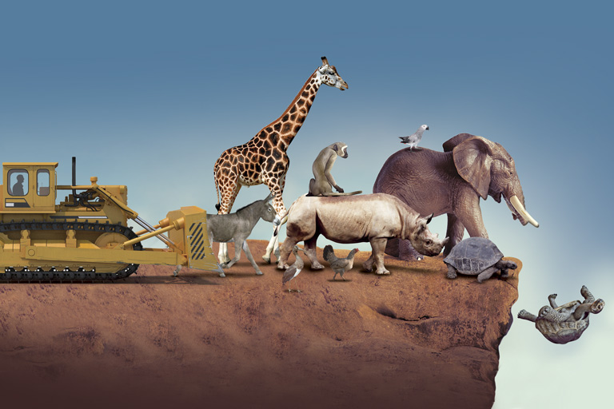
Enabling tasks:
• Presentation: PowerPoint, Prezi, etc.
• Videos and photographs
• Include a list of vocabulary with all the words you have learnt. 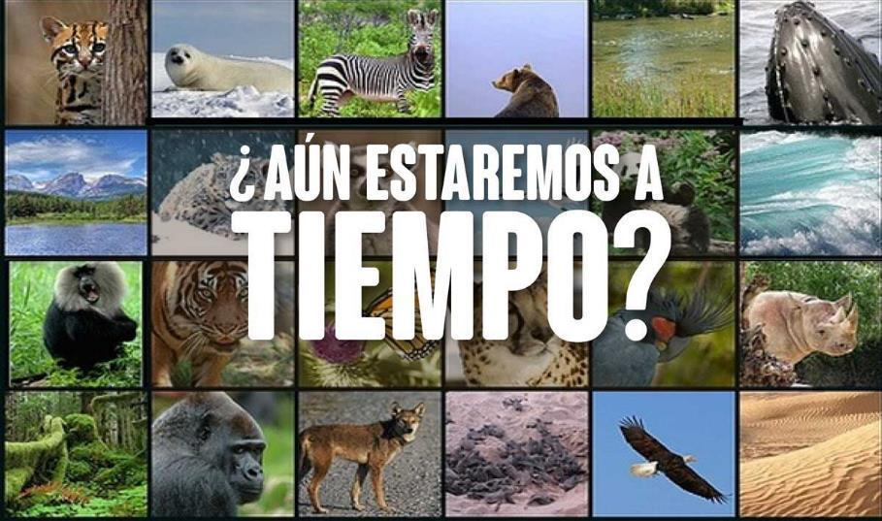
Make notes.
These questions and ideas may help you:
- Common name (which may vary depending on the site) and scientific name.
- Physical description and features (weight and height), character, personality, etc.
- Behaviour at different stages of life or at different times of the day. How do they live? Do they live in pairs or herds? How many babies do they have per year?
- How long can they live?
- Food: What do they usually feed on? What is their diet like? Are they carnivores, omnivores, herbivores, etc.?
- Habitat: Where can you find them in the world nowadays? Point out on a map where they can be found.
- How many specimens are there currently in the world?
- What do they do in their everyday life? How do they behave? What do they enjoy doing? How many times a day do they eat?
- Why are they endangered? Give reasons.
- Threats: What other species put them in danger or feed on them? Who are their predators?
- Why are they endangered?
- Measures to prevent their extinction: What are we doing to prevent their extinction?
- Curiosities about the species.

These websites may be helpful:
https://www.nationalgeographic.com.es/naturaleza/grandes-reportajes/animales-peligro-extincion_12536
https://www.mundodeportivo.com/urbantecno/ciencia/animales-en-peligro-de-extincion-en-2022-listado-con-las-25-especies-mas-emblematicas
https://youtu.be/n7eCHK6RwRU
https://youtu.be/o7nna7NrTh0
https://youtu.be/uEmXljfD1wE
www.wordreference.com for single words
www.linguee.com for sentences

Presentation:
- Decide how many slides your presentation will have and give a title to each slide, with a brief description of what will be included.

Remember, if your presentation is too long you may bore your classmates!
You could use a computer programme to make the presentation including all this information.

Basic competences:

- Transversal competences:
- Verbal, non-verbal and digital.
- Learning to learn and think.
- Communication competence.
- Initiative and entrepreneurship.
- Learning to be.

- Specific competences:
- Linguistic and literary communication.
- Technological.
- Artistic.

Educational objectives:

- To participate in groups or teams while respecting the ideas of others, to defend one's own and to share responsibilities for teamwork.
- To assess one's own and others' production by using objective indicators that point out the best aspects of the production and what could be improved.
- To search for information about surrounding places.
- To understand and critically interpret the information found.
- To use information and communication technologies with autonomy.
- To express oneself and to interact orally in a coherent, correct and appropriate way.
- To work in groups and to share responsibilities for teamwork.
- To make a presentation of the studied topic in front of the class and to use digital support whenever necessary.
Learning outcomes:
- Understanding oral and written discourse in different contexts of life.
- Expressing oneself orally and in written form in different situations.
- Knowing and interpreting the foreign language and avoiding stereotypes and prejudices.
- Using the language in a critical and reflective way.
- Appreciating the diversity of languages.
- Interpreting, appreciating and enjoying different cultures.
- Making good use of new methodologies.
- Reflecting on what has been studied.
Sequence of activities:
- Initial stage:
Activity 1: Analysis of scenario.

- Development stage:
Activity 2: Selection of information and activities to be carried out.
Activity 3: Creation of the basic outline that the presentation will follow with each of the personal aspects to be included. Creation of the vocabulary list with new terms learnt.

- Application and communication stage:
Activity 4: Sharing what has been learnt: presentation of the project.

- Generalisation and transfer:
Activity 5: Losing fear and embarrassment when making mistakes while speaking and being able to communicate.
Assessment
Indicators:
- Students analyse the information found.
- Students carry out individual and teamwork, which helps them choose the topics they must develop.
- Students carry out teamwork to prepare the presentation.
- Students make a presentation on the prepared topic.
- Students collaborate with their teammates.
- Students attempt to use the language appropriately.
- Students respect diversity.

- Tools:

Initial stage: activity 1
Development stage: activities 2 and 3
Application and communication stage: activity 4
Generalisation and transfer stage: activity 5

ACTIVITY 1: Collection of ideas

- Students get into groups of 3 to 5 people. They will keep the same working team for the whole didactic sequence.
- In 10 minutes, students individually write what they will include in the presentation, the orderthey will follow and what kind of material they will use (pictures, videos, recordings...).
- Students discuss with their teammates what they have written and see if there are any coincidences.
- Students complete the list of information collected until everything the class knows has been collected.
- At the end of the discussion, the teacher will make a brief summary of what has been said so far, making any necessary corrections or clarifications.

ACTIVITY 2: Selection of topic to be covered

- Each team makes a list of the collected information.
- Once the list is made, the most relevant data is selected and classified.

ACTIVITY 3: Invention of ideas

- Each team selects their own information and potential activities.
- Each team develops an outline with the information they will include. The necessary web tools will be used for this purpose.
- It is essential that the team understands that the work does not consist of dividing up the task among its members and then simply putting it together. It must be a team project, in which all members know all parts, and in which the selection and use of information are commonly agreed upon.

ACTIVITY 4: Sharing what students have learnt

- In turns, students present their work in front of the class. All group members must participate.
- To organise their oral presentation, students have to choose the audiovisual support they will use. They should use as much visual support as needed, but they should take into account that speaking is not reading.
- Students put their ideas in order and distribute the presentation among all group members so that it is balanced.
- Students should be careful with the language they use. They should use short sentences, look for synonyms to enrich the vocabulary, etc.
- Students should rehearse before the final presentation.
- At the end of the presentation, students hand out the previously prepared questionnaire to the rest of the class. It can be oral or written. Their classmates can also ask them questions if they consider them necessary.
- While the team gives the presentation, the teacher will assess the work of each team member by using the following indicators:

Rubric for projects in Secondary School
Transversal and group competences  20% | Work & Attitude 20% | Always Hardworking, active, supportive and positive 20 points | Most of the time 15 points | Sometimes 10 points | Just a few times 5 points
 | Accuracy and morphosyntax (mistakes, structures, level of difficulty) 20% | Correct word order. Hardly any grammatical mistakes.  Very suitable high level of difficulty. No cut-and-paste. 20 points | A few grammatical mistakes.  High level of difficulty.  A little cut-and-paste.  15 points | Some grammatical mistakes.  Medium level of difficulty.  Mostly cut-and-paste.  10 points | Many grammatical mistakes.  Poor level of difficulty.  All cut-and-paste. 5 points
 | Presentation  40 % | Very few hesitations. Student does not read at all, just has a look to go on. Very good pronunciation. 40 points | A few hesitations. Student just reads a few sentences.  Good pronunciation. 30 points | Some hesitations. Sometimes student reads and gets stuck. Has some problems to be understood. 20 points | Student often gets stuck and reads most of it.  Poor pronunciation. 10 points
 | Visual Presentation (PowerPoint, Prezi, video) 20% | Very good material that supports the oral presentation. 20 points | Good material that supports the oral presentation. 15 points | The material sometimes supports the oral presentation. 10 points | Poor material that hardly supports the oral presentation. 5 points
 | TOTAL AMOUNT
 | 20%

ACTIVITY 5: Getting to know what is going on in the world to improve it

* Once the presentations are made, all teams will try to extrapolate what they have learnt with the rest of their classmates to raise awareness of the reality in which we live by justifying their opinions with critical thinking.

