AGENDA 2030: What can we do?
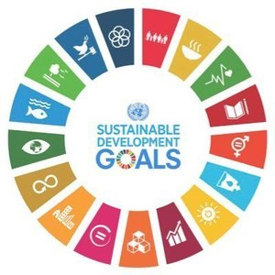

Creator: Carmela Menna
Student profile: 26 students, aged 11-12.
They work in teams and cooperate in order to share ideas and opinions.
They use the target language in the foreign language lessons.
They use several digital tools in classroom, thanks to the interactive whiteboard, and in computer room.
Language level: Language level: A2 (based on the common European framework reference for languages)
Duration: 4 teaching periods
Individual occupation time: 7-8 hours
Requirements and Prior Knowledge: Classroom with interactive whiteboard or projector and internet connection, personal smartphone (one per group).
Knowledge of internet navigation and use of Web 2.0. tools.
Brief description of the scenario

Starting from the concept of sustainable development, the Agenda 2030 is explained and the 17 goals are shown to the class. Then the class is divided into groups and each group chooses 5 goals and defines the actions we can do in everyday life to achieve those objectives.

1st teaching period

1st Activity: braistorming: what does sustainable development mean?

Time: 10’

Type of activity: discussion

Class organisation: discussion in class

Actions/Tasks: the teacher presents the topic and asks questions to pupils to understand their foreknowledge.

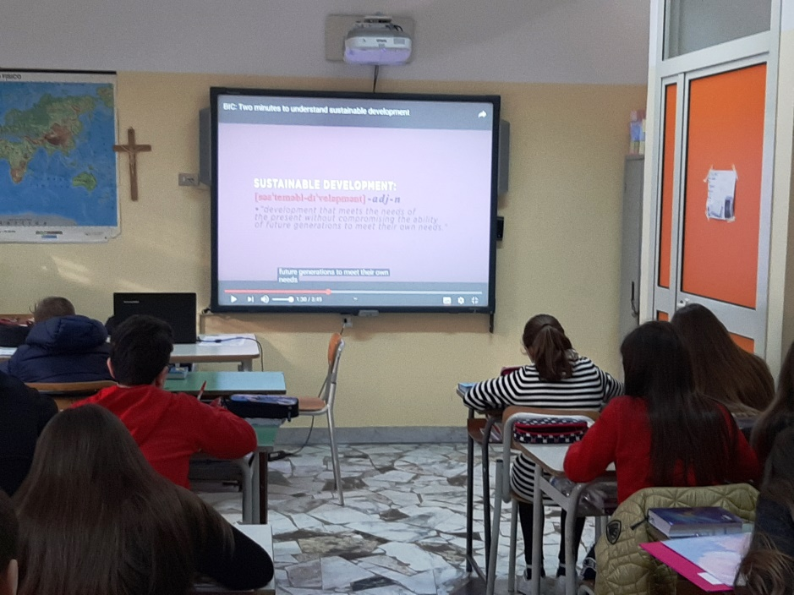

2nd Activity:

Time:30’

Type of activity: videoprojection and discussion

Class organisation: discussion in class

Actions/Tasks: the teacher shows an educational video about sustainable development

https://www.youtube.com/watch?v=jfsWI8XgQyo&t=16s

During the projection of the video, the teacher writes on the blackboard the keywords and the definition of sustainable development.

“development that meets the needs of the present without compromising the ability of future nerations to meet their own needs

3rd Activity:

Time: 20’

Type of activity: questionnaire in class

Class organisation: discussion in class

Actions/Tasks: the teacher projects a questionnaire created with google forms on the interactive whiteboard to explain the questions and sends the link to answer on the students’ email. Each pupil answer fron their smartphone. In the end the teacher shows the statistics of the answers.

https://forms.gle/SVLHqBJYpy2FtQDB7

2nd teaching period

1st Activity: discussion about AGENDA 2030

Time: 15’

Type of activity: videoprojection and discussion

Class organisation: discussion in class

Actions/Tasks: teacher shows an education video “Understanding the dimensions of sustainable development”

https://www.youtube.com/watch?v=pgNLonYOc9s

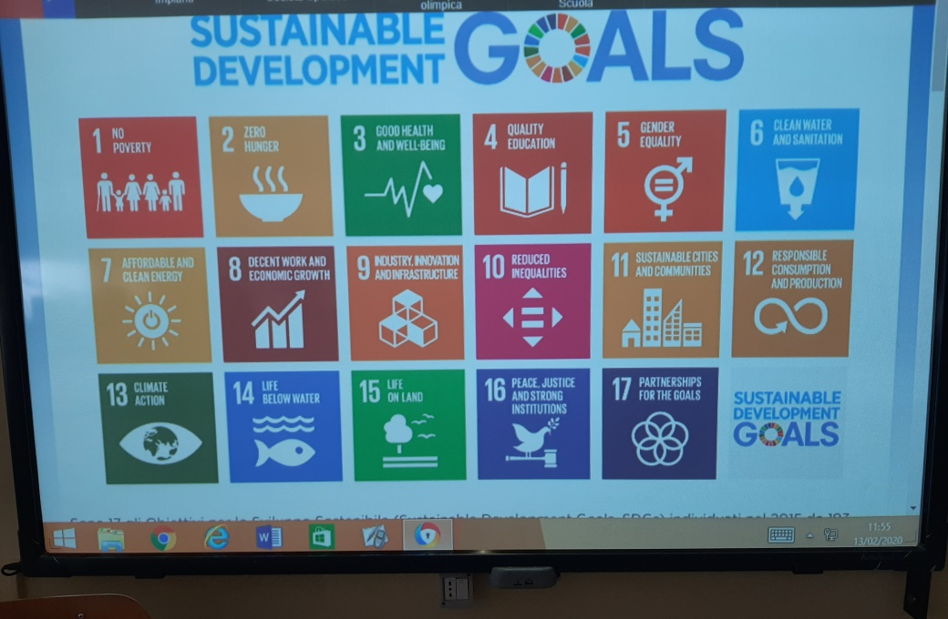

2nd Activity:

Time: 45’

Type of activity: teamwork

Class organisation: discussion in groups

Actions/Tasks: the teacher divides the pupils into 6 groups of 4-5 students and explains the work to be done in class. The teacher shows the 17 goals of the Agenda 2030 on the whiteboard, each group must choose 4 goals and indicate the actions that we can carry out in the day to achieve them. Each group is given a table with the 17 goals and space to write actions

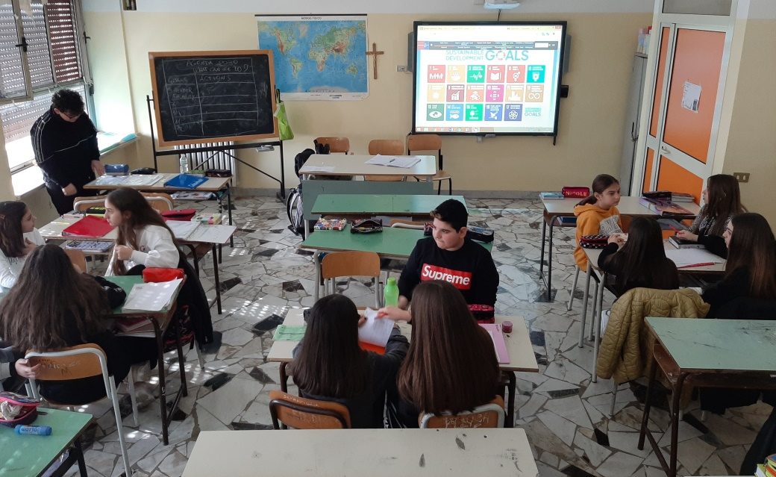

3rd teaching period

1st Activity: teamwork

Time: 45’

Type of activity: team work and discussion

Class organisation: the classi s divided into 6 groups of 4-5 students

Actions/Tasks: The teacher rearranges the groups so that there are all people in each that the previous lesson had not worked together. Everyone has the form filled in with the actions to reach from the previous time.

In each group the students discuss the actions already written in the module and comparing with the others add other actions and impement the work already done.

2nd Activity:

Time: 15’

Type of activity: elaboration teamwork

Class organisation: discussion

Actions/Tasks: the teacher projects the table made with Google documents all the goals and insertsall the resulted from the teamwork.

