Log house
WHERE?____________________
Walls:
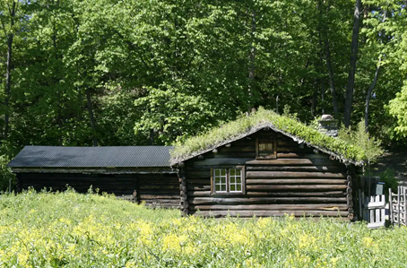
Interior:
windows:
Roof:
AGE:_________________

