HOUSING EUROPE

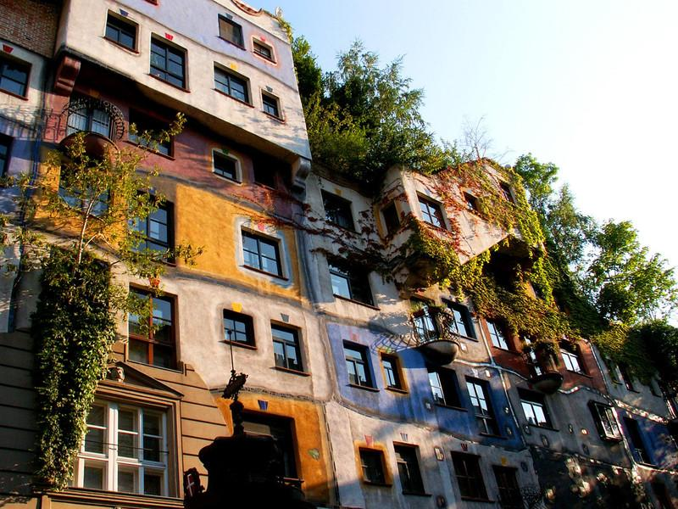

Creator: Carmela Menna
Student profile: 26 students, aged 11-12.
They work in teams and cooperate in order to share ideas and opinions.
They use the target language in the foreign language lessons.
They use several digital tools in the classroom, thanks to the interactive whiteboard, and in the computer room.
Language level: Language level: A2 (based on the common European framework reference for languages)
Duration: 3 teaching periods
Individual occupation time: 3-4 hours
Requirements and Prior Knowledge: Classroom with interactive whiteboard or projector and internet connection, personal smartphone (one per group).
Knowledge of internet navigation and use of Web 2.0. tools.

Brief description of the scenario
We often see gorgeous homes and interiors in the movies or in glossy magazines and admire the design that went into these architectural masterpieces. Thanks to the mass media, we have a general idea of what the dwellings of people in different corners of Europe look like. But rarely do we realize that what we see on the screen can differ greatly from the reality.
In this scenario we will find out how people in different types of housing in Europe were born and how they developed throughout history.
1st teaching period
1st Activity: brainstorming: How many types of buildings are there?
Time: 10’
Type of activity: discussion
Class organisation: discussion in class
Actions/Tasks: the teacher presents the topic and asks questions to pupils to understand their foreknowledge about buildings.

2nd Activity:
Time:20’
Type of activity: video projection and discussion
Class organisation: discussion in class
Actions/Tasks: the teacher shows an educational video about “Falling water” of Frank Lloyd Wright.
https://www.youtube.com/watch?v=TPYNcYNU0Ig
During the projection of the video, the teacher writes on the blackboard the keywords about the building.
“an exaltation of the senses a return to nature”, “romance” “it is a house that takes on a life of its own every season and every time of day” “the greatest house of the 20th century” “unforgettable”

3rd Activity:
Time: 30’
Type of activity: questionnaire in class with “Google document”
Class organisation: discussion in class. One tablet for each group.
Actions/Tasks: the teacher projects a questionnaire created with google document on the interactive whiteboard to explain the questions and sends the link to answer on the students’ email.
https://docs.google.com/document/d/1hhnBLWE79NZldmCq9Uvf-ZqCFlumwzzC4nfloey-e48/edit?usp=sharing
Each group of 5/6 pupils answers from their tablet. In the end the teacher shows the answers.

2nd teaching period
1st Activity: discussion about “Types of houses in Europe”
Time: 30’
Type of activity: projection of images on the lim and discussion
Class organisation: discussion in class
Actions/Tasks: the teacher shows images of typical houses Europe and asks the students to describe the types of houses shown using simple adjectives.
The images and a short description of houses are in a Google Presentation
https://docs.google.com/presentation/d/1TH311HqpXcARiM4B9GmsTuR1IqMhG3Y8QZb9bDjy5_U/edit?usp=sharing

2nd Activity:
Time: 20’
Type of activity: teamwork
Class organisation: discussion in groups
Actions/Tasks: the teacher divides the pupils into 6 groups of 4-5 students and explains the work to be done in class. The teacher gives a card to each group with a typology of the houses shown above. Pupils must mark the main characteristics in English on the form. See attachment.
3rd Activity:
Time: 10’
Type of activity:discussion
Class organisation: discussion in class
Actions/tasks: The teacher explains the teamwork for the next lesson. He divides the pupils into 6 groups of 4-5 students. Each group chooses a type of houses seen in class and creates a 3D model using recycled material according to the following scheme.

The students make agreements on the material to find to make the model home.
3rd teaching period
1st Activity: teamwork
Time: 45’
Type of activity: team work
Class organisation: the class is divided into 6 groups of 4-5 students
Actions/Tasks: each group of students works to make the model. One student will take care of describing the geographical place that will go to the rear of the model on the left side, another student will take care of describing the technological characteristics of the house, which will go to the right rear of the model and the other two or three students will build the actual model of the chosen type.
2nd Activity:
Time: 15’
Type of activity: elaboration teamwork
Class organisation: discussion
Actions/Tasks: each group shows their work to the class and photos and videos of the works are taken which will then be published on the school's website and social pages

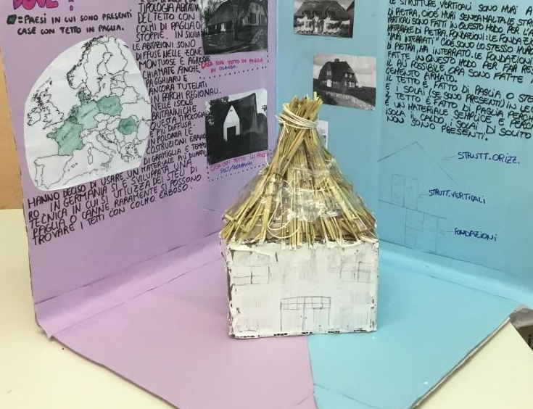

Suggestions for future development and expansion of the scenario
Types of houses: apartment, buildings or condominiums (condos). Web-request about these types and geography localization in Europe.
Production of a film on the evolution of housing over time
SITES
https://www.worldat
las.com/articles/15-traditional-house-types-from-around-the-world.html
https://whc.unesco.org/en/list/787/
https://realgreekexperiences.com/why-are-buildings-in-the-cyclades-painted-blue-and-white

