Whitewashed style
WHERE?____________________
Walls:
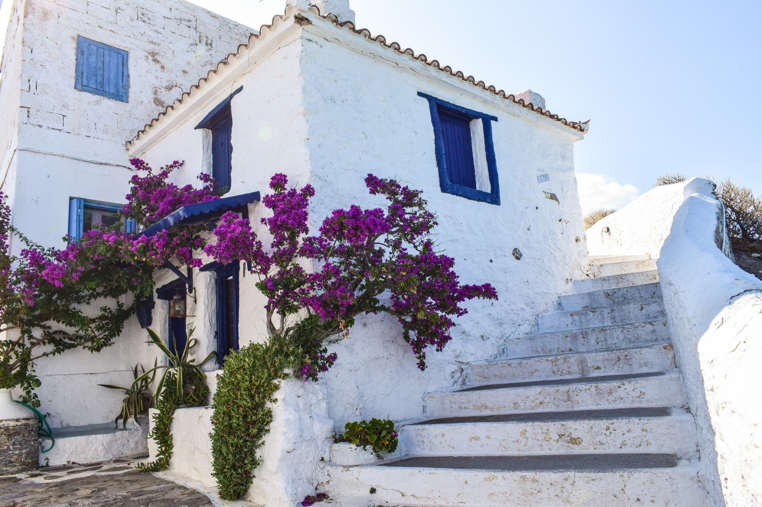
Interior:
windows:
Roof:

AGE:_________________

