**ECOHOUSE**

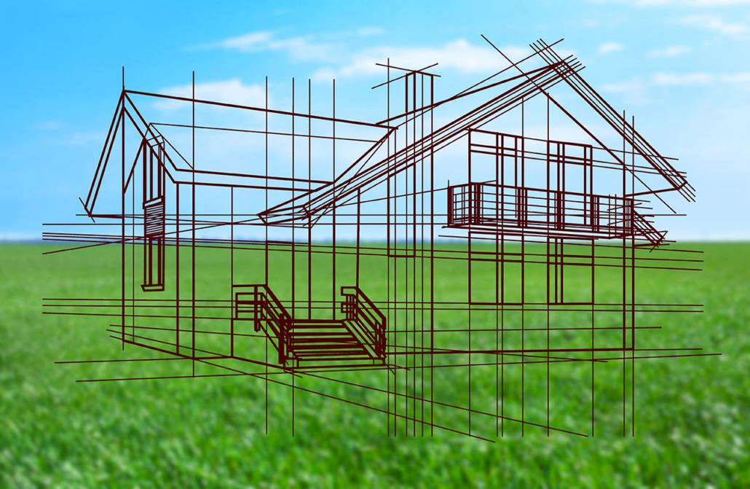

**Creator: Carmela Menna**

**Student profile:** 26 students, aged 11-12.

They work in teams and cooperate in order to share ideas and opinions.

They use the target language in the foreign language lessons.

They use several digital tools in classroom, thanks to the interactive whiteboard, and in computer room.

**Language level:** Language level: **A2** *(based on the common European framework reference for languages)*

**Duration: 3** teaching periods

**Individual occupation time:** 3-4 hours

**Requirements and Prior Knowledge:** Classroom with interactive whiteboard or projector and internet connection, personal smartphone (one per group).

Knowledge of internet navigation and use of Web 2.0. tools.

**Brief description of the scenario**

An Eco-house (or eco-home) is an environmentally low-impact home designed and built using materials and technology that reduces its [carbon footprint](https://en.wikipedia.org/wiki/Carbon_footprint) and lowers its energy needs. Eco-homes are measured in multiple ways meeting sustainability needs such as water conversation, reducing wastes through reusing and recycling materials, controlling pollution to stop global warming, energy generation and conservations, and decreasing CO2 emissions.

**1st teaching period**

**1st Activity:** brainstorming: what does eco-house means?

Time: 10’

Type of activity: discussion

Class organisation: discussion in class

Actions/Tasks: the teacher writes on the blackboard the characteristics of an ecological house according to the students and explain that everyone is conscious that we need to take actions to protect the environment. But what about housing? We spent 2/3 of our lives inside buildings: at home, at school, at work, etc. Where people live and the quality of their housing has a direct influence in the environment, and even in their health. Environment and housing issues are often tied together.

How can we collaborate to make our houses more sustainable? Which factors do we need to take into account when building a house? How can we save energy? How can we protect our health when choosing materials for our house? What is an eco-house?

**2nd Activity:**

Time:20’

Type of activity: video projection and discussion

Class organisation: discussion in class

Actions/Tasks: the teacher shows an educational video about “the home of future”

<https://www.youtube.com/watch?v=BBFBODPndPI>

During the projection of the video, the teacher writes on the blackboard the keywords about the renewable energy: “astronomic electric bill”, “the home of the future will always need power”, “solar panels”, power outage”.

**3rd Activity:**

Time: 30’

Type of activity: comprehension of the text with questionnaire

Class organisation: discussion in class. One tablet for each group.

Actions/Tasks: the teacher sends the link to read an article about Eco housing. After reading the article, students have to answer a questionnaire created with google form

<https://forms.gle/HfM9T7EdkfKfaB1HA>

Each student answers from their tablet. In the end the teacher shows the answers.

**2nd teaching period**

**1st Activity:** ESCAPE ROOM

Time: 45’

Type of activity: escape room

Class organisation: activity in class with GOOGLE FORM

Actions/Tasks: the teacher gives gives the students the link to solve an escape room on Greta Thumber and environmental issues. Students can work in pairs using the school's tablet or PC

https://forms.gle/ohvyAkXicNXgLugQA

**2nd Activity:**

Time: 15’

Type of activity: self-evaluation

Class organisation: discussion in groups

Actions/Tasks: The teacher asks the students how they worked as a couple, if they had any difficulties and how they solved them, if they enjoyed the activity and what they learned

**3rd teaching period**

**1st Activity:** teamwork

Time: 20’

Type of activity: team work

Class organisation: the class is divided into 8 groups of 3-4 students

Actions/Tasks:

The teacher gives the pupils two links on a photovoltaic system and smart home.

Some groups are assigned the first link and some groups the second link. Students from each group read the text.

<https://www.eni.com/en-IT/global-energy-scenarios/sunlight-inexhaustible-gift.html>

https://www.eni.com/en-IT/smart-home/combined-window-solar-panel.html

**2nd Activity:**

Time: 20

Type of activity: final questionnaire

Class organisation: discussion

Actions/Tasks: After reading the text, every group explain it to a group that had the other link and then swap roles. Students who have read the first link do the questionnaire on the second link and those who have had the second link do the questionnaire on the first link.

See “Final questionnaire group A” and “Final questionnaire group B”