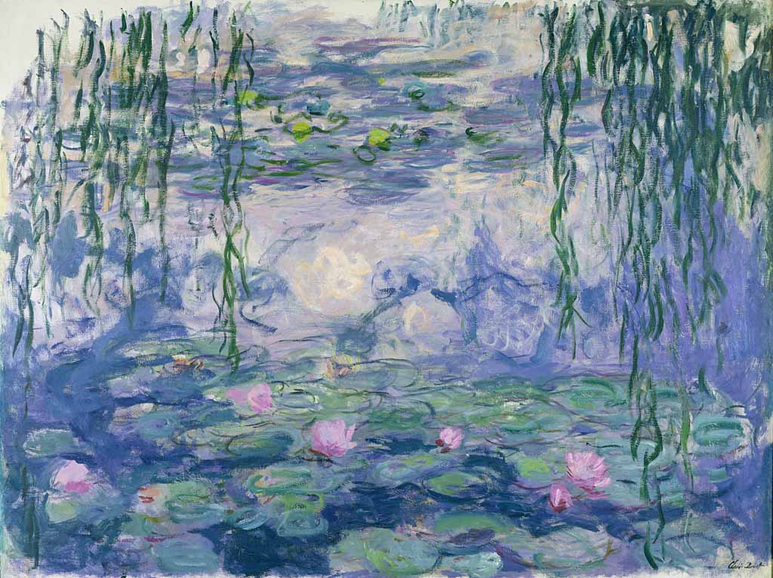

“ART OUTDOORS!”
THE IMPRESSIONISTS
Art and Design at grade 7

Creator: DE SANTIS ANTONELLA
Students’ profile: class 2C (lower secondary school), aged 11-12.
The pupils are collaborative and love working in groups through cooperative learning activities.
They use the digital device that our school make available: IWB, TABLETS, PCs.
They work on the Gsuite digital platform.
Linguistic level: A2 (based on the Common European Framework Reference for Languages)
Duration: 4 teaching periods (1 hour each)
Competences:
Surfing the Internet
Use of the 2.0 Web
Knowing the artistic techniques used by the Impressionists
Critical thinking.

The pupils from the class 2C (lower secondary school) are going to participate in the project; they will be divided into six groups. Every teaching period is going to last one hour and the final product would be a “little work of art” inspired to one of the masterpieces by one impressionist artist, selected by each group.

FIRST TEACHING PERIOD

1st activity:
Time: 30'
Type of activity: Introduction to the main idea of the project
Class organization: group work (creation of the groups), discussion

2nd activity:
Time: 30'
Type of activity: Video-projection, discussion
Class organization: group work, discussion
Actions/Tasks: Under the guidance of the teacher, the pupils research some images of Impressionist works and choose the work of art they want to inspire to.
Then they do some research about the influence of the Impressionist movement on European countries.
The pupils work in groups, in order to foster their collaborative and cooperative skills and to reach a common goal.
https://www.britannica.com/art/Impressionism-art
https://www.tate.org.uk/art/art-terms/i/impressionism
https://www.history.com/topics/art-history/impressionism
https://www.youtube.com/watch?v=eYOeH-EF00s&t=1244s
https://www.youtube.com/watch?v=3jhHX_tpy70

SECOND TEACHING PERIOD

1st activity
Time: 60'
Class organization: group work
Type of activity: Realization of the work of art
The groups approach the out-and-out work, following these WORK PHASES:

- Observe and study the paintings they chose as inspiration for their final product
- Focus on the knowledge of the main Impressionists and on their techniques;
- Develop their work creatively
- Create a work of art thanks to the information they have collected

The theme and aim of the project is the realization of a work of art through the techniques and the styles of the Impressionists.
Actions/Tasks: the pupils are lead to the garden and start drawing, getting inspired by the work they have chosen. Everyone puts in play all of their competences, in service to the entire group. During the realization of the painting, the pupils document the process of their activities by taking pictures and videos.
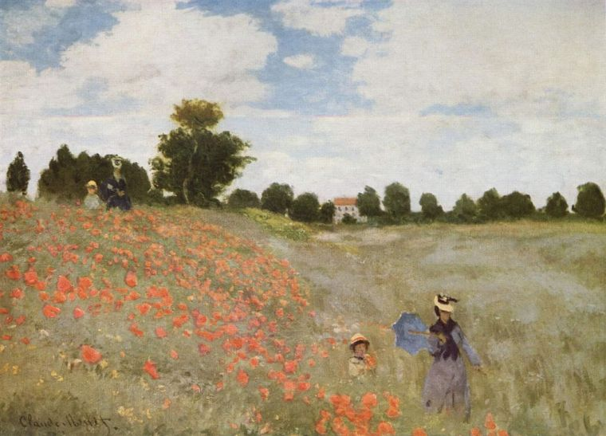
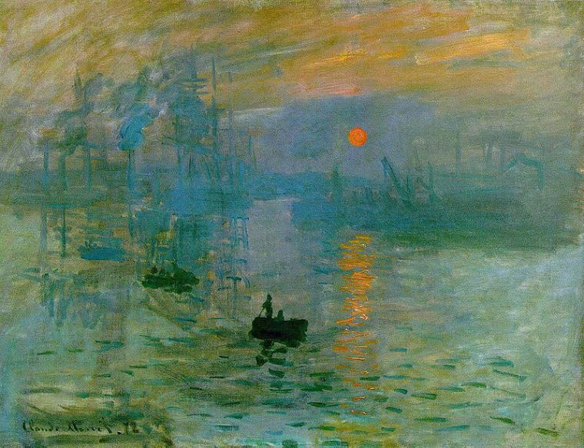

Claude Monet, Poppies (1873), Musée d’Orsay
Claude Monet, Impression, soleil levant, 1872, Musée Marmottan Monet, Parigi

THIRD TEACHING PERIOD
1st activity
Time: 60'
Type of activity: Realization of the work of art
The theme and aim of the project is the realization of a work of art through the techniques and the styles of the Impressionists.
Actions/Tasks: the pupils finish their work in the garden. During the realization of the painting, the pupils document the process of their activities by taking pictures and videos.

FOURTH TEACHING PERIOD
1st activity (DISSEMINATION)
Time: 60'
Type of activity: Realization of a PowerPoint Presentation (in Italian and English): each group presents its research and the work they have produced.
Class organization: whole class, discussion
Actions/Tasks: The pupils realize a multimedial product through PowerPoint, in which they include the images and pictures that document their process of creation: the images of the works of art they inspired to and the pictures of the phases of the realization of their product in the garden.
At the end of the lesson, the pupils take a quiz on WORDWALL:

https://wordwall.net/it/resource/29011031

