

**“MEMORIZING TECHNIQUES!”**

**PIECES: Ragtime Minuet, Impromptu, OR Minuetto in sol.**

Musical instrument: piano

School grade: 8 (3rd year of lower secondary school).

Creator: Gennaro Benvenuto

Student profile: class 3A (lower secondary school), aged 12-13

The pupils are collaborative and love working in groups (cooperative learning activities). They use the digital devices provided by our school: IWB, TABLETS, PCs. They work on the digital platform GSuite.

Linguistic level: A2 (based on the CEFRL)

Duration: 4 teaching periods (1 hour each)

Competences:

Surfing the Internet

Using the 2.0 web

Knowing the basic musical theory and the main piano techniques

The class 3A of our lower secondary school participates in this project. Every teaching period lasts one hour and the final product is a memorization skill: the pupils can memorize a passage or a musical piece, using some specific techniques.

**FIRST TEACHING PERIOD**

***1st activity:***

**Time**: 30'

**Type of activity:** Introduction to the main idea of the project

**Class organization**: group work (creation of the groups), discussion

***2nd activity:***

**Time**: 30'

**Type of activity**: Video-projection, discussion

**Class organization**: discussion

**Actions/Tasks**: Under the guidance of the teacher, the pupils discover various memorization techniques and study one of the pieces provided (free choice). They are going to apply the techniques to the piece they choose and work together to reach a common goal.

https://www.youtube.com/watch?v=ISxKSMbIWtE

<https://colorinmypiano.com/2010/03/02/12-tips-for-memorizing-piano-music/>

**SECOND TEACHING PERIOD**

***1st activity***

**Time**: 60'

**Class organization**: group work

**Type of activity:** memorization of the piece

The groups approach the out-and-out work, following these WORK PHASES:

* Introduction to the different types of memory
* Listening of the piece;
* Warm-up: study of the musical scales;
* Subdivision of the piece into parts, following and respecting the line of the melody (periods and sections);
* Rewriting on the stave: one random passage or 4 or more bars from the piece that has to be memorized;
* Memorization of musical phrases.

The theme of the project is the memorization of any musical passage of 4 (maximum 8) bars from a musical piece, applying some memorization techniques.

**Actions/Tasks**: the pupils start applying the memorization techniques on their musical piece. While studying the piece, the pupils document the process of their learning by taking pictures and videos.

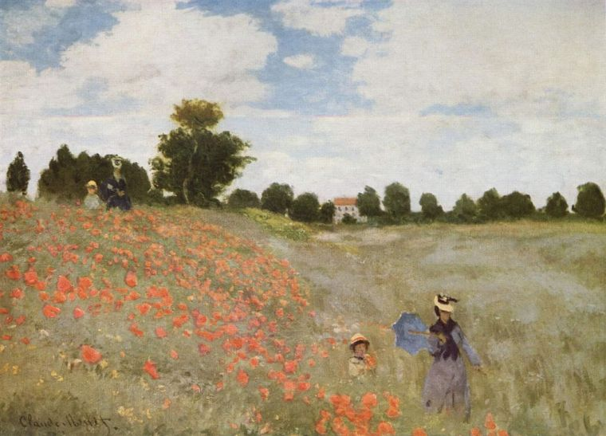

**THIRD TEACHING PERIOD**

***1st activity***

**Time**: 60'

**Type of activity:** Realization of the project

The theme of the project is the memorization of any musical passage (after having studied various techniques). The pupils should become able to do this also starting from a random point on the stave.

**Actions/Tasks**: the pupils finish their work. While studying the piece, they document the process of their activities by taking pictures and videos.

**FOURTH TEACHING PERIOD**

***1st activity (MUSICAL FRAGMENTATION)***

**Time: 60'**

**Type of activity:** Memorizing a musical fragment: the pupils prove their learning through the record of a brief video/audio-track in which they play the memorized passage.

**Class organization**: whole class, discussion

**Actions/Tasks**: The pupils show, through pictures and videos, how they used their memorization skills to learn a passage of the musical piece they chose.

At the end of the lesson, the pupils answer some questions about general musical theory, taking a quiz on **WORDWALL.**

<https://wordwall.net/it/resource/31682130>