GREEK MYTHOLOGY

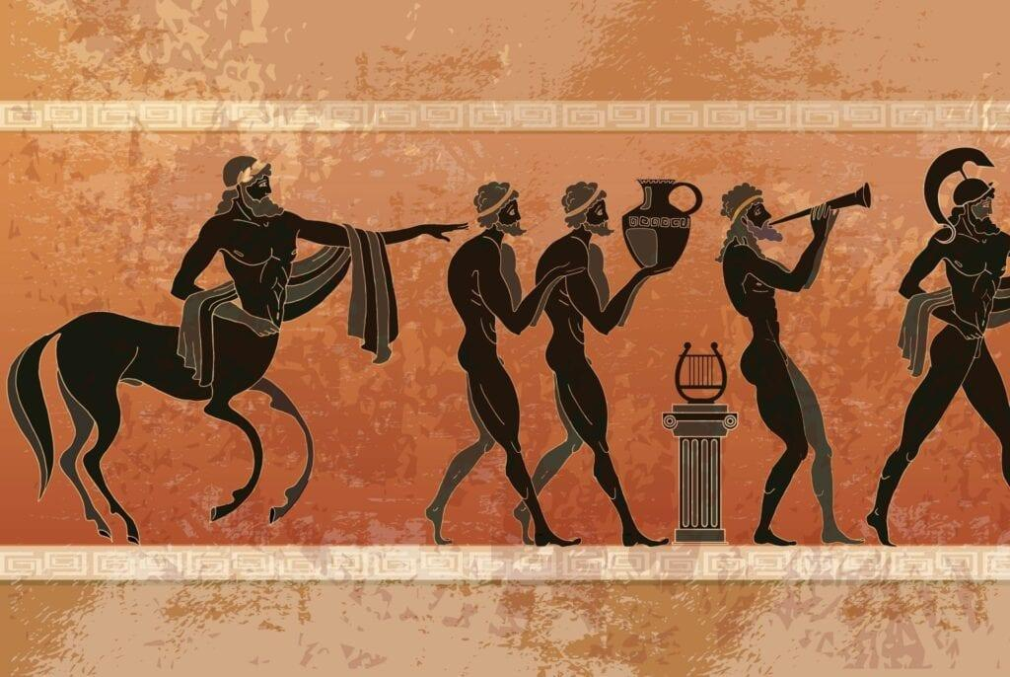

Creator: Michela Franzese - Carmela Menna
Student profile: 22 students, aged 10-11.
They work in teams and cooperate in order to share ideas and opinions.
They use the target language in the foreign language lessons.
They use several digital tools in the classroom, thanks to the interactive whiteboard, and in the computer room.
Language level: Language level: A2 (based on the common European framework reference for languages)
Duration: 3 teaching periods
Individual occupation time: 5-6 hours
Requirements and Prior Knowledge: Classroom with interactive whiteboard or projector and internet connection, personal smartphone (one per group).
Knowledge of internet navigation and use of Web 2.0. tools.
Brief description of the scenario
Greek mythology is not only interesting, but it is also the foundation of allusion and character genesis in literature. In this scenario, students will gain an understanding of Greek mythology and the Olympian Gods and goddesses.
1st teaching period
1st Activity: guided discussion
Time: 30’
Type of activity: discussion
Class organisation: discussion in class
Actions/Tasks: the teacher shows the document "Greek views of the World" and the map
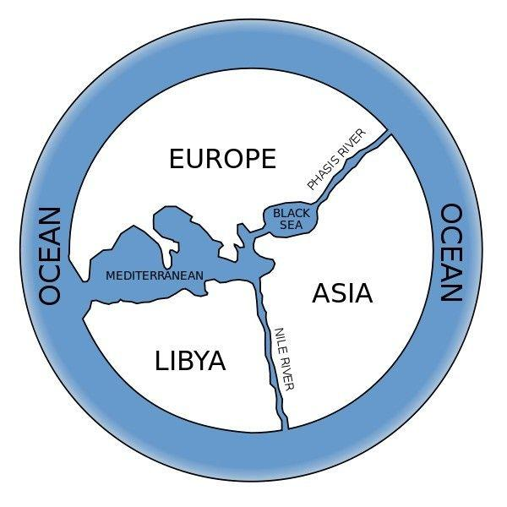
2nd Activity:
Time: 30’
Type of activity: drawing
Actions/Tasks: The teacher asks to draw their own representation of the Greek view of the world on the paper plate using colored pencils and the map on the previous page as a guideline. The teacher has to be sure students include the Ethiopians, the Hyperboreans and the Elysian Fields on their map.

2nd teaching period
1st Activity: discussion in class
Time: 20’
Type of activity: discussion
Class organisation: discussion in class
Actions/Tasks: the teacher explains the origins and characteristic of the myth and the myth of Europa with pptx file
2nd Activity:
Time: 10’
Type of activity: video - projection
Class organisation: discussion in class
Actions/Tasks: the teacher project video “How Europa got its name”
https://www.youtube.com/watch?v=ARfw1ou5JoY

3rd Activity:
Time: 30’
Type of activity: writing a text
Class organisation: individual work
Actions/Tasks: the students have to write a biopoem about one of the gods or goddesses you have studied.
They may choose any god or goddess. When they’re done, copy their final version onto a separate sheet of paper and, if they would like, decorate it.
3rd teaching period
1st Activity: chart
Time: 20’
Type of activity: test
Class organisation: team work
Actions/ tasks: Students use the information that they found at home about the gods of Olympus to begin to fill in the gods and goddesses chart.

2nd Activity:
Time: 15’
Type of activity: Olympian quiz
Class organisation: team work
Actions/Tasks: students take the quiz in pairs. Then they evaluate themselves by comparing the answers with the other couples
3rd Activity:
Time: 25’
Type of activity: individual work
Class organisation: computer lab
Actions/Tasks: Students must respond to the following assignment using a multimedia presentation program:
“Imagine that Zeus has come to you and said that Olympus is lacking a god or goddess, and he needs you to help. Invent a new Olympian and describe him or her below.”
Eventually each student will upload their work to the virtual classroom, course blog or school website

