Title: Stories in Time and Space : The case of Kepler 452 b and the Pythagorean Theorem.
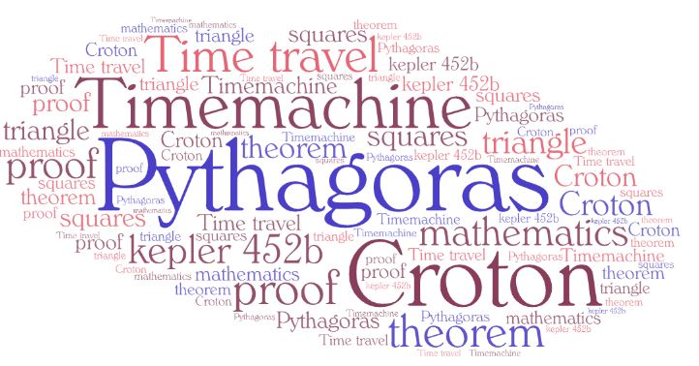

1st Teaching period
1st Activity
Time: 15’
Type of activity: Listening to the first episode of a science fiction story and doing a listening comprehension activity.
Class organisation: whole class/individual work.
Actions/Tasks: The teacher gives the students an interactive image with the 1st part of a science fiction story, which is also provided in a worksheet (Episode 1 / The exoplanet 452b) for reference. The interactive image includes eight stations (1-8). For the first activity, students are asked to listen to the story (station 1, a custom-made video made for the purposes of the lesson) and do an activity, which they need to fill in with information from the story in note form (station 2, made with H5P). While listening, many issues for discussion are raised, which the students are usually very interested in.

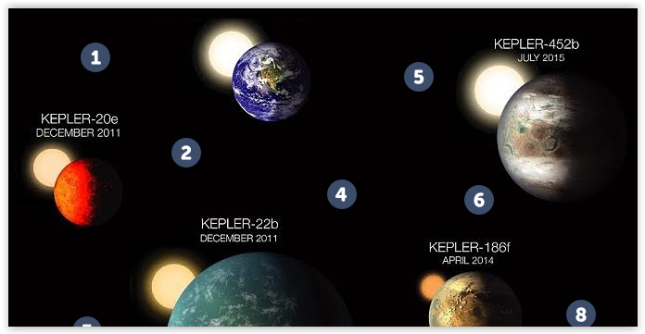

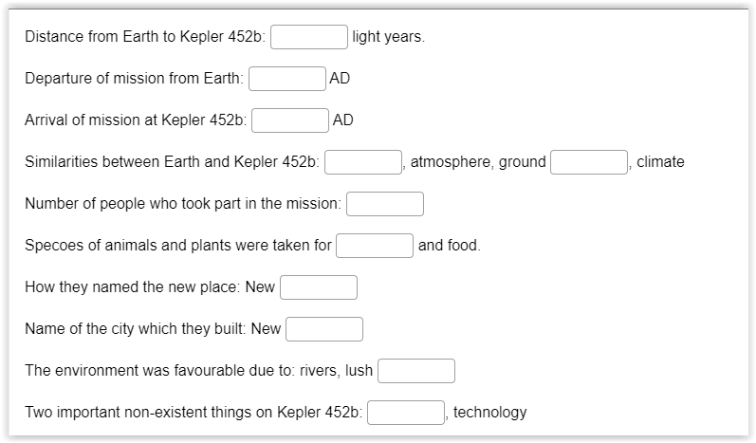

2nd Activity
Time: 30’
Type of activity: group/class discussion based on the story/ explanation of terms of physics involved in that story.
Class organisation: groups/whole class.
Actions/Tasks: The teacher informs the students that they should discuss issues from the video. They are asked to follow the stations one by one on the interactive image (3-8). Some stations lead them to a website for more information. While exploring, students will find many opportunities to discuss issues that they are usually very interested in. They will discuss whether or not the exoplanet 452b exists, they will comprehend the notion of light year (station 5), they will acquire some insights into the theory of relativity (station 6) and they will finally discuss the possibility of travelling in time (stations 7 & 8). On the interactive image, there are references to pages of NASA's website where there is valid information about the above issues (stations 4 & 8).
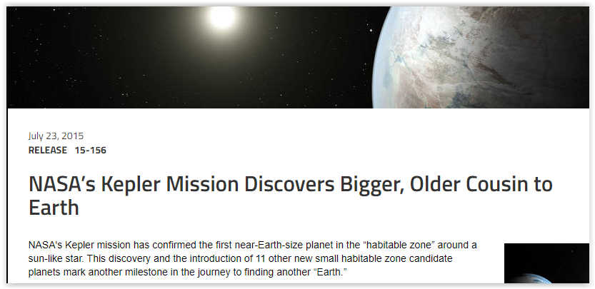
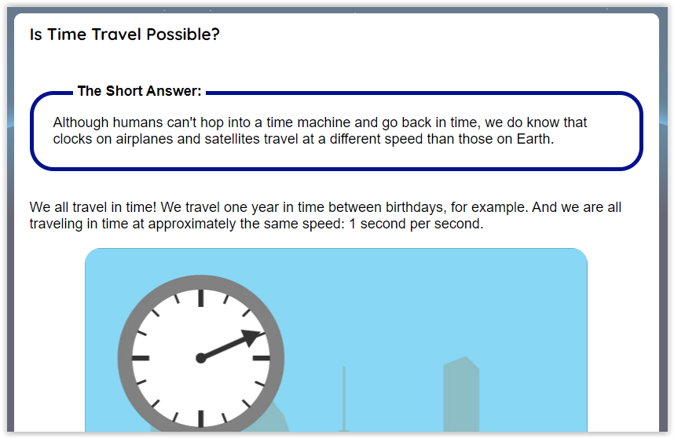
The goal is to get students interested in dealing with a subject such as mathematics and their history outside its strict context and through a science fiction story, which will serve as an opportunity for students to "visit" important moments in space and time for the historical evolution of mathematics. Of course we don’t want to create misunderstandings to the students about travelling back in time and for that reason we refer to NASA website, where there is information about that. We want to make it clear to the students that this story is fictional .

2nd Teaching Period
1st Activity
Time: 30’
Type of activity: Reading a Fiction Story about the Life of Pythagoras and class discussion based on that story.
Class organisation: group work / whole class
Actions/Tasks The teacher gives the students the 2nd part of the worksheet (Episode 2 / The meeting with Pythagoras), and asks them to read the story. The students are going to assume roles (Christine, James, Pythagoras, Pythagoras’ students, narrator), and read their part aloud. By this story students will make an imaginary trip back in time and space to meet Pythagoras, one of the most important pre-Socratic philosophers and mathematicians. They will have the opportunity to discuss the life of Pythagoras, his School and some of his findings in mathematics in quite a theatrical way. And through this, they will try to feel the atmosphere of an era in which the ideas of the people that lived then and at this particular place defined our modern civilization.
While reading, the students can use an interactive map made in h5p in order to visualise the area that we are referring to.
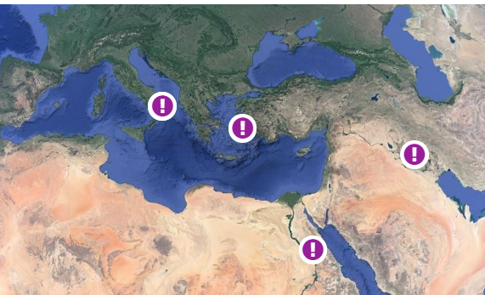
After reading, the students are divided in groups and are given a worksheet with some questions to discuss. Then, a whole class discussion follows with the teacher clarifying difficult concepts.
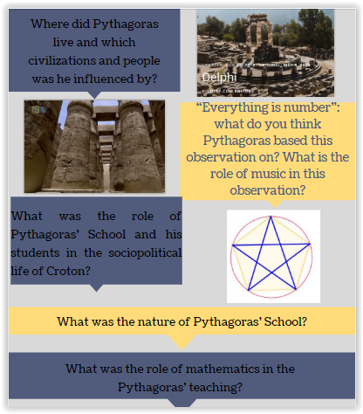

2nd Activity
Time: 15’
Type of activity: creation of a word cloud with key words
Class organisation: group work
Actions/Tasks Students are asked to create a word cloud with the key words they have encountered and could prove useful in order to keep in mind the important things of the lesson and understand the proof of the Pythagorean theorem. (suggested tool: https://wordart.com/)
Example: https://wordart.com/7jdnm0mto7oo/pythagoras

Homework (asynchronous activity): Students are presented with an interactive map with the cities that Pythagoras lived, which are pinned providing some visual help and students are asked to find and post information on the map.
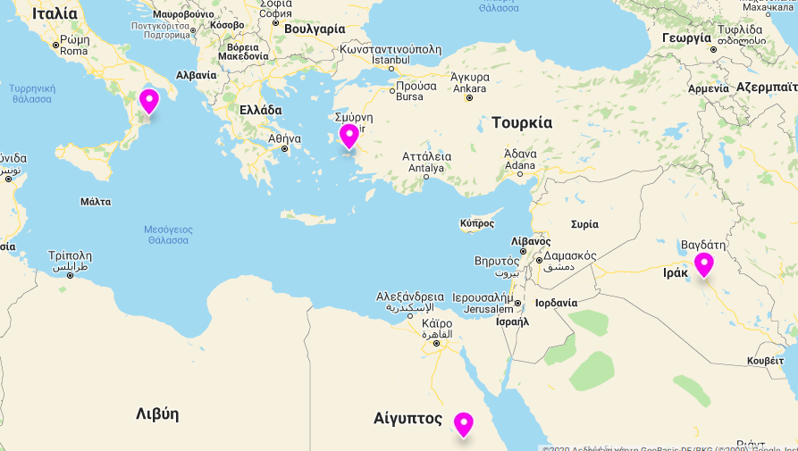

3nd Teaching period

1st Activity
Time: 5’
Type of activity: warm up/remind terminology
Class organisation: individual/ pairs / in plenary.
Actions/Tasks: Students are given the 3rd part of the worksheet ( Episode 3, The proof of Pythagorean Theorem ), Activity 1 and are asked to name the triangles according to the type of its Angles. Apart from the worksheet, the teacher can open an interactive web page in order to experiment with the various triangles. They are also provided with a glossary with definitions and the corresponding term in their native language.
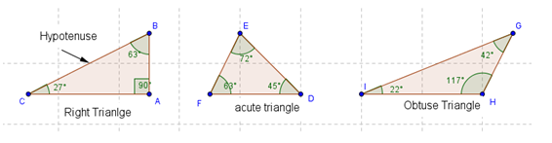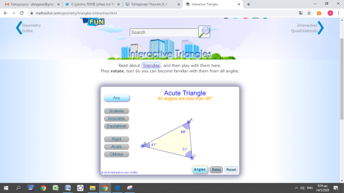

2nd Activity
Time: 25’
Type of activity: interactive applet, note taking, discussion, making speculations, terminology.
Class organisation: individual/ pairs / in plenary.
Actions/Tasks: Students are given a number of right , obtuse and acute triangles at interactive applets made in the free Math app Geogebra and it is posted at the site of the internet community of Geogebra users at https://www.geogebra.org/m/menfujjh
or embedded in moodle. They are asked to interact with the applets, keep notes in a table on the worksheet and to make speculations about the relation of the squares and the sides of a triangle.
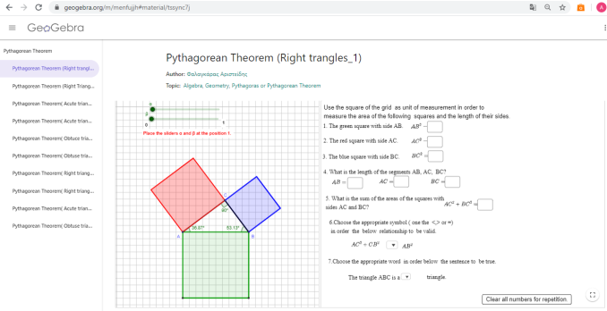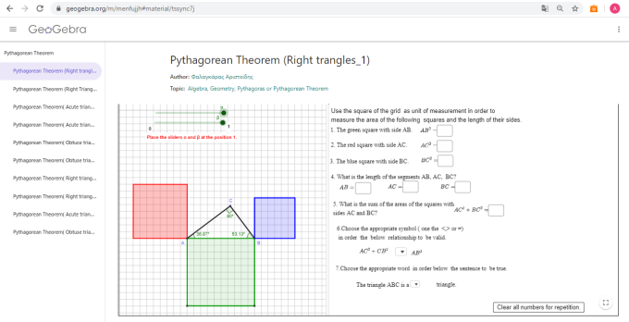

3nd Activity
Time: 15’
Type of activity: Apply conclusions that emerged from activity 2 in specific triangles
Class organisation: individual/ pairs / plenary.
Actions/Tasks: Students are given the 3rd part of the worksheet ( Episode 3, The proof of Pythagorean Theorem ), Activity 3 and are asked to apply the knowledge that was obtained in Activity 2 in order to decide whether or not the given triangles are right angle triangles.

4th Teaching period

1st Activity
Time: 15’
Type of activity: video projection/ discussion
Class organisation: whole class
Actions/Tasks: The students will watch a video about the proofs of Pythagoras and discuss in plenary the necessity of the proof in mathematics, the difference between speculation and proved knowledge.

Time: 30’
Type of activity: simulating the Proof of Pythagorean theorem.
Class organisation: pair work /in plenary
Actions/Tasks: the students, in pairs, are given a pair of scissors and the Activity 4 of the worksheet and are asked to try to simulate one of the many proofs of the Pythagorean Theorem. At the end they are called to demonstrate the proof of the Pythagoras theorem in plenary.

Language Support
Throughout the lessons there is an interactive glossary which they practise online either in class or as homework.
Students are also taught about the derivatives of useful lexis and complete an online worksheet.
Teachers cak keep track of their language progress since the results of the activities assigned to students can be sent automatically.

Expansion: students read the novel ‘The music of Pythagoras’ , which is a story about the relation of Pythagoras, Mathematics and Music. It could be done in collaboration with the Literature teacher.
