Episode 1

The exoplanet Kepler 452b (1st Teaching period )

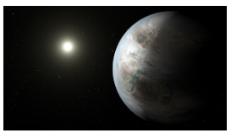
We are on the exoplanet Kepler 452b in 6003 AD. This exoplanet is 1400 light-years away from Earth and was inhabited by Earthlings in 4231 AD, in a space mission which departed from Earth in 2061AD.
It was the era when humanity managed to manufacture machines that could travel with speed close to the speed of light. The mission consisted of both scientists and people of various professions , who liked adventure. They were eager to risk their lives in a voyage in which there wasn’t any possibility of coming back to Earth, because the distance is enormous and it can't be covered during a single lifetime. Their goal was to establish a colony on Kepler -452b because the problems of overpopulation and pollution on Earth were out of control.
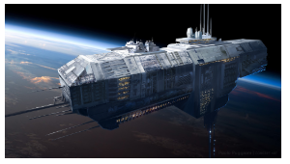
This exoplanet was discovered on 24 of July 2015 by using the Kepler space telescope. The planet was similar to Earth regarding their masses, atmospheres, ground composition and their climate and so it could be inhabited by Earthlings with relatively small adjustments of the human body to the new environment. The people of Earth had already established colonies on the planets close to Earth such as Mars or the Moon but they weren’t happy with the conditions on those planets and thus they decided to organise that mission. In the mission more than 2000 people took part , with a lot of species of animals and plants for reproduction after arriving at the exoplanet but also for covering their needs for food during the voyage. The spaceship looked like Noah's Ark.
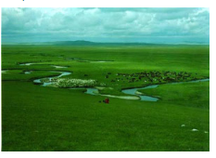
The mission landed on Kepler 452b on 23rd of January 4231 AD on a vast green valley which seemed to be inhabited . Across the valley there were 2 big rivers. Between them there was a dense forest with tall trees. A kid who was born during the mission on the spaceship, looking down at the valley remembered, from the Geography lesson, the rivers Tigris and Euphrates at Mesopotamia. That’s why they decided to name this plain New Mesopotamia. Where the forest was about to end, a valley appeared ,with low vegetation, suitable for raising cattle , sheep and farming. At this nice place they built a city which was named New Babylon. The city turned out to be the financial and cultural centre of the planet , since in the next 2000 years the planet was inhabited from one side to the other, while the plants and the animals that had been brought from the Earth found a favourable environment and they grew up rapidly.
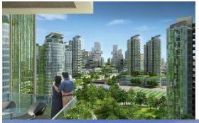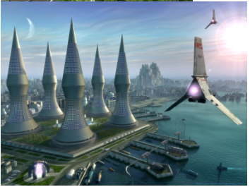
Unfortunately on this planet there weren't any creatures with intelligence like humans ,and thus civilization did not exist at all . Thus the members of the mission had to build the infrastructure that was necessary for the survival of the community from scratch. Meanwhile its population had grown bigger, since they had been travelling for about 1500 years close to the speed of light. During these years that the voyage lasted , because of lack of materials , space and small population there wasn’t any significant evolution of technology. We could say that when the colonists arrived at Kepler 452b, in terms of knowledge and technology, they were at the same level as the Earthlings of 2600 AD. Nevertheless, the environment was favourable , since there were plenty of materials for the construction of cities , manufacture of tools and vehicles, and the technological evolution was impressive within the next 300 years. They founded marvellous Universities, the top of which was the New Academy University at the city New Stagira which is 4000 Km North of New Babylon.
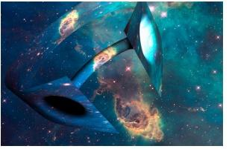
One of its Departments , Technology and Communications , focused on the research for the development of suitable technology for communication with the Earth. According to the Theory of Relativity, it is not possible to travel at a speed higher than the speed of light . Thus the communication with the Earth was practically impossible since a message in the form of a wave needs 1400 years to reach Earth. Nevertheless the scientists of the mission ,from the beginning of the voyage, were working on the wormholes (Einstein-Rosen Bridge). This theory was put forward ,at the beginning of the 20th century, by Einstein and Rosen. The theory contended that we could create some kind of Cosmic Tunnels , which could connect distant places in space and time. In this way, someone could travel in space and in time. Indeed, in 4673 AD the first trip in space and time took place and thus restored the communication with Earth. Since then , a long time went by , and the journeys in space and in time turned to be something common and frequent for Humans both on Earth and on Kepler 452b. Many old space machines thaτ were used for the cosmic trips and which are now technologically outdated are in various museums of technology on both planets.
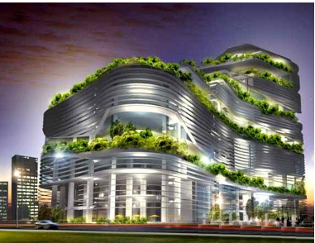
Today the students of the second grade of the 1st Experimental Gymnasium of New Babylon are visiting the Museum Of Cosmic Communication of their city. The exhibits are space machines that were used for the trips between Earth and Kepler b-452. In the morning at school their teachers collected the money for the air-bus that would carry them to the museum and made sure that the students had their worksheets. At 09:30 in the morning they arrived at the museum and they began their exploration in order to gather the information required to fill in their worksheets. They were walking around the museum ,collecting and exchanging information, and talking about the exhibits of the museum. Some of them were not interested in the space machines and they were talking about next weeks’ mathematics test. They knew that it would be difficult.
Christina and James were filling in the worksheet, just the two of them. They entered a room with 12 space machines. Some of those machines were in good condition . The information that was on the signs in front of them explained that these machines were probably used for educational purposes. The wars on Earth, The colonies on planet Mars, the period of 4321-5000 AD on Kepler 452b…. were written in the notes in front of them. They realized that it referred to some historical events that happened on various planets which had been inhabited by Humans . A very well preserved machine drew their attention . Its title was :
Geometry in the Mediterranean
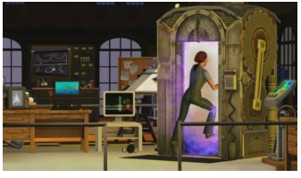
This combination seemed peculiar to them. Geometry and a sea like the Mediterranean. What was the connection between them? They decided to enter the machine , although this was prohibited by their teachers and the people of the museum. The interior of the machine looked like a circular disk with seats inside, arranged in a circle and in the centre there were two seats with controls. Probably these were the seats of the instructors and the others were the seats of the students , James thought. The two children had the fear of being caught in the machine by their teachers and punished for that, but their curiosity to find out what the purpose of the machine was, was big enough to get into it . They sat at the seats of the instructors and began to touch the buttons. They were sure that the machine was out of order. They found the manual of how to get the machine started and they tried to follow the instructions.

Episode 2

The meeting with Pythagoras ( 2nd Hour )
James: Look . I found the manual for turning on the machine..
Christina : So what?
James : I will try it .
Christina : Don’t be a fool..They told us not to touch anything.
James: I Know but I’m sure that it is not working.
Christina. How are you sure?
James. Because..
Christina. Please stop ….

James didn’t listen to Christina and kept following the instructions of the manual for turning on the machine. And suddenly the unexpected happened. The machine was turned on and a message appeared on the screen :

Welcome to the Educational Time Machine called: Geometry in Mediterranean . Next to your seats you will find the material with the information about the implementation of the educational project.

C. James, what is going on? What is this noise?
J. I don’t know. Something has been turned on.
C. Something? or the Time machine?
J. Oh . Don’t try to scare me.
C. Me, scare you? I told you not to play with this manual.

The two kids took the material and started reading. Meanwhile the noise from the machine stopped and another message appeared on the screen:

The trip has begun. Good Luck.
The leaflet that James had in his hands informed them that the time machine was programmed to take them back in time to specific areas of the Earth and to specific periods of time where something important had happened. They had to find the people that had been involved in the creation of the object in that period of time and carry out a task that the machine would assign to them. They would have a portable device at their disposal like today's computers from which they could extract information. Of course, their teachers would be with them to guide them.
Every time they completed their assignment , they would automatically move onto the next mission. Their return to Kepler-b452 would take place upon completion of all missions.

C. James. I hope we haven't gone back in time. How do we get back?
J. I don't know, Open the door to see where we are.
C. Oh James, we are not in the museum… and our teachers are not here either… The machine is working and has sent us back in time…
J. Yes, but where? ..Wait just a minute to find out what the first mission is. Maybe we can do the assignment..It's our only hope…
C. Look for the device , maybe we can get some information.
J. Here it is… I hope it works…

Christina turned on the mobile device. The following message appeared on the screen:

In closet no1 you will find clothes of this era and instructions about your mission.

After the shock of the moment , the two kids realised their situation and they decided to calm down and follow the instructions. They opened the closet where they found many outfits of different sizes for boys and for girls, and the leaflet for the mission. They read carefully the manual and they put on one of the many outfits .

J. I like this outfit . It's very comfortable .
C. James , please be serious. We are in a difficult situation. We don’t Know where we are and how we will go back.
J. According to the machine, the only way to return to our planet is to accomplish the mission. But I like the weather here on Earth and I’m thinking of staying permanently here.
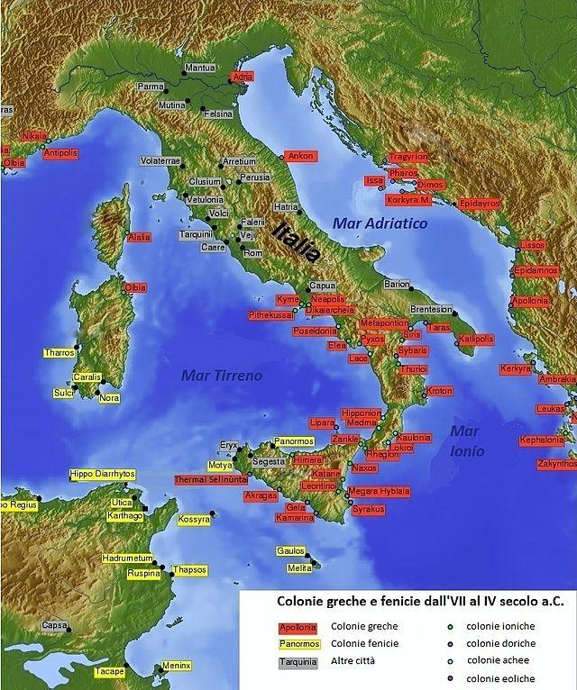
C. Ohhhhh…. In the leaflet it says that we are in Spring of 502 BC in a city named Croton , In Megale Hellas ( Magna Gracea-Great Greece ).
J. Just a minute….I’ll take a look to find that place on the map…Ahh….I found that it’s a place on one of the Peninsulas of the Mediterranean Sea. The Italian one.

C. Italy , I’ve heard a lot about this place in history class, art class , philosophy class . But I’ve never heard that there was a place in it called Great Greece . I Know that Greece is another peninsula of the Mediterranean , close to Italy.
J. You are right. South Italy was called Great Greece after the 6th century BC , by the Ancient Greek colonialists who developed a great culture in the area , back then..
C. So our mission , according to the leaflet , is to find a man here named Pythagoras and ask him to explain to us some of his mathematical discoveries.
J. Oh no….I have heard about him in the Mathematics class … and as you know I hate maths …so I don’t remember a lot about him .
C. I know that you are a math hater …Me, I remember a theorem named after him.
J. How will we find this guy?
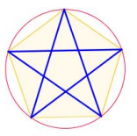
C. Here it says that he has a secret School. The members of this School have a secret sign. The pantalfa. Look, this one.

J. And so what?
C. We must wander around the city and if we see that sign, we can ask how to get to the School of Pythagoras.
J. Ok. Let’s go this way….

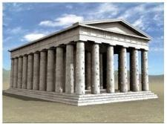
The two kids started walking and looking for the sign of pantalfa. They walked along the seafront of the city, passing by buildings like that, for a while, when suddenly James saw the sign. It was carved on the wall of a house
J. Christina , look over there, the pantalfa .
C. Yes , I see it . Let’s ask that gentleman over there for information.
J. What are we going to ask him?
C. We will tell him that we are looking for the school of Pythagoras .
J. Ok. Will you ask?
C. ok. ….Sir? Do you know where the school of Pythagoras is?
SP. I don’t know anything about this , Miss.
C. We saw the sign of pantalfa outside your house and we thought that you might know something .
SP. What do you know about this sign?
C. We know that it is the secret sign for the members of the Pythagoras’ school.
SP. And what do you want ?
Christina suspected that this man knew things about Pythagoras but he was suspicious, so she decided to pretend that they wanted to become members of the School.
C. We know that Pythagoras is a wise man , and we want to become his students.
SP. Who told you about the school and the sign?

James didn’t want to tell him the truth because he wouldn’t believe them . But he remembered that he read in the leaflet that Themistoclea , the priestess of Delphi , taught Pythagoras some of his doctrines and said :
J. Themistoclea, the priest of Delphi told us about Pythagoras , and how we can find him.
SP. Oh then you know …Sorry for becoming rude but we, the students of Pythagoras, have taken an oath that we should not reveal any of the secrets of the School to people outside.. But since Themistoclea is the one who sent you here, it is ok. So follow me, I'm going there .
C. Thank you, vey much.
SP. You are very lucky , today Pythagoras is going to tell us about his life. It is his 70th Birthday and he wants to tell us where he learned many of the wise things that he is teaching us.
C. We are very lucky indeed.
SP. But as newcomers at the school you cannot see him while he’s teaching. You can only hear him. This applies to all freshmen. That’s why we call them akousmatikous (listeners) because they can only listen. The others, who have been introduced to the secrets of the teaching of Pythagoras, can see the teacher, and we call them mathematikous. (mathematicians). The mathematicians are vegetarian and live in the School permanently, but the listeners don’t live in the school premises and are not obliged to be vegetarians.
James thought : This is the origin of the words mathematics and mathematician . A mathematician is someone who is knowledgeable about subjects , called mathimata in Greek.
The man turned out to be a student of Pythagoras and he led them to their destination . They were very lucky because Pythagoras was going to tell his students about his life , or maybe it was not just a coincidence and the time machine may have arranged to take them there at this particular time.
They entered the building where the school of Pythagoras was and the companion of the two kids arranged them to attend the lecture of Pythagoras as listeners (akousmatikoi) . They saw men and women in the school.

C. Look, the students of Pythagoras could also be women.
J. Why are you surprised?
C. Because I know from the history class that there was a debate at that time whether or not women were human beings. And I know that women in Europe could vote not earlier than 1900 . For example in France they got the right to vote in 1944.
J. I didn’t know that. So Pythagoras is way ahead of his time.
The room was circular and it was divided in three parts . The centre of the room was free of seats . Probably it was the place where the teacher was standing . Around this area there was a ring with seats that had direct eye contact with the teacher ,and around those, there was another ring of seats which prevented eye contact with the teacher by means of a curtain. When everybody sat down, the curtain was drawn and the speaker started his lecture.
Pythagoras : Today I’m turning 70 years old and I will talk to you about my life. You can ask me whatever you want.
Student: Teacher , what urged you to get involved in philosophy and science?
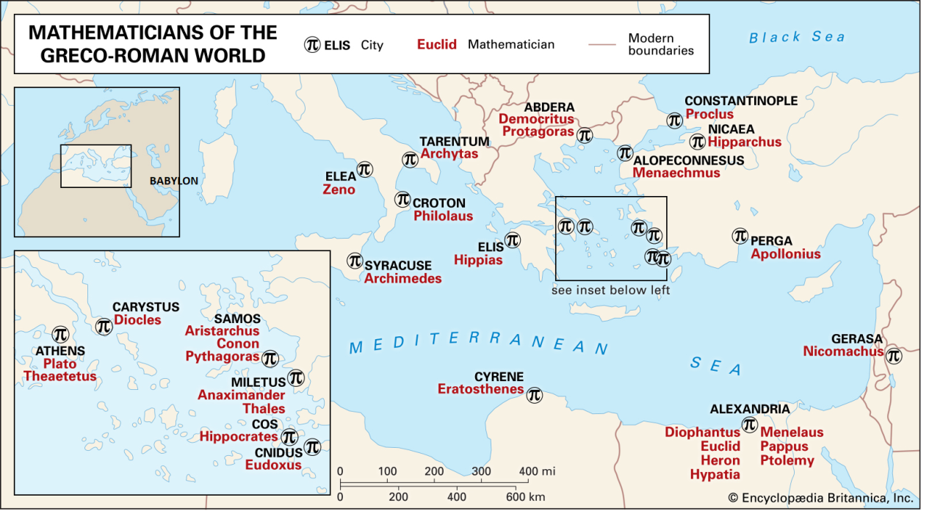
Pythagoras: I wanted to explain how the Cosmos that surrounds us is organised and of course to understand what we, human beings, are . As you know I was born on the Island of Samos , which is close to Ionia (Minor East) . When I was young in Ionia there lived many wise men like Thales, Anaximandros , Anaxemenes, who were great philosophers and who had the same questions as I did. I had heard about their teaching and their travels to the East in order to meet other wise people in Egypt and in Babylon. Due to the fact that my father, Mnesarchus, was a merchant, it was easy for me to take the decision to travel to Egypt to gain the knowledge that these people had gathered in the last 2000 years. As you know Egyptians and Babylonians were way ahead of us in fields like astronomy ,the study of numbers , the calculations concerning areas on Earth , and of course the matter of religion . Have in mind that the Pyramids in Egypt and the sphinx were built almost 1800 years before our era.

Student: When did you arrive in Egypt?
P. I was a young man when I left Samos for Egypt and I studied alongside the priests in the city of Thebes. There I learned a lot of things about arithmetic , geometry, astronomy and religion. I stayed there for about 10 years, when the king of Persia Cambyses invaded Egypt and took me as a prisoner back to Babylon. I stayed there for 5 more years where I learned a lot of things about geometry , arithmetic, music , astronomy and also about religion by the Magi. When they let me free, I went back to Samos and I founded the Semicircle, a school where the Samians could talk about the things that I learned in Egypt and Babylon . Meanwhile I was doing , privately in a cave , my research in philosophy, religion and the use of arithmetic and geometry. After 2 years I left the Island of Samos and came here to Croton.

Student . What was your major discovery in those researches ?
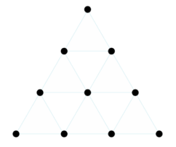
Pythagoras . I discovered that our reality is in virtue mathematical . That’s why I say that everything is numbers. Here is a small demonstration of why I believe such a thing. One day I was passing outside some ironworks. A pleasant melody was coming from it. I entered the place and I saw the blacksmith forging a piece of metal on his anvil with four different hammers. I asked him about the material of the hammers and he told me that they were made of the same material and their only difference was their weight. I asked him to weigh those hammers and we found that their weight was 1, 2 3 and 4 minas ( μνα) respectively . I started to do some calculations and I found out that if we add these four numbers their sum is 10 , the tetraktys :
1+2+3+4 =10
also if we calculate the ratios of these numbers and ratio of the two first ratios, we will find something interesting :

$\frac{1}{2}, \frac{2}{3}, \frac{3}{4}$
and
$\frac{\frac{1}{2}}{\frac{2}{3}}= \frac{1⋅3}{2⋅2}=\frac{3}{4}$
After that, I started to investigate the relationship between harmonic sounds and their connection with numbers . I found out that there is always such a relationship, whether the instrument that produces the sound is a string or a piece of metal etc.
For my research I constructed this monochord and I will try to demonstrate what I mean .

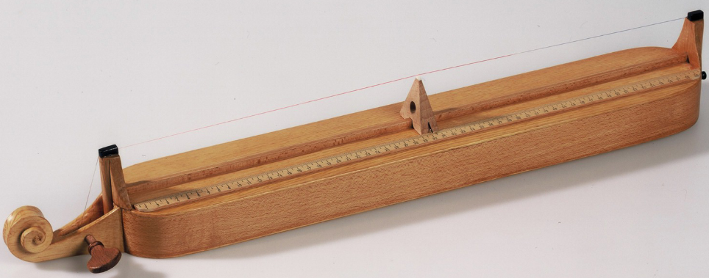
Pythagoras started playing the monochord and produced a harmonic sound. When he finished he said :
During my investigation I managed to hear also the cosmic music that our universe produces with the movement of the spheres on which the planets are moving . You will listen to this cosmic music if you first prepare your soul and mind for such a thing.

C. Do you believe that Pythagoras can listen to that music?
J. No. But it’s a very nice story. And he plays the monochord very well .
C. The melody is very pleasant and the mathematical relations are wonderful.
J. That’s why he believed that every configuration that is nice and beautiful must have some nice arithmetic relation. And that is why he stated that everything is numbers.

Pythagoras : Another thing that I learned in Egypt was a nice arithmetical relation among the sides of some Right triangles which the Egyptians were using to construct right angles. And that’s what we are going to discuss now.

Episode 3 ( The proof of Pythagorean Theorem) (3rd-4th Teaching periods)

Activity 1
Pythagoras : First of all , I will remind you the types of triangles according to their angles .
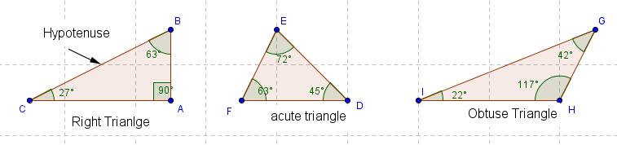

Activity 2
Pythagoras: Now that we remembered the types of the triangles let’s try to observe an interesting relation among the squares of the sides of these triangles. I will give you some squares and I want you to keep some notes and try to make speculations.

Follow the link below, open the first six links you will see on the left bar and fill in the following table:
https://www.geogebra.org/m/menfujjh#material/tssync7j

 | Type of triangle | Length of sides |  |  | Squares
 |  | AB | AC | BC | AB² | AC² | BC² | AC²+AB² | BC²
Triangle 1
Triangle 2
Triangle 3
Triangle 4
Triangle 5
Triangle 6

What do you notice?

Activity 2 (4)
Pythagoras: let’s try to see if the same thing can be observed for the following triangles.

Follow the link below, open the last four links you will see on the left bar and fill in the following table:
https://www.geogebra.org/m/menfujjh#material/tssync7j

 | Type of triangle | Length of sides |  |  | Squares
 |  | AB | AC | BC | AB² | AC² | BC² | AC²+AB² | BC²
Triangle 1
Triangle 2
Triangle 3
Triangle 4

Activity 3
Pythagoras : Which of the following Triangles are Right Triangles. Explain why.
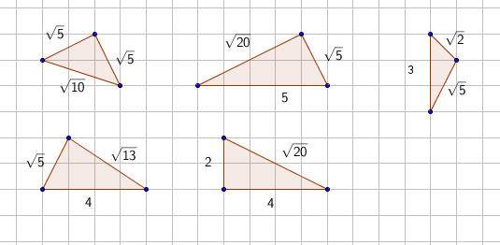

Activity 4
Pythagoras : These are the things I have learned from the Egyptians and Babylonians. But I was not sure if the observations above would be valid for all triangles and discovered a method that would reassure me that the aforementioned claims are indeed valid for all triangles. This method is called a proof.
Watch now : https://www.youtube.com/watch?v=YompsDlEdtc
You could do it by yourself if you have only a pair of scissors.

The proof of the Pythagorean Theorem
The following figures show a puzzle. Cut carefully the 11 yellow triangles and squares on the right and try to cover the big squares on the left.
A. What is the relationship of the big squares on the left?
B. What is the relationship between the sides of the triangles and the sides of all the squares.
C. What is the relationship of the area of the squares?
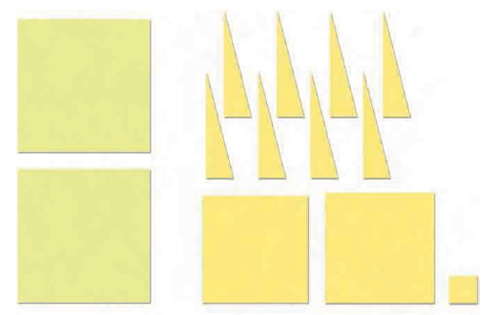

The lecture finished and the students of the school of Pythagoras started leaving the room. The two kids went outside and began talking about what they must do next.
C. James, Pythagoras’ life was very interesting. I would like to talk to him but I think that we are not allowed to . What a pity.
J . These are the rules and we cannot do anything about that.
C. What are the questions that we have in order to complete the task of the time machine ?
J. Just a moment to look at the device . We have to write down some information about Pythagoras’ life on this map:
https://padlet.com/afalagaras/49kw3ujrjj50d819
and prove the Pythagorean theorem.

