**PROPHET MUHAMMAD**

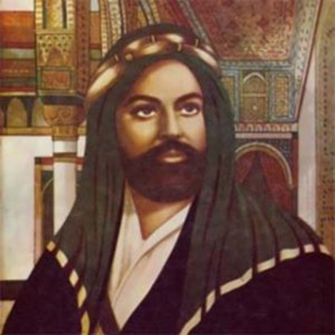

**Creator: Carmela Menna**

**Student profile:** 22 students, aged 11-12.

They work in teams and cooperate in order to share ideas and opinions.

They use the target language in the foreign language lessons.

They use several digital tools in the classroom, thanks to the interactive whiteboard, and in the computer room.

**Language level:** Language level: **A2** *(based on the common European framework reference for languages)*

**Duration: 3** teaching periods

**Individual occupation time:** 5-6 hours

**Requirements and Prior Knowledge:** Classroom with interactive whiteboard or projector and internet connection, personal smartphone (one per group).

Knowledge of internet navigation and use of Web 2.0. tools.

**Brief description of the scenario**

The scenario allows to deepen the study of Islamic civilization and its founding values ​​also in order to promote the inclusion of foreign children

**1st teaching period**

**1st Activity:** guided discussion

Time: 35’

Type of activity: discussion

Class organisation: discussion in class

Actions/Tasks: The teacher asks the children to write on a white sheet the words or names that come to mind when thinking about word “ISLAM”.

After completing the sheet, the teacher outlines the concepts that have emerged on the blackboard to share them with the class and stimulate a motivated participation.

**2nd Activity:**

Time: 25’

Type of activity: video projection

Actions/Tasks:

<https://www.youtube.com/watch?v=WEEORXFj-lo&t=65s>

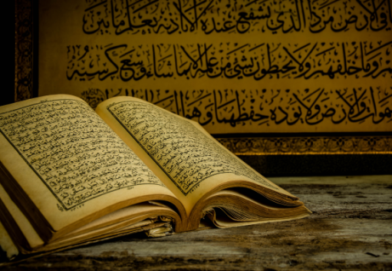

**2nd teaching period**

**1st Activity:** storytelling

Time: 15’

Type of activity: discussion

Class organisation: discussion in class

Actions/Tasks: the teacher distributes to the pupils the storytelling sheet with the story of Muhammad in disorder that they have to rearrange

**2nd Activity:**

Time: 10’

Type of activity: self-correction of work

Class organisation: discussion in class

Actions/Tasks: Pupils discuss the exact solution of the assigned task

**3rd Activity:**

Time: 35’

Type of activity: discussion

Class organisation: discussion in class

Actions/Tasks: the teacher distributes to the pupils the TIMELINE that they can complete it in pairs.

**3rd teaching period**

**1st Activity:** Quiz in BYOD

Time: 10’

Type of activity: test

Class organisation: test with tablet or notebook and discussion

Actions/Tasks: The teacher gives the google modules link with the quiz “How Well Do You Know the Prophet Muhammad”

**2nd Activity:**

Time: 30’

Type of activity: Webquest

Class organisation: groups in the computer lab

Actions/Tasks: the pupils divided into groups research the origin, function(s), and underlying principles of one of the following tools: astrolabe, sundial, compass, water clock, or telescope.

**3rd Activity:**

Time: 15’

Type of activity: Compare and contrast findings with peers

Class organisation: groups in the computer lab

Actions/Tasks: Students discuss what functions or guiding principles, if any, the works share and how these devices might support daily life or scientific practice.

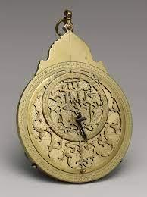

**AFTER**

Afterwards, at home, the students answer the final questionnaire