**THE IMITATION GAME**

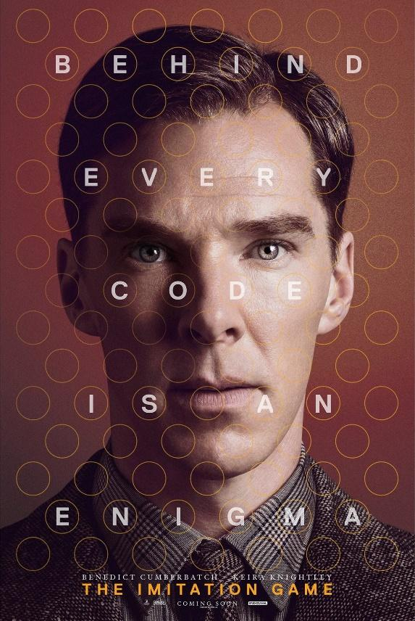

**Creator: Carmela Menna**

**Student profile:** 20 students, aged 12-13.

They work in teams and cooperate in order to share ideas and opinions.

They use the target language in the foreign language lessons.

They use several digital tools in the classroom, thanks to the interactive whiteboard, and in the computer room.

**Language level:** Language level: **A2** *(based on the common European framework reference for languages)*

**Duration: 3** teaching periods

**Individual occupation time:** 5-6 hours

**Requirements and Prior Knowledge:** The film “The imitation game” .Classroom with interactive whiteboard or projector and internet connection, personal smartphone (one per group).

Knowledge of internet navigation and use of Web 2.0. tools.

**Brief description of the scenario**

The scenario, starting from the vision of the film "The imitation game" on the story of Alan Turing, intends to deepen the theme of the Turing machine and the birth of computers.

**1st teaching period**

**1st Activity:** guided discussion

Time: 20’

Type of activity: discussion

Class organisation: discussion in class

Actions/Tasks: Previously students must have seen the movie "The Imitation game".

The teacher starts a guided discussion pointing out how we are surrounded by "intelligent" machines and in these years artificial intelligence is making enormous strides. Thermostats are not particularly smart (but work), but we are amazed by the referral systems of YouTube, Amazon and Netflix. There are "smart" programs

who invest our money in the stock market and experience the first intelligent cars that drive themselves ...

**2nd Activity:**

Time: 20’

Type of activity: video projection

Actions/Tasks: Watch the video “The Turing test: Can a computer pass for a human?” by Alex Gendler.

<https://www.youtube.com/watch?app=desktop&v=3wLqsRLvV-c#menu>

**3rd Activity:**

Time: 20’

Type of activity: questionnaire

Actions/Tasks: Students answer the questionnaire after watching the video

**2nd teaching period**

**1st Activity:** discussion in class

Time: 20’

Type of activity: discussion

Class organisation: discussion in class

Actions/Tasks: the teacher shows “The Ethics guidelines for trustworthy AI”.

**2nd Activity:**

Time: 40’

Type of activity: conceptual map

Class organisation: team work

Actions/Tasks: the students divided into groups of 4 elaborate a conceptual map of the guidelines of the European Union and then they compare their works.

**3rd teaching period**

**1st Activity:** video projection

Time: 20’

Type of activity: video projection and discuss

Class organisation: watching videos

Actions/Tasks: the teacher shows the most significant clip of films in English first with subtitles and then without

“Can a machine think?”

<https://www.youtube.com/watch?v=er_Jfprw6qY>

“Breaking the Enigma Code”

<https://www.youtube.com/watch?v=zZuqLLdx2YQ>

“Wonderful War Together”

<https://www.youtube.com/watch?v=9GuBabLXoJI>

**2nd Activity:**

Time: 40’

Type of activity: Role playing

Class organisation: groups for role playing

Actions/Tasks: the teacher has them play the clips they have seen.