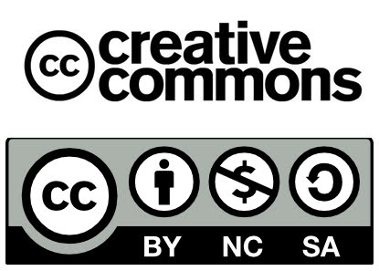

Name:
Class:
Date:

One-minute paper

What do you think was the most important point or central concept communicated during today’s class?

