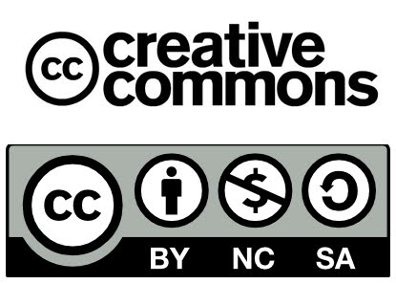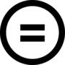

Name:
Class:
Date:

Exercise 1:
Drag the symbol under the corresponding definition.

Non-commercial | No derivatives | Acknowledgment | Share Alike

Exercise 2:
For each label, mark the sentences in the boxes that apply

⬜ Attribution is mandatory  ⬜ Attribution is not required | 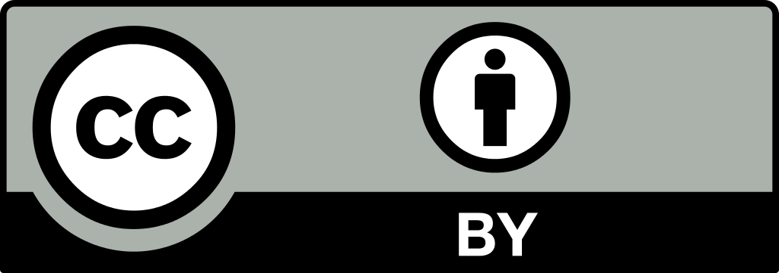 | ⬜ The license allows commercial use  ⬜ The license doesn't allow commercial use
⬜ Distribute under the terms of the original license  ⬜ License can be changed |  | ⬜ The work must remain the same  ⬜ The work can be modified

⬜ Attribution is mandatory  ⬜ Attribution is not required | 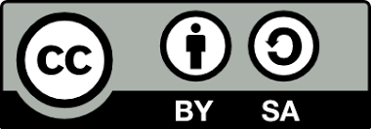 | ⬜ The license allows commercial use  ⬜ The license doesn't allow commercial use
⬜ Distribute under the terms of the original license  ⬜ License can be changed |  | ⬜ The work must remain the same  ⬜ The work can be modified

⬜ Attribution is mandatory  ⬜ Attribution is not required | 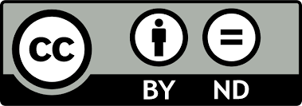 | ⬜ The license allows commercial use  ⬜ The license doesn't allow commercial use
⬜ Distribute under the terms of the original license  ⬜ License can be changed |  | ⬜ The work must remain the same  ⬜ The work can be modified

⬜ Attribution is mandatory  ⬜ Attribution is not required | 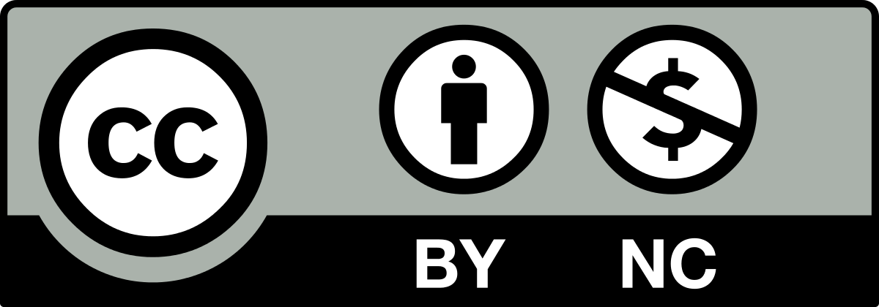 | ⬜ The license allows commercial use  ⬜ The license doesn't allow commercial use
⬜ Distribute under the terms of the original license  ⬜ License can be changed |  | ⬜ The work must remain the same  ⬜ The work can be modified

⬜ Attribution is mandatory  ⬜ Attribution is not required | 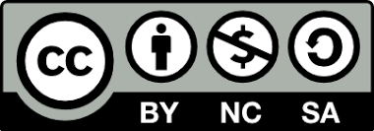 | ⬜ The license allows commercial use  ⬜ The license doesn't allow commercial use
⬜ Distribute under the terms of the original license  ⬜ License can be changed |  | ⬜ The work must remain the same  ⬜ The work can be modified

⬜ Attribution is mandatory  ⬜ Attribution is not required | 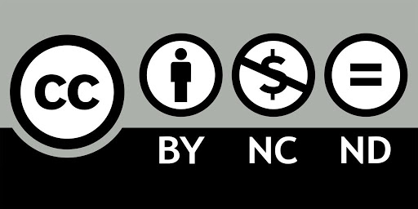 | ⬜ The license allows commercial use  ⬜ The license doesn't allow commercial use
⬜ Distribute under the terms of the original license  ⬜ License can be changed |  | ⬜ The work must remain the same  ⬜ The work can be modified

Exercise 3:
Match the labels to their definition.
Others can redistribute, make modifications, create derivatives of the project even for commercial use as long as they mention the creator
Others can redistribute, make modifications, create derivatives of the project, as long as they mention the creator and distribute the remixes under the terms of the original license
Others can redistribute the project as long as they mention the creator but no remixing is allowed
Others can redistribute, make modifications, create derivatives of the project only for non-commercial use as long as they mention the creator
Others can redistribute, make modifications, create derivatives of the project only for non-commercial use, as long as they mention the creator and distribute the remixes under the terms of the original license
Others can redistribute the project only for non-commercial use as long as they mention the creator, but no remixing is allowed

Exercise 4:
Select all that apply
- You want to modify and use a work in your classroom. Which license(s) allow for this? (Select all that apply)
- CC BY
- CC BY-SA
- CC BY-ND
- CC BY-NC-SA
- CC BY-NC
- CC BY-NC-ND

- You want to use a piece of work in your classroom without changing it in any way. Which license(s) allow for this? (Select all that apply)
- CC BY
- CC BY-SA
- CC BY-ND
- CC BY-NC-SA
- CC BY-NC
- CC BY-NC-ND

- You want to use somebody else’s work without modification in a student workbook that you will sell. Which license(s) allow for this? (Select all that apply)
- CC BY
- CC BY-SA
- CC BY-ND
- CC BY-NC-SA
- CC BY-NC
- CC BY-NC-ND

- You want to create a piece of work that may be used by other students, but it may not be modified or used for commercial purposes. Which license(s) could you put on your work? (Select all that apply)
- CC BY
- CC BY-SA
- CC BY-ND
- CC BY-NC-SA
- CC BY-NC
- CC BY-NC-ND

- You want to create a resource that can be used freely by others. You are okay with them modifying it if they'd like to and they are also free to use it for commercial purposes. Which license(s) could you use? (Select all that apply)
- CC BY
- CC BY-SA
- CC BY-ND
- CC BY-NC-SA
- CC BY-NC
- CC BY-NC-ND
Exercise 5:
- Look at the following questions and study the use of the words in bold. | - As you noticed, all of the questions contained a conditional without if. Can you answer the questions?
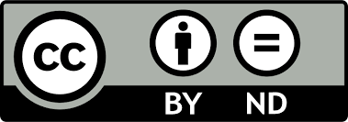
- Does this symbol mean that we can’t make profit from this picture unless we give some of it to the original creator?
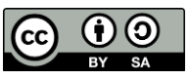
- Can we use this song as long as we do not change it?
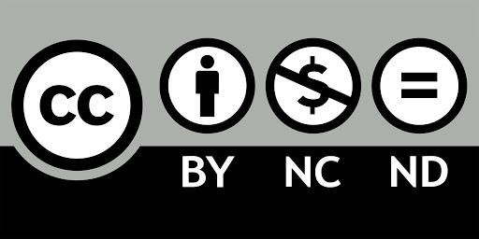
- Can teachers use this online worksheet provided (that) they mention the original author?
- Supposing that we want to use an article under CC-BY-NC, can we distribute free copies of it?
- Which licence means that we can use a document in whichever way we like on condition that we mention the author?

- Now use one of these structures to give advice to the following people:

- A classmate of yours wants to change a picture he found on the internet and then use it in his geography project. The projects will be published on the school’s website.
- CC BY-NC

- Your mother wants to use a diagram she found in an online newspaper article in a report to her boss. The article is marked under the following CC licence:
- CC BY-SA

- Your foreign language school owner wants to publish a booklet that he will sell to his students. Some exercises that he is planning to use are marked under this licence. He is asking you if he can do it.
- CC BY-ND

- Your cousin is asking you what the following CC licence means.
- CC BY-NC-SA

